Section I: Authentication & Session Management

1. Login with valid credentials | CMPT-39

User Story
As a user, I want to log in with valid credentials so that I can access the system.
User Journey
- Login Screen Access
  - Step 1: User navigates to the Calculus application URL./ Using SSO from Rangdhanu
  - Step 2: The Login screen is displayed with PIN and Password fields filled.
- System Validation
  - Step 3: System validates the entered credentials against stored user records.
  - Step 4: If credentials are valid, the system creates a session.
  - Step 5: If credentials are invalid, the system displays an error message.
- Post Login Navigation
  - Step 6: On successful login, user is redirected to the role-based landing screen.
Actors
- Admin
- Project Lead
- Line Manager
- Team Member/any employees in BracIT.
- Management Viewer
Scope
This feature covers authentication into the Calculus system using PIN and password credentials and controls access to all protected modules of the application.

Pre-conditions
- User can be logged in by SSO through Randhanu (HRMS platform).
- User account must be active.

Assumptions
- Credentials are maintained securely in the backend.
- Passwords are stored in encrypted/hashed format.
- User accesses the system via a supported web browser.

Impacted Areas
- Pages: Login Page, All Protected Pages
- Modules: Authentication, Session Management

Mock-ups / Prototypes
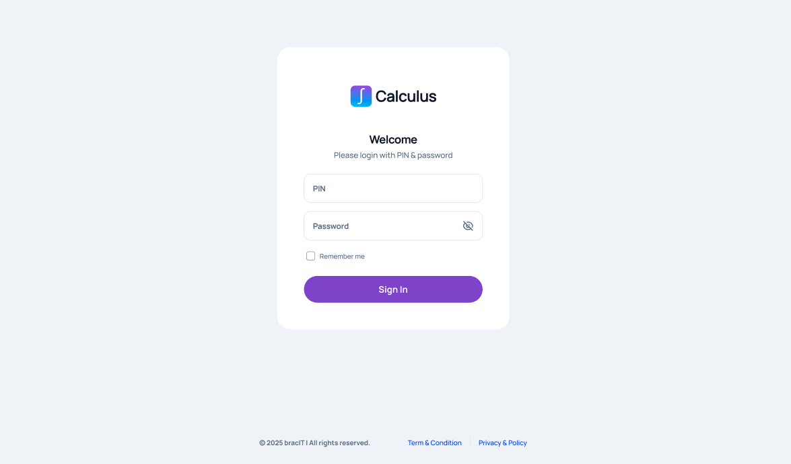

Functional Requirements
- The system must display a login form with:
  - PIN (mandatory)
  - Password (mandatory)
- The system must validate entered credentials.
- The system must create a user session (as par the policy of Brac SSO) upon successful authentication.

Validation Rules
- Pin cannot be blank.
- Password cannot be blank.
- Credentials must match an active user record.

Acceptance Criteria
- User is successfully logged in when valid credentials are provided.
- User is redirected to the appropriate landing page after login.
- Invalid credentials result in an error message.
- Mandatory field validation prevents submission with empty fields.

Exceptions
- If the authentication service is unavailable, the system must show a system error message.
- If user account is inactive, login must be denied with an appropriate message.

3. Logout | US-A03 | CAL-AUTH-003
Terminate User Session Securely

User Story
As a user, I want to log out so that my session is secure.

User Journey
- Logout Action
  - Step 1: User clicks “Logout” from the navigation menu.
- Session Termination
  - Step 1: System invalidates the active session.
  - Step 2: System clears session tokens/cookies.
- Post Logout Navigation
  - Step 4: User is redirected to the Login page.

Actors
- All logged-in users

Scope
This feature ensures secure termination of user sessions and prevents unauthorized access after logout.

Pre-conditions
- User must be logged in.
- An active session must exist.

Assumptions
- Session management is centralized.
- Browser supports cookie/session handling.

Impacted Areas
- Pages: All secured pages
- Modules: Session Management

Mock-ups / Prototypes
N/A

Requirements

Functional Requirements
- The system must provide a Logout option.
- Clicking Logout must terminate the session.
- User must be redirected to Login screen.
- Browser back button must not restore access to protected pages.

Acceptance Criteria
- Session is destroyed upon logout.
- Accessing protected URLs after logout redirects to Login.
- User must log in again to regain access.

Exceptions
- If session has already expired, user must be redirected to Login automatically.
- Network failure during logout must still invalidate session locally.

