Feature 1:

Create Daily Time Log Entry

User Story
As a team member, I want to log my daily working hours against projects so that my effort is recorded accurately.

User Journey
Step 1: User logs into the Calculus application
Step 2: User lands on role-based home screen
Step 3: User clicks “Add work Log” buttons from the landing page.
Step 4: System opens pop-up to Add work logs
Step 5: User selects the date, work log category, Projects, hours and Work description
Step 6: User saves the entry as Draft or submits it

Actors
- Team Member (only individual view)
- Project Lead / Manager
- Team lead
- Admin

Scope
This feature allows users to capture daily time spent on assigned projects without any approval workflow.

Pre-conditions
- User must be authenticated
- Project must be active
- User must be allocated or permitted to log time on the project
- Work log

Assumptions
- Time logging is mandatory for all working days
- Users are responsible for entering accurate data

Impacted Areas
Pages: Timesheet Entry Page
Modules: Timesheet Management

Mock-ups / Prototypes

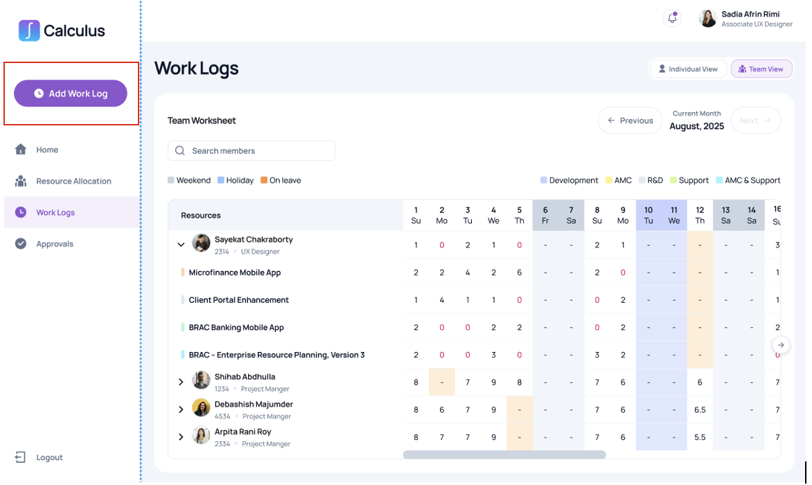
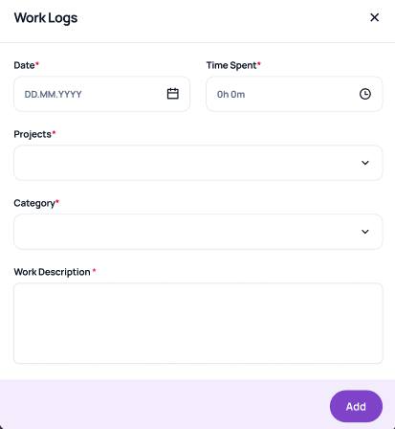

Requirements
- The system must allow users to create daily time log entries and can select any previous date but not beyond the current month.
- All the fields are mandatory.
- Hours must be numeric and greater than zero
- Work Description field must be available
- The system must allow submitting completed entries.
- Without allocation the system will not allow to log
- List of Work log category is static and taken from portfolio manager.
- Project will be searchable from both Brac and BracIT jira and shown list must be assigned to the user.

Acceptance Criteria
- User can successfully log time with valid inputs
- Invalid or missing inputs block submission.
- Data fields validation:
Field Name | Data Type | Validation Logic | Validation Message | Message Appearance
Date | Date Picker | Required; Must be a valid date; Cannot be a future date | "Date is required" / "Please enter a valid date" | Inline
Time Spent | Time (Duration) | Required; Format: 0h 0m; Must be greater than 0 | "Time spent is required" / "Time must be greater than 0" | Inline
Projects | Dropdown (Enum) | Required; Must select one project from the list (Project category same as project creation process) | "Please select a project" | Inline
Category | Dropdown (Enum) | Required; Must select one category from the list (list from Portfolio manager) | "Please select a category" | Inline
Work Description | Text Area (String) | Required; Min 10 chars; Max 500 chars | "Description is required" / "Minimum 10 characters required" | Inline

Exceptions
- If project is archived, it must not be selectable

