Set Up a Jenkins Build Server

In this project, you will learn how to deploy and host Jenkins, an open-source automation software predominantly used for CI/CD (Continuous Integration/Continuous Deployment). You will use Amazon Elastic Compute Cloud (EC2) in a public subnet within your own Amazon Virtual Private Cloud (VPC) and you will also set up an Amazon Elastic Block Store (EBS) volume.

# What you'll accomplish:

Launch a virtual application server to host your Jenkins installation using Amazon EC2. In this single-node setup, both the Jenkins server and agent run on the same Amazon EC2 instance. The instance type you provision will match your expected load. You will also be able to resize the instance if your expected load changes.

**Deploy Jenkins** on Amazon EC2. You will download and deploy the latest version of Jenkins.

**Configure Jenkins** with build servers. You will configure Jenkins so that it spins up additional Amazon EC2 instances as build servers, based on resource consumption.

# Introduction

Jenkins is an open-source automation server that integrates with a number of AWS Services, such as AWS CodeCommit, AWS CodeDeploy, Amazon EC2 Spot, and Amazon EC2 Fleet. You can use Amazon Elastic Compute Cloud (Amazon EC2) to deploy a Jenkins application on AWS in a matter of minutes.

This tutorial walks you through the process of deploying a Jenkins application. You will launch an EC2 instance, install Jenkins on that instance, and configure Jenkins to automatically spin up Jenkins build slave instances if build abilities need to be augmented on the instance.

In this tutorial, you will perform the following steps:

• Step 1: Launch an EC2 Instance

• Step 2: Install and Configure Jenkins

• Step 3: Clean Up

# Step 1: Launch an EC2 Instance

In this step you will launch a virtual server to host Jenkins. These virtual servers are called EC2 instances. Typically, you start from a base image called an Amazon Machine Image (AMI).

You will complete the following tasks:

• Create a Security Group for Your Amazon EC2 Instance

• Launch Your EC2 Instance

# Step 2: Install and Configure Jenkins

In this step you will deploy Jenkins on your EC2 instance by completing the following tasks:

• Connect to Your Linux Instance

• Download and Install Jenkins

• Configure Jenkins

After you launch your instance, you can connect to it and use it the way that you would use a computer sitting in front of you.

Before you connect to your instance, get the public DNS name of the instance using the Amazon EC2 console. Select the instance and locate **Public DNS** on the **Description tab**.

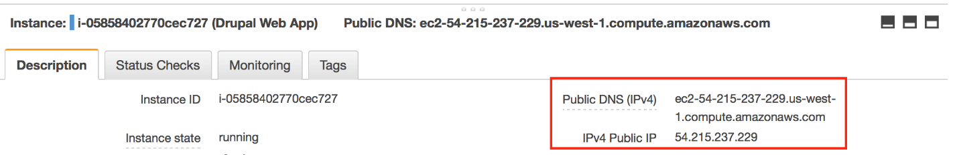

## Prerequisites

The tool that you use to connect to your Linux instance depends on the operating system running on your computer. If your computer runs Windows, you will connect using PuTTY. If your computer runs Linux or Mac OS X, you will connect using the SSH client. These tools require the use of your key pair. Be sure that you created your key pair as described in Create a Key Pair.

## To Connect to Your Linux Instance from Windows Using PuTTY

1. From the **Start** menu, choose **All Programs > PuTTY > PuTTY**.
2. In the Category pane, select **Session**, and complete the following fields:
3. In **Host Name**, enter *ec2-user@public_dns_name*.
4. Ensure that **Port** is 22.

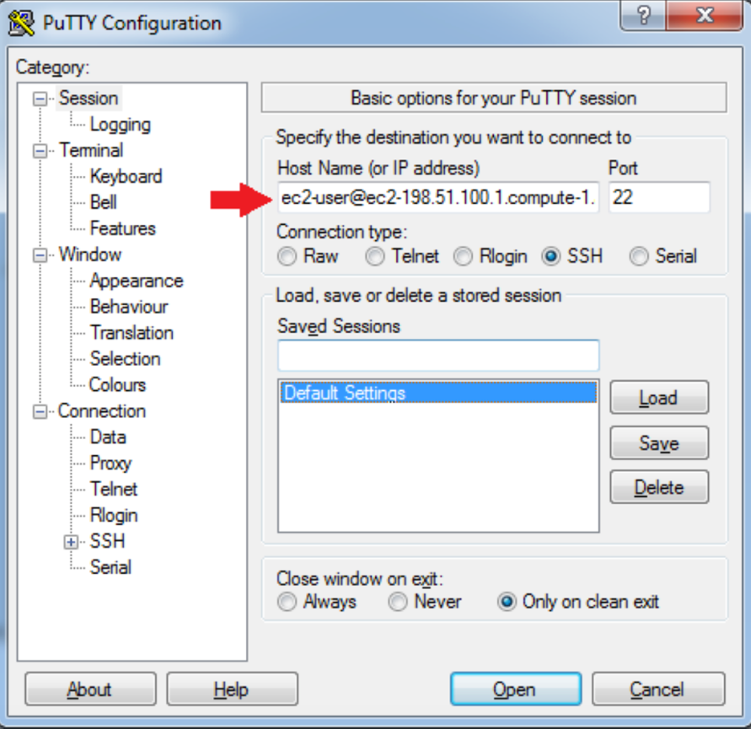

1. In the **Category** pane, expand **Connection**, expand **SSH**, and then select **Auth**. Complete the following:
2. Click **Browse**.
3. Select the .ppk file that you generated for your key pair and then click **Open**.
4. Click **Open** to start the PuTTY session.

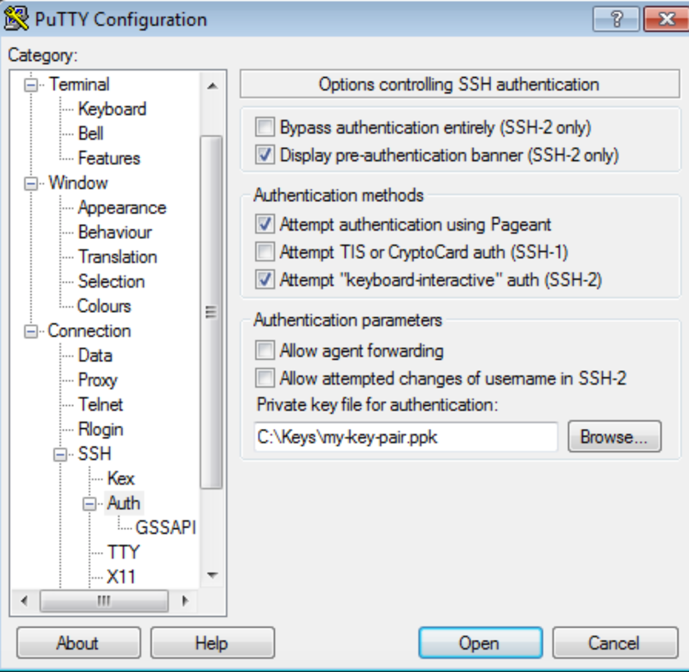

1. If this is the first time you have connected to this instance, PuTTY displays a security alert dialog box that asks whether you trust the host you are connecting to. Click **Yes**. A window opens and you are connected to your instance.

## To Connect to Your Instance from Linux or Mac OS X Using SSH

1. Use the **ssh** command to connect to the instance. You will specify the private key (.pem) file and ec2-user@public_dns_name.

$ ssh -i /path/my-key-pair.pem ec2-user@ec2-198-51-100-1.compute-1.amazonaws.com

You will see a response like the following:

The authenticity of host 'ec2-198-51-100-1.compute-1.amazonaws.com (10.254.142.33)' can't be established.

RSA key fingerprint is 1f:51:ae:28:bf:89:e9:d8:1f:25:5d:37:2d:7d:b8:ca:9f:f5:f1:6f.

Are you sure you want to continue connecting (yes/no)?

1. Enter *yes*.

You will see a response like the following:

Warning: Permanently added 'ec2-198-51-100-1.compute-1.amazonaws.com' (RSA) to the list of known hosts.

# Download and Install Jenkins

To download and install Jenkins:

1. Become root using “sudo su -” command:

[ec2-user@ip-172-31-3-88 ~]$ sudo su

1. To ensure that your software packages are up to date on your instance, use the following command to perform a quick software update:

[root@ip-172-31-3-88 ec2-user]# apt-get update -y

1. Get Jenkins repository using following command:

[root@ip-172-31-3-88 ec2-user]# wget -q -O - http://pkg.jenkins-ci.org/debian/jenkins-ci.org.key | sudo apt-key add -

1. Get Jenkins repository key:

[root@ip-172-31-3-88 ec2-user]# echo "deb http://pkg.jenkins-ci.org/debian binary/" | sudo tee -a /etc/apt/sources.list.d/jenkins.list

sudo apt-get update

1. Install Jenkins package:

[root@ip-172-31-3-88 ec2-user]# sudo apt-get install jenkins

1. Start Jenkins and make sure it starts automatically at system startup:

[root@ip-172-31-3-88 ec2-user]# service jenkins start

[root@ip-172-31-3-88 ec2-user]# chkconfig jenkins on

1. Open your browser and navigate to http://<Elastic-IP>:8080. You will be able to access Jenkins through its management interface:

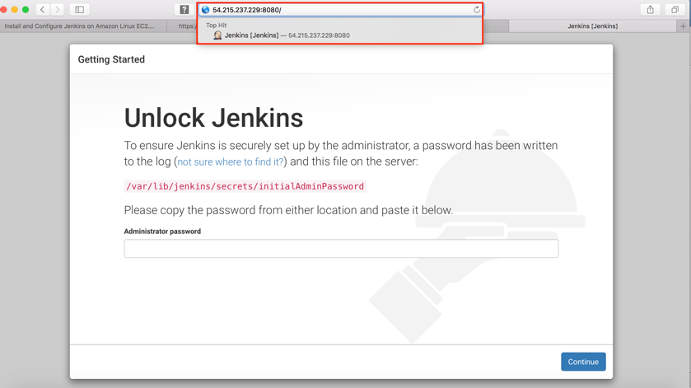

1. As prompted, enter the password found **in /var/lib/jenkins/secrets/initialAdminPassword**. Use the following command to display this password:

[root@ip-172-31-3-88 ec2-user]# sudo cat /var/lib/jenkins/secrets/initialAdminPassword

1. Copy and paste password in **Administrator password** option and click **Continue**.

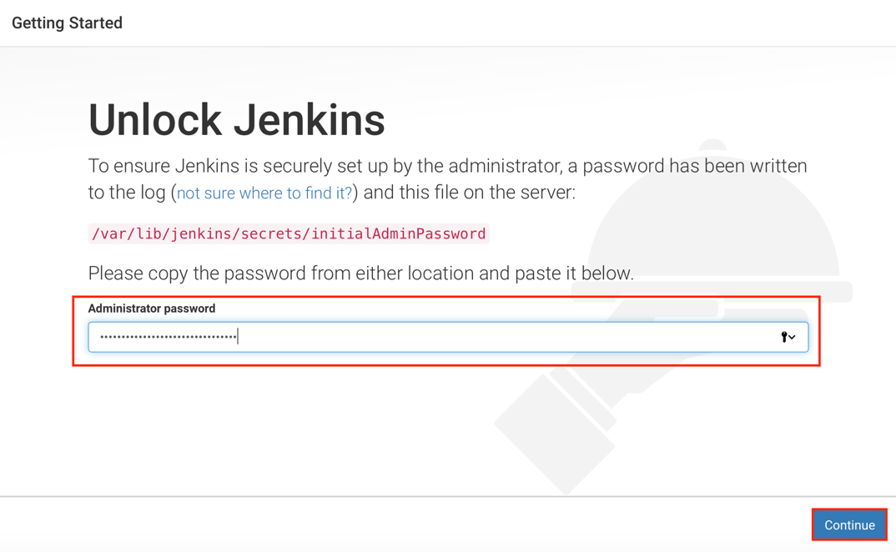

1. The Jenkins installation script directs you to the **Customize Jenkins** page. Click **Install suggested plugins**.

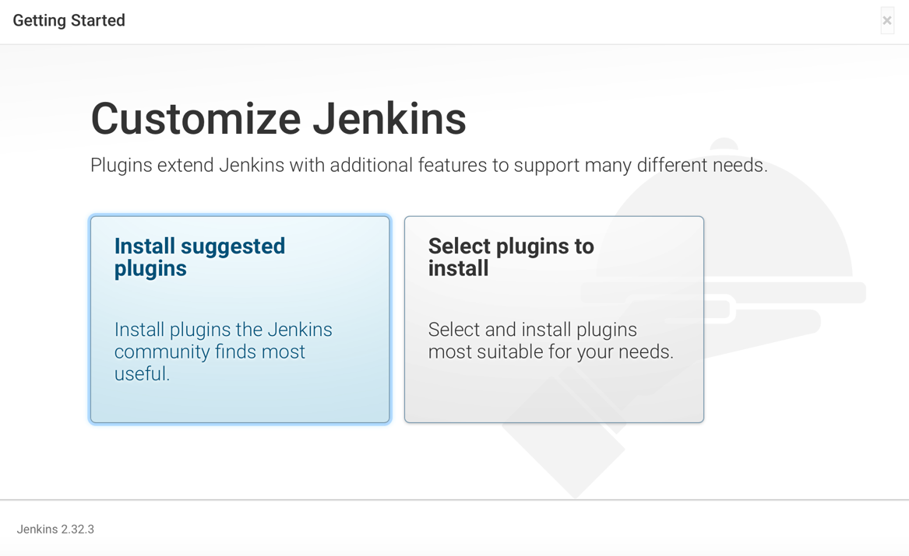

This will initiate the installation.

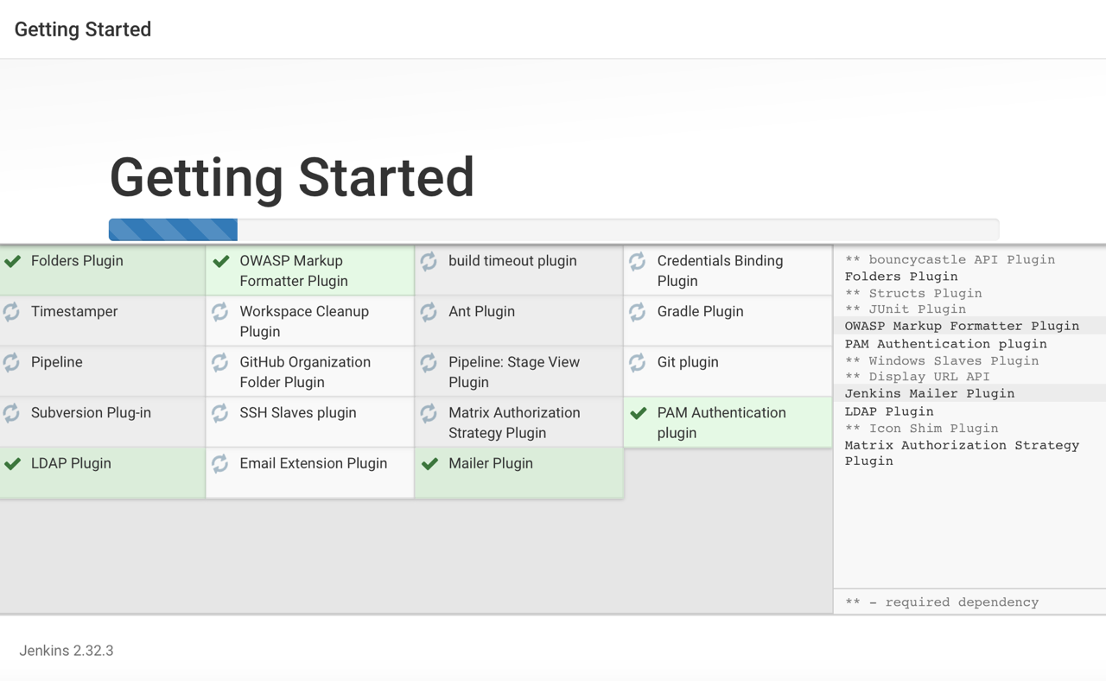

1. Once the installation is complete, enter Administrator Credentials and click **Save and Finish.**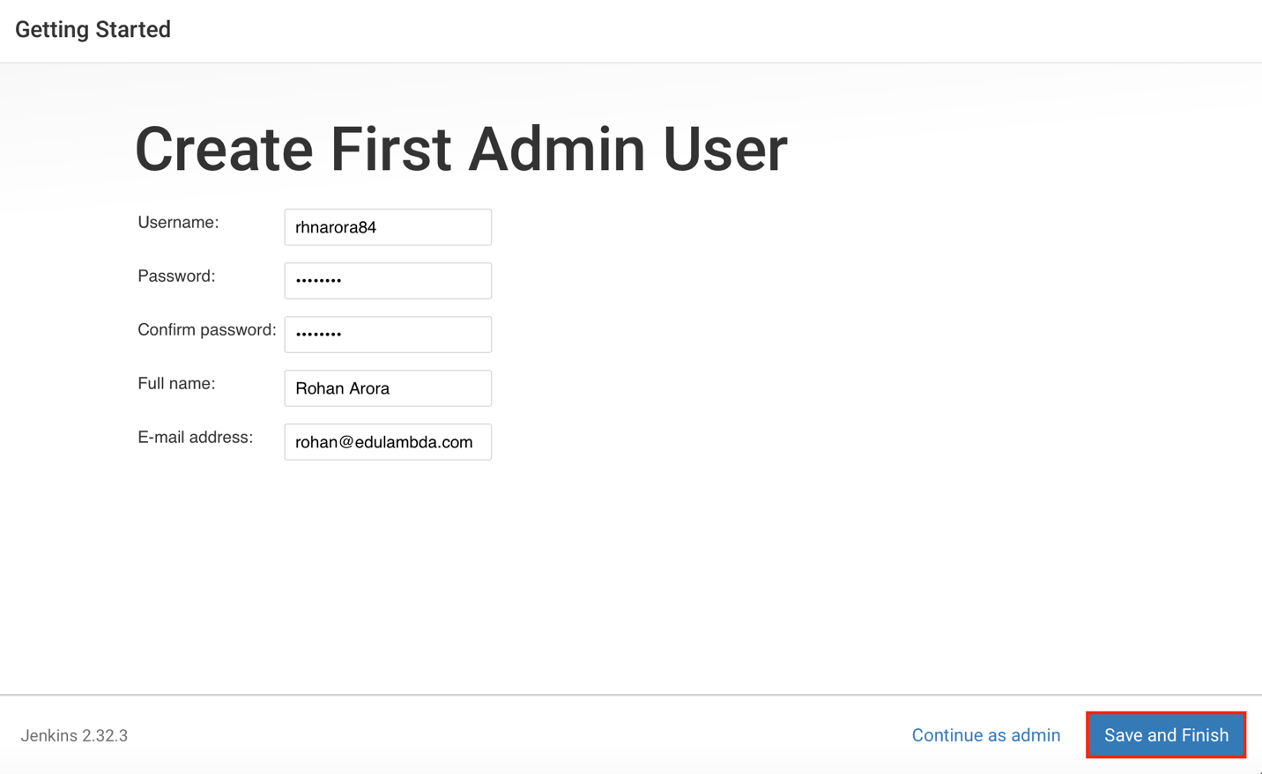
2. Click **Start Using Jenkins**.

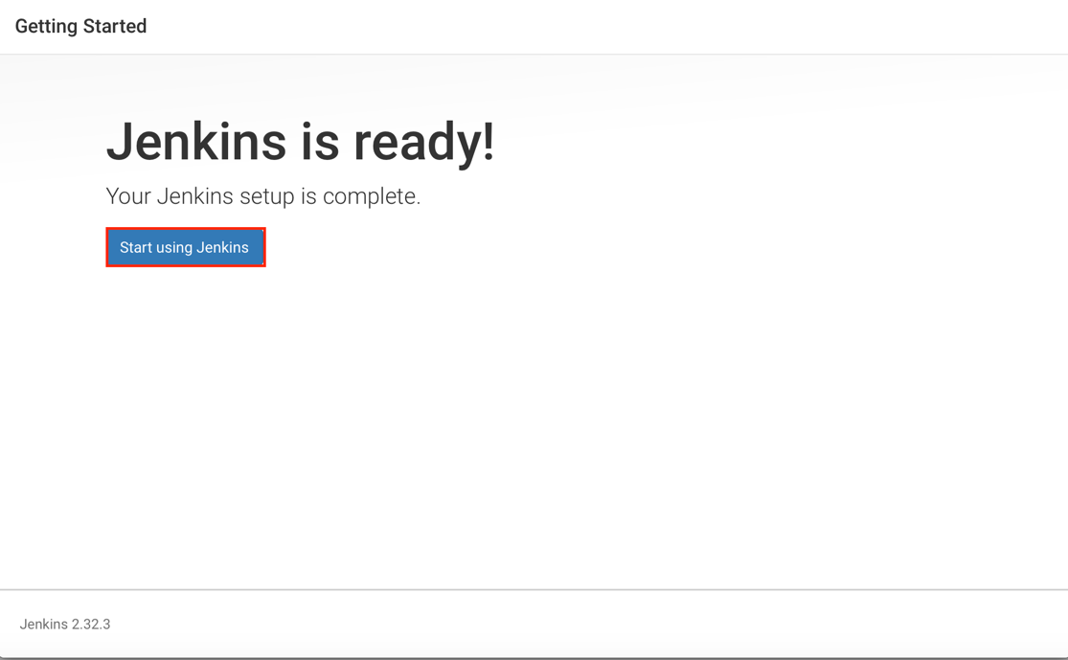

1. On the left-hand side, click **Manage Jenkins**, and then click **Manage Plugins**.

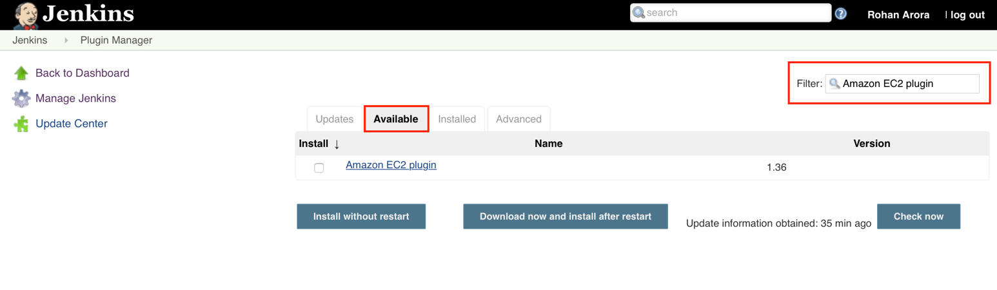

1. Select the checkbox next to **Amazon EC2 plugin**, and then click **Install without restart**.

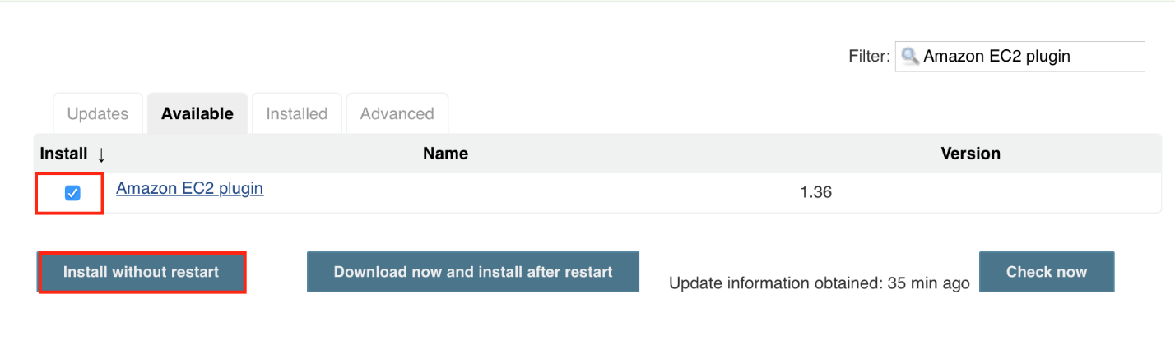

1. Once the installation is done, click **Go back to the top page**.

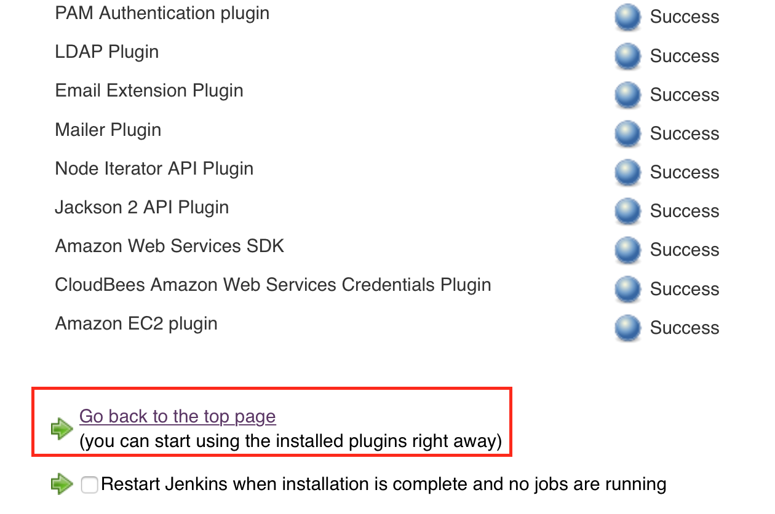

1. Click on **Manage Jenkins**, and then **Configure System**.
2. Scroll all the way down to the section that says **Cloud**.
3. Click **Add a new cloud**, and select **Amazon EC2**. A collection of new fields appears.
4. Fill out all the fields. (Note: You will have to Add Credentials of the kind **AWS** **Credentials**.)

You are now ready to use EC2 instances as Jenkins build slaves.

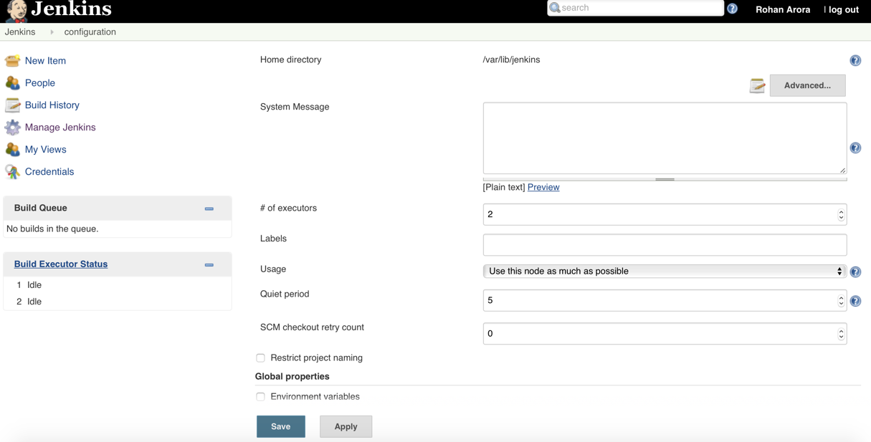

# Step 4: Clean Up

After completing this tutorial, be sure to delete the AWS resources that you created so that you do not continue to accrue charges.

## Delete Your EC2 Instance

1. In the left-hand navigation bar of the Amazon EC2 console, choose **Instances**.
2. Right-click on the instance you created earlier and select **Instance State > Terminate**.

