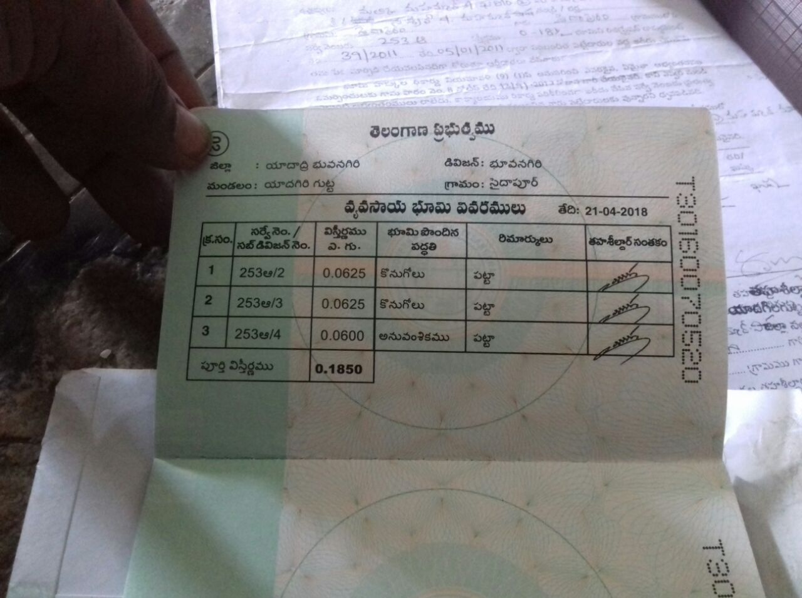

1) From this Doc we get 18.50 – 3 guntas was already sold out. So 15.50 guntas ki the above is the document.

2)

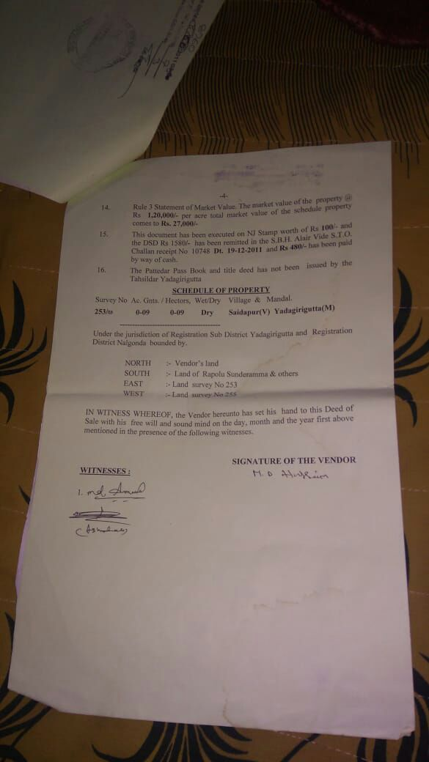

So here the document is for 9 Guntas

Total 1+2 = 24.5 Guntas approximately

3) 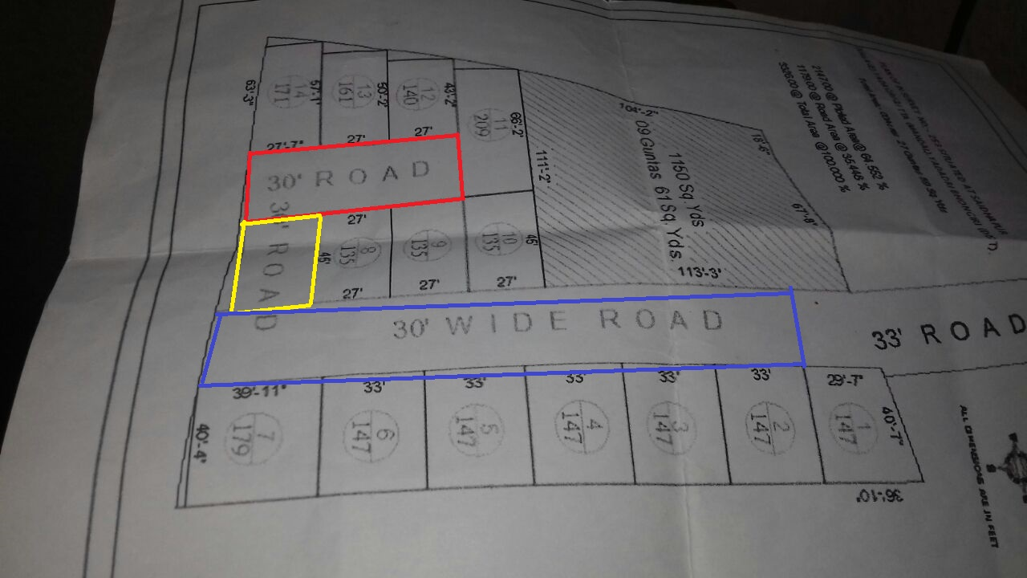

From Plot Number 2 till 14 total area is.

147+147+147+147+147+179+135+135+135+209+140+161+171 = 2000 Sq Yds which is 16.66667 Guntas

Red Border road which is (27.7+27+27)\*30 = 270 Sq Yds or 2.25 Guntas

Yellow Box 45\*30 = 150 Sqyds or 1.25 Guntas

Case 1: Blue Box: (40+33+33+33+33+33)\*40.5 = 922.5 Sq Yds or 7.68 guntas

Case 2: If the Blue Box is cut short upto plot no 4 (40+33+33+20)\*30 = 420 sq yds or 3.5

So

All Plots + Open Land shown will comprise of 16.6+2.25+1.25+Case 1 7.68 = 27.78 which is much more…

All Plots + Open Land shown will comprise of 16.6+2.25+1.25+Case 2 3.5 = 23.6 which closely matches with 24.5 for the documents Papa has shared.