Profile Summary:

Technically sophisticated professional with 2.3 years of experience in the area of Data Analysis and 2 years in software engineering.

Proficient in R, Python and developing Machine Learning algorithms.

Strong analytical skills.

Experience:

Data Scientist – November 2015 to Present

FirstTech – Hyderabad, Telangana.

Software Engineer – October 2013 to May 2015

Web - Insys Software Pvt. Ltd. – Solapur, Maharashta.

Technical Skills:

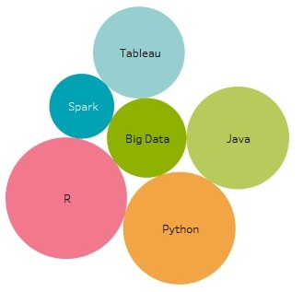

Education Qualification:

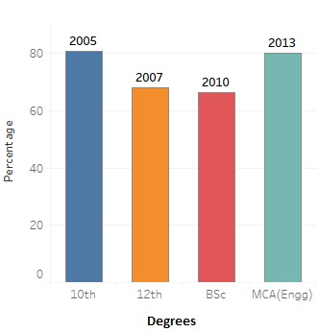

Projects:

- Voice connectivity Project :
It was a US telecom company project in which we have to find out the major reasons behind the call drop. While making any call the company stores all the information of the customers such as Cell ID, Location Area Code, Type Allocation Code, Physical Cell ID, Latitude and Longitude, Network type , Name of network operator, data state on device, is device on roaming, mobile country code, mobile network code, frequency band, etc.. Data is prepared in such a way that these change in attributes at the time of call drop and call end are captured.
Successful call have events such as
  - New outgoing call
  - Placing call
  - Off hook
  - Connected
  - Call disconnected
  - Call end
Call drop call have events such as
  - New outgoing call
  - Placing call
  - Off hook
  - Connected
  - Call drop

Responsibilities:
    - Worked on data pre-processing stage which involved cleaning of data using R
    - Created various dummy variables from the data using R
    - Used data imputation techniques for missing data using R
    - Involved in coming up with various visualizations using ggplot
    - Analyzed and used advanced analytical techniques such as Regression, ARM and Random forest algorithm.
    - Used ROC and AUC to check optimal cutoff value and performance of model.

- Health Care
In this project the dataset contain various variables like, patient id, age, gender, chief complaint, diagnostic codes, diagnoses, etc… Unique diagnostic code is assigned for each injury happen due to accidents or any such event. Whenever any patient admitted to the hospital with injury we have to find out the other injuries that may associated with it and also we have to predict whether the patient is going to live or not due to the associated injuries. Ex. When a patient come to hospital with head injury we have to find out the possibility of other types of injuries that are associated with head injury.
Responsibilities:
    - Cleaned and pre-processed data using R
    - Created various visualizations (Frequency plot) based on data.
    - Used analytical techniques such as Association Rule Mining, Regression, Tree and Random forest algorithm.
    - Used ROC and AUC to check optimal cutoff value and performance of model.

- Coal Mining
AC Miner is a coal mining company and is one of the largest coal miners in the world. They use 100s of heavy machinery which are very expensive (in $Millions) and needed a way to constantly monitor the downtime to get an idea of the resource utilization of various machines used in coal mining. A small downtime of any of these machines would have an impact of thousands to million dollars a day and wanted to find ways to predict if any of the machines were about to fail as part of their predictive maintenance strategy.

Responsibilities:
    - Supplied data is provided in csv formats which is the outputs of sensor data hooked up with the machines
    - Cleaned and pre-processed data using R
    - Created various visualizations using ggplot based on data which would help the business users understand the utilization of machines to be able to do predictive maintenance
    - Used various techniques using R data structures to get the data in right format to be analyzed which is later used by other internal applications to calculate the thresholds.

Certifications:

- Diploma in Data Science from NIT Hyderabad.
- Diploma in Java programming from CDAC.
- PHP, Linux, MySql from IIT Bombay funded by Govt. of India.

Achievements:

- Secured first rank in M.C.A (Engg) department of Solapur University in 2013.
- Presented research papers in national conferences in 2017 and 2012.
- Got “best employee of the month “award internship.

Personal Skills:

- Fast learner.

Strong analytical skills.
- Self-motivated and dedicated.
- Possess good management and organizational skills.
Extra-Curricular:
- Participated in Robotryst organized by IIT Kharagpur.
- Passed the Government of Maharashtra Drawing examination.
- Passed the English Intermediate examinations.
- Organizing committee member of national conferences SINCA and CSBM.
- Won the best teacher award at teacher’s day.
- Participated in various events at school and colleges and own prizes and certificates.
Personal Profile:
- Date of Birth : 24 May 1990
- Marital Status : Married
- Hobbies : Painting, Reading, playing outdoor and indoor games etc...
- Linguistic proficiency : English, Urdu, Hindi, Marathi.
- Blood group : B+ve.

Place: Hydrabad
Date: 06 – 03 - 2018

