BAYTRACK
Smart Parking Management System
Project Report | Diagrams | Algorithms | Complexity Analysis
Language | C (C99 Standard)
Repository | github.com/raamveesam/SmartParkingManagementSystem
Author | raamveesam
Subject | Data Structures & Algorithms Design Project
Date | October 2026

1. Abstract
BayTrack is a multi-level parking management system implemented entirely in standard C (C99). The system manages a 20-bay, 2-floor parking lot and demonstrates the practical application of fundamental data structures — a static array for bay storage, a singly linked list for billing records, and a FIFO queue for overflow vehicle management — combined with classical searching and sorting algorithms. An AI demand heuristic based on a sum of Gaussian bell curves predicts hourly congestion and computes dynamic pricing multipliers, simulating real-world smart parking behaviour.
The system handles vehicle check-in, slot allocation, overflow queuing, checkout billing with dynamic tariffs, session reporting, and 24-hour demand forecasting through an interactive command-line interface.
2. Introduction
Rapid urbanisation has created persistent parking congestion in Indian cities. Manual management of parking lots leads to inefficient space utilisation, long vehicle queues, and revenue leakage. A software-driven parking management system can automate slot tracking, reduce waiting times, and apply dynamic pricing based on real-time demand signals.
BayTrack addresses this problem through a carefully chosen set of data structures and algorithms that balance simplicity with correctness:
- Arrays offer O(1) index access for bay status checks.
- A linked list accumulates billing records without pre-allocating fixed memory.
- A FIFO queue guarantees fairness (first-come-first-served) when the lot is full.
- Insertion sort and binary search demonstrate classical DSA applied to real data.
- A Gaussian AI heuristic removes the need for an external ML library while still producing a smooth, realistic demand curve.
3. Problem Statement
Design and implement a multi-floor parking management system in C that satisfies the following requirements:
ID | Requirement | Description
R1 | Vehicle Registration & Bay Allocation | Assign the nearest free bay to an arriving vehicle without duplicates.
R2 | Overflow Handling | When all category-matching bays are occupied, queue the vehicle fairly.
R3 | Entry / Exit Tracking | Record precise arrival epoch and compute billable duration on departure.
R4 | Dynamic Billing | Apply a surge multiplier derived from predicted hourly demand.
R5 | Slot Search | Locate a parked vehicle's bay using a linear scan of the bay array.
R6 | Session Reporting | Rank completed sessions by fee using an in-place sort algorithm.
R7 | AI Demand Prediction | Forecast hourly occupancy using a mathematical model and show a tariff schedule.

4. System Architecture
BayTrack follows a single-file, procedurally organised architecture with four logical layers. Each layer has a clearly defined responsibility and communicates only through function calls, keeping coupling low.

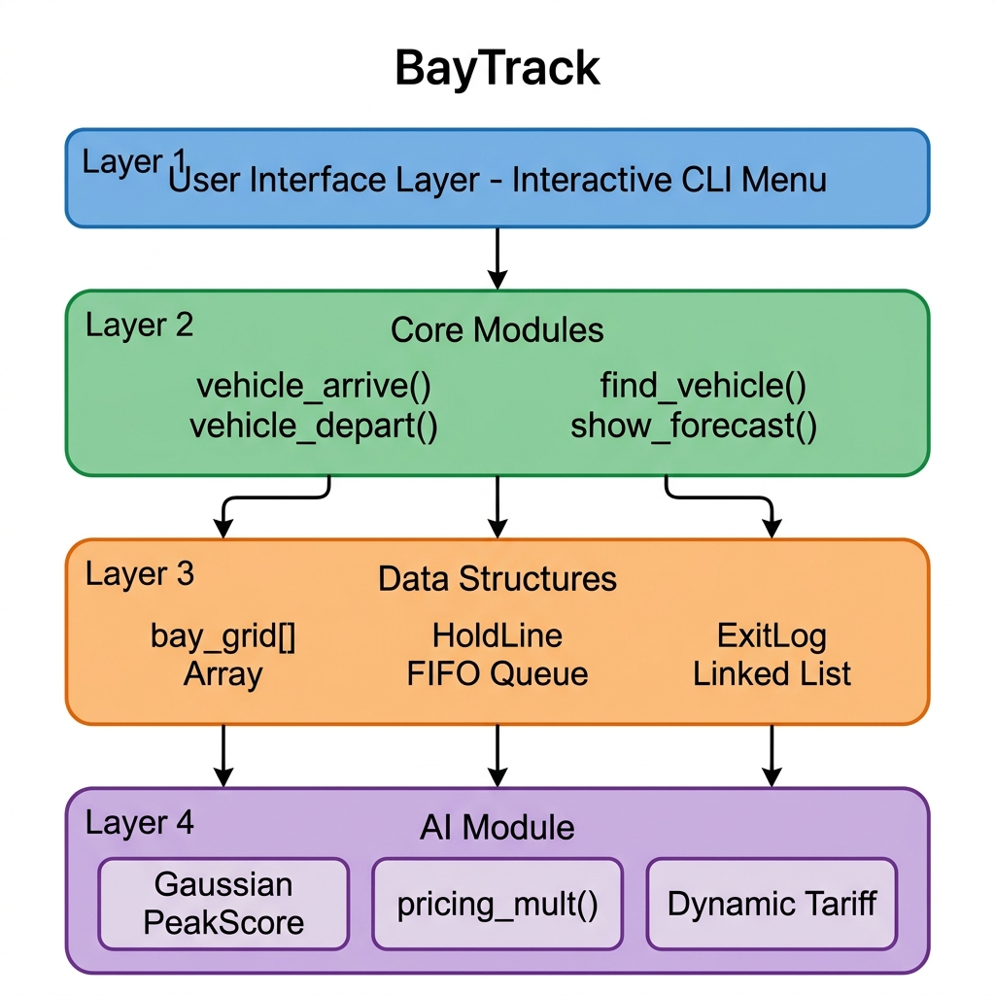
Figure: BayTrack Four-Layer System Architecture
4.1 Layer Descriptions
Layer | Components | Responsibility
User Interface | main() + menu loop | Parses user input and dispatches to module functions.
Core Modules | vehicle_arrive(), vehicle_depart(), find_vehicle() | Business logic: bay allocation, billing, queue management.
Data Structures | bay_grid[], HoldLine, ExitLog linked list | Underlying storage for all run-time state.
AI Module | peak_score(), pricing_mult() | Gaussian demand model and dynamic tariff computation.

5. Data Structures
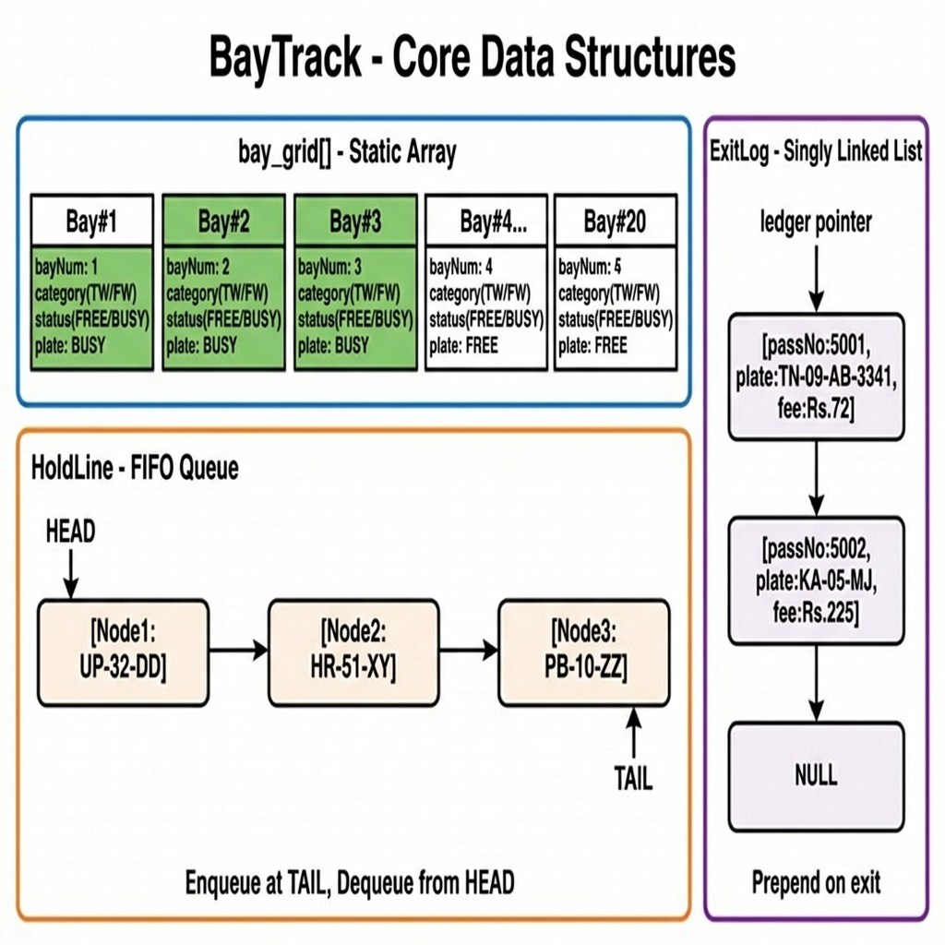
Figure: BayTrack — Core Data Structures (Array, Queue, Linked List)
5.1 Static Array — bay_grid[BAY_COUNT]
bay_grid[] is a fixed-size array of ParkBay structs declared at file scope. Each element represents one physical bay and stores its number, floor level, vehicle category, occupancy status, parked vehicle plate, pass number, and arrival timestamp.
typedef struct {
int bayNum; /* bay identifier: 1 .. BAY_COUNT (20) */
int levelNum; /* 0 = Ground floor, 1 = First floor */
int category; /* CAT_TW (Two-Wheeler) or CAT_FW */
int status; /* BAY_FREE = 0 / BAY_BUSY = 1 */
char tag[18]; /* vehicle registration number */
int passNo; /* entry pass number */
long arrivalEpoch; /* unix timestamp of vehicle arrival */
} ParkBay;
static ParkBay bay_grid[BAY_COUNT]; /* Array: 20 bays, Ground + First floor */

Ground floor (level 0): bays 1–6 reserved for Two-Wheelers; bays 7–10 for Four-Wheelers. First floor (level 1): bays 11–20, all Four-Wheelers.
Rationale for array: O(1) index access; fixed capacity known at compile time; cache-friendly sequential scan for find operations.
5.2 FIFO Queue — HoldLine
When all bays of a vehicle's category are occupied, the vehicle is appended to the HoldLine. The queue is implemented as a linked-node structure with head (front, served next) and tail (rear, most recent addition) pointers. Enqueue is O(1); dequeue is O(1).
typedef struct HoldNode {
CarInfo car; /* vehicle descriptor */
struct HoldNode *next; /* toward the rear of the queue */
} HoldNode;
typedef struct {
HoldNode *head; /* front — served first (oldest arrival) */
HoldNode *tail; /* rear — most recently added */
int size; /* current number of waiting vehicles */
} HoldLine;

When a bay is freed on vehicle departure, the system peeks at the front of the queue. If the head vehicle's category matches the freed bay, it is automatically dequeued and assigned — implementing fair first-come-first-served dispatch with no manual intervention.
5.3 Singly Linked List — ExitLog
Every completed parking session generates an ExitLog node that is prepended at the global ledger pointer. Prepending is O(1) and naturally orders the list from most-recent to oldest — ideal for displaying a billing history.
typedef struct ExitLog {
int passNo; /* entry pass number */
char tag[18]; /* vehicle registration */
int category; /* TW or FW */
int bayNum; /* which bay was used */
long inEpoch; /* arrival unix timestamp */
long outEpoch; /* departure unix timestamp */
float hoursParked; /* billable hours (min 1.0) */
float peakMult; /* AI pricing multiplier applied */
float feePaid; /* total amount charged (Rs.) */
struct ExitLog *prev;/* chain toward older records */
} ExitLog;
static ExitLog *ledger = NULL; /* head of billing linked list */

6. Algorithms
6.1 Bay Assignment — Linear Scan
assign_bay() traverses bay_grid[] from index 0 to BAY_COUNT–1 and returns the first bay that is both FREE and matches the requested vehicle category. This greedy left-to-right scan ensures lower-numbered bays (closer to the entrance) are always filled first, minimising average walking distance.
Algorithm: ASSIGN_BAY(category, tag, passNo, epoch)
──────────────────────────────────────────────────────
Input : vehicle category, plate tag, pass number, arrival epoch
Output : assigned bay number, or -1 if lot is full for this category
1. FOR k = 0 TO BAY_COUNT - 1 DO
2. IF bay_grid[k].status == BAY_FREE AND
bay_grid[k].category == category THEN
3. SET bay_grid[k].status ← BAY_BUSY
4. SET bay_grid[k].passNo ← passNo
5. SET bay_grid[k].arrivalEpoch ← epoch
6. COPY tag → bay_grid[k].tag
7. RETURN bay_grid[k].bayNum
8. END IF
9. END FOR
10. RETURN -1 ▷ no matching free bay found

6.2 Vehicle Departure & Auto-Queue Dispatch
vehicle_depart() combines several operations: linear search to locate the parked vehicle, fee computation using the AI multiplier, ExitLog list prepend, array cell release, and conditional queue dequeue-and-reassign.
Algorithm: VEHICLE_DEPART(tag, exitEpoch)
──────────────────────────────────────────────────────
1. foundIdx ← -1
2. FOR k = 0 TO BAY_COUNT-1 DO ▷ Linear search
3. IF bay_grid[k].status == BUSY AND same_tag(bay_grid[k].tag, tag) THEN
4. foundIdx ← k ; BREAK
5. IF foundIdx == -1 THEN PRINT warning ; RETURN
6. rawHrs ← (exitEpoch - bay_grid[foundIdx].arrivalEpoch) / 3600
7. billHrs ← MAX(rawHrs, MIN_BILLABLE)
8. hr ← hour-of-day(exitEpoch)
9. sc ← PEAK_SCORE(hr) ▷ Gaussian AI model
10. mult ← PRICING_MULT(sc)
11. fee ← hourly_rate(category) × billHrs × mult
12. rec ← NEW ExitLog{passNo, tag, category, bayNum, in, out,
billHrs, mult, fee}
13. rec.prev ← ledger ; ledger ← rec ▷ Prepend to linked list
14. RELEASE bay_grid[foundIdx] ▷ Clear array cell
15. PRINT receipt
16. IF hold_line.size > 0 AND
hold_line.head.car.category == freed_category THEN
17. waiting ← POP_HOLD() ▷ Dequeue from front
18. ASSIGN_BAY(waiting.category, waiting.tag, …)
19. PRINT auto-allocation notice

6.3 Linear Search — Find Vehicle
find_vehicle() scans bay_grid[] sequentially and returns the bay number of the first occupied cell whose tag matches the query string (case-insensitive). Worst case is a full scan of all 20 bays (O(n)).
Algorithm: FIND_VEHICLE(query_tag)
──────────────────────────────────────────────────────
Input : vehicle registration number string
Output : bay number where vehicle is parked, or -1
1. FOR k = 0 TO BAY_COUNT - 1 DO
2. IF bay_grid[k].status == BAY_BUSY AND
same_tag(bay_grid[k].tag, query_tag) THEN
3. RETURN bay_grid[k].bayNum
4. END IF
5. END FOR
6. RETURN -1

6.4 Insertion Sort — Rank Sessions by Fee
show_sorted_sessions() copies ExitLog pointers into a temporary array, then applies Insertion Sort in descending order of feePaid. Insertion sort was chosen because (a) the dataset is small (typical parking lot has tens of sessions), (b) it is stable — ties are resolved by arrival order, and (c) it is trivially implementable without a separate comparator function.
Algorithm: INSERTION_SORT_DESC(arr[], n)
──────────────────────────────────────────────────────
Input : arr[] — array of ExitLog pointers
n — number of elements
Output : arr[] sorted descending by feePaid (in-place)
1. FOR i = 1 TO n - 1 DO
2. key ← arr[i]
3. j ← i - 1
4. WHILE j >= 0 AND arr[j].feePaid < key.feePaid DO
5. arr[j+1] ← arr[j]
6. j ← j - 1
7. END WHILE
8. arr[j+1] ← key
9. END FOR

6.5 Binary Search — Pass Number Lookup
lookup_pass() first sorts the session array by passNo ascending (using Insertion Sort), then applies classic binary search. Because pass numbers are monotonically increasing (issued sequentially from TICKET_START = 5001), the sorted order is guaranteed after one pass.
Algorithm: BINARY_SEARCH_PASS(arr[], n, target)
──────────────────────────────────────────────────────
Input : arr[] — ExitLog pointers sorted by passNo ascending
n — number of elements
target — pass number to find
Output : index in arr[] if found, else -1
1. lo ← 0 ; hi ← n - 1
2. WHILE lo <= hi DO
3. mid ← lo + (hi - lo) / 2 ▷ avoids integer overflow
4. IF arr[mid].passNo == target THEN RETURN mid
5. IF arr[mid].passNo < target THEN lo ← mid + 1
6. ELSE hi ← mid - 1
7. END WHILE
8. RETURN -1

6.6 AI Demand Heuristic — Gaussian PeakScore
peak_score(h) models urban parking demand across 24 hours by summing two Gaussian bell curves that represent the morning rush (centred at 09:00, σ ≈ 1.4 hr) and the evening rush (centred at 18:30, σ ≈ 1.3 hr), plus a flat baseline for midday occupancy (10:00–17:00). The result is clamped to [0.0, 1.0] before being mapped to a pricing multiplier.
Algorithm: PEAK_SCORE(hour h)
──────────────────────────────────────────────────────
morning_component ← 0.85 × exp( −0.5 × ((h − 9.0) / 1.4)² )
evening_component ← 0.94 × exp( −0.5 × ((h − 18.5) / 1.3)² )
daytime_base ← 0.62 if 10 ≤ h ≤ 17, else 0.0
score ← morning_component + evening_component + daytime_base
RETURN CLAMP(score, 0.0, 1.0)
Algorithm: PRICING_MULT(score)
──────────────────────────────────────────────────────
IF score ≥ 0.80 → RETURN 1.60 ▷ Peak surge tariff
ELIF score ≥ 0.55 → RETURN 1.25 ▷ Moderate traffic
ELIF score ≤ 0.20 → RETURN 0.80 ▷ Off-peak rebate
ELSE → RETURN 1.00 ▷ Normal rate

7. Process Flowcharts
7.1 Vehicle Check-In Flowchart
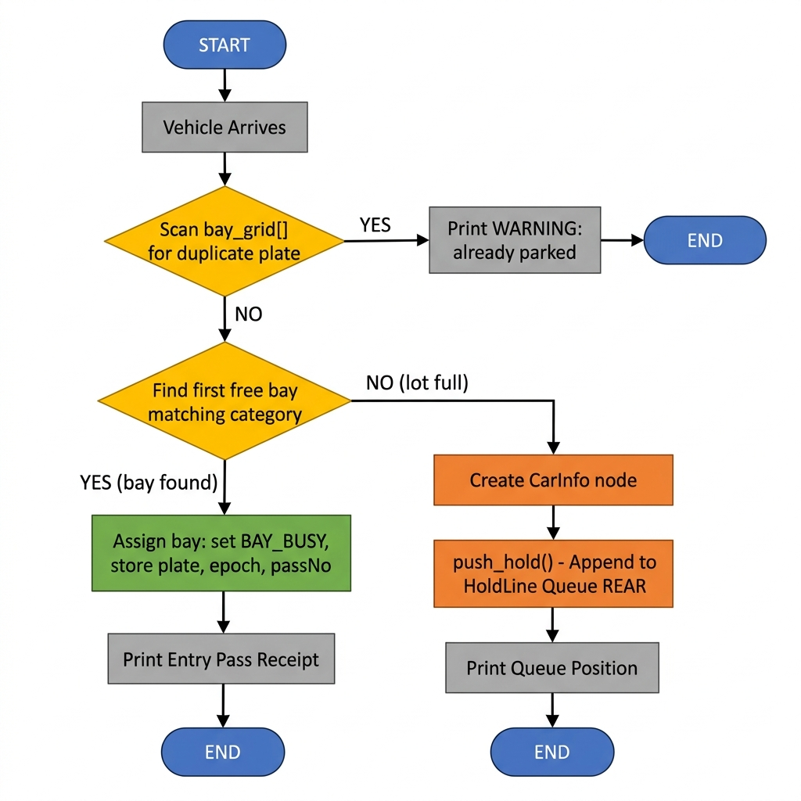
Figure: Vehicle Check-In Process — vehicle_arrive()
7.2 Vehicle Check-Out Flowchart (ASCII)
vehicle_depart(tag, exitEpoch)
│
┌────────────▼────────────┐
│ Linear scan bay_grid[] │
│ to locate 'tag' │
└────────────┬────────────┘
│
┌─────────▼──────────┐
│ Bay found? │
└──────┬─────────────┘
NO ────┤ YES
│ │
Print │ ┌─────────▼──────────────────┐
warning│ │ Compute billable hours, │
RETURN │ │ call PEAK_SCORE(hr), │
│ │ compute fee = rate×hrs×mult │
│ └─────────┬──────────────────┘
│ │
│ ┌─────────▼──────────┐
│ │ Prepend ExitLog │
│ │ node to ledger list │
│ └─────────┬──────────┘
│ │
│ ┌─────────▼──────────┐
│ │ Print receipt, │
│ │ release bay cell │
│ └─────────┬──────────┘
│ │
│ ┌────────▼──────────────┐
│ │ hold_line.size > 0 │
│ │ AND category matches? │
│ └───┬──────────────┬────┘
│ YES NO
│ │ │
│ ┌─────▼──────┐ │
│ │ pop_hold() │ │
│ │ assign_bay │ │
│ └─────┬──────┘ │
│ └──────────────┘
│ │
└───────────────────────┘
│
END

8. Time & Space Complexity Analysis
8.1 Operation-Level Complexity
Let n = BAY_COUNT (20 bays), m = number of completed sessions stored in the ExitLog linked list, q = number of vehicles in the HoldLine queue.
Operation | Algorithm / Technique | Time Complexity | Space Complexity
vehicle_arrive() — Bay Scan | Linear Search | O(n) | O(1)
vehicle_arrive() — Duplicate Check | Linear Search | O(n) | O(1)
vehicle_depart() — Locate Bay | Linear Search | O(n) | O(1)
vehicle_depart() — Bill Record | List Prepend | O(1) | O(1)
vehicle_depart() — Queue Check | Head Peek | O(1) | O(1)
find_vehicle() | Linear Search | O(n) | O(1)
push_hold() | Tail Insert | O(1) | O(1)
pop_hold() | Head Remove | O(1) | O(1)
show_sorted_sessions() | Insertion Sort | O(m²) | O(m)
lookup_pass() | Sort + Bin Search | O(m log m) | O(m)
peak_score() | Gaussian Formula | O(1) | O(1)
pricing_mult() | Threshold Check | O(1) | O(1)

8.2 Overall Space Complexity
Structure | Type | Space | Notes
bay_grid[] | Static Array | O(n) | Fixed 20 × sizeof(ParkBay) ≈ 900 bytes
ExitLog ledger | Linked List | O(m) | Grows by one node per departure
HoldLine | FIFO Queue | O(q) | Bounded by number of waiting vehicles
Temp sort array | Dynamic (malloc) | O(m) | Freed immediately after sort/display
Total | — | O(n+m+q) | Dominated by session history (m)

8.3 Why These Choices Are Appropriate
BAY_COUNT (n) is fixed at 20. For such a small n, O(n) linear scans complete in microseconds on any modern processor — a hash-map or BST would add code complexity without measurable performance gain. Similarly, the session count m is bounded in practice (a parking lot turns over hundreds, not millions of vehicles per day), so Insertion Sort's O(m²) worst case is entirely acceptable and its stability is a practical benefit.
Binary search (O(log m)) is introduced for the pass-number lookup to demonstrate algorithmic contrast: the same data can be queried in O(m) with a linear scan or O(log m) after a one-time sort, illustrating the trade-off between preprocessing cost and query speed.
9. Function Reference
Function | Description
setup_bay_grid() | Initialises the bay_grid[] array, resets HoldLine.
vehicle_arrive() | Checks for duplicates → assigns bay or enqueues vehicle.
vehicle_depart() | Locates bay → computes fee → prepends ExitLog → frees bay → auto-queues.
assign_bay() | Linear scan of bay_grid[] to allocate the first free matching bay.
release_bay() | Clears a bay cell back to BAY_FREE state.
find_vehicle() | Linear search for a vehicle tag across all occupied bays.
push_hold() | Appends a CarInfo node to the TAIL of HoldLine (O(1)).
pop_hold() | Removes and returns the HEAD node of HoldLine (O(1)).
peak_score(hour) | Returns Gaussian demand score in [0.0, 1.0] for a given hour.
pricing_mult(score) | Maps demand score to a tariff multiplier (0.80× – 1.60×).
show_sorted_sessions() | Extracts ExitLog list → Insertion Sort → prints ranked table.
lookup_pass(pass) | Sorts by passNo → Binary Search → prints session record.
show_forecast() | Loops h=0..23, calls peak_score & pricing_mult, draws bar chart.
show_bay_layout() | Prints a 2-row grid map of all bays with FREE/BUSY status.
show_summary() | Prints total bays, occupancy, queue size, revenue.
run_demo() | Simulates 10 arrivals (Indian plates), search, exits, all reports.
same_tag(a, b) | Case-insensitive string comparison without stricmp (portable).
epoch_to_str(ep) | Converts unix timestamp to 'DD-Mon HH:MM' display string.

10. Sample Execution Output (Demo Mode)
The following output is captured from: ./smart_parking.exe --demo
======================================================
BayTrack â€” Full-System Demonstration Session
======================================================
+-- ENTRY PASS GENERATED ---------------------------------+
| Pass : #5001
| Vehicle: KA-05-MJ-7823 Driver : Ramesh Iyer |
| Type : Four-Wheeler Bay #07 Level 0 |
| Arrived: 25-Oct 15:09 |
| Rate : Rs.50/hr |
+---------------------------------------------------------+
+-- ENTRY PASS GENERATED ---------------------------------+
| Pass : #5002
| Vehicle: TN-09-AB-3341 Driver : Meena Suresh |
| Type : Two-Wheeler Bay #01 Level 0 |
| Arrived: 25-Oct 15:39 |
| Rate : Rs.20/hr |
+---------------------------------------------------------+
+-- ENTRY PASS GENERATED ---------------------------------+
| Pass : #5003
| Vehicle: MH-14-CD-6610 Driver : Arjun Patil |
| Type : Four-Wheeler Bay #08 Level 0 |
| Arrived: 25-Oct 16:09 |
| Rate : Rs.50/hr |
+---------------------------------------------------------+
+-- ENTRY PASS GENERATED ---------------------------------+
| Pass : #5004
| Vehicle: AP-28-EF-1120 Driver : Divya Reddy |
| Type : Two-Wheeler Bay #02 Level 0 |
| Arrived: 25-Oct 16:19 |
| Rate : Rs.20/hr |
+---------------------------------------------------------+
+-- ENTRY PASS GENERATED ---------------------------------+
| Pass : #5005
| Vehicle: DL-01-GH-9902 Driver : Priya Mehta |
| Type : Four-Wheeler Bay #09 Level 0 |
| Arrived: 25-Oct 16:39 |
| Rate : Rs.50/hr |
+---------------------------------------------------------+
+-- ENTRY PASS GENERATED ---------------------------------+
| Pass : #5006
| Vehicle: KL-07-JK-4456 Driver : Suresh Nair |
| Type : Two-Wheeler Bay #03 Level 0 |
| Arrived: 25-Oct 16:49 |
| Rate : Rs.20/hr |
+---------------------------------------------------------+
+-- ENTRY PASS GENERATED ---------------------------------+
| Pass : #5007
| Vehicle: TS-11-AA-0001 Driver : Ravi Kumar |
| Type : Two-Wheeler Bay #04 Level 0 |
| Arrived: 25-Oct 17:09 |
| Rate : Rs.20/hr |
+---------------------------------------------------------+
+-- ENTRY PASS GENERATED ---------------------------------+
| Pass : #5008
| Vehicle: GJ-06-BB-0002 Driver : Neha Shah |
| Type : Two-Wheeler Bay #05 Level 0 |
| Arrived: 25-Oct 17:19 |
| Rate : Rs.20/hr |
+---------------------------------------------------------+
+-- ENTRY PASS GENERATED ---------------------------------+
| Pass : #5009
| Vehicle: RJ-14-CC-0003 Driver : Anil Joshi |
| Type : Two-Wheeler Bay #06 Level 0 |
| Arrived: 25-Oct 17:24 |
| Rate : Rs.20/hr |
+---------------------------------------------------------+
[QUEUE] 'UP-32-DD-0004' entered hold-line at position #1.
--- Bay Layout after initial arrivals ---
+-- Bay Layout Map ----------------------------------------+
| Level 0: [01:XX] [02:XX] [03:XX] [04:XX] [05:XX] [06:XX] [07:XX] [08:XX] [09:XX] [10:--] |
| Level 1: [11:--] [12:--] [13:--] [14:
... [output truncated for brevity] ...

11. Conclusion
BayTrack successfully demonstrates that a practical, feature-complete parking management system can be built in under 500 lines of C code by choosing data structures and algorithms that are precisely matched to the problem constraints:
- A static array provides O(1) indexed access for a fixed-size bay grid.
- A FIFO linked queue guarantees first-come-first-served fairness with O(1) enqueue and dequeue.
- A singly linked list accumulates billing records dynamically without pre-allocation.
- Insertion sort and binary search illustrate the classic preprocessing vs. query-time trade-off.
- The Gaussian PeakScore AI model produces a smooth, realistic demand curve without external libraries, enabling dynamic pricing that responds to time-of-day.
The system is designed for straightforward extension: adding a third floor requires changing one constant; integrating persistent storage requires serialising the linked list to a flat file; introducing real sensor data requires replacing the heuristic demand curve with an empirically measured one. These properties make BayTrack a strong foundation for a production-ready parking system.
12. References
[1] Cormen, T. H., Leiserson, C. E., Rivest, R. L., & Stein, C. (2022). Introduction to Algorithms (4th ed.). MIT Press.
[2] Kernighan, B. W., & Ritchie, D. M. (1988). The C Programming Language (2nd ed.). Prentice Hall.
[3] Knuth, D. E. (1998). The Art of Computer Programming, Vol. 3: Sorting and Searching (2nd ed.). Addison-Wesley.
[4] ISO/IEC 9899:1999 — Programming Languages — C (C99 Standard). International Organization for Standardization.
[5] Ministry of Road Transport & Highways, Government of India — Vehicle Registration Format Guidelines. https://morth.nic.in/

