Protocol is a set of rule which both the parties are using to communicate with each other.

HTTP:

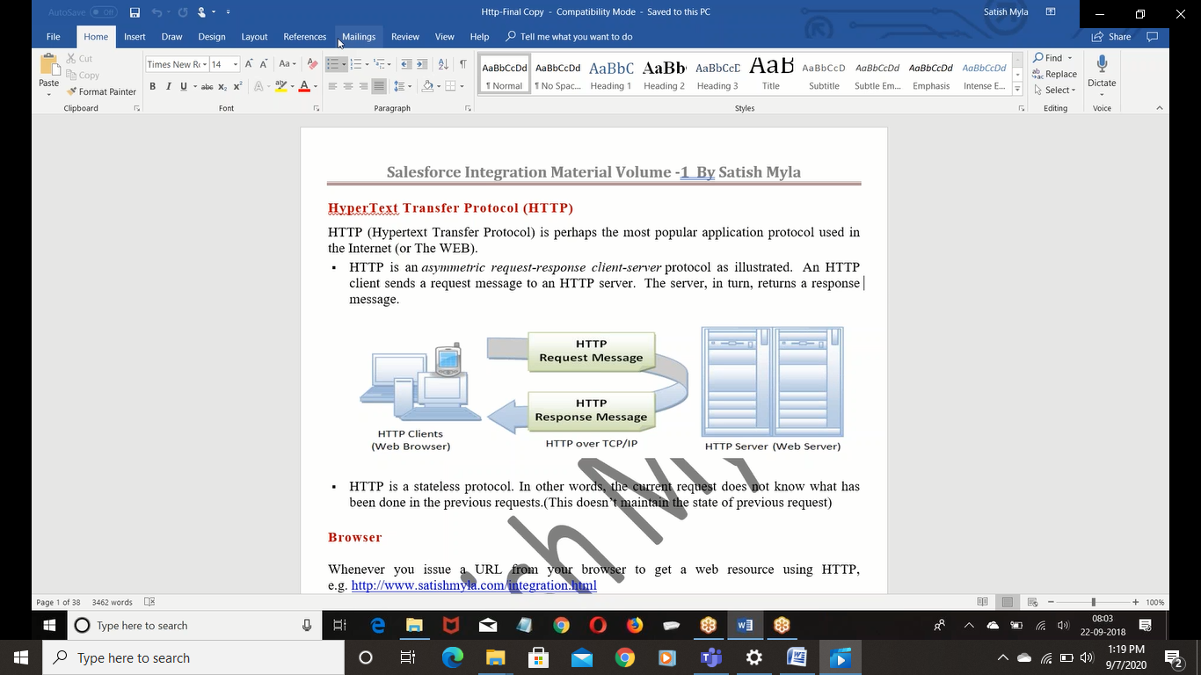

SERVER:

Appli server – support both web & appln server… ex: force.com

Web server – for buld web appl

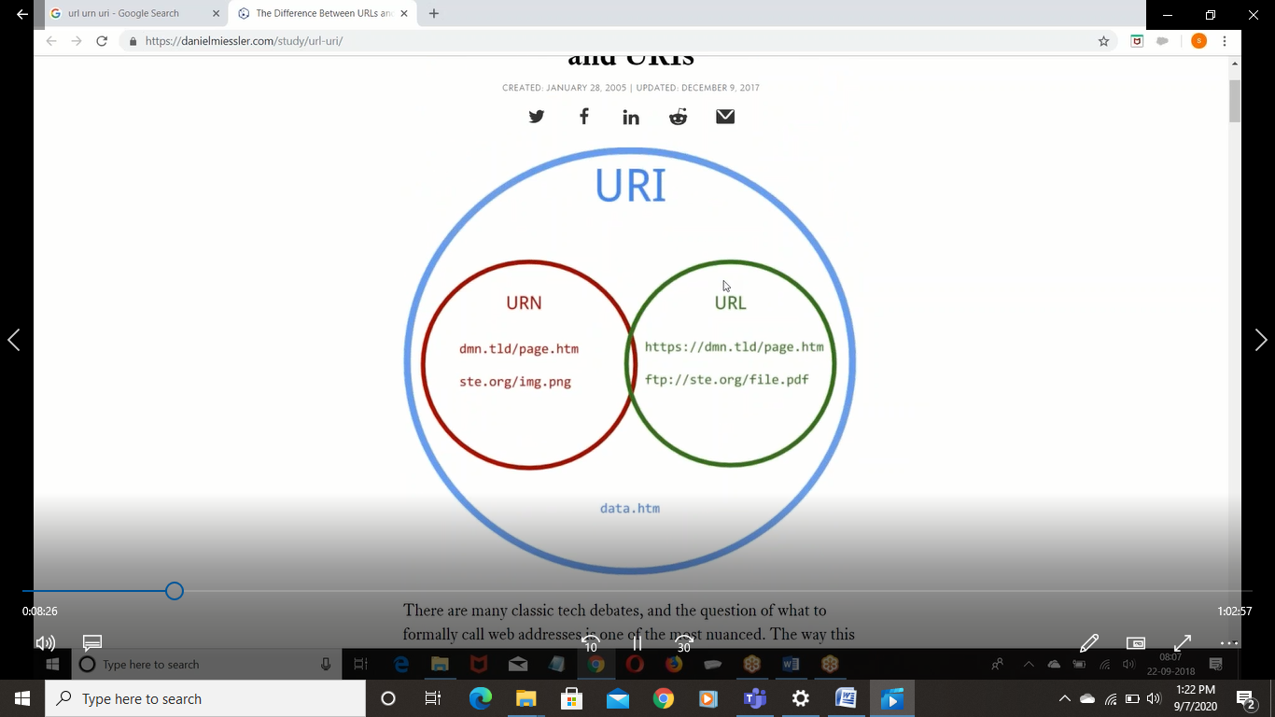

URI: uniform resorce identifier

Resources can be identified by name or locator

Every URL is a URI but every URI is may not URL

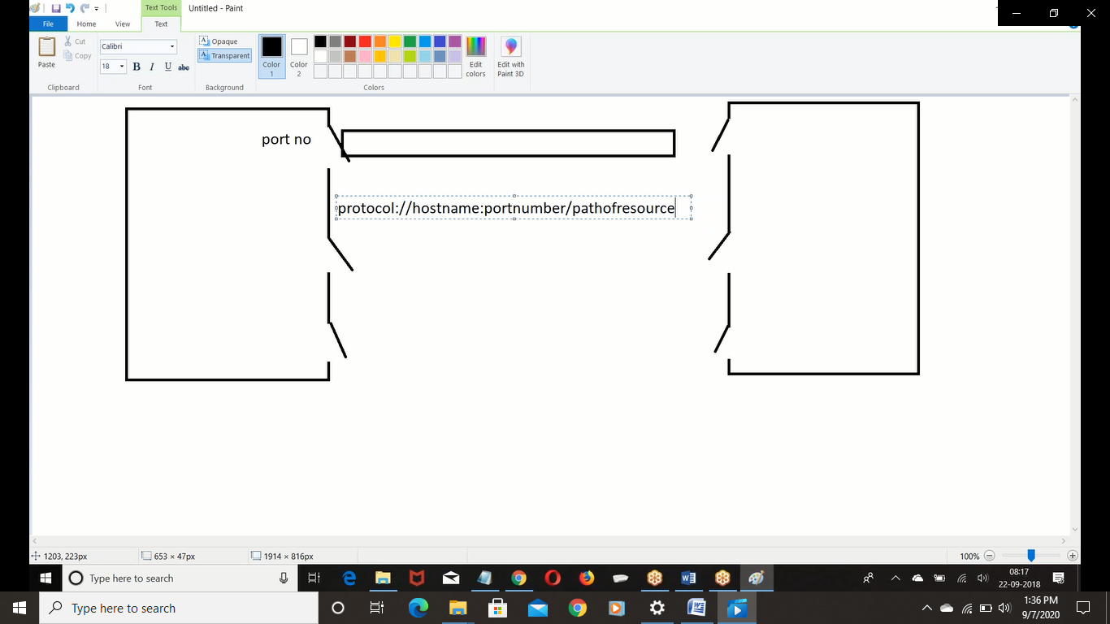

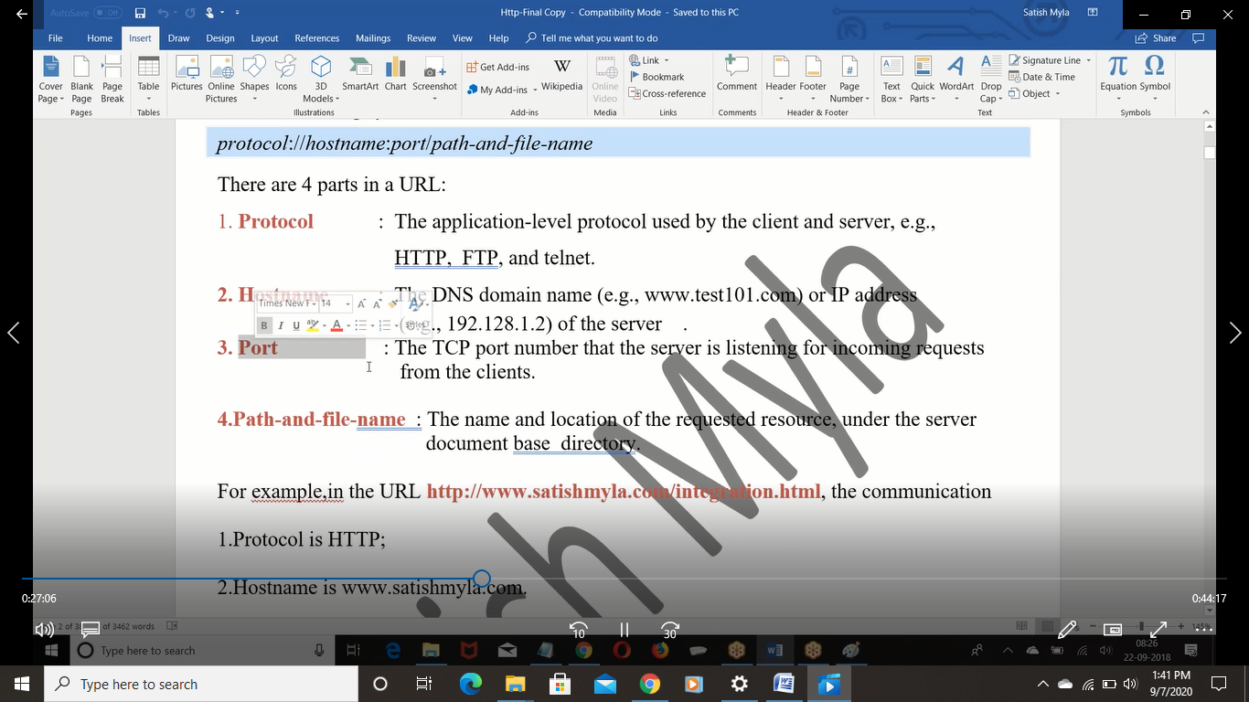

HTTP is a stateless protocol & Http is connection less protocol

