SEASONAL AGRICULTURE PERFORMANCE ANALYSIS
Major Project Report – VOIS AICTE Batch 1 (2026–2027)

Student Name: Raashid Ahamed Nazeer Hussain
College: B. S. Abdur Rahman Crescent Institute of Science and Technology
AICTE STU ID: STU684a6ad30560a1749707475

1. Introduction
This project analyzes agricultural activities across Kharif, Rabi and Zaid seasons. The supplied dataset contains 4,000 farm-level records and 28 variables covering location, crop, farm area, environmental conditions, soil characteristics, inputs, irrigation, yield, production, market price, cost, revenue, profit, water use, water efficiency and disease/pest risk.
The purpose is to identify meaningful seasonal patterns, differences and relationships that can support evidence-based agricultural planning.

2. Problem Statement
Agricultural performance is influenced by seasonal environmental conditions, farming practices, resource availability and market conditions. Raw agricultural data does not directly explain how performance changes across seasons. This project therefore investigates seasonal differences using data cleaning, descriptive statistics, visualization and statistical analysis.

3. Objectives
- Explore and understand the agricultural dataset.
- Clean and prepare the data for analysis.
- Compare agricultural performance across seasons.
- Identify important seasonal patterns and trends.
- Investigate relationships between environmental/resource variables and outcomes.
- Compare crops, irrigation methods and geographical groups.
- Identify significant or unusual observations.
- Apply appropriate statistical and visualization techniques.
- Develop evidence-based conclusions and recommendations.

4. Dataset Description
Records: 4,000
Variables: 28
Seasons: Kharif, Rabi, Zaid
Crops: Wheat, Maize, Pulses, Rice, Cotton, Chilli, Groundnut, Sugarcane
States: 8
Irrigation methods: Drip, Flood, Rainfed, Sprinkler

5. Data Cleaning and Preparation
The dataset contains 120 missing numeric observations across three fields (Rainfall_mm, Soil_Moisture_pct and Yield_Tonnes_Ha). There are 0 duplicate rows. Missing numeric values were replaced using column medians because the missing proportion is small and the variables contain substantial skew. No duplicate rows were present. Categorical missing values were handled with the mode where necessary.
Missing values before cleaning: 120
Missing values after cleaning: 0
Duplicate rows: 0

6. Exploratory Data Analysis

6.1 Seasonal performance
Seasonal summary
Season | Farms | Avg_Yield | Median_Yield | Avg_Production | Avg_Revenue | Avg_Cost | Avg_Profit | Median_Profit | Avg_Water | Avg_Efficiency | Avg_Risk
Kharif | 1,779.00 | 5.64 | 1.95 | 46.31 | 710,719.06 | 531,804.41 | 178,914.65 | 38,808.00 | 6,102.20 | 5.89 | 54.47
Rabi | 1,627.00 | 5.08 | 1.66 | 41.49 | 601,526.05 | 513,836.58 | 87,689.47 | -3,187.00 | 5,846.99 | 5.19 | 40.48
Zaid | 594.00 | 4.67 | 1.45 | 38.89 | 519,171.90 | 543,976.73 | -24,804.82 | -62,144.00 | 6,419.89 | 4.41 | 38.22

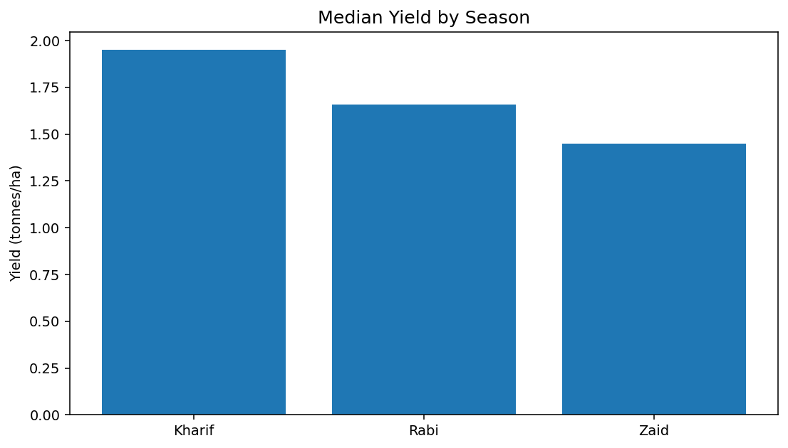
Figure 1. Median yield by season.
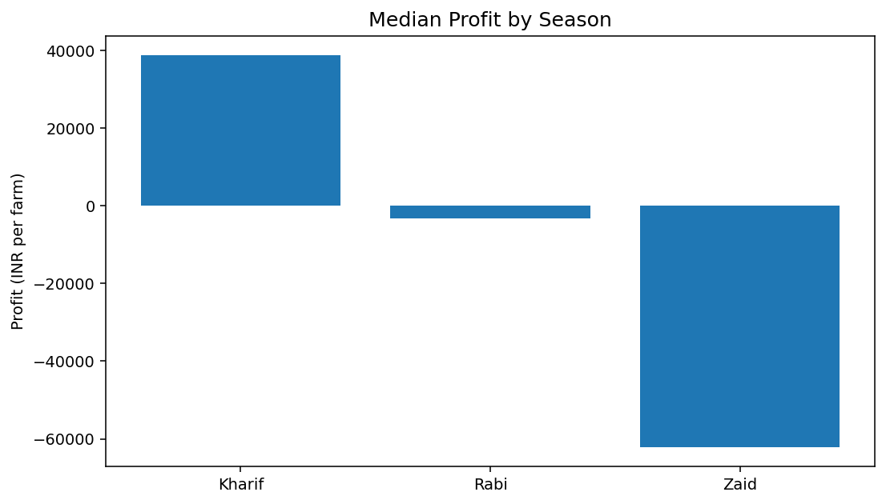
Figure 2. Median profit by season.
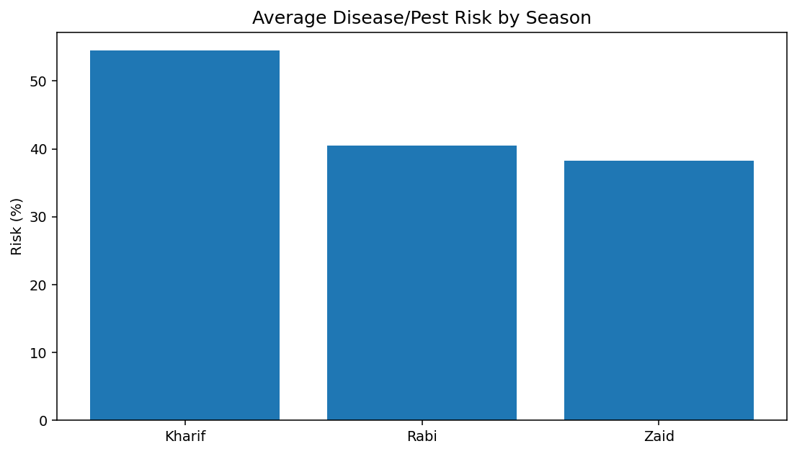
Figure 3. Average disease/pest risk by season.

6.2 Crop analysis
Crop-level performance
Crop | Avg_Yield | Avg_Production | Avg_Revenue | Avg_Profit | Avg_Efficiency | Avg_Risk
Sugarcane | 46.94 | 392.41 | 1,371,980.11 | 817,187.99 | 30.48 | 45.40
Chilli | 1.54 | 12.38 | 1,276,777.23 | 750,878.34 | 2.95 | 46.06
Cotton | 1.23 | 9.40 | 639,423.08 | 124,546.92 | 1.94 | 45.97
Groundnut | 1.32 | 9.66 | 542,935.50 | 44,858.12 | 3.15 | 46.29
Pulses | 0.92 | 7.40 | 528,465.87 | -4,238.05 | 2.90 | 46.57
Maize | 2.72 | 21.78 | 457,067.99 | -83,978.33 | 5.60 | 45.54
Rice | 2.44 | 19.29 | 423,615.26 | -102,213.50 | 1.95 | 46.50
Wheat | 2.11 | 16.85 | 400,104.89 | -123,398.34 | 4.63 | 47.85

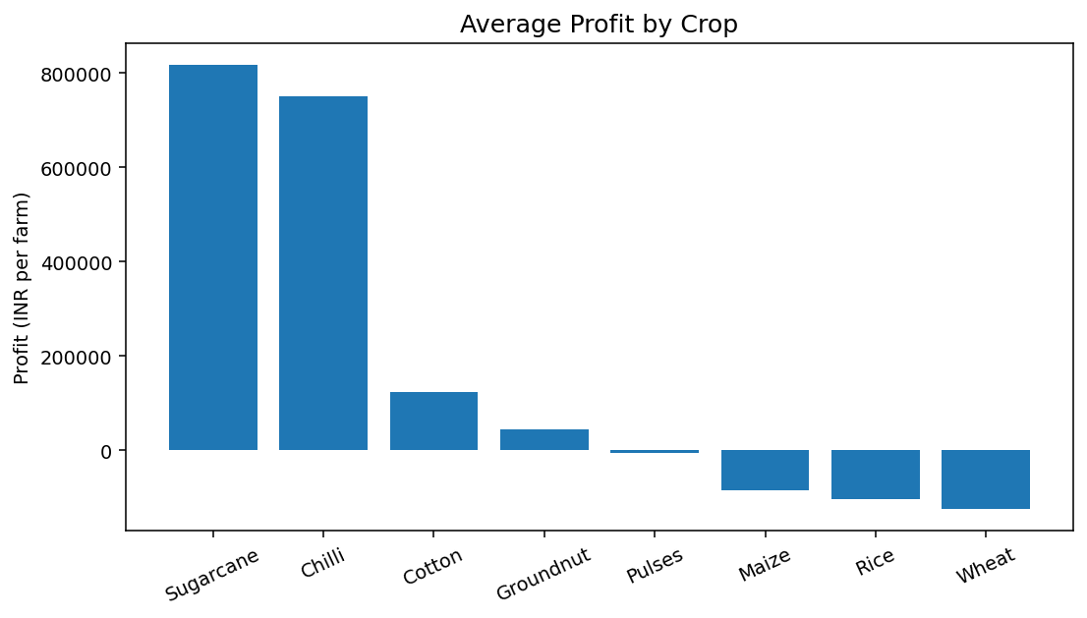
Figure 4. Average profit by crop.

6.3 Irrigation analysis
Irrigation-level performance
Irrigation_Method | Avg_Yield | Avg_Profit | Avg_Water | Avg_Efficiency
Drip | 6.62 | 219,626.00 | 5,918.75 | 6.27
Sprinkler | 5.19 | 91,121.08 | 6,208.26 | 4.67
Rainfed | 4.61 | 79,050.37 | 3,549.55 | 7.56
Flood | 4.90 | 73,354.02 | 8,026.47 | 3.44

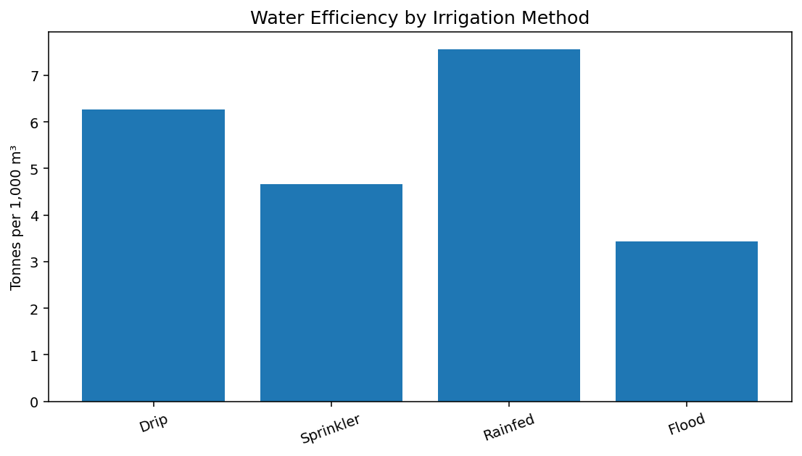
Figure 5. Average water efficiency by irrigation method.

6.4 Regional analysis
State-level performance
State | Avg_Yield | Avg_Profit | Avg_Revenue | Avg_Efficiency
Punjab | 6.12 | 136,025.64 | 686,225.70 | 5.62
Maharashtra | 5.03 | 135,428.86 | 650,032.67 | 5.28
Karnataka | 5.73 | 119,422.34 | 653,426.18 | 5.56
Tamil Nadu | 4.90 | 117,744.75 | 629,093.42 | 5.31
Gujarat | 5.70 | 117,568.24 | 654,692.86 | 5.58
Telangana | 5.08 | 108,829.62 | 628,784.53 | 5.46
Madhya Pradesh | 5.03 | 86,840.76 | 597,558.36 | 5.27
Andhra Pradesh | 4.65 | 73,453.53 | 606,663.66 | 5.03

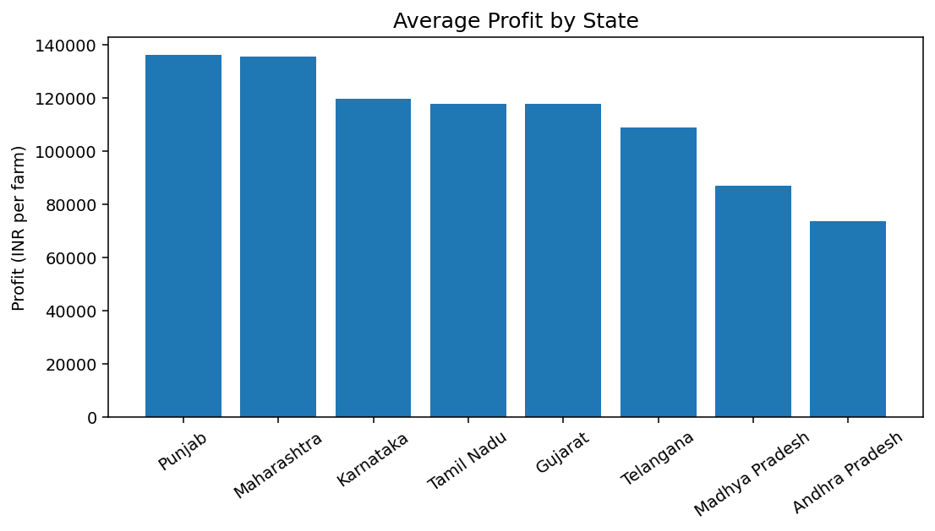
Figure 6. Average profit by state.

7. Relationship Analysis
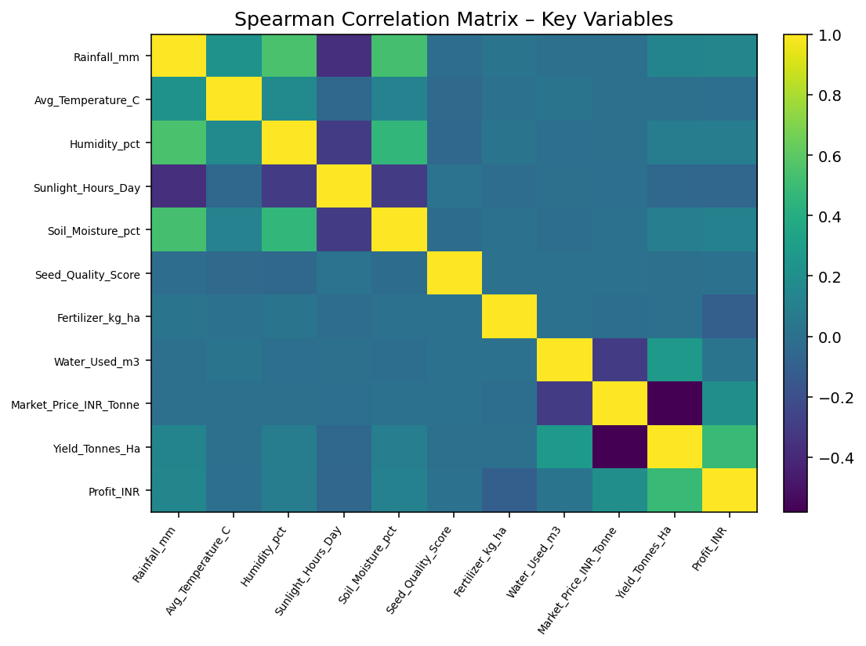
Figure 7. Spearman correlation matrix for key variables.
The strongest positive association with yield is water-efficiency (Spearman rho ≈ 0.915), followed by production (≈ 0.885). Rainfall has a weaker positive association with yield (≈ 0.131). Market price shows a moderate negative association with yield (≈ -0.582) in this dataset. These are associations only and should not be interpreted as causal effects.
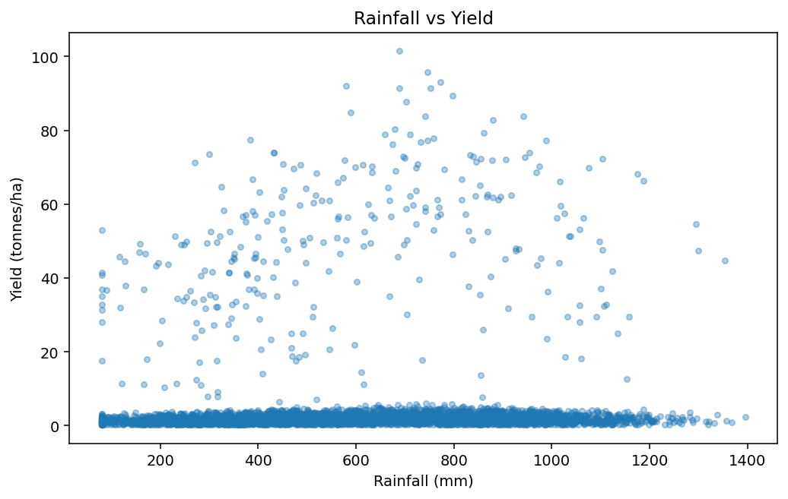
Figure 8. Rainfall versus yield.

8. Statistical Analysis
A Kruskal–Wallis test was used to compare the distributions of selected measures across Kharif, Rabi and Zaid. This non-parametric test is suitable when data may be skewed or may not meet normality assumptions.
Metric | H statistic | p-value | Interpretation
Yield | 68.6 | 1.267e-15 | Significant
Profit | 101.9 | 7.363e-23 | Significant
Revenue | 40.85 | 1.35e-09 | Significant
Disease/Pest Risk | 1431 | 1.913e-311 | Significant

9. Key Findings
- Kharif has the highest median yield (1.95 tonnes/ha) and the highest median profit (₹38,808).
- Zaid has the lowest median yield (1.45 tonnes/ha) and a negative median profit (₹-62,144).
- Average disease/pest risk is highest in Kharif (54.47%) and lowest in Zaid (38.22%).
- Sugarcane has the highest average profit among crops (₹817,188), followed by Chilli (₹750,878).
- Drip irrigation has the highest average yield (6.62 tonnes/ha) and average profit (₹219,626) among the listed irrigation methods.
- Rainfed farming has the highest average water-efficiency value (7.56 tonnes per 1,000 m³), although its average yield is lower than drip.
- The Kruskal–Wallis tests indicate statistically significant seasonal differences in yield, profit, revenue and disease/pest risk at the 5% level.

10. Recommendations
- Use season-specific agricultural planning rather than assuming similar performance across seasons.
- Investigate the practices and crop mix associated with stronger Kharif performance.
- Evaluate irrigation choices using both profitability and water-efficiency measures.
- Review crop-season combinations with consistently negative profitability before allocating additional resources.
- Strengthen disease and pest monitoring during higher-risk periods.
- Add more years of data, detailed weather observations and market information for stronger decision support.
- Use an interactive dashboard in future work for easier monitoring by farmers and planners.

11. Technology Used
- Python
- Google Colab / Jupyter Notebook
- Pandas
- NumPy
- Matplotlib
- SciPy
- python-pptx for presentation preparation
- python-docx and ReportLab for report generation

12. Limitations
- The dataset is a single supplied dataset; it does not establish long-term year-to-year trends.
- Correlation does not imply causation.
- The dataset contains extreme values, especially for some crops such as Sugarcane, so median-based comparisons are emphasized.
- Seasonal differences may partly reflect differences in crop composition and geographical representation.
- Recommendations should be validated with local agronomic expertise and additional field data.

13. Conclusion
The analysis shows clear seasonal variation in agricultural performance. Kharif demonstrates the strongest typical yield and profitability, while Zaid shows weaker typical economic outcomes. Crop type and irrigation method are also associated with substantial differences in yield, profit and water efficiency. The results provide a data-driven foundation for seasonal planning, while the limitations emphasize the need for broader data before making causal or operational decisions.

14. Deliverables
- Completed Jupyter Notebook with analysis and visualizations
- Cleaned CSV dataset
- Annual Review presentation based on the supplied template
- Detailed project report in DOCX and PDF
- Summary CSV files for season, crop, irrigation and state analysis
- Charts used in the report and presentation
- README with execution instructions

