ARTIFICIAL INTELLIGENCE AND MACHINE LEARNING

Project Documentation format

# Introduction

* + **Project Title:** TrafficTelligence: Advanced Traffic Volume Estimation with Machine Learning
  + **Team Members:**

Bayana Harshini

Badarla Rushika

Bommnaboina Lokesh

Bandaru Raatna sai

# Project Overview

* + **Purpose:** TrafficTelligence is an advanced system that uses machine learning algorithms to estimate and predict traffic volume with precision.
  + **Features:** Real-Time Traffic Volume Prediction, Multi-Source Data Integration

# Architecture

|  |  |
| --- | --- |
| **Data Ingestion** | **: Collects temporal, weather, and holiday data** |
| **Preprocessing** | **: Cleans, encodes, and engineers features** |
| **Model Training** | **: Trains multiple ML models (scikit-learn, xgboost)** |
| **Evaluation** | **: Assesses models using metrics and visualizations** |
| **Deployment** | **: Serializes best model for real-time or batch predictions** |
| **Visualization** | **: Uses seaborn/matplotlib for insights and monitoring** |

# Setup Instructions

* We have to write code to get the model first to use for the next model. To use hich one is better to predict.
* Write the flask code o run tha app
* Write the index.html and output.hrml to enter the values and get the outpt on the sreen

# Folder Structure

* Traffic-volume-estimator/
* ├── app.py # Flask web application
* ├── model.pkl
* ├── static/images/Car.jpg/Traffic.jpg
* ├─ templates/index.html /output.html
* ├── notebook/
* ├──MLPROJECT.ipynb
* ├── requirements.txt #
* └── README.md

# Running the Application

* + Provide commands to start the frontend and backend servers locally.
  + Use CMD OR ANACONDA PROMPT
  + navigathe the your project folder
  + run the python app.y

# Flask

# Writhe th application usinf Flask and use the both index.html and output.html to run and execute the ouput.

# Authentication

* + Explain how authentication and authorization are handled in the project.
  + Include details about train the model,test the model,select model .

# Flask code:

# 

* + Provide screenshot of Flask code

# Giving the data:

* + Given data be like

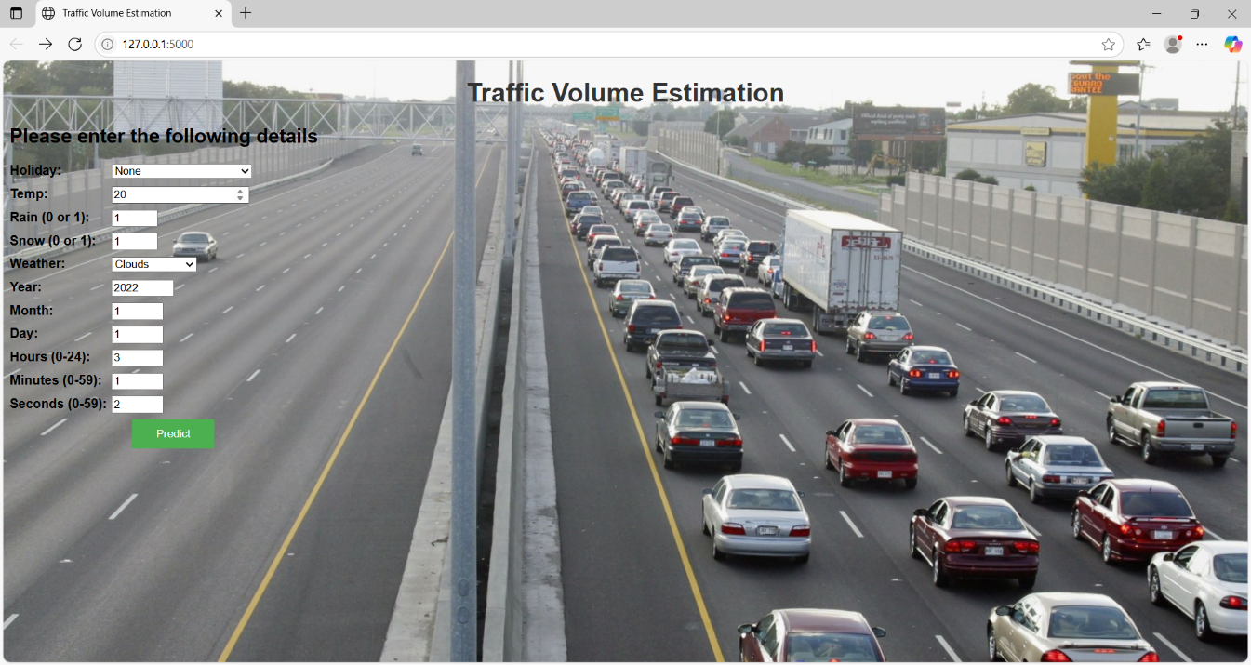

# Output:

# 

# Known Issues

* + Users should be aware of giving values of carefully.

# Future Enhancements

* + Outline potential future features or improvements that could be made to the project.