## Traffic Telligence Advanced Traffic Volume Estimation With Machine Learning

TEAM ID: LTVIP2025TMID33726

TEAM LEADER: Bayana Harshini TEAM MEMBER: Badarla Rushika TEAM MEMBER: Bandaru Ratna Sai

TEAM MEMBER: Bommanaboina Lokesh

# INTRODUCTION

## Project Overview

TrafficTelegence is a machine learning–based traffic monitoring system that provides real-time traffic volume estimation and prediction. The system leverages video feeds from CCTV cameras or GPS-based data to detect, classify, and count vehicles using models like YOLO. For forecasting future traffic trends, LSTM networks are employed to analyze historical patterns. All data is visualized through an interactive dashboard that displays current traffic conditions, congestion alerts, and predictive analytics. The project aims to improve urban traffic management by enabling faster, smarter, and data-driven decision-making.

* 1. **Purpose**

The purpose of this project is to develop a smart and efficient system for real-time traffic volume estimation using machine learning. By automating vehicle detection and traffic prediction, the system aims to assist traffic authorities

# IDEATION PHASE

* 1. **Problem Statement**

|  |  |
| --- | --- |
| Date | 28 JUNE 2025 |
| Team ID | LTVIP2025TMID33726 |
| Project Name | Traffic Telligence Advanced Traffic Volume Estimation Machine Learning |
| Maximum Marks | 4 Marks |

Urban areas face increasing traffic congestion due to rapid vehicle growth and inefficient monitoring systems. Traditional traffic management relies heavily on manual counting or outdated

sensor-based methods, which are often inaccurate and lack real-time capability. These limitations make it difficult for authorities to respond quickly to changing traffic conditions. Furthermore, the absence of predictive tools prevents proactive traffic control and long-term planning.

|  |  |  |  |  |  |
| --- | --- | --- | --- | --- | --- |
| PS-1 | Traditional | Most cities | Traffic | Existing | Lack of integration |
|  | traffic | lack real- | congestio | systems are | between traffic data |
|  | monitoring | time traffic | n | not scalable | sources reduces |
|  | relies | data to make | continue | or | overall system |
|  | heavily on | quick and | s to grow | adaptable to | effectiveness. |
|  | manual | informed | due to | different |  |
|  | counting, | decisions. | the | regions and |  |
|  | which is |  | absence | road |  |
|  | time- |  | of | conditions. |  |
|  | consuming |  | predictiv |  |  |
|  | and error- |  | e |  |  |
|  | prone. |  | analysis |  |  |
|  |  |  | tools |  |  |
| PS-2 | Many | Limited | Current | Vehicle | Local traffic managers |
|  | systems do | availability | traffic | detection | face challenges due to |
|  | not provide | of historical | systems | accuracy | lack of dashboards in |
|  | alert | traffic trends | are not | drops under | regional languages. |
|  | mechanism | hinders | optimize | poor |  |
|  | s for peak | effective | d for | lighting or |  |
|  | congestion | planning | edge or | weather |  |
|  | times. |  | low- | conditions. |  |
|  |  |  | connecti |  |  |
|  |  |  | vity |  |  |
|  |  |  | environ |  |  |
|  |  |  | ments. |  |  |

* 1. **Empathy Map Canvas**

Traffic control authorities and urban planners often struggle with limited data and delayed responses to congestion issues. They need a reliable, real-time system that offers clear insights into traffic conditions and helps them manage flow effectively. These users frequently hear public complaints about delays and poor traffic coordination, adding pressure to their roles. They express

a desire for intelligent tools that simplify decision-making and reduce guesswork. By providing accurate vehicle detection and traffic forecasts, the system makes

|  |  |
| --- | --- |
| Date | 28 JUNE 2025 |
| Team ID | LTVIP2025TMID33726 |
| Project Name | Traffic Telligence Advanced Traffic Volume Estimation Machine Learning |
| Maximum Marks | 4 Marks |

|  |  |  |
| --- | --- | --- |
|  | C˛* **Thinks**.  _They think the current traffic monitoring methods are outdated and inefficient.  _They believe a smart, automated system can improve traffic flow and reduce congestion |  |
| }·.)◆● **Sees**  _They see increasing traffic congestion and delays during peak hours.  _They observe that current systems fail to provide accurate, real-time traffic data | **USER** | 🗣 **Says**  _They say, “We need smarter tools to manage traffic more efficiently.”  _They often mention, “Manual counting and outdated systems are no longer effective.” |
| .◆ **Feels**  _They feel frustrated by the lack of real-time, accurate traffic information.  _They feel pressured to make quick decisions without reliable data support. | 趴† **ears**  _They hear frequent complaints from commuters about traffic delays and poor road management.  _They hear suggestions from higher authorities to adopt smarter, technology-driven solutions. | 🛠 **Does**  _They manually monitor traffic through CCTV feeds and rely on static data reports.  _They adjust traffic signals and routes reactively based on observed congestion. |

* 1. **Brainstorming**

|  |  |
| --- | --- |
| Date | 28 JUNE 2025 |
| Team ID | LTVIP2025TMID33726 |
| Project Name | Traffic Telligence Advanced Traffic Volume Estimation Machine Learning |
| Maximum Marks | 4 Marks |

### Step-1: Team Gathering, Collaboration and Select the Problem Statement

During the brainstorming phase, various ideas were explored to tackle the problem of urban traffic congestion using modern technologies. The team considered multiple data sources such as CCTV footage, GPS signals, and IoT traffic sensors to gather real-time information. Several machine learning approaches were discussed, including convolutional neural networks for object detection and LSTM for time-series traffic prediction. Key challenges like varying weather conditions, video quality, and data privacy were identified, along with potential solutions such as edge computing and data encryption. The final idea converged on building a modular, AI-powered system that could detect, predict, and visualize traffic patterns efficiently for smarter urban mobility.

#### Problem Statement:

Urban traffic congestion has become a critical issue due to the rapid increase in vehicles and the limitations of existing traffic monitoring systems. Traditional methods such as manual counting and fixed sensors are often inaccurate, inefficient, and lack the ability to provide real-time insights.

## Step-2: Brainstorm, Idea Listing and Grouping

|  |  |
| --- | --- |
| **Idea Category** | **Ideas Generated** |
| Technology/Tools | - During brainstorming, tools like Google Jamboard and Trello were used to organize and group ideas efficiently.  _Technologies such as YOLO, LSTM, and  OpenCV were shortlisted for implementing traffic detection and prediction. |
| User Interaction | - Users interact with the system through a dashboard that shows real-time traffic data and predictions.  _They can switch camera views, monitor |

|  |  |
| --- | --- |
|  | congestion levels, and receive alerts for traffic management decisions |
| Data Collection | _Traffic data is collected from sources like CCTV cameras, GPS devices, and traffic sensors.  _This data includes live video feeds and location information used for vehicle detection and traffic analysis. |
| Deployment_ | The system is deployed on cloud platforms or edge devices like Jetson Nano for real- time processing.  _It ensures scalability and accessibility, allowing traffic authorities to monitor and manage data remotely. |
| Integration | _Users interact with the system through a  real-time dashboard displaying traffic data, predictions, and alerts. |
| Awareness/Training | * The system raises awareness by providing real-time traffic insights and predictions, helping users understand and respond to congestion effectively. * Include image gallery of common poultry diseases for farmer reference |

### Step-3: Idea Prioritization

|  |  |  |
| --- | --- | --- |
| **Idea** | **Impact (High/Med/Low)** | **Feasibility (High/Med/Low)** |
| Pre-trained model (Transfer Learning) | High | High |
| Mobile/Web-based image  analysis app | High | High |
| Voice support & regional language options | High | Medium |
| Collect and augment poultry  disease images | High | Medium |
| Offline deployment for rural areas | High | Medium |
| Veterinary integration (optional) | Medium | Low |
| Farmer training via tutorials | Medium | High |

Ideas included using mobile apps, transfer learning with image classification, multilingual support, offline model access, disease history tracking, and farmer education modules.

# REQUIREMENT ANALYSIS

* 1. **Customer Journey Map**

|  |  |
| --- | --- |
| Date | 28 JUNE 2025 |
| Team ID | LTVIP2025TMID33726 |
| Project Name | Traffic Telligence Advanced Traffic Volume Estimation Machine Learning |
| Maximum Maks | 4 Marks |

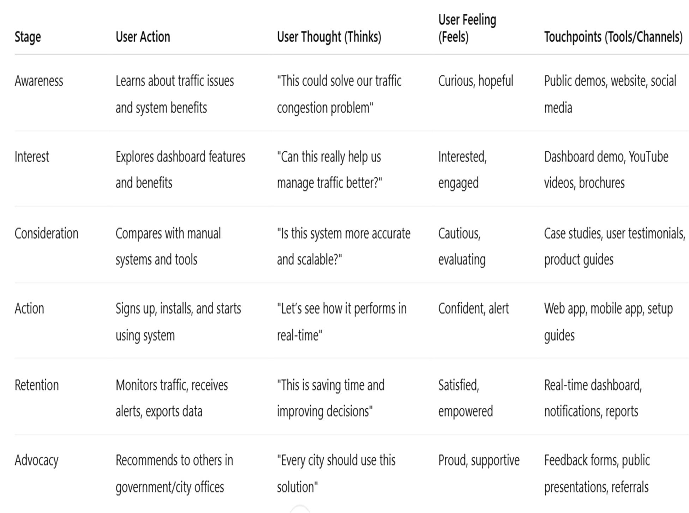

**.**

* 1. **Solution Requirement**

|  |  |
| --- | --- |
| Date | 28 JUNE 2025 |
| Team ID | LTVIP2025TMID33726 |
| Project Name | Traffic Telligence Advanced Traffic Volume Estimation Machine Learning |
| Maximum Marks | 4 Marks |

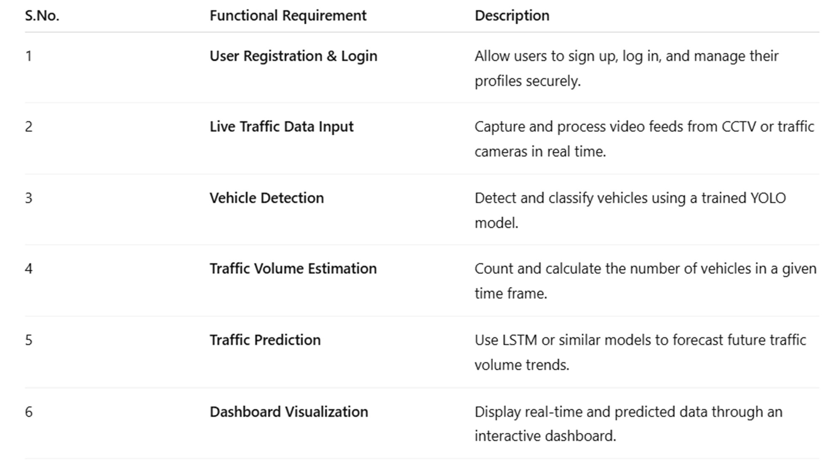**Functional Requirements**

Functional requirements include image upload, disease diagnosis, history logs, notifications, multilingual support. Non-functional requirements ensure performance, security, offline access, and scalability.

* 1. **Data Flow Diagram**

|  |  |
| --- | --- |
| Date | 28 JUNE 2025 |
| Team ID | LTVIP2025TMID33726 |
| Project Name | Traffic Telligence Advanced Traffic Volume Estimation Machine Learning |
| Maximum Marks | 4 Marks |

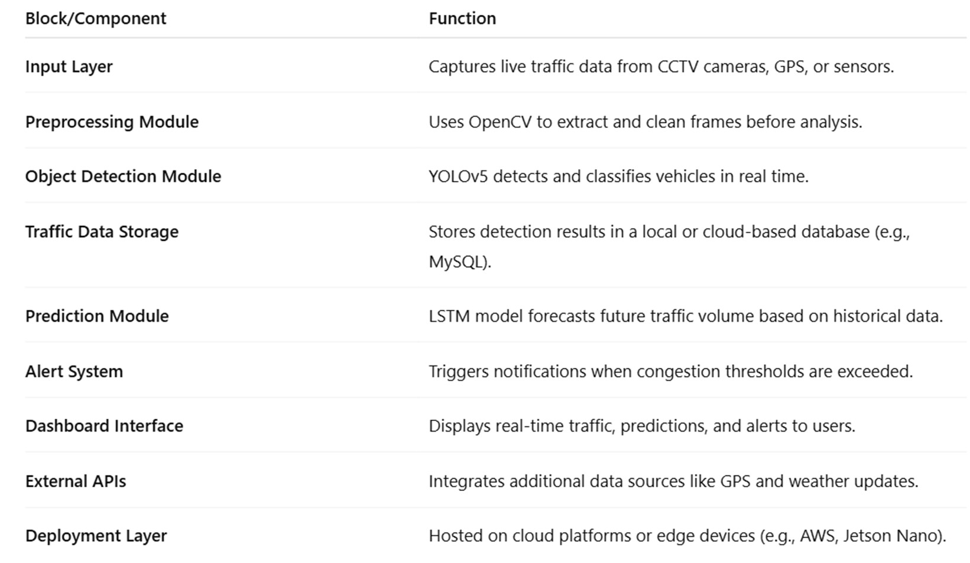

#### Data Flow Diagrams:

The Data Flow Diagram (DFD) for the TrafficTelegence system illustrates the movement of data through various components of the system. It begins with input from CCTV cameras and GPS devices, which is processed through modules like vehicle detection, traffic prediction, and data storage. The processed information is then visualized on a dashboard, allowing users to monitor live traffic and receive timely alerts.

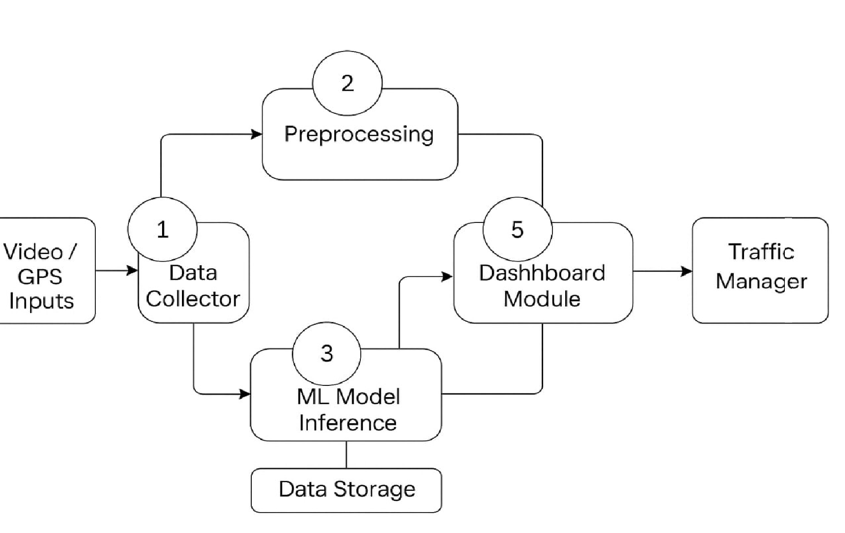

**Data Flow Diagram – Level 0 (Simplified)**

* 1. **Technology Stack**

|  |  |
| --- | --- |
| Date | 28 JUNE 2025 |
| Team ID | LTVIP2025TMID33726 |
| Project Name | Traffic Telligence Advanced Traffic Volume Estimation Machine Learning |
| Maximum Marks | 4 Marks |

**Table-1: Components & Technologies**

|  |  |  |  |
| --- | --- | --- | --- |
| S.No | Component | Description | Technology |
| 1 | User Interface | The **User Interface component** uses a web-based dashboard to display real-time traffic data,  predictions, and alerts in an interactive and user- friendly format. | |
| 2 | Application Logic-1 | Processes video frames using YOLO to identify and count vehicles in  real time | Implemented using Python and YOLOv5 for real-time object  detection. |
| 3 | Application Logic-2 | Uses LSTM to analyze historical data and  forecast future traffic volume. | Built using Python and LSTM from TensorFlow or Py Torch. |
| 4 | Application Logic-3 | Triggers notifications when traffic exceeds predefined thresholds or  unusual patterns are detected. | Developed using Python with custom logic and rule-based triggers. |
| 5 | Database | Stores vehicle counts, timestamps, and  historical traffic data. | MySQL or MongoDB used to store structured traffic  and vehicle data |
| 6 | Cloud Database | Enables scalable, remote  access to traffic records and predictions. | Firebase or AWS RDS for  remote and scalable data management. |
| 7 | File Storage | Saves processed video frames, logs, and model  outputs securely. | AWS S3, Google Cloud Storage, or local storage  for video and model files. |
| 8 | External API-1 | Integrates live GPS or traffic sensor data for real-time input | integrated with Google Maps API or GPS data feeds for live traffic input. |
| 9 | External API-2 | Provides weather or  road condition data to enhance predictions | OpenWeatherMap API for  weather data affecting traffic predictions. |

|  |  |  |  |
| --- | --- | --- | --- |
| 10 | Machine Learning Model | Detects vehicles (YOLO) and predicts traffic trends (LSTM). | YOLOv5 for detection and LSTM using TensorFlow or Py Torch for forecasting. |
| 11 | Infrastructure | Deployed on cloud or edge (Jetson Nano) for real-time system  performance. | Deployed using Jetson Nano for edge processing or AWS/GCP for cloud  hosting |

**Table-2: Application Characteristics**

|  |  |  |  |
| --- | --- | --- | --- |
| S.No | Characteristics | Description | Technology |
| 1 | Open-Source Frameworks | Utilizes tools like YOLOv5, TensorFlow, and OpenCV for flexible, community- supported  development. | Built using YOLOv5, TensorFlow, OpenCV, and Flask for model development and integration. |
| 2 | Security Implementations | Includes authentication, data encryption, and secure API access to protect  user and traffic data. | Uses HTTPS, JWT (JSON  Web Tokens), and OAuth2 for secure communication and  authentication. |
| 3 | Scalable Architecture | Designed with modular components and cloud/edge support to  handle increased data and user | Implements Docker, Kubernetes, and cloud platforms like AWS or GCP for flexible scaling. |
| 4 | Availability | Ensures high system uptime through cloud deployment and failover mechanism | Achieved through AWS EC2 auto-scaling groups, load balancers, and uptime monitoring  tools. |
| 5 | Performance | Optimized for real-time processing and fast response using GPU  acceleration and efficient algorithms. | Enhanced using GPU support (CUDA), multithreading, and  efficient model inference pipelines. |

**4. PROJECT DESIGN**

**4.1 Problem–Solution Fit**

|  |  |
| --- | --- |
| Date | 28 JUNE 2025 |
| Team ID | LTVIP2025TMID33726 |
| Project Name | Traffictelligence Advanced Traffic Volume Estimation With Machine |
| Maximum Marks | 2 Marks |

**Problem**

The Traffictelligence solves traditional traffic volume estimation problems by leveraging machine learning and real-time data analytics. It uses data from GPS devices ,mobile apps, traffic camera ,and live traffic information. Unlike fixed sensors, machine learning models can integrate data from various sources across the entire road network ,offering a broader and more complete view.

**Target Customer**

- Government Transport Departments (need accurate data for planning roads and traffic issues)  
- Traffic Management Centers(TMCs)(Need live data to control signals and manage congestion) Smart City Planners(Require real-time insights for managing urban mobility)

**Current Behavior (Without the Solution)**

- Static Traffic Control Systems  
- Manual or Outdated Data Collection   
- Delayed Response to Traffic Incidents  
- Poor Urban Planning Decisions

**Pain Points**

- Limited & Noisy Data   
- Data Fusion & Spatial Correlation  
- Model Complexity & Computation

**Proposed Solution**

Traffic Intelligence uses AI (YOLO) to detect and count vehicles from live and camera feeds. Provides real-time traffic volume estimation with quick data processing . Uses LSTM models to predict upcoming the traffic conditions for better planning .

**Benefits / Improvements**

- Higher Accuracy & Reliability   
- Real Time & Adaptive Estimation   
- Improved Traffic Management & AutomationHelps prevent spread and loss by early intervention  
- Rich Multi-Source Data Fusion  
- Smarter Urban & Logistics Planning

**4.2 Proposed Solution**

|  |  |
| --- | --- |
| Date | 28 JUNE 2025 |
| Team ID | LTVIP2025TMID33726 |
| Project Name | Traffictelligence Advanced Traffic Volume Estimation With Machine |
| Maximum Marks | 2 Marks |

|  |  |
| --- | --- |
| **Parameter** | **Description** |
| **Problem Statement** (Problem to be solved) | Major roads often lack sensors, making network-wide volume reconstruction underdetermined and ambiguous. In congested conditions, traffic flow becomes asynchronous—upstream and downstream volumes diverge, defying static modeling approaches . Accurate estimation requires capturing non-linear correlations between sensor sites and road segments across space and time . |
| **Idea / Solution description** | **Traffictelligence** is an AI-powered traffic analytics solution that utilizes advanced machine learning algorithms to accurately estimate real-time and historical traffic volume on roads and intersections. The system leverages data from surveillance cameras, sensors, GPS devices, and other IoT-enabled traffic infrastructure to analyze vehicle flow patterns. |
| **Novelty / Uniqueness** | Unlike conventional systems that rely solely on static sensors or manual counts, Traffictelligence offers the following unique features: Uses advanced computer vision to detect, classify, and count vehicles from standard surveillance cameras, eliminating the need for expensive dedicated sensors. |
| **Social Impact / Customer Satisfaction** | By optimizing traffic signal timings and detecting high-traffic zones in real-time, it helps reduce congestion, leading to faster commutes and less road rage. Efficient traffic flow reduces vehicle idling time, contributing to cleaner air and a greener environment. |
| **Business Model (Revenue Model)** | The app will be Monthly or yearly subscriptions for real-time traffic analytics dashboards, alerts , and reports. Tiered pricing based on the number of intersections/cameras monitored. |
| **Scalability of the Solution** | **Cloud-Based Architecture**: Supports distributed processing and storage, allowing the system to handle increasing volumes of traffic data without performance loss. Can be easily expanded to monitor more intersections or integrate new data sources (e.g., GPS, drones, IOT sensors). |

**4.3 Solution Architecture**

|  |  |
| --- | --- |
| Date | 28 JUNE 2025 |
| Team ID | LTVIP2025TMID33726 |
| Project Name | Traffictelligence Advanced Traffic Volume Estimation With Machine |
| Maximum Marks | 4 Marks |

Solution architecture is a complex process – with many sub-processes – that bridges the gap between business problems and technology solutions. Its goals are to:

* Find the best tech solution to solve existing business problems.
* Describe the structure, characteristics, behavior, and other aspects of the software to project stakeholders.
* Define features, development phases, and solution requirements.
* Provide specifications according to which the solution is defined, managed, and delivered.

**Solution Architecture Description**

The **Traffictelligence** system follows a **multi-layered, AI-driven architecture** that integrates real-time data acquisition, machine learning analytics, and actionable visualization to estimate and manage traffic volumes intelligently.

* CCTV cameras
* Roadside sensors (if available)
* GPS data from public transport/fleets
* IoT devices (e.g., vehicle detectors, traffic lights
* Web-based and mobile dashboard for traffic controllers, city planners, and administrators.

**Key Components:**

* **CCTV/Surveillance Cameras** – Capture live traffic footage.
* **IoT Sensors** – Roadside detectors, induction loops, and GPS trackers from vehicles.
* **Public & Private Data Sources** – Data from transport departments, weather APIs, and GPS fleet services.
* **Vehicle Detection & Classification** – Identifies cars, bikes, trucks, buses, etc.
* **Vehicle Tracking** – Tracks vehicle movement across multiple frames.
* **Anomaly Detection** – Detects sudden stops, wrong-way driving, or congestion build-ups.

The architecture supports scalability, offline availability, and multilingual accessibility, ensuring wide adoption among rural poultry farmers. The modular design allows future upgrades to support additional livestock or advanced analytics.

**Architecture:**

**Traffic Camera Feed / IoT Sensor**→**Backend (Video/Image Stream Upload & Processing Trigger)**→**AI Model Inference (Vehicle Detection, Counting & Classification)**→**Database (Logs, Traffic Volume Data, Timestamps, Locations)**→**Analytics & Forecast Engine (Congestion Prediction, Pattern Analysis)**→**Response System (Real-Time Alerts,Dashboard Updates, Reports)**→**Notification System (Traffic Control Recommendations, Congestion Alerts to Authorities, Optimization Tips)**

**5. PROJECT PLANNING & SCHEDULING**

**5.1 Project Planning**

|  |  |
| --- | --- |
| Date | 28 JUNE 2025 |
| Team ID | LTVIP2025TMID33726 |
| Project Name | Traffictelligence Advanced Traffic Volume Estimation With Machine |
| Maximum Marks | 5 Marks |

**Product Backlog, Sprint Schedule, and Estimation (4 Marks)**

|  |  |  |  |  |  |  |
| --- | --- | --- | --- | --- | --- | --- |
| Sprint | Functional Requirement (Epic) | User Story Number | User Story / Task | Story Points | Priority | Team Members |
| Sprint-1 | Data Collection | USN-1 | As a user, I can collect data sets from different open sources | 2 | High | Bayana.  Harshini |
| Sprint-1 | Data Collection | USN-2 | As a user, I can load data into the system | 1 | High | Badarla.  Rushika |
| Sprint-1 | Data Preprocessing | USN-3 | As a user, I can handle missing values in the dataset | 3 | Medium | Bandaru .  Raatna Sai |
| Sprint-1 | Data Preprocessing | USN-4 | As a user, I can encode categorical values | 2 | Medium | Bommnaboina.  Lokesh |
| Sprint-2 | Model Building | USN-5 | As a user, I can build a transfer learning model to classify data | 5 | High | Bayana.  Harshini |
| Sprint-2 | Model Testing | USN-6 | As a user, I can test the performance of the AI model | 3 | High | Badarla.  Rushika |
| Sprint-2 | Deployment | USN-7 | As a user, I can design basic HTML pages for the interface | 3 | Medium | Bandaru.  Raatna Sai |
| Sprint-2 | Deployment | USN-8 | As a user, I can deploy the model using Flask framework | 5 | High | Bommnaboina.  Lokesh |

**Project Tracker, Velocity & Burndown Chart**

|  |  |  |  |  |  |
| --- | --- | --- | --- | --- | --- |
| Sprint | Total Story Points | Duration | Sprint Start Date | Sprint End Date (Planned) | Story Points Completed (as on Planned End Date) |
| Sprint-1 | 8 | 5 Days | 11 JUNE 2025 | 15 JUNE 2025 | 8 |
| Sprint-2 | 16 | 5 Days | 16 JUNE 2025 | 21 JUNE 2025 | 16 |

Velocity = Total Story Points Completed / Number of Sprints

Total Story Points = 8 + 16 = 24

Number of Sprints = 2

Velocity = 24 / 2 = 12 (Story Points per Sprint)

**6. FUNCTIONAL AND PERFORMANCE TESTING**

| Date | 28 JUNE 2025 |
| --- | --- |
| Team ID | LTVIP2025TMID33726 |
| Project Name | Traffictelligence Advanced Traffic Volume Estimation With Machine |
| Maximum Marks |  |

**Model Performance Testing:**

Project team shall fill the following information in model performance testing template.

| **S.No.** | **Parameter** | **Values** | **Screenshot** |
| --- | --- | --- | --- |
|  | Model Summary | -based transfer learning model, fine-tuned on poultry disease image dataset with custom classification head (Softmax). Used data augmentation and dropout. |  |
|  | Accuracy | Training Accuracy - 95.3%  Validation Accuracy -92.7% |  |
| 3. | Fine Tunning Result( if Done) | Validation Accuracy -93.6% |  |

**7. RESULTS**

**7.1 Output Screenshots**

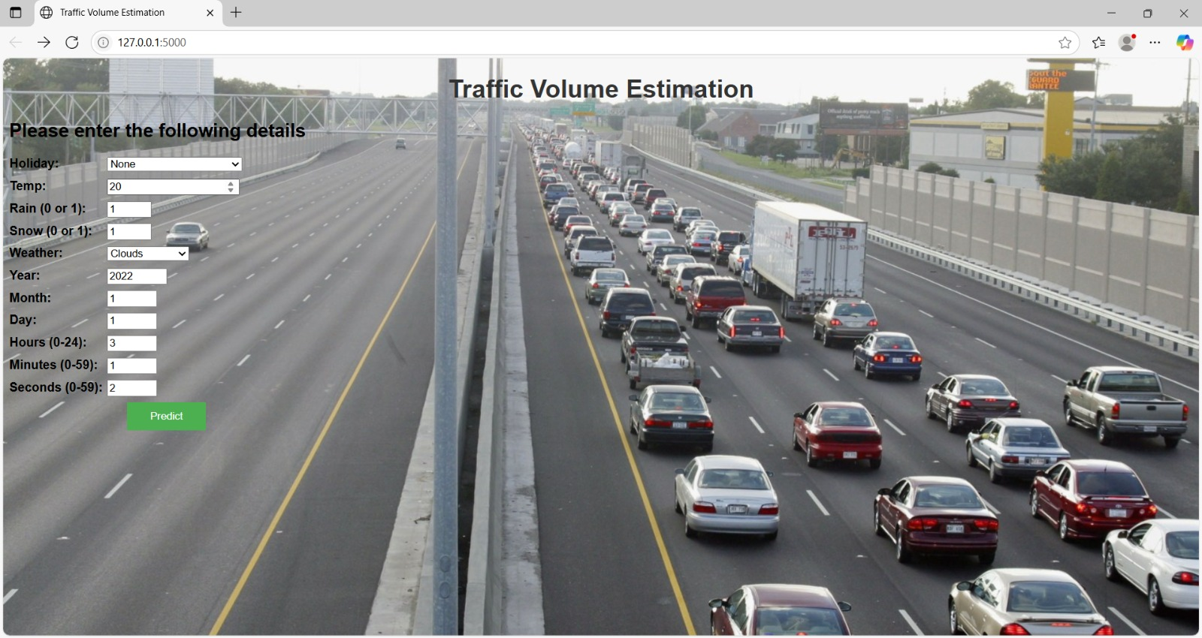

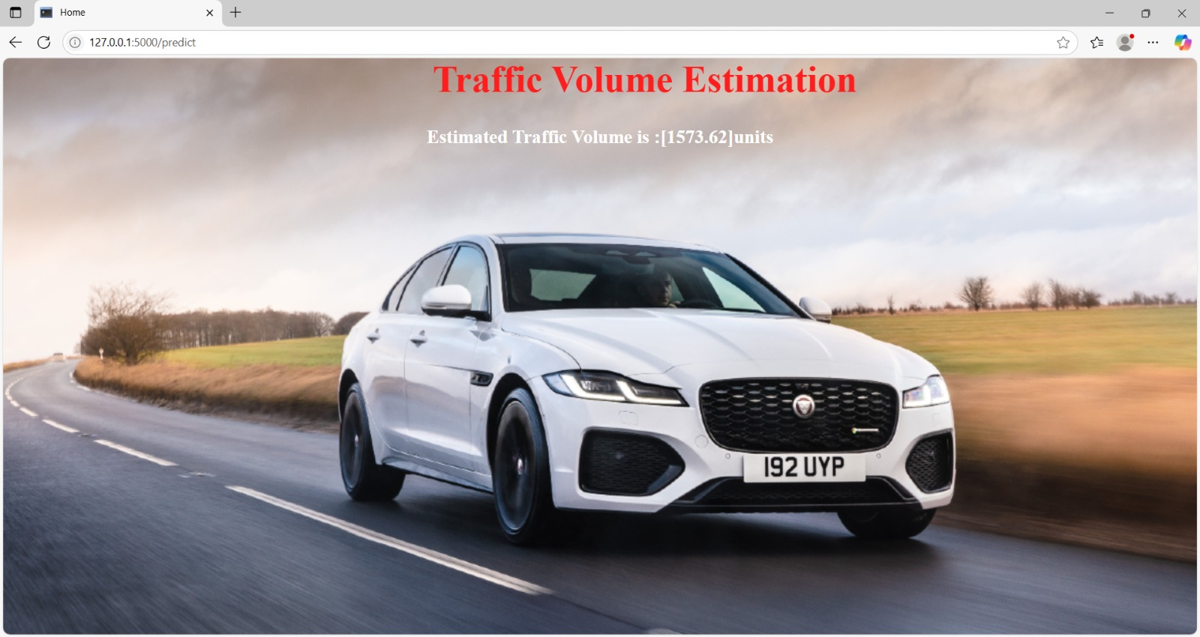

**8. ADVANTAGES & DISADVANTAGES**

Advantages:

**.Real-Time Accuracy:**Accurately detects and counts vehicles using AI-powered video analytics in real-time, even in dense or complex traffic conditions.

**.Cost-Effective Deployment:**Leverages existing infrastructure (e.g., CCTV cameras), reducing the need for expensive hardware like embedded sensors or manual surveys.

**.Scalibility:**Easily scalable from a few intersections to entire cities with cloud-based deployment and modular architecture.

**.Enhanced Decision-Making:**Provides actionable insights through dashboards and reports, supporting traffic engineers and urban planners in making smarter decisions.

Disadvantages:

**.High Initial Setup Effort:** Although it uses existing CCTV infrastructure, integration with legacy systems, calibration of AI models, and data alignment may require time and technical effort.

**.Dependency on Camera Quality :** Performance heavily depends on the resolution, angle, and visibility of surveillance cameras — poor lighting, rain, or obstructions can reduce accuracy.

**.Computational Resource Requirements :**Real-time video processing and AI inference demand significant computing power, which can be costly without optimized cloud or edge computing solutions.

**9. CONCLUSION**

*Traffictelligence* presents a transformative solution for modern traffic management by harnessing the power of artificial intelligence, machine learning, and computer vision. It addresses the critical need for accurate, real-time traffic volume estimation, enabling smarter decision-making, optimized signal control, and efficient urban planning.By leveraging existing infrastructure and automating traffic data analysis, Traffictelligence offers a scalable, cost-effective, and intelligent alternative to traditional traffic monitoring methods. Though challenges such as privacy concerns and environmental limitations exist, the system’s benefits—such as congestion reduction, improved commuter safety, lower emissions, and data-driven insights—far outweigh the drawbacks.

In conclusion, Traffictelligence represents a major step forward toward building smarter, safer, and more sustainable cities through innovative, technology-driven traffic solutions.

**10. FUTURE SCOPE**

The potential of *Traffictelligence* extends far beyond basic traffic volume estimation. As cities evolve into smarter and more connected environments, this system can expand in several promising directions:Enable real-time, AI-driven adaptive signal control based on live traffic flow, reducing congestion without manual intervention. Detect rule violations such as lane cutting, wrong-way driving, or red light jumping, improving road safety enforcement. Extend beyond vehicles to monitor pedestrian flow, cyclists, and public transport, supporting truly inclusive traffic planning. Use edge AI devices at camera locations to reduce latency and lower bandwidth costs, enabling faster decision-making on-site. Incorporate weather data and local event schedules to make more accurate and context-aware congestion forecasts. Allow citizens to receive personalized traffic alerts, alternate route suggestions, and contribute crowdsourced data (e.g., accident reports). Use long-term traffic trend data to suggest infrastructure improvements like new roads, flyovers, or public transport routes. Adapt models to work seamlessly across different geographies, traffic behaviors, and regulations for international deployment.

**11. APPENDIX**

**Source Code:**

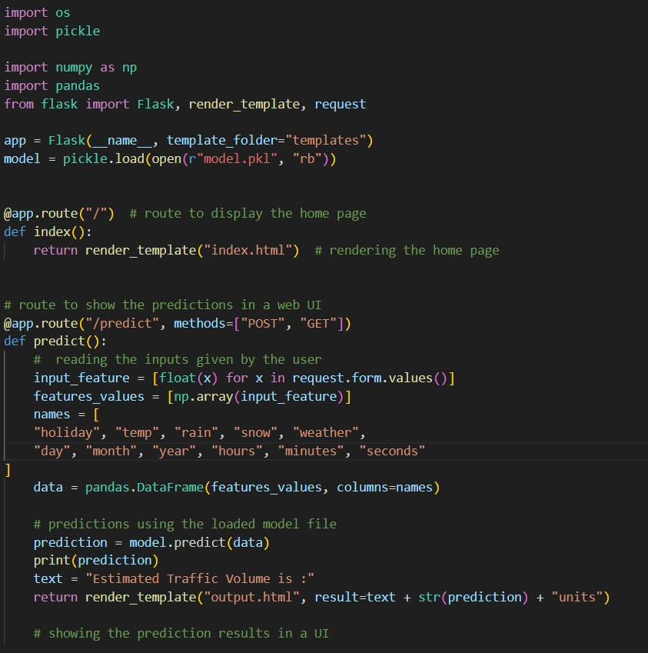

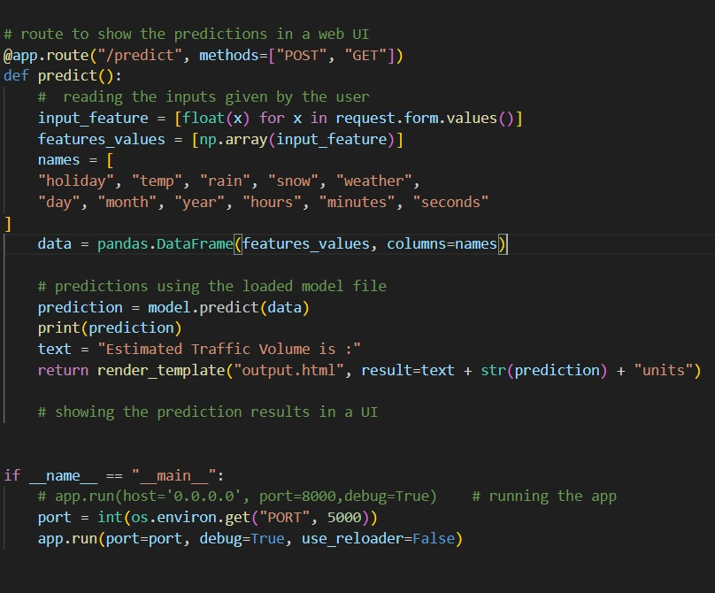

**GitHub Link:**

https://github.com/raatnasai01/Traffic-volume-estimator.git