DATABASE SYSTEM ENGINEERING AND DISTRIBUTED BACKEND DEVELOPMENT
Course Code: 25CS13002E
ROLL NO: 2520030489
NAME: Raavi Bhavitha

SETUP — DATABASE AND TABLES
CREATE DATABASE
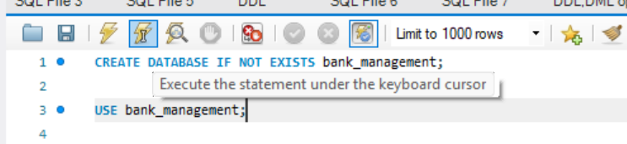
Output:
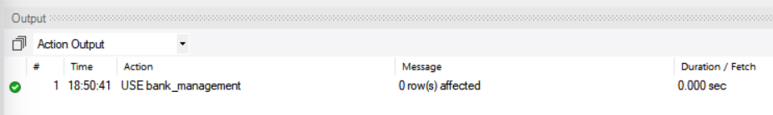
CREATE TABLE
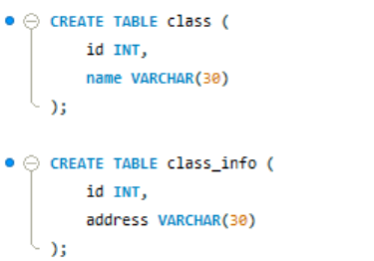
Output:

INSERT SAMPLE DATA
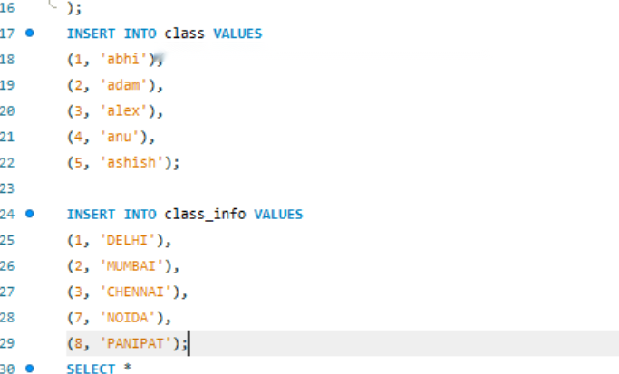
Output:
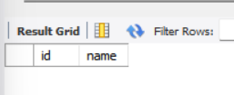
PART 1: CROSS JOIN
Query 1: CROSS JOIN
Query / Code:
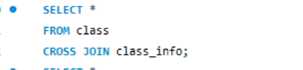
Output:
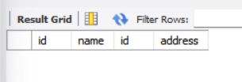

PART 2: INNER JOIN
Query 2: INNER JOIN
Query / Code:
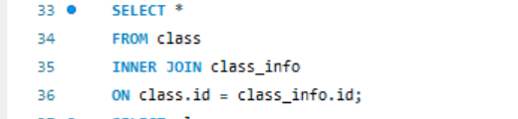
Output:

Query 3: INNER JOIN
Query / Code:
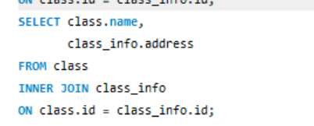
Output:
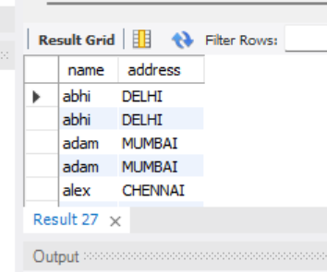

PART 3: NATURAL JOIN
Query 4: NATURAL JOIN
Query / Code:
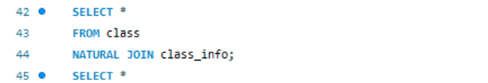
Output:
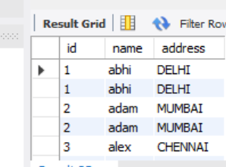

PART 4: LEFT OUTER JOIN
Query 5: LEFT JOIN
Query / Code:
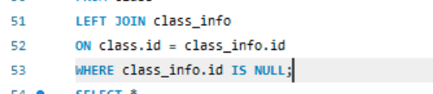
Output:

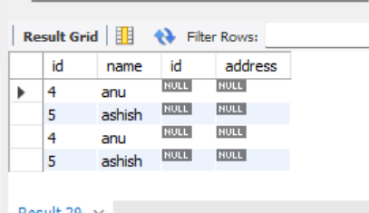
Query 6: LEFT JOIN
Query / Code:
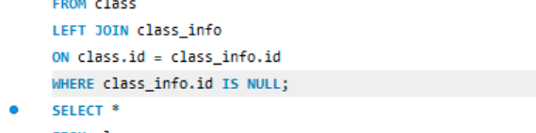
Output:
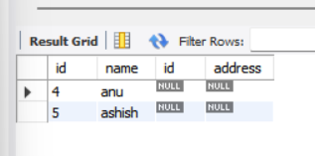

PART 5: RIGHT OUTER JOIN
Query 7: RIGHT JOIN
Query / Code:
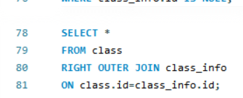
Output:
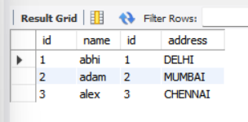

Query 8: RIGHT JOIN
Query / Code:
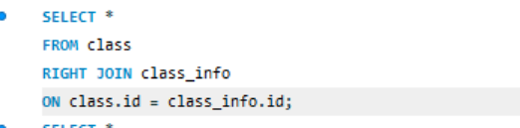
Output:
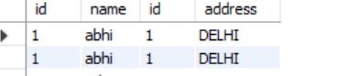

PART 6: FULL OUTER JOIN
Query 9: FULL OUTER JOIN
Query / Code:
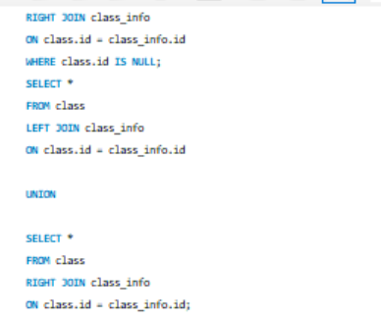
Output:
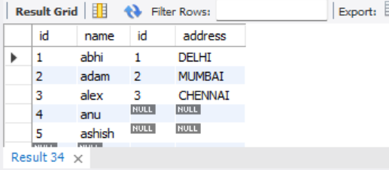

Query 10: FULL OUTER JOIN
Query / Code:
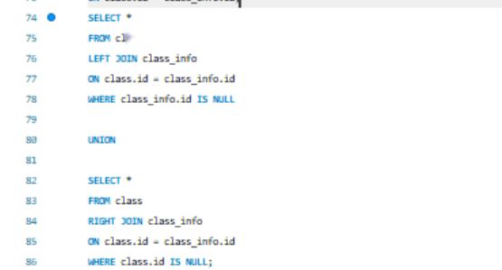
Output:
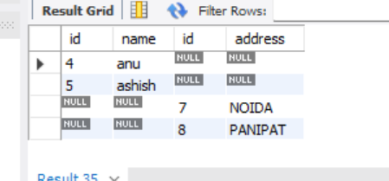
PART 7: UNION
Query 11: UNION
Query / Code:
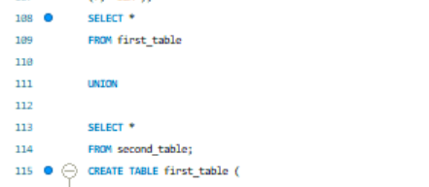
Output:
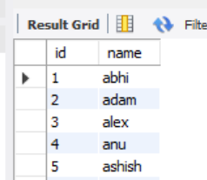

Query 12: UNION
Query / Code:
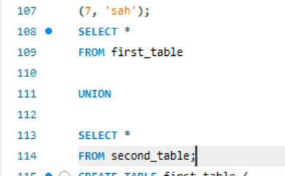
Output:
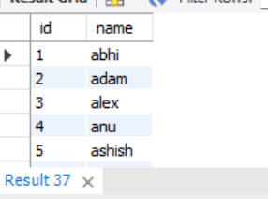

PART 8: UNION ALL
Query 13: UNION ALL
Query / Code:
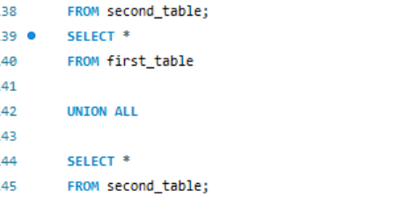
Output:
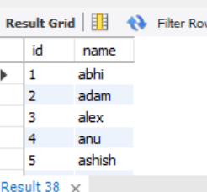

Query 14: UNION ALL
Query / Code:
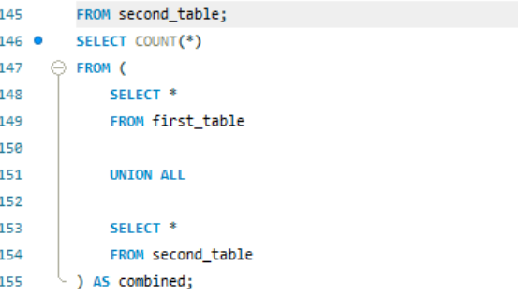

Output:
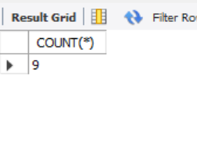

PART 9: INTERSECT
Query 15: INTERSECT
Query / Code:
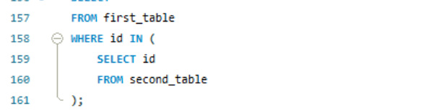
Output:
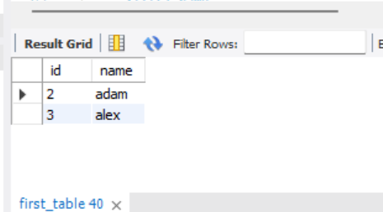

Query 16: INTERSECT
Query / Code:
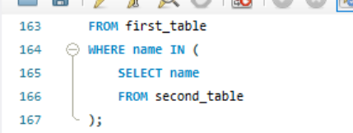
Output:
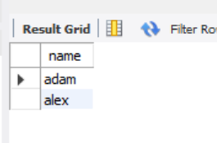

PART 10: MINUS
Query 17: MINUS
Query / Code:
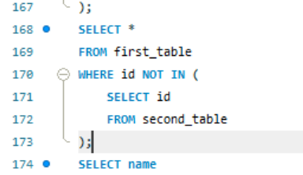
Output:
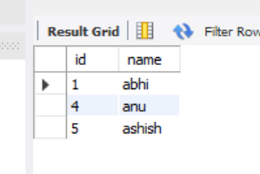

Query 18: MINUS
Query / Code:
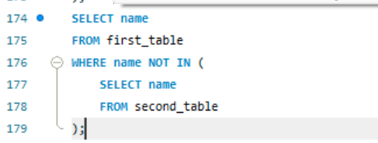
Output:
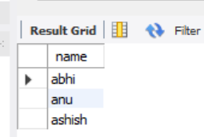

ADVANCED INTERVIEW QUESTIONS
Query 19: INNER JOIN — MATCHING ADDRESSES
Query / Code:
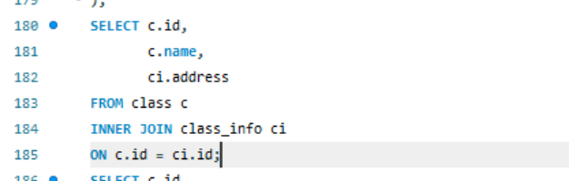
Output:

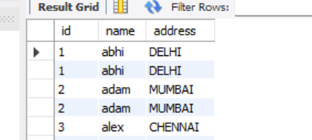

Query 20: CASE + LEFT JOIN — ADDRESS STATUS
Query / Code:
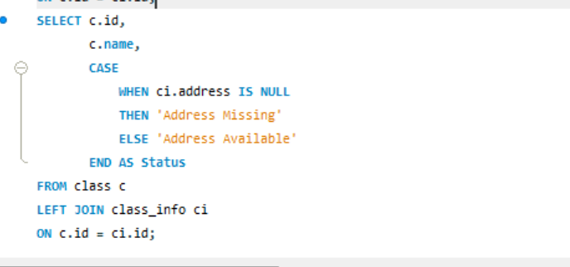
Output:
