Raavi Bhavitha | Roll No: 2520030489
User Service Running
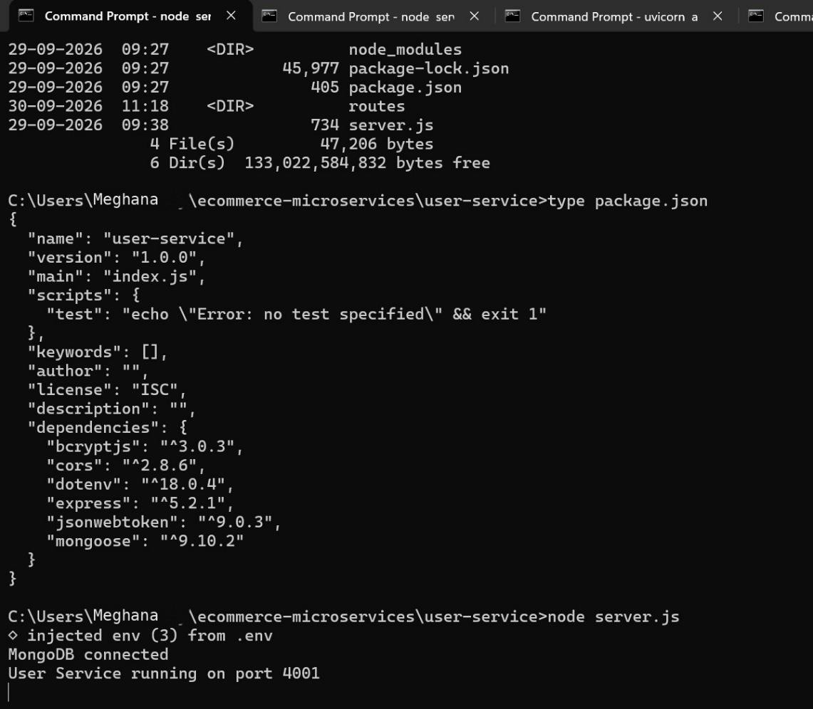

Activity Service Running
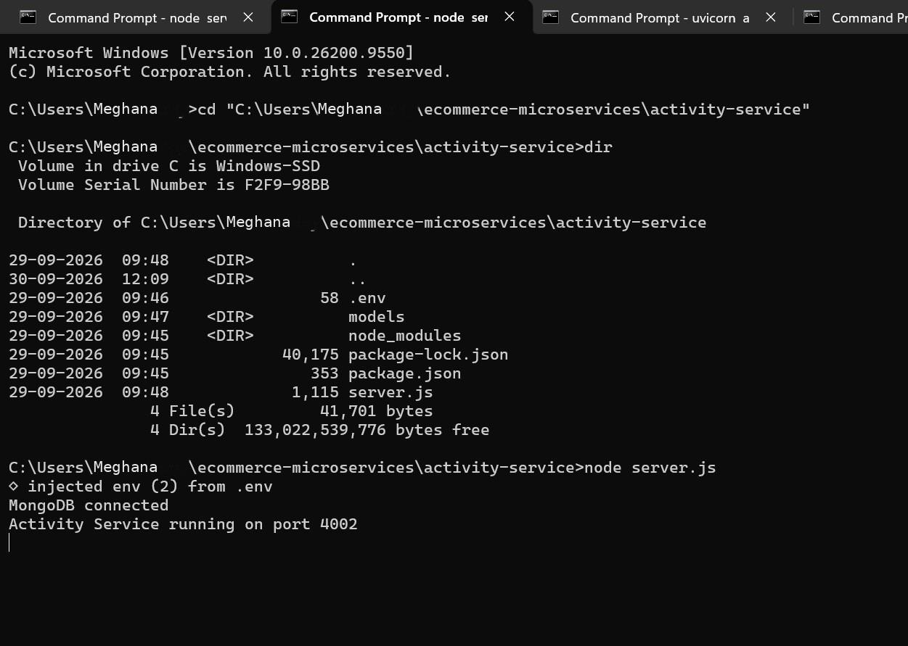

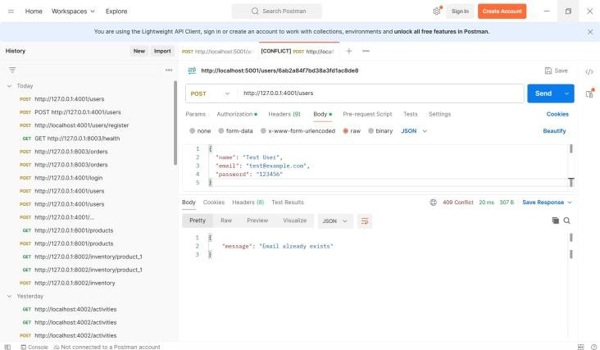
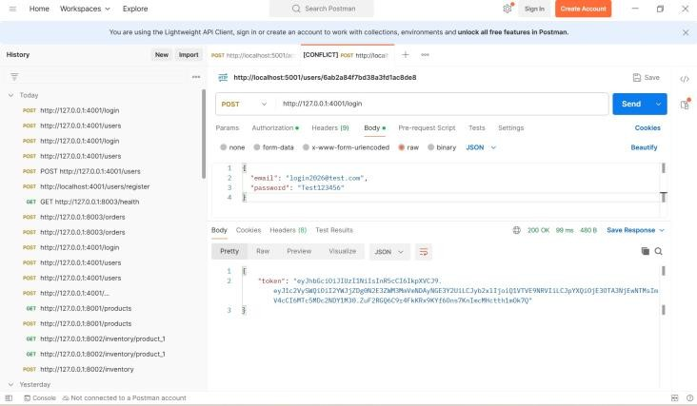
T. Tejaswini | Roll No: 2520030510
User Registration API

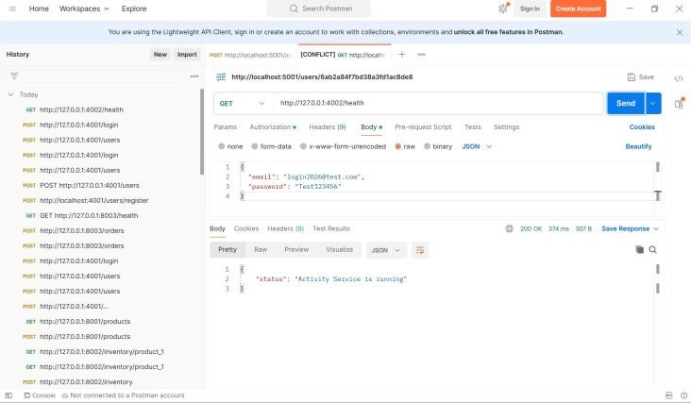
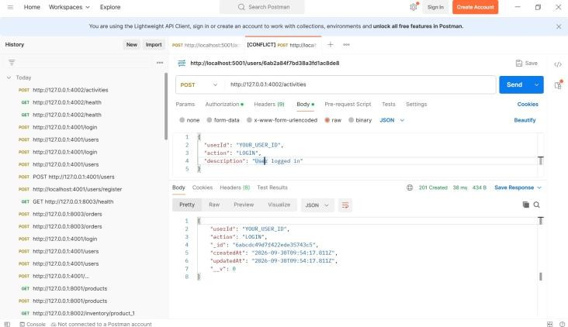
T. Tejaswini | Roll No: 2520030510
Activity Service Health Check

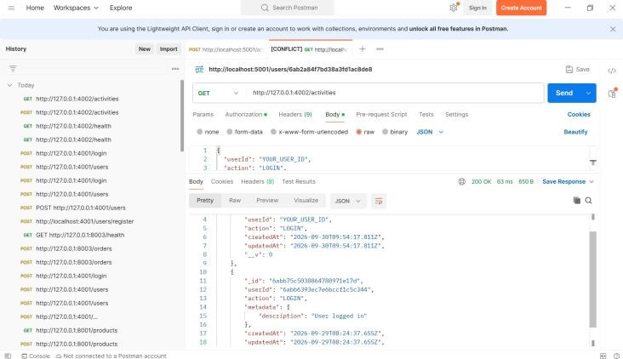
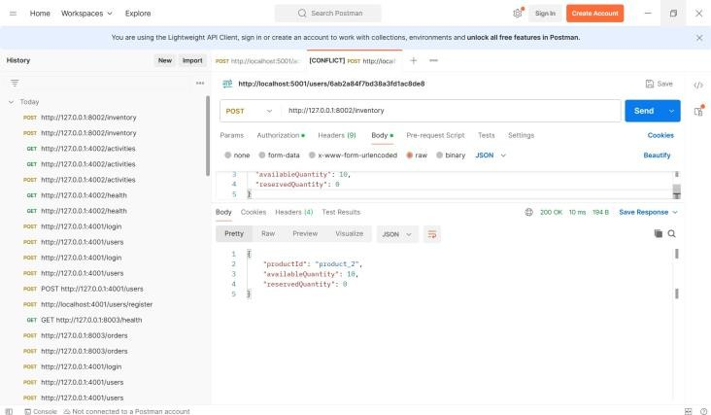
T. Tejaswini | Roll No: 2520030510
Activity Retrieval API

T. Tejaswini | Roll No: 2520030510
Inventory Service Running
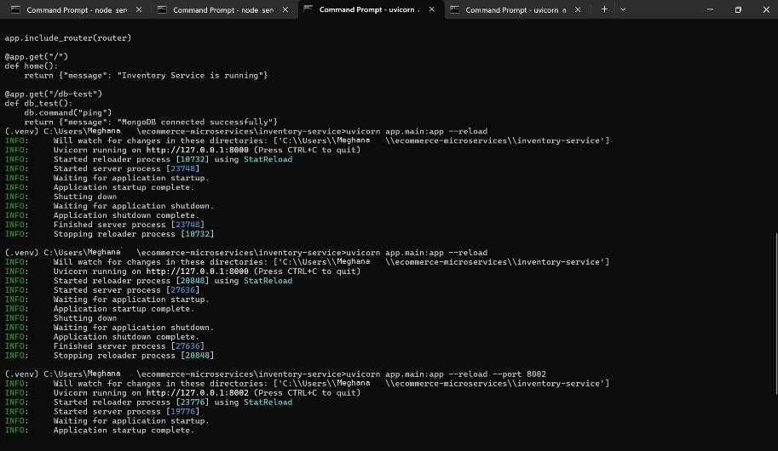
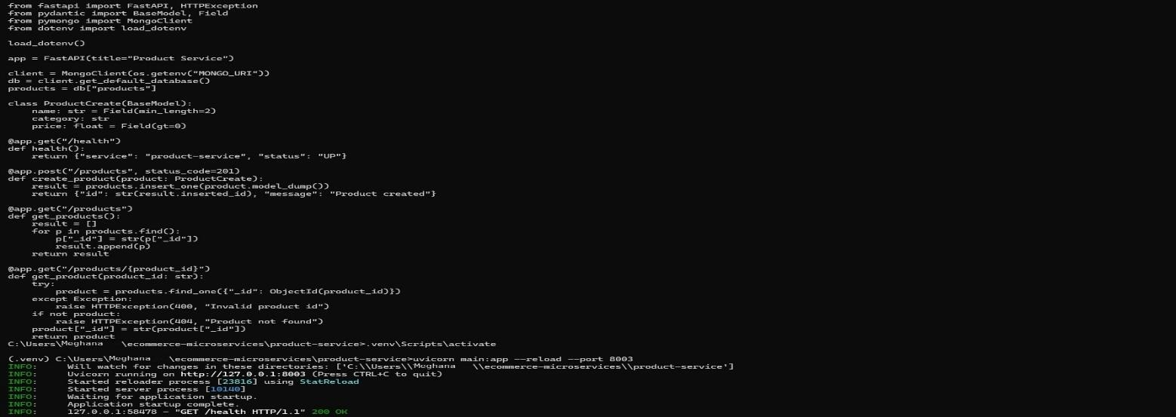
Product Service

