1. **Import the dataset and do usual exploratory analysis steps like checking the structure & characteristics of the dataset**
   1. **Data type of columns in a table**

select column_name, data_type

from `solid-hope-367013.Target_sql.INFORMATION_SCHEMA.COLUMNS`

where table_name = 'orders'

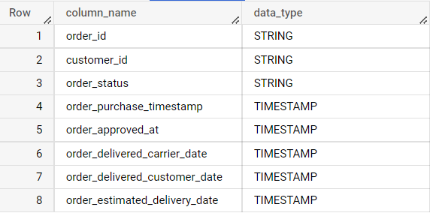

* 1. **Time period for which the data is given**

select min(order_purchase_timestamp) as first_purchase,

max(order_purchase_timestamp) as last_purchase

from `solid-hope-367013.Target_sql.orders` limit 10



* 1. **Cities and States covered in the dataset**

select

  c.customer_state, c.customer_city

from `solid-hope-367013.Target_sql.orders` o  inner join  `solid-hope-367013.Target_sql.customers` c

on o.customer_id = c.customer_id

group by 1,2 limit 10

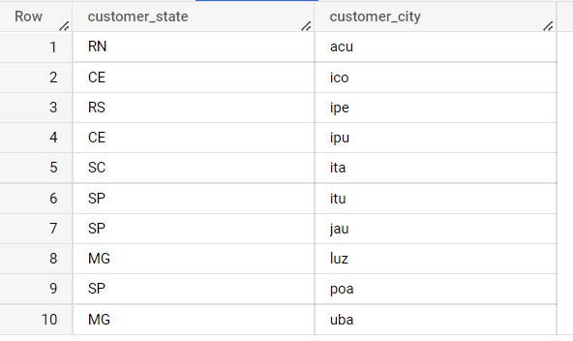

1. **In-depth Exploration:**
   1. **Is there a growing trend on e-commerce in Brazil? How can we describe a complete scenario? Can we see some seasonality with peaks at specific months?**

select

  extract(year from order_purchase_timestamp) as year,

  extract(month from order_purchase_timestamp) as month,

  count(distinct (order_id))

from `solid-hope-367013.Target_sql.orders`

group by 1,2

order by 1,2

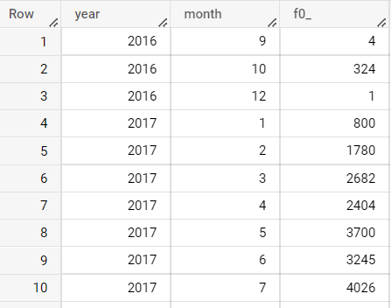

* 1. **What time do Brazilian customers tend to buy (Dawn, Morning, Afternoon or Night)?**

select

  sum(case when hours between 0 and 6 then orders end )as dawn,

  sum(case when hours between 7 and 12 then orders end )as morning,

  sum(case when hours between 13 and 18 then orders end )as eveining,

  sum(case when hours between 19 and 23 then orders end )as night,

  from

  (select

  extract(hour from order_purchase_timestamp) as hours,

  count(distinct(order_id)) as orders

  from `solid-hope-367013.Target_sql.orders`

  group by 1) as a

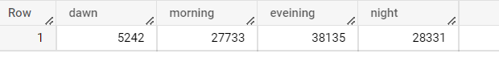

1. **Evolution of E-commerce orders in the Brazil region:**
   1. **Get month on month orders by region, states**

select

c.customer_state, c.customer_city,

extract(month from order_purchase_timestamp) as month,

count(distinct(order_id)) as orders

from `solid-hope-367013.Target_sql.orders` o join `solid-hope-367013.Target_sql.customers` c on o.customer_id = c.customer_id

group by 1,2,3

order by 1,2,3

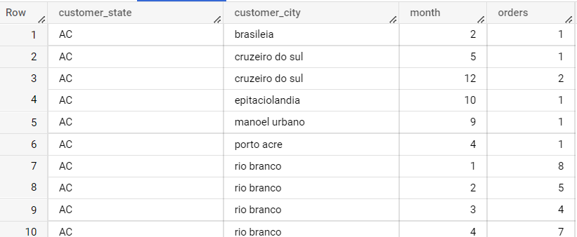

* 1. **How are customers distributed in Brazil**

select

distinct(customer_unique_id) ,

customer_state, customer_city

from `solid-hope-367013.Target_sql.customers`

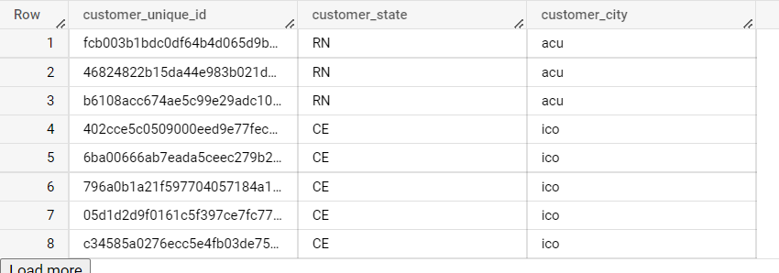

1. **Impact on Economy: Analyze the money movemented by e-commerce by looking at order prices, freight and others.**
   1. **Get % increase in cost of orders from 2017 to 2018 (include months between Jan to Aug only)**

with base as (

select * from `solid-hope-367013.Target_sql.orders` a

inner join

`solid-hope-367013.Target_sql.payments` b

on a.order_id = b.order_id

where

extract(year from a.order_purchase_timestamp) between 2017 and 2018

and

extract(month from a.order_purchase_timestamp) between 1 and 8

),

base_2 as (

select extract(year from order_purchase_timestamp) as year, sum(payment_value) as cost from base

group by 1

order by 1 asc

),

base_3 as (

select *, lead(cost, 1) over (order by year) as next_year_cost from base_2)

select *, (next_year_cost - cost)/ cost *100 as per_inc from base_3

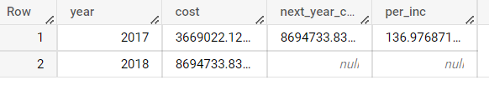

* 1. **Mean & Sum of price and freight value by customer state**

select

c.customer_state, avg(price) as mean_of_price,

  sum(price) as sum_of_price,

  avg(freight_value) as mean_of_freight,

  sum(freight_value) as sum_of_freight

from `Target_sql.customers` c join `Target_sql.orders` o on c.customer_id = o.customer_id join `Target_sql.order_items` oi on o.order_id = oi.order_id

group by c.customer_state

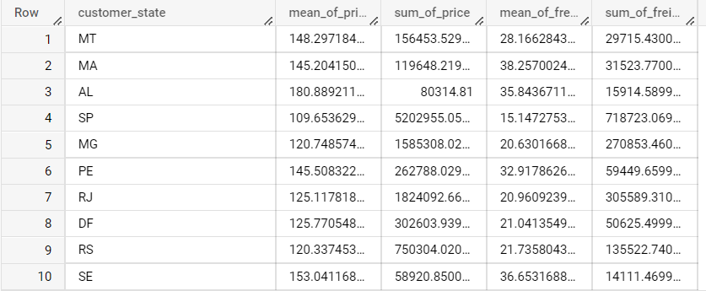

1. Analysis on sales, freight and delivery time
   1. Calculate days between purchasing, delivering and estimated delivery
   2. Create columns:
      * time_to_delivery = order_purchase_timestamp-order_delivered_customer_date

select

date_diff( order_delivered_customer_date,order_purchase_timestamp, day) as time_to_delivery

 from `Target_sql.orders`

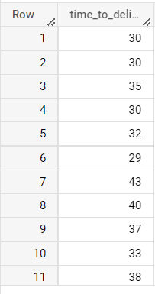

* + - diff_estimated_delivery = order_estimated_delivery_date-order_delivered_customer_date

select

date_diff( order_delivered_customer_date,order_estimated_delivery_date, day) as diff_estimated_delivery

 from `Target_sql.orders`

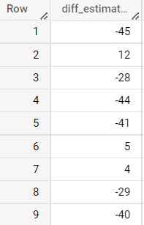

* 1. Group data by state, take mean of freight_value, time_to_delivery, diff_estimated_delivery
  2. **Sort the data to get the following:**
     + **Top 5 states with highest/lowest average freight value - sort in desc/asc limit 5**

select

c.customer_state,

avg(freight_value) as avg_of_freight,

from `Target_sql.customers` c join `Target_sql.orders` o on c.customer_id = o.customer_id join `Target_sql.order_items` oi on o.order_id = oi.order_id

group by 1

order by avg_of_freight desc limit 5

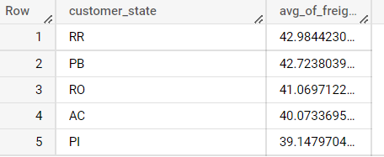

select

c.customer_state,

avg(freight_value) as avg_of_freight,

from `Target_sql.customers` c join `Target_sql.orders` o on c.customer_id = o.customer_id join `Target_sql.order_items` oi on o.order_id = oi.order_id

group by 1

order by avg_of_freight  limit 5

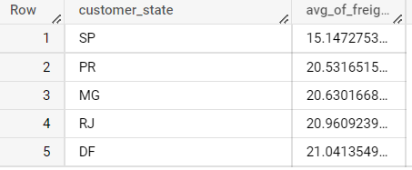

* + - **Top 5 states with highest/lowest average time to delivery**

select

c.customer_state,

  avg(date_diff(order_estimated_delivery_date,order_purchase_timestamp, day)) as avg_time

 from `Target_sql.orders` o join `Target_sql.customers` c on o.customer_id = c.customer_id

 group by c.customer_state

 order by avg_time desc limit 5   
  
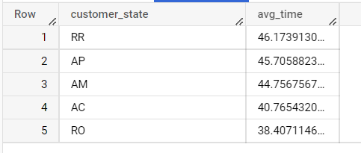

select

c.customer_state,

  avg(date_diff(order_estimated_delivery_date,order_purchase_timestamp, day)) as avg_time

 from `Target_sql.orders` o join `Target_sql.customers` c on o.customer_id = c.customer_id

 group by c.customer_state

 order by avg_time  limit 5

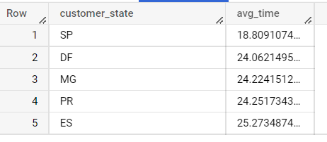

* + - **Top 5 states where delivery is really fast/ not so fast compared to estimated date**  
      **slow:**

select

c.customer_state,

sum(date_diff(order_delivered_customer_date,order_purchase_timestamp, day)) as total_time

 from `Target_sql.orders` o join `Target_sql.customers` c on o.customer_id = c.customer_id

 group by c.customer_state

 order by total_time desc limit 5

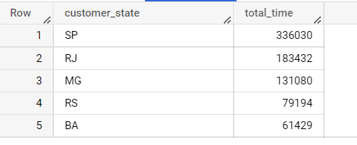

**Fast:**

select

c.customer_state,

sum(date_diff(order_delivered_customer_date,order_purchase_timestamp, day)) as total_time

 from `Target_sql.orders` o join `Target_sql.customers` c on o.customer_id = c.customer_id

 group by c.customer_state

 order by total_time  limit 5

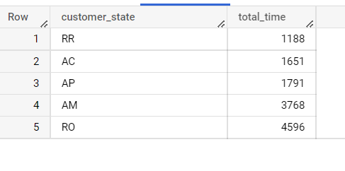

1. **Payment type analysis:**
   1. **Month over Month count of orders for different payment types**

select

  extract(month from order_purchase_timestamp) as month,

  payment_type,

  count(distinct (p.order_id)) as count_of_orders

from `solid-hope-367013.Target_sql.payments` p join `Target_sql.orders` o on p.order_id = o.order_id

group by month, payment_type

order by month,payment_type

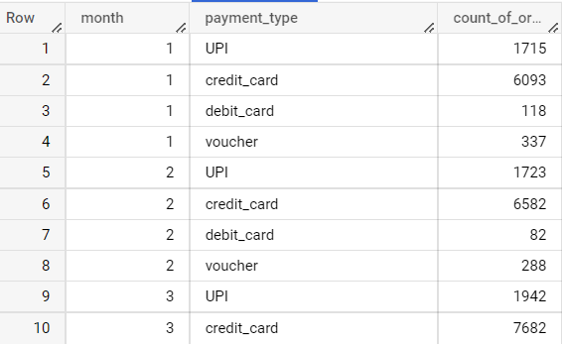

* 1. **Distribution of payment installments and count of orders**

select

payment_installments,

count(distinct(order_id)) as count_of_orders

from `Target_sql.payments`

group by payment_installments

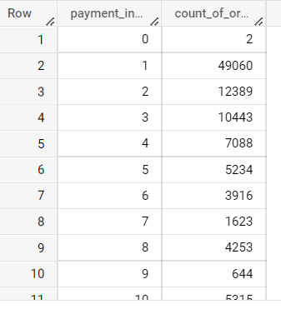

**Actionable Insights:**1. There was an **increasing/ growing trend** on e-commerce in brazil, high sales were recored in the month of **november** 2. Brazilian customers tend to buy more in the **evening**

3.**136.9%** increase in the cost of orders from 2017 to 2018

4. **customers like to use credit cards** for payments  
 **Recommendations:**  
1. as brazil e-commerence is in growing trend, there will be a huge demand in future.  
2.make sure there will be full function and available of products at evenings.  
3. need to make sure that products reach customers before estimated delivery time in some regions.  
4.majority of the customers use credit cards, providing offers on cards can increase sales.  
5.need to deliver the products ASAP