***Software Technology-1***

**Report**

*Raavin Ashwath Sundar Rajan|u31898852*

***Mandatory Test Cases***

***Test 1:***

|  |  |  |  |  |
| --- | --- | --- | --- | --- |
| ***Company: ECP***  ***Date cake: 0***  ***Beef sandwich: 1***  ***Cheese sandwich: 0***  ***Strawberry desert: 0***  ***Scrambled eggs: 0*** | ***Cost*** | ***Cost Total*** | ***Weight*** | ***Weight total*** |
| ***Date cake: 0*** |  |  |  |  |
| ***Beef sandwich: 1*** | ***49.50*** | ***49.50*** | ***164*** | ***164*** |
| ***Cheese sandwich: 0*** |  |  |  |  |
| ***Strawberry desert: 0*** |  |  |  |  |
| ***Scrambled eggs: 0*** |  |  |  |  |
| ***Totals*** |  | ***49.50*** |  | ***164 grams*** |
| ***Rounding (up to nearest KG)*** |  |  |  | ***1 kg*** |
| ***Cost of Packing*** |  | ***3,192.00*** |  |  |
| ***Cost to Orbit*** | ***1*18,127*** | ***18,127*** |  |  |
| ***Total cost of meal*** |  | ***$21,368.50*** |  |  |

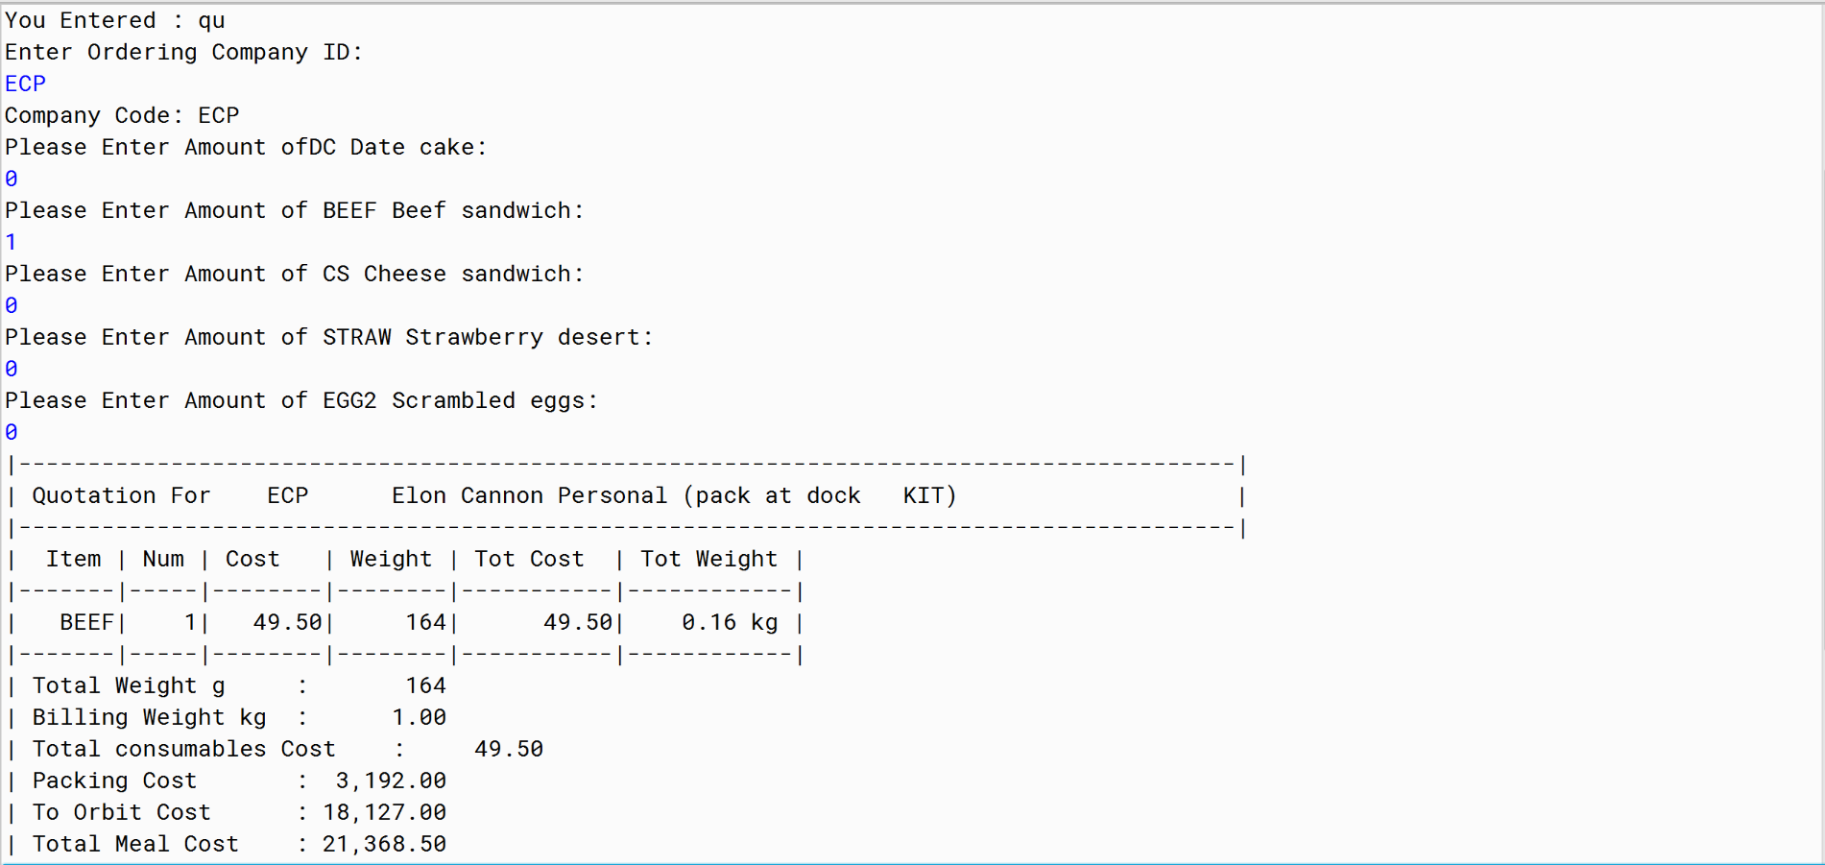

***RESULT: PASS***

***Test 2:***

|  |  |  |  |  |
| --- | --- | --- | --- | --- |
| ***Company: NAASA***  ***Date cake: 2***  ***Beef sandwich: 1***  ***Cheese sandwich: 2***  ***Strawberry desert: 24***  ***Scrambled eggs: 0*** | ***Cost*** | ***Cost Total*** | ***Weight*** | ***Weight total*** |
| ***Date cake: 2*** | ***2*59.00*** | ***118.00*** | ***2*134*** | ***268*** |
| ***Beef sandwich: 1*** | ***1*49.50*** | ***49.50*** | ***1*164*** | ***164*** |
| ***Cheese sandwich: 2*** | ***2*93.70*** | ***187.40*** | ***2*206*** | ***412*** |
| ***Strawberry desert: 24*** | ***24*157.05*** | ***3769.2*** | ***24*177*** | ***4248*** |
| ***Scrambled eggs: 0*** |  |  |  |  |
| ***Totals*** |  | ***4124.1*** |  | ***5092*** |
| ***Rounding (up to nearest KG)*** |  |  |  | ***6kg*** |
| ***Cost of Packing*** |  | ***$6,823.50*** |  |  |
| ***Cost to Orbit*** | ***6*18,127*** | ***$108,762*** |  |  |
| ***Total cost of meal*** |  | ***119,709.60*** |  |  |

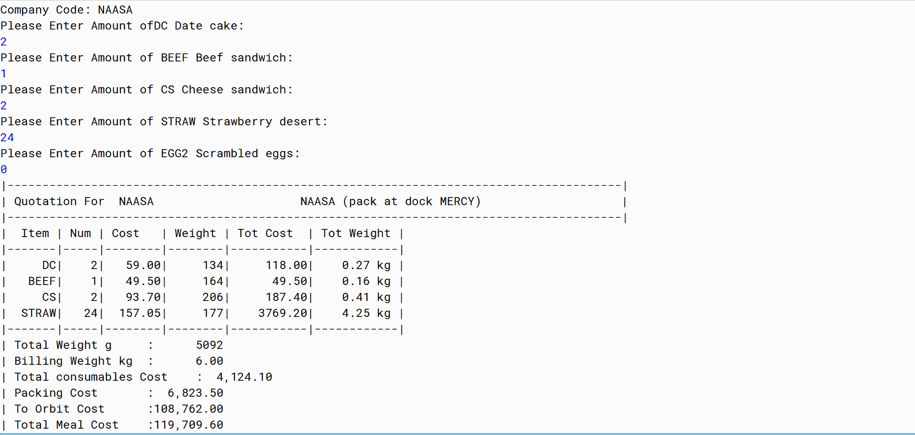

*\*****NOTE: Used QU in the menu.***

***RESULT: PASS***

***Test 3:***

|  |  |  |  |  |
| --- | --- | --- | --- | --- |
| ***Company: ECP***  ***Date cake: 0***  ***Beef sandwich: 1***  ***Cheese sandwich: 20***  ***Strawberry desert: 0***  ***Scrambled eggs: 1*** | ***Cost*** | ***Cost Total*** | ***Weight*** | ***Weight total*** |
| ***Date cake: 0*** |  |  |  |  |
| ***Beef sandwich: 1*** | ***49.50*** | ***49.50*** | ***164*** | ***164*** |
| ***Cheese sandwich: 20*** | ***20*93.70*** | ***1874.00*** | ***20*206*** | ***4120*** |
| ***Strawberry desert: 0*** |  |  |  |  |
| ***Scrambled eggs: 1*** | ***1*77.15*** | ***77.15*** | ***1*112*** | ***112*** |
| ***Totals*** |  | ***2000.65*** |  | ***4396 grams*** |
| ***Rounding (up to nearest KG)*** |  |  |  | ***5 kg*** |
| ***Cost of Packing*** |  | ***6823.50*** |  |  |
| ***Cost to Orbit*** | ***5*18,127*** | ***90,635.00*** |  |  |
| ***Total cost of meal*** |  | ***$99,459.15*** |  |  |

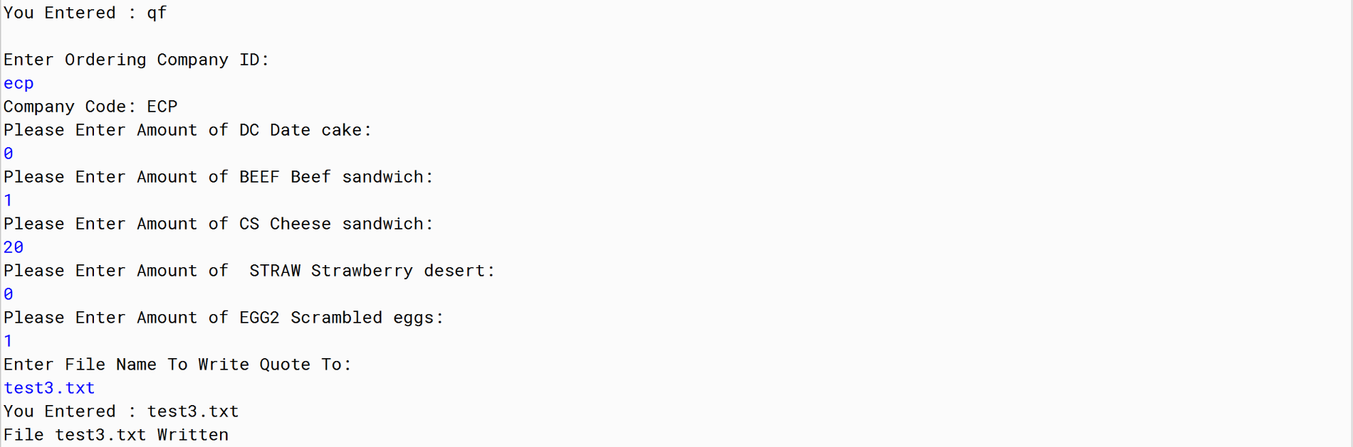

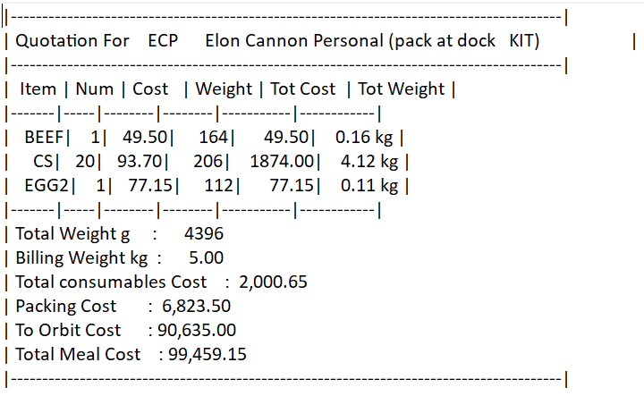

***RESULT: PASS***

***Test 4:***

|  |  |  |  |  |
| --- | --- | --- | --- | --- |
| ***Company: BFSC***  ***Date cake: 0***  ***Beef sandwich: 1***  ***Cheese sandwich: 25***  ***Strawberry desert: 2***  ***Scrambled eggs: 0*** | ***Cost*** | ***Cost Total*** | ***Weight*** | ***Weight total*** |
| ***Received Error*** | ***Cannot order more than 24 !!*** | | | |

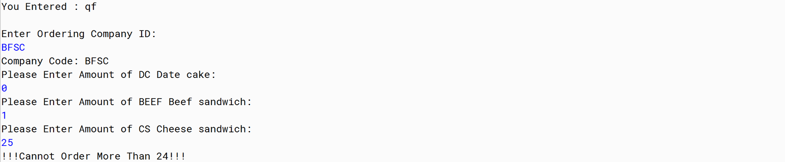

***RESULT: PASS***

***\*Note: The test case failed as the CS Cheese sandwich quantity exceeded the limit.***

***Test 5:***

|  |  |  |  |  |
| --- | --- | --- | --- | --- |
| ***Company: PUB***  ***Date cake: 24***  ***Beef sandwich: 23***  ***Cheese sandwich: 22***  ***Strawberry desert: 21***  ***Scrambled eggs: 20*** | ***Cost*** | ***Cost Total*** | ***Weight*** | ***Weight total*** |
| ***Date cake: 24*** | ***24*59.00*** | ***1416.00*** | ***24*134*** | ***3216*** |
| ***Beef sandwich: 23*** | ***23*49.50*** | ***1138.50*** | ***23*164*** | ***3772*** |
| ***Cheese sandwich: 22*** | ***22*93.70*** | ***2061.40*** | ***22*206*** | ***4532*** |
| ***Strawberry desert: 21*** | ***21*157.05*** | ***3298.05*** | ***21*177*** | ***3717*** |
| ***Scrambled eggs: 20*** | ***20*77.15*** | ***1543.00*** | ***20*112*** | ***2240*** |
| ***Totals*** |  | ***9456.65*** |  | ***17477 grams*** |
| ***Rounding (up to nearest KG)*** |  |  |  | ***18 kg*** |
| ***Cost of Packing*** | ***18*457*** | ***8,226.00*** |  |  |
| ***Cost To Orbit*** | ***18*18,127*** | ***326,286*** |  |  |
| ***Total cost of meal*** |  | ***$343,968.95*** |  |  |

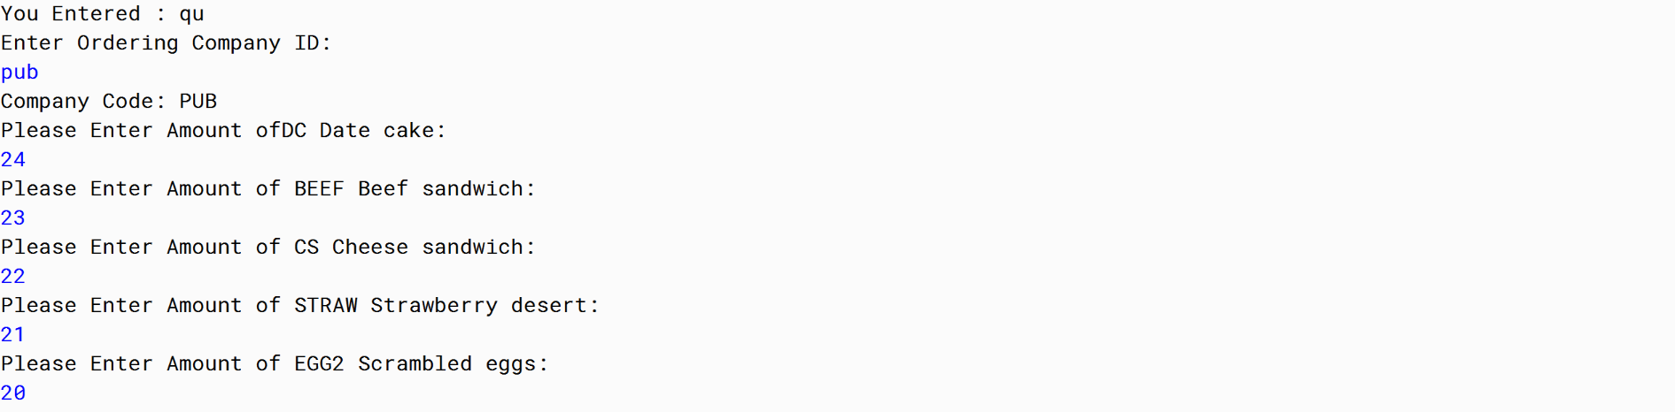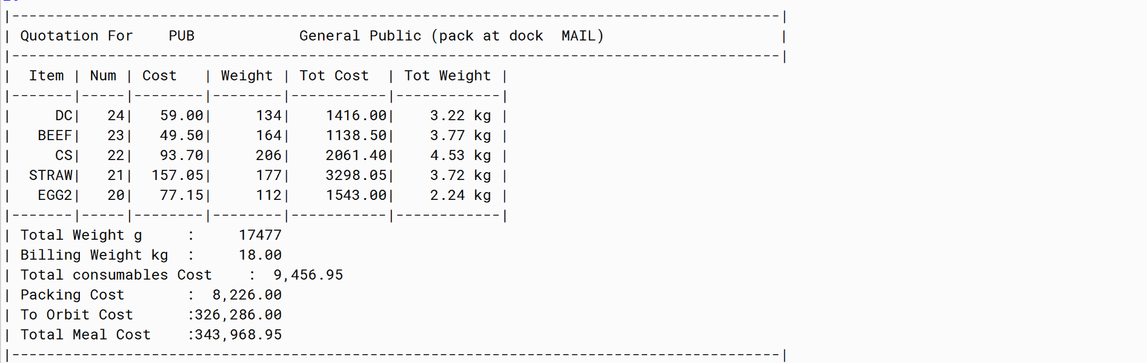

***RESULT: PASS***

***Test Plan***

***Test I:***

|  |  |  |  |  |
| --- | --- | --- | --- | --- |
| ***Company: PUB***  ***Date cake: 1***  ***Beef sandwich: 2***  ***Cheese sandwich: 3***  ***Strawberry desert: 4***  ***Scrambled eggs: 5*** | ***Cost*** | ***Cost Total*** | ***Weight*** | ***Weight total*** |
| ***Date cake: 1*** | ***1*59.00*** | ***59*** | ***134*** | ***134*** |
| ***Beef sandwich: 2*** | ***2*49.50*** | ***99*** | ***164*** | ***328*** |
| ***Cheese sandwich: 3*** | ***3*93.70*** | ***281.10*** | ***206*** | ***618*** |
| ***Strawberry desert: 4*** | ***4*157.05*** | ***628.20*** | ***177*** | ***708*** |
| ***Scrambled eggs: 5*** | ***5*77.15*** | ***385.75*** | ***112*** | ***560*** |
| ***Totals*** |  | ***1453.05*** |  | ***2348g*** |
| ***Rounding (up to nearest KG)*** |  |  |  | ***3 kg*** |
| ***Cost of Packing*** |  | ***3192*** |  |  |
| ***Cost to Orbit*** | ***3*18127*** | ***54381*** |  |  |
| ***Total cost of meal*** |  | ***59026.05*** |  |  |

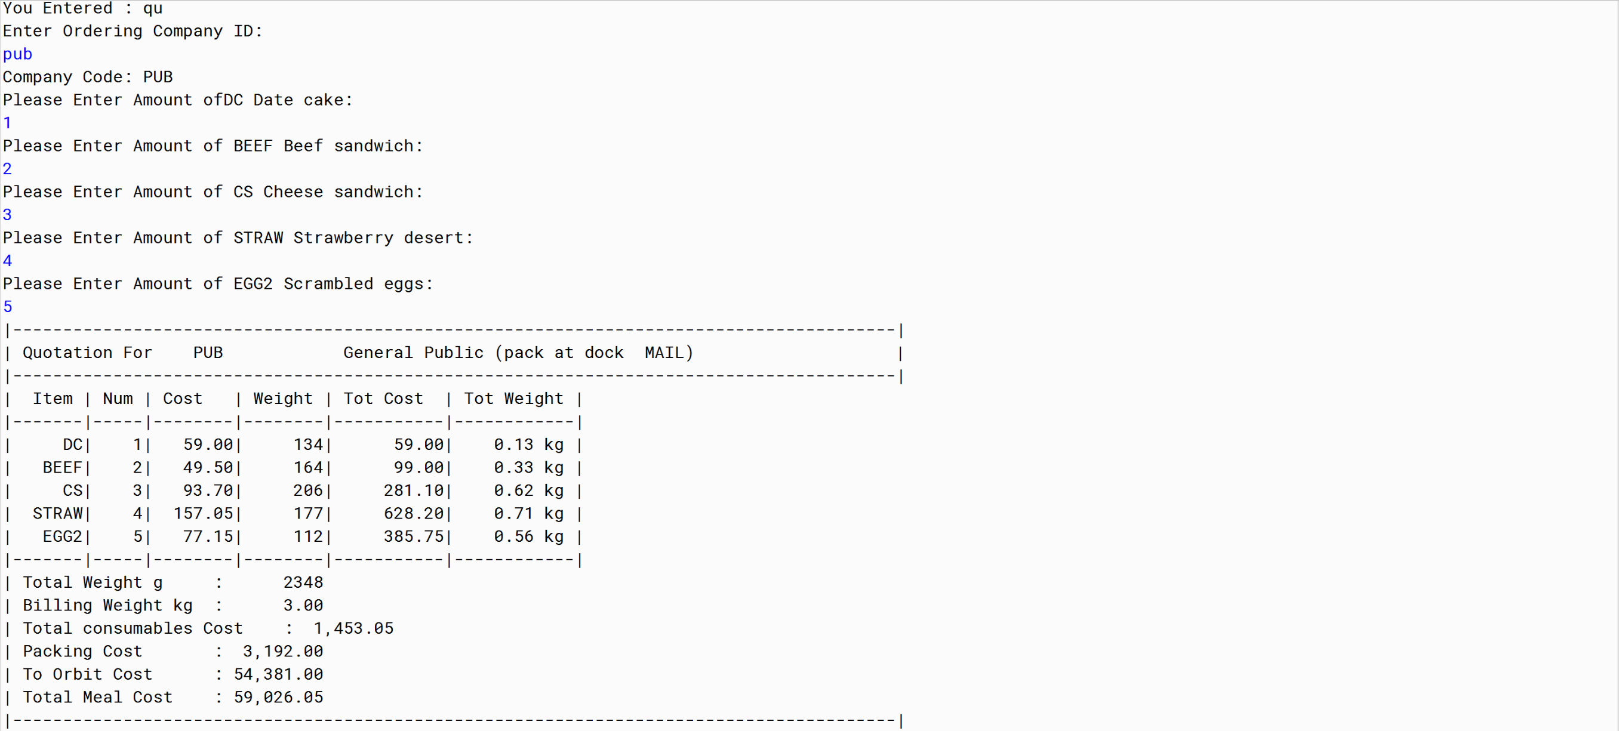

***RESULT: PASS***

***Test II:***

|  |  |  |  |  |
| --- | --- | --- | --- | --- |
| ***Company: AARG***  ***Date cake: 6***  ***Beef sandwich: 7***  ***Cheese sandwich: 8***  ***Strawberry desert: 9***  ***Scrambled eggs: 10*** | ***Cost*** | ***Cost Total*** | ***Weight*** | ***Weight total*** |
| ***Date cake: 1*** | ***6*59*** | ***354*** | ***134*** | ***804*** |
| ***Beef sandwich: 2*** | ***7*49.50*** | ***346.50*** | ***164*** | ***1148*** |
| ***Cheese sandwich: 3*** | ***8*93.70*** | ***749.60*** | ***206*** | ***1648*** |
| ***Strawberry desert: 4*** | ***9*157.05*** | ***1413.45*** | ***177*** | ***1593*** |
| ***Scrambled eggs: 5*** | ***10*77.15*** | ***771.50*** | ***112*** | ***1120*** |
| ***Totals*** |  | ***3635.05*** |  | ***6313g*** |
| ***Rounding (up to nearest KG)*** |  |  |  | ***7kg*** |
| ***Cost of Packing*** |  | ***6823.50*** |  |  |
| ***Cost to Orbit*** | ***7*18127*** | ***126889*** |  |  |
| ***Total cost of meal*** |  | ***127347.55*** |  |  |

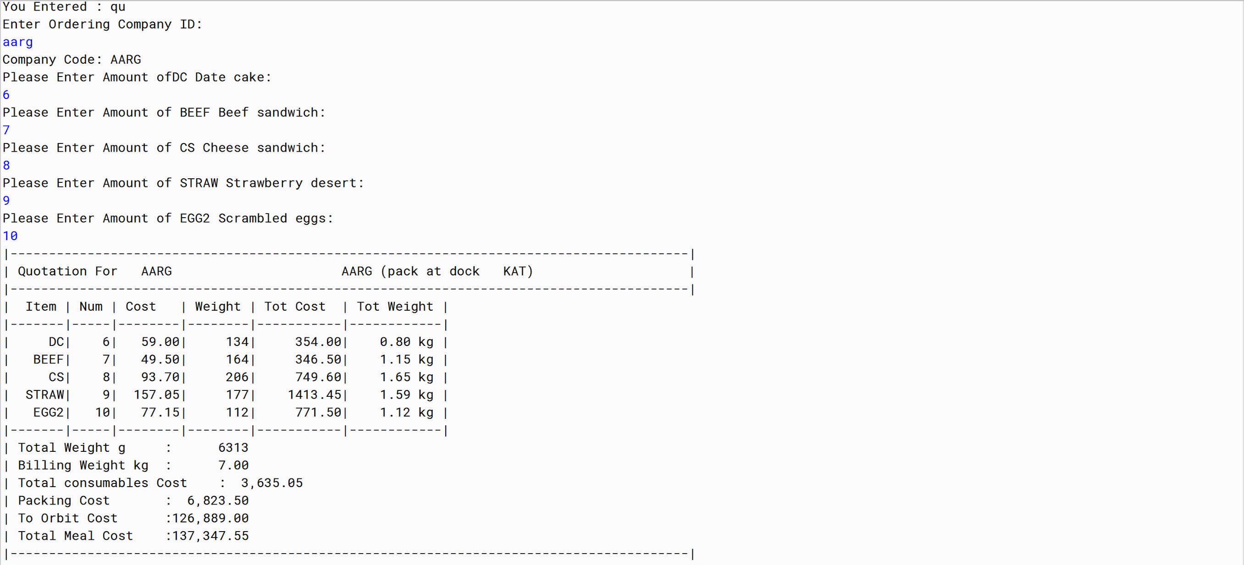

***RESULT: PASS***

***Personal Reflection***

***Through this assignment, I learnt how to write codes strings, loops such as if-else, do-while and for loops. This assignment gave me confidence to write a full-fledged java code. I enjoyed every minute working on this assignment for the past one week. I would like to thank Rob for bringing up very a decent assignment.***