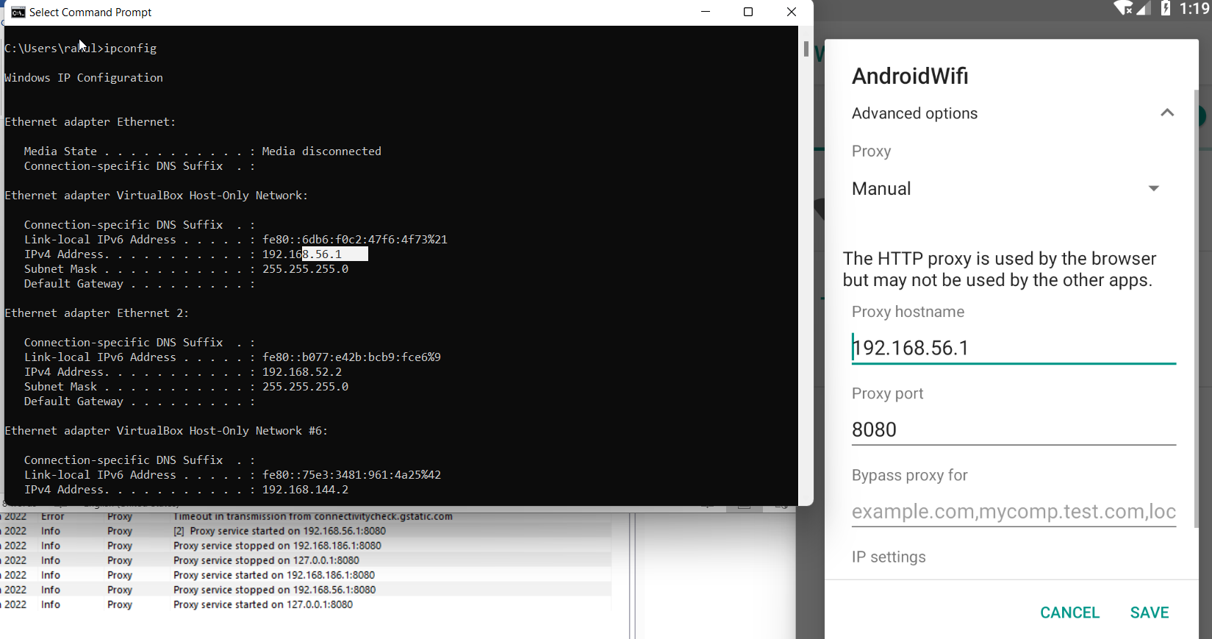Set proxy inside phone same as Host-only (ip)

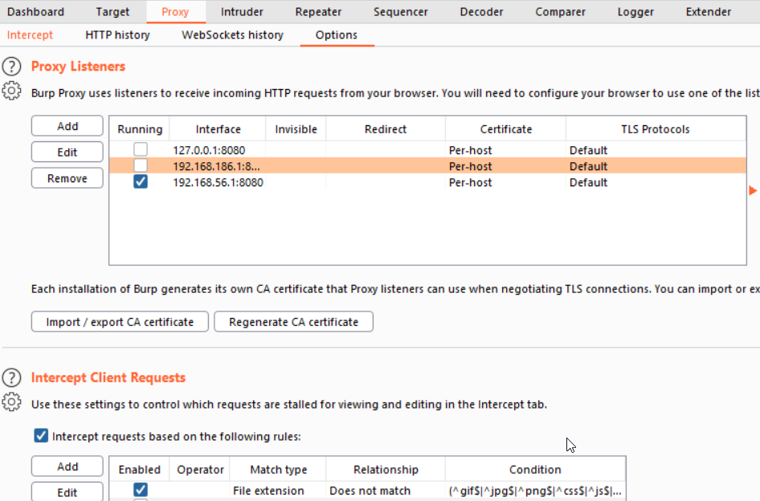Set same proxy in burp suit

this means proxy is set

test the connection with intercept in burp

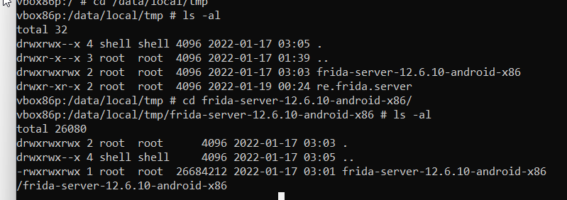now turn up frida in shell for phone

run the script to bypass sslpinnig

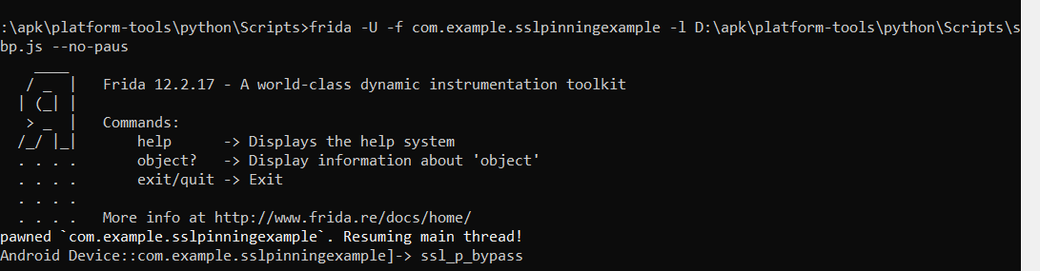**code**: frida -U -f com.example.sslpinningexample -l D:\apk\platform-tools\python\Scripts\slbp.js --no-paus

run application inside phone

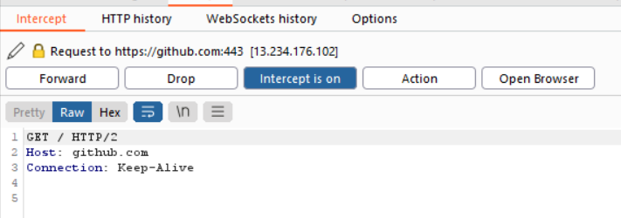

we have successfully bypass sslpinning

open application and get request is send here

