Robots.txt

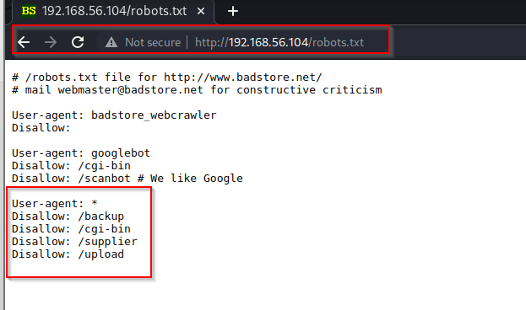url: <http://192.168.56.104/robots.txt>

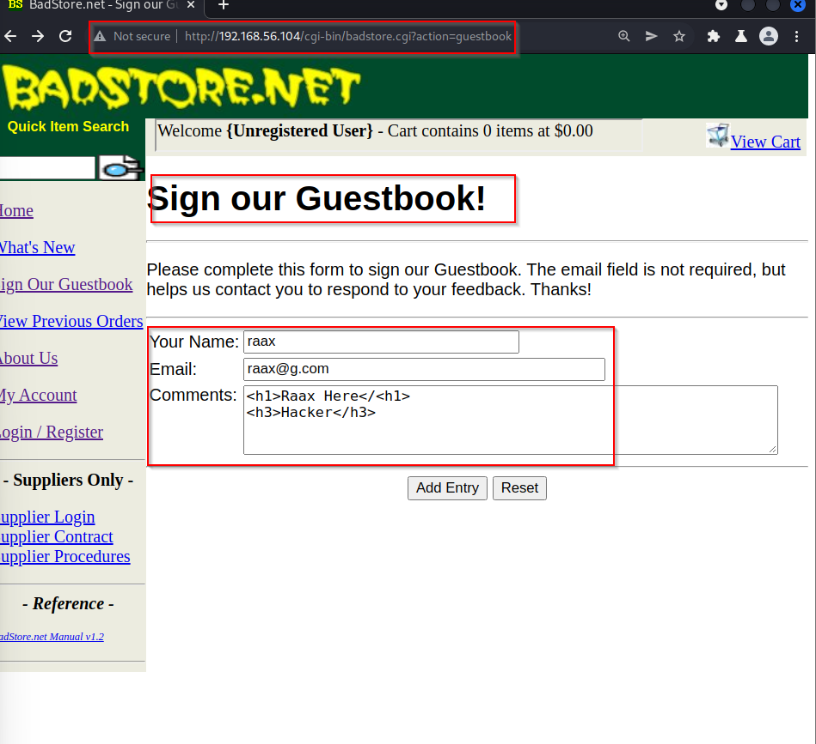html injection

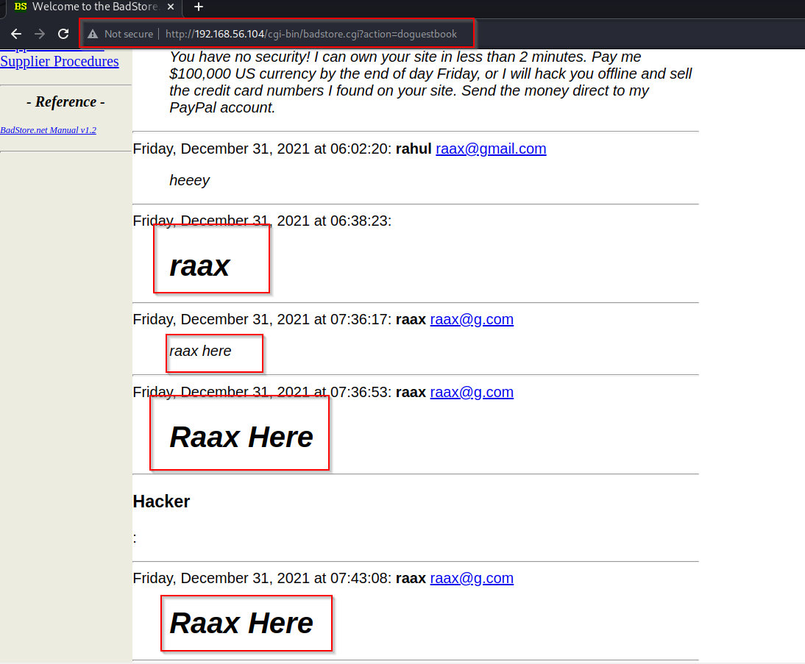

Refelceted xss

url:

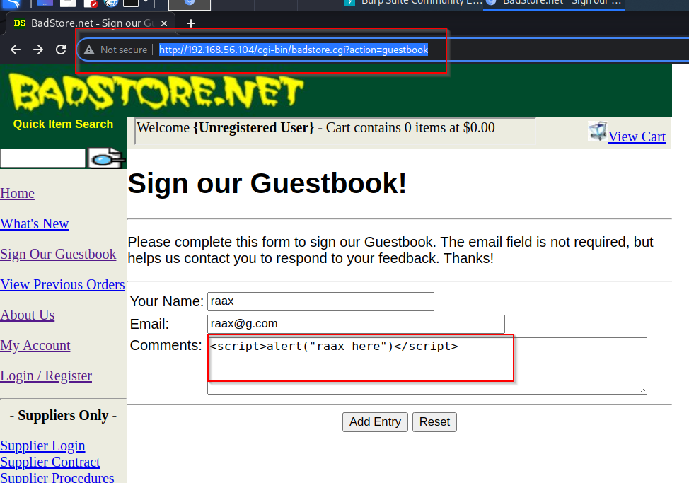<http://192.168.56.104/cgi-bin/badstore.cgi?action=guestbook>

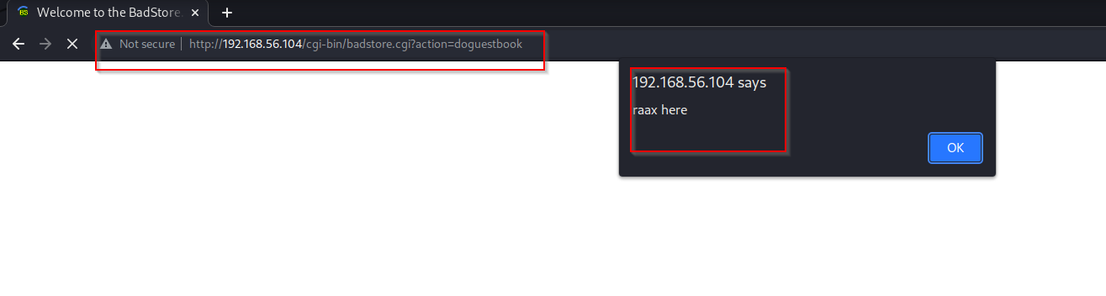

Document.cooke

url: <http://192.168.56.104/cgi-bin/badstore.cgi?action=guestbook>

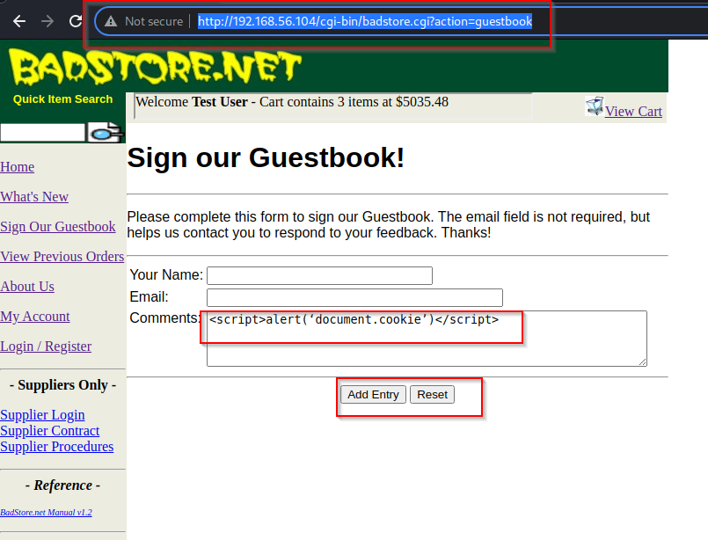

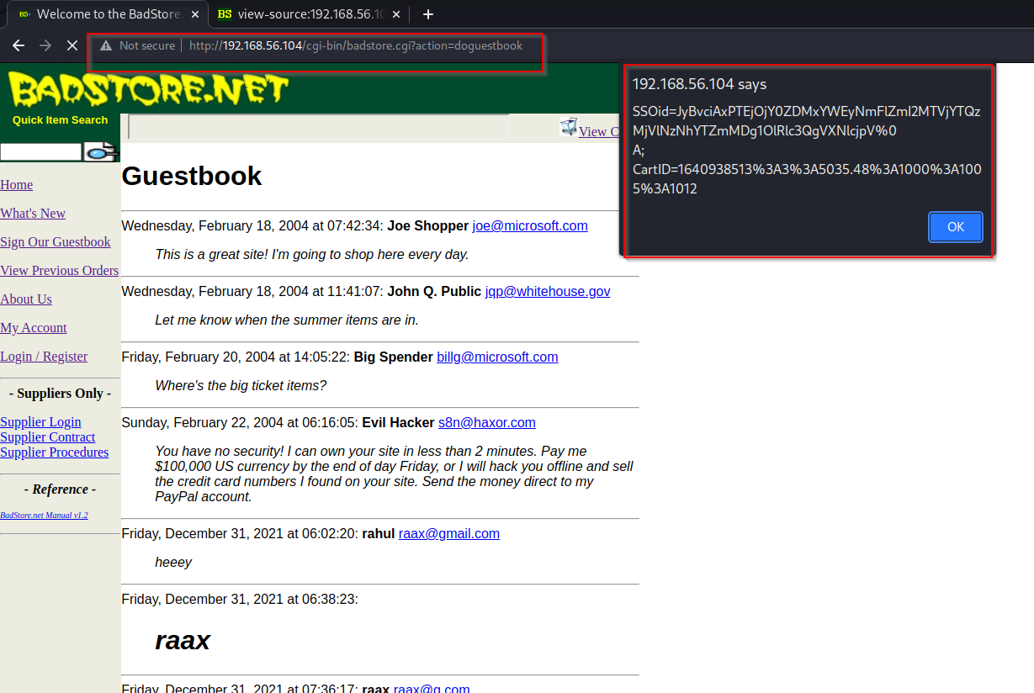

Sql injection

url: http://192.168.56.104/cgi-bin/badstore.cgi?action=loginregister

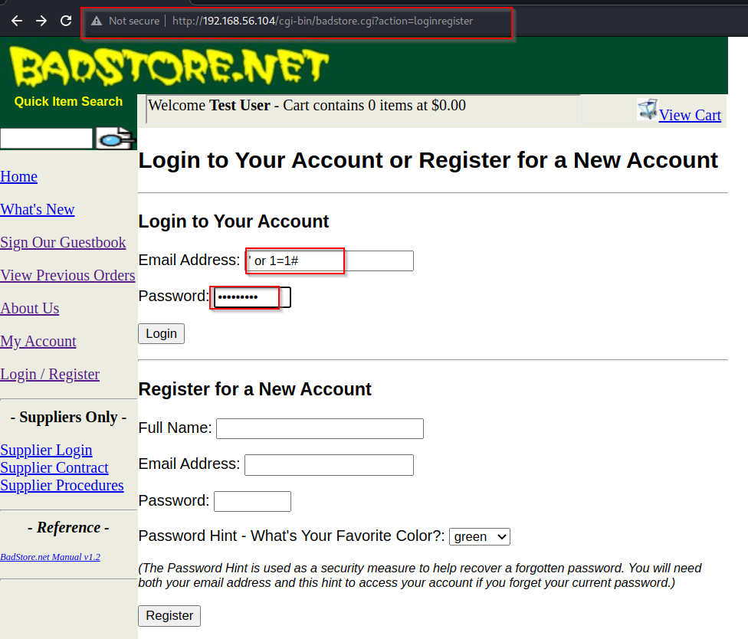

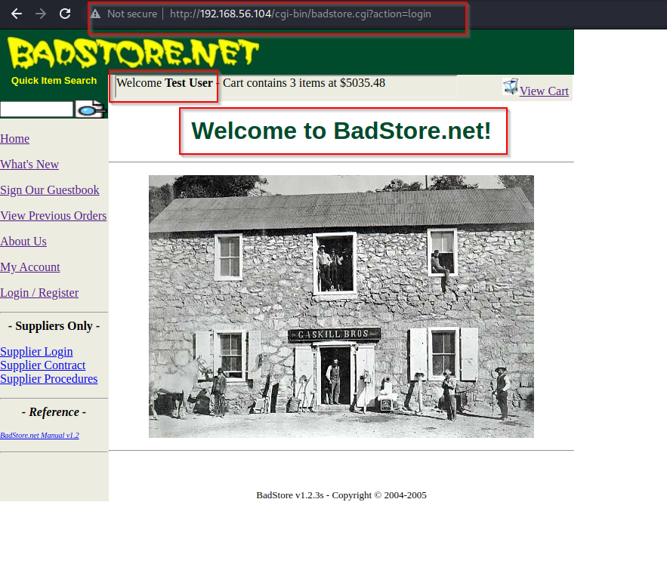

**IDOR**

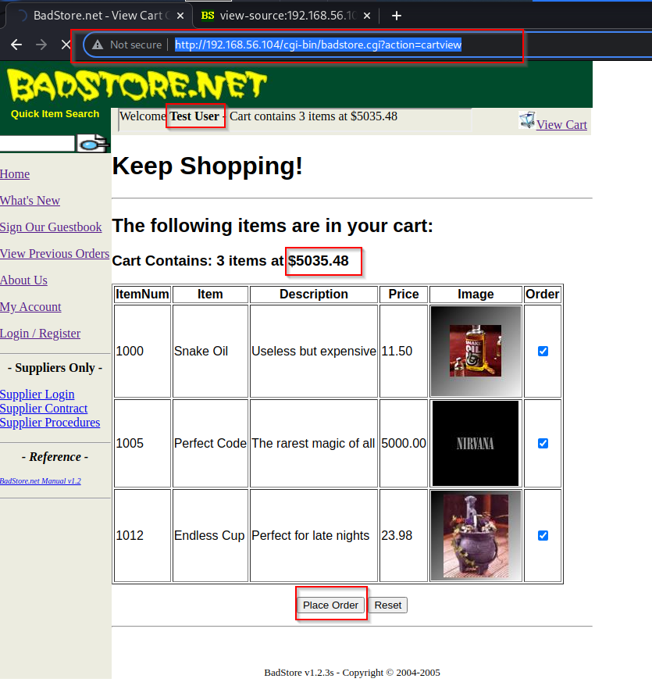url: http://192.168.56.104/cgi-bin/badstore.cgi?action=cartview

