1. Provide a detailed theory and explanation of each operation.  
  
2. Execute the assigned tasks.  
  
3. Utilize suitable images that correspond to each respective operation.  
  
**OBJECTIVES**  
• To perform various spatial operations on images.  
 • To perform gradient filtering.   
• To perform sharpening on images.

Note:

* Ensure that your roll number is incorporated within all output materials.
* Avoid capturing screenshots of the images.
* Abstain from submitting compressed or archived file folders.
* Refer to the instructions slide for guidelines on report naming conventions and content requirements.

#### COMMANDS/ SYNTAX

1. B = imfilter(inputImage,filter) : Filters the multidimensional array inputImage with the multidimensional filter filter and returns the result in B.
2. filter2(filter,inputImage): It is a 2D digital filter. It applies a finite impulse response filter to a matrix of data inputImage according to coefficients in a matrix filter.
3. medfilt2(inputImage): Performs median filtering of the image inputImage in two dimensions. Each output pixel contains the median value in a 3-by-3 neighborhood around the corresponding pixel in the input image.
4. [gmag, gphase] = imgradient(img): Returns the gradient magnitude, gmag, and the gradient direction, gphase, of the 2-D grayscale or binary image img.

1. Find an X-ray image of fractured bone, use combination of spatial filters to enhance the image. Evaluate and elaborate the difference in original and final image. (There should be at least 5 spatial operations performed to obtain the final image. Write your reasons for selecting those spatial operations.)

##### I. Unified Mean Filtering

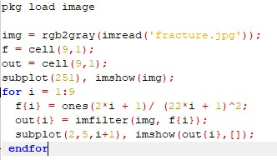

##### Weighted Mean Filtering

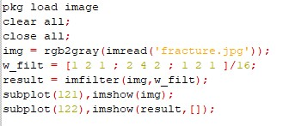

##### Median Filtering

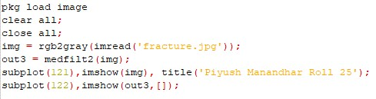

##### Sharpening

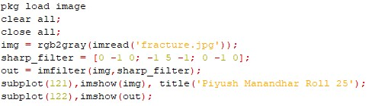

##### Gradient Filter

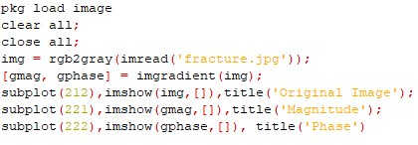

**1. Spatial Filters:**

**Spatial Filter** is just moving the filter mask from point to point in an image. The filter mask may be 3x3 mask or 5x5 mask or so on. Generating a MxN linear spatial filter requires MN mask coefficients. These are selected based on the type of filter, so it computes the sum of products.

The spatial filter is mainly classified into two types. They are: **I.** Low-Pass Filter (i.e. Smoothing)

**II.** High-Pass Filter (i.e. Sharpening)

There are two types of smoothing spatial filters.

#### I. Linear Spatial Filter

Linear spatial filter is simply the average of the pixels contained in the neighborhood of the filter mask. The idea is replacing the value of every pixel in an image by the average of the grey levels in the neighborhood define by the filter mask.

The types of linear filter:

1. Averaging Filter: It is used in reduction of the detail in image. All coefficients are equal.

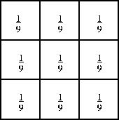

1. Weighted Averaging Filter: In this, pixels are multiplied by different coefficients. Center pixel is multiplied by a higher value than average filter.

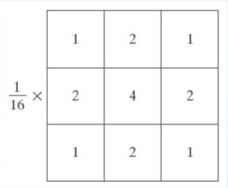

#### II. Non- Linear Spatial Filter

It is based on the ordering the pixels contained in the image area encompassed by the filter. It replaces the value of the center pixel with the value determined by the ranking result. Edges are better preserved in this filtering. Its types are:

1. Minimum Filter**:** 0th percentile filter is the minimum filter. The value of the center is replaced by the smallest value in the window.
2. Maximum Filter**:** 100th percentile filter is the maximum filter. The value of the center is replaced by the largest value in the window.
3. Median Filter**:** Each pixel in the image is considered. First neighboring pixels are sorted and original values of the pixel is replaced by the median of the list.

**2. Sharpening Spatial Filter:**

It is also known as derivative filter. The purpose of the sharpening spatial filter is just the opposite of the smoothing spatial filter. Its main focus in on the removal of blurring and highlight the edges. It is based on the first and second order derivative. Sharpening of images is done through **Laplacian Operator** which is given by:

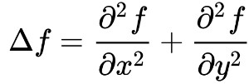

When converting this derivative to mask form, we get

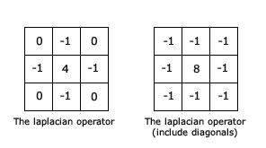

##### 3. Gradient Filter

An image gradient is a directional change in the intensity or color in an image. The gradient of the image is one of the fundamental building blocks in image processing.

Image gradients can be used to extract information from images. Gradient images are created from the original image (generally by convolving with a filter, one of the simplest being the Sobel filter) for this purpose.

The gradient magnitude provides information about edge strength. The gradient direction is perpendicular to the direction of the edge.

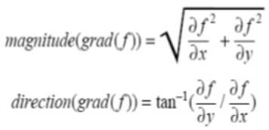

**4. Sobel Operator:**

**The Sobel operator** performs a 2-D spatial gradient measurement on an image and so emphasizes regions of high spatial frequency that correspond to edges. Typically, it is used to find the approximate absolute gradient magnitude at each point in an input grayscale image.

