基本属性 2

基本属性
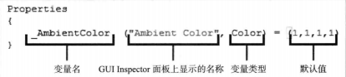

属性种类
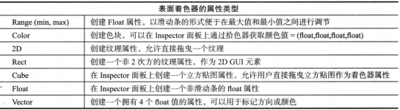
属性默认值格式
Color：(1,1,1,1)
2D/Rect/Cube : “white”{} 法线贴图可以是”bump” {}
Vector: (1,1,1,1)
Float/Range:0

Surface shader全部函数模版

Shader "Nafio/BaseSurf" {
Properties
{
_MainTex("_MainTex",2D) = "white" {}
_Color("Color",Color) = (1,1,1,1)
}

SubShader
{
Tags{"RenderType" = "Opaque"}
LOD 200
CGPROGRAM
#pragma surface surf CustomLambert vertex:vert finalcolor:final
sampler2D _MainTex;
fixed4 _Color;
struct Input{
half2 uv_MainTex;
float4 vertcolor;
};
void vert(inout appdata_full v,out Input IN)
{
UNITY_INITIALIZE_OUTPUT(Input,IN);//不初始化会报错..
IN.vertcolor = v.color;
}
void surf(Input IN,inout SurfaceOutput o)
{
half4 c = tex2D(_MainTex,IN.uv_MainTex) * _Color;
o.Albedo = c.rgb;
o.Alpha = c.a;
}
inline half4 LightingCustomLambert(SurfaceOutput s,half3 LightDir,half atten)
{
half nl = max(0,dot(s.Normal,LightDir));
half4 c;
c.rgb = s.Albedo * _LightColor0.rgb * (nl * atten * 2);
c.a = s.Albedo;
return c;
}
void final(Input IN,SurfaceOutput s,inout fixed4 c)
{
c = c * 0.9+0.1;
}
ENDCG
}
FallBack "Diffuse"
}

常用tags
下面几张图记录subShader和pass可共同设置的tag，subShader自己单独的tags，还有pass自己单独的tags

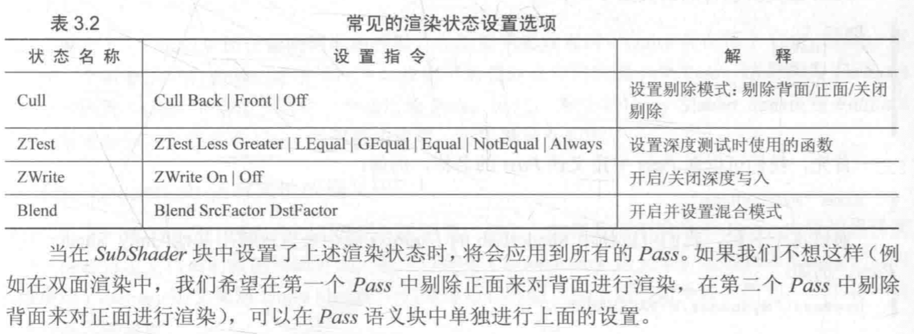

“IgnoreProjector”=“True”告诉Unity3D，我们不希望任何投影类型材质或者贴图，影响我们的物体或者着色器。这个特性往往那个用在GUI上。程序默认“IgnoreProjector”=“Flase”
