Help Desk System
Graduation Project

Prepared by:

Amira Aly Marzouk
Aya Gamal
Eman Mohamed Anwar
Rabab Magdy Zein
Samah Ahmed El-Sanour
Yosra Mohamed Yasser Hamza

Supervized by:
Eng. Noha Salah El-Tohamy

Table of Contents:

Chapter 0:
Acknowledgment

Chapter 1: Introduction

1.1) Project description
1.2) Stakeholders
1.3) Vision
1.4) Mission
1.5) Project Scope
1.6) Assumptions
1.7) constraints
1.8) Business risks
1.9) Resources

Chapter 2: System Analysis:

2.2)

1)


What Comman between Us !?

Benefits of a Free Ticketing System
The main benefit of free ticketing software is that it simplifies and automates help desk ticket management. With the help of Web-based service request portal for customers to log tickets, and an intuitive Web-based help desk console for IT technicians to manage tickets.
- Centralize help desk ticket management – from request creation to resolution
- Save time and resources on manual and repetitive help desk tasks
- Track and monitor help desk and technician performance in real time
- Build help desk knowledge repository and promote self-service options for end-users
- Improve operational efficiency of customer service
- Realize higher levels of customer satisfaction

Seamless Communication between Customers & Help Desk Team
Help desk ticketing software allows you to establish seamless communication and a simple interaction platform between the customers who are requesting IT service and the IT practitioners who are supporting end-users and fulfilling the service request.
A free ticketing system centralizes the channel for receiving IT service requests via an interactive Web portal. IT teams can benefit from avoiding the use of disparate sources such as chat, phone, email and in-person discussions for customer communication. Once the request is logged in the ticketing system, IT pros communicate back to the end-user with acknowledgement and update ticket fulfilment progress including technician assignment and expected request fulfilment date/time. Free help desk software also converts inbound service requests via email into help desk tickets in the ticketing system.

Web Help Desk is Free Forever – No Ads, No Cost, No Expiration!

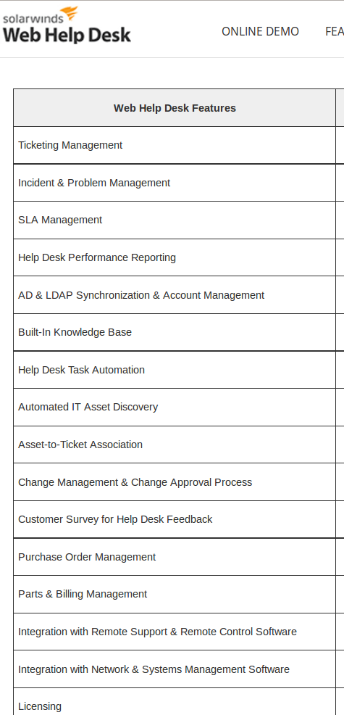

1-Ticket Management :
Manage all tickets by : priorty , assign to technical , deadline , close after solved , reopen if not solved will ! .

2- Incident & Problem Management :
Analysis Tickets and its problem , write reports , write article of common problem to help users to get the solution very fast .

3- Help Desk Performance Reporting :
write reports about all tickets and who solve it , how solve it , Analysis every Tickets and its problem .

4- Built-In Knowledge Base :
write article of common problem to help users to get the solution very fast .

5- Help Desk Task Automation :
Automatic , Know how technical is free and assign ticket to tchnical to solve .

6- Asset-to-Ticket Association:
If the ticket releated to asset , make a relational between them .

2)
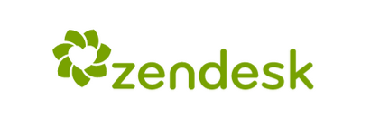

What Comman between Us !?

1) Online help desk software that’s ready when you are :

ready to use as soon as you create an account. Because it's online help desk software, you don't need to worry about servers or software updates, and you can access it anywhere, from any device.
You can use it from windows or ubuntu or any operating syatem and answer help desk tickets on the go.

2) Your help desk plays well with others :
Integrations make it easy to create a seamless workflow experience and improve productivity by unifying the tools your team already uses into one interface.
Now you can finally close the loop between support and other departments in your company without the headaches of managing and syncing data.

3)


What Comman between Us !?

1)

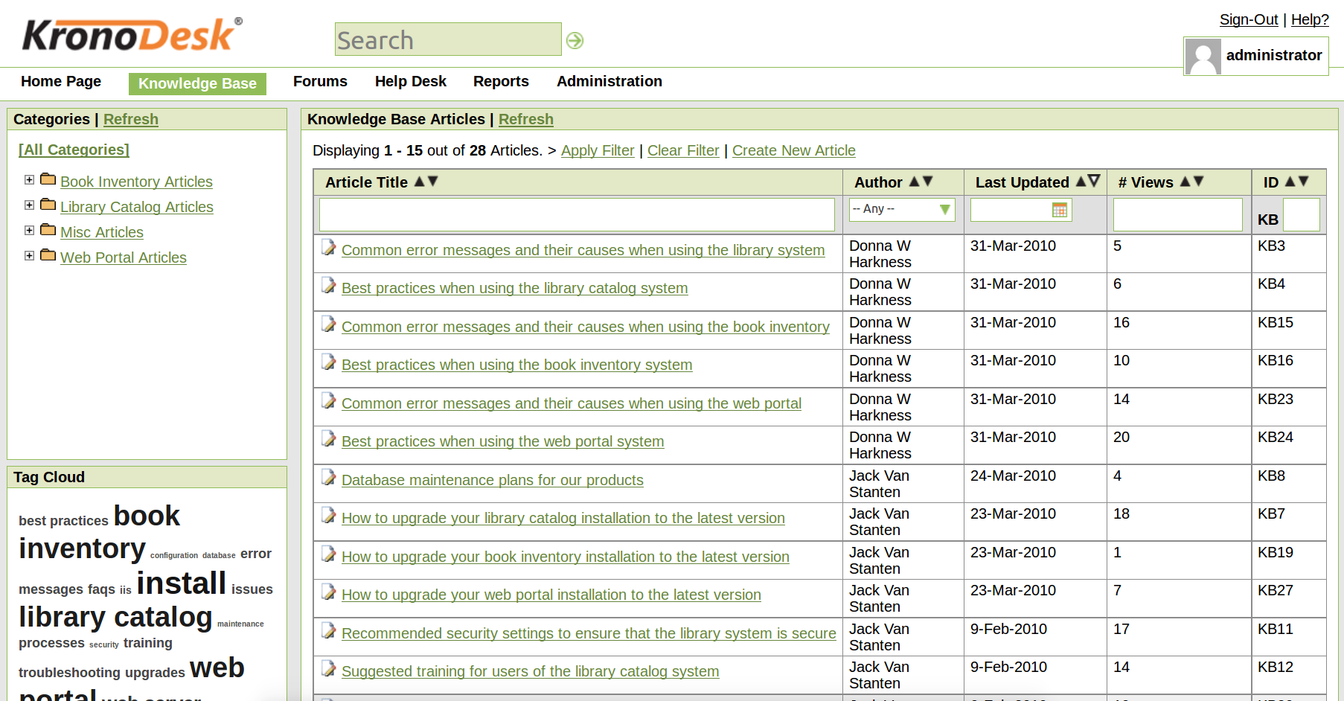
a) Knolwledge Base :

write article of common problem to help users to get the solution very fast .

b) Original search and Advanced search by every field in article .

c) Divide Article and Ticket to Category , to find related articles and tickets , and make it easy during search .

d) Divide Article and Ticket to Tags , to find related articles and tickets , and make it easy during search .

2)
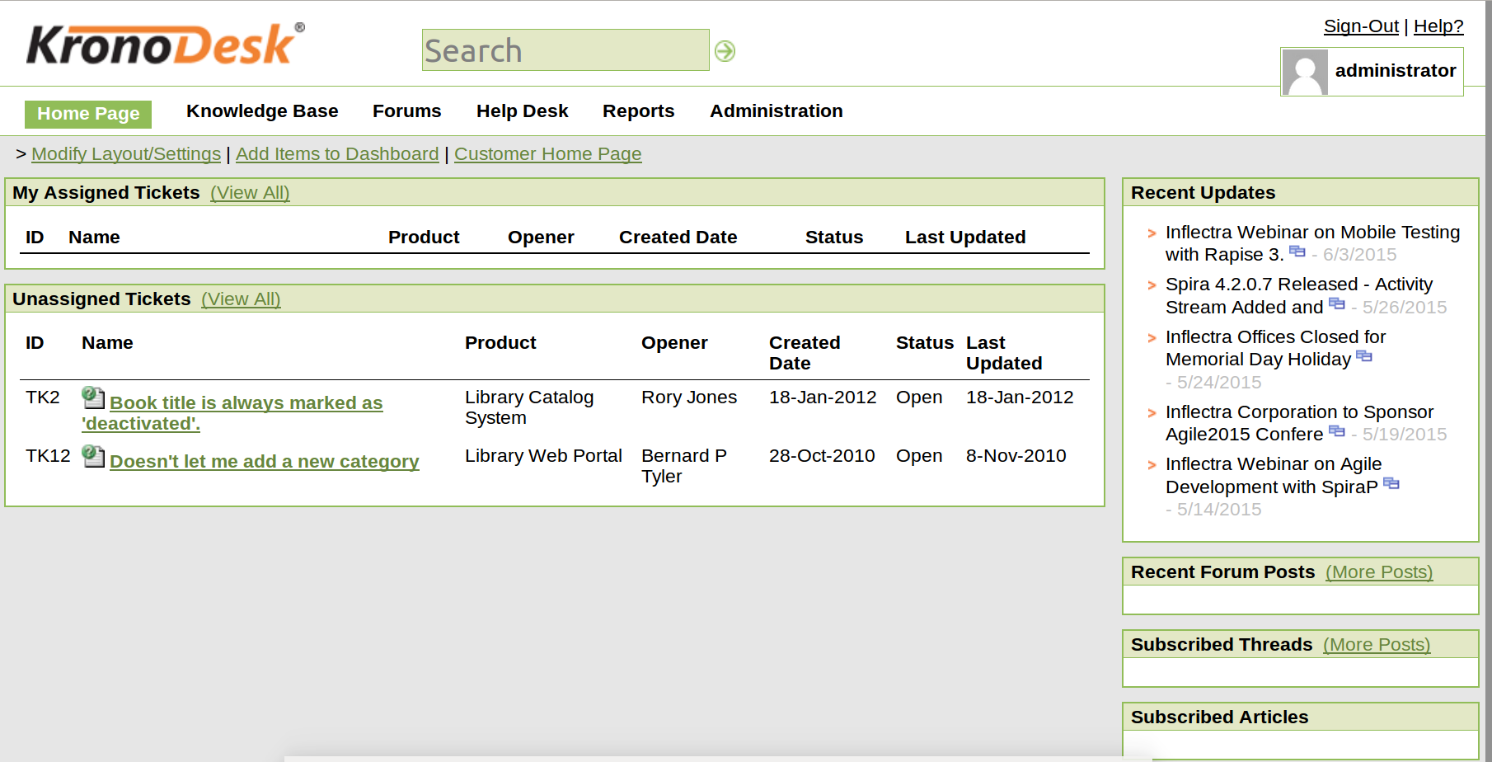

a) Admin can see all tickets in the system and its details .

b) Assign Technical to solve it , close it if solved and reopen it if there are problems in the solving .

3)
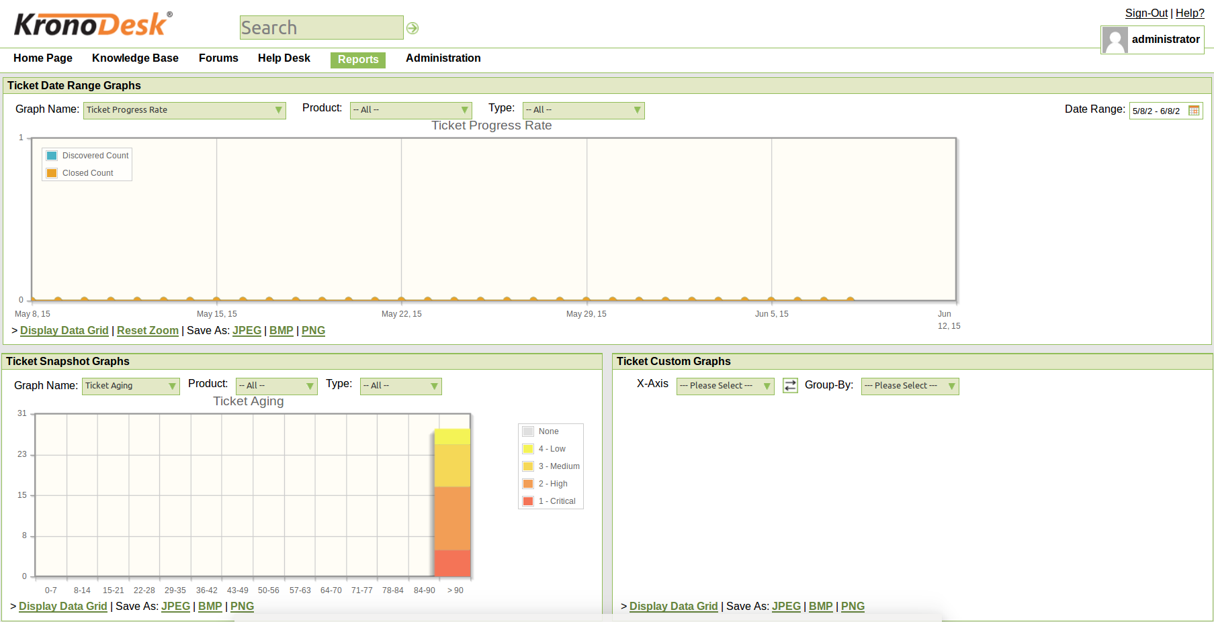

Get reports about all tickets by Aging , Report about count close and open tickets and Analsis Tickets and its problems .

4)


1)
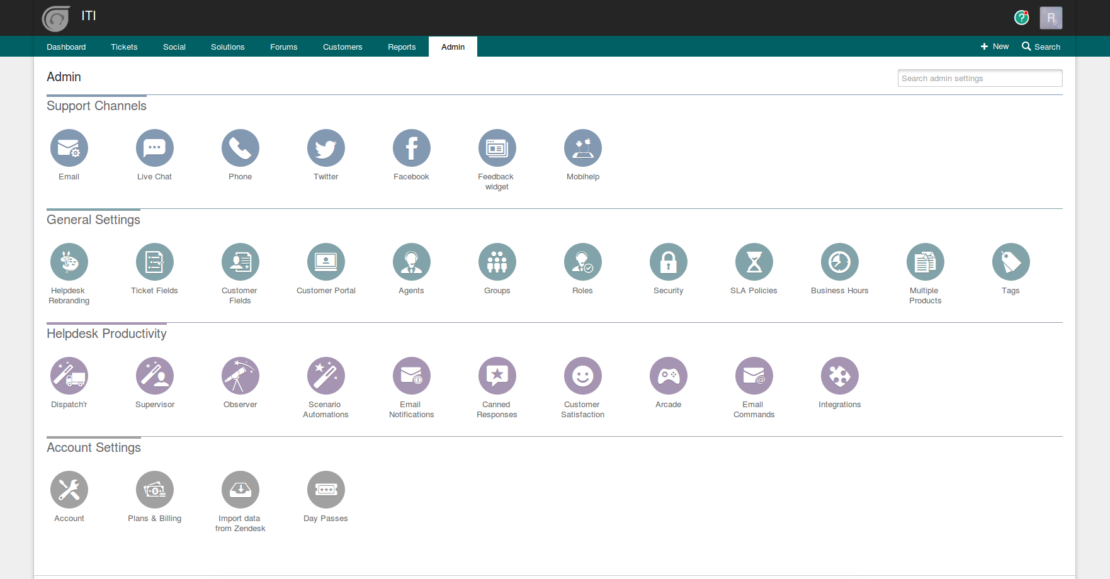

a) Support Channels :
Email .

b) General Settings :
Ticket fields
Roles
Security
Business Hours
Multiple Products
Tags

c) Helpdesk Productivity :
Email notifications
Supervisor
Integrations
Customer Satisfaction

d)Account Settings :
Account .
Export Data to CSV file .

2)
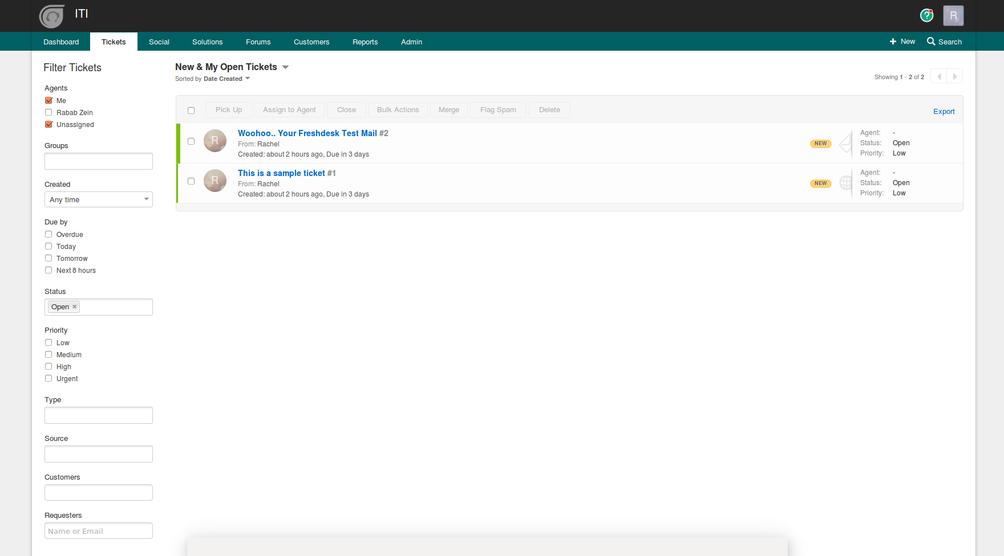

a) Admin can see all tickets in the system and its details .

b) Assign Technical to solve it , close it if solved and reopen it if there are problems in the solving .

c) Search by any field in Tickets .

3)

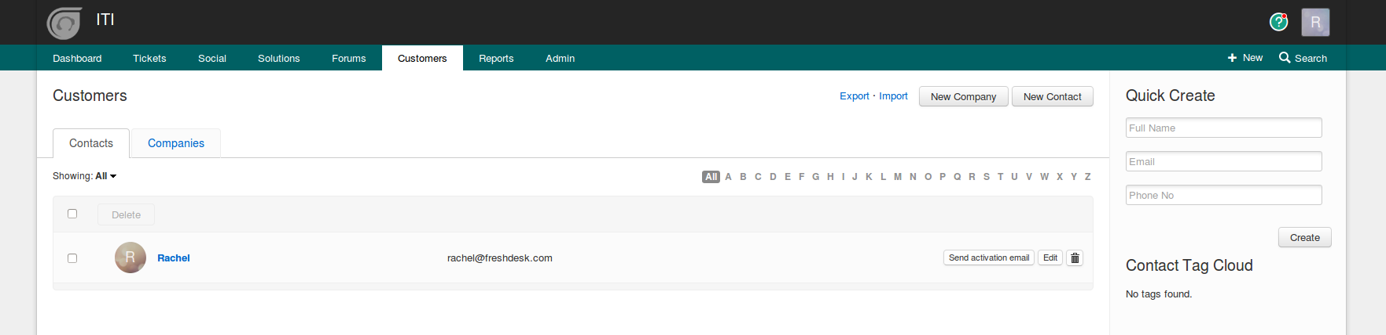
Customers :

Get All informations about the customers and client how use the system , delete or Spam if they are hackers or send mail .

Search by any field in their informations .
4)
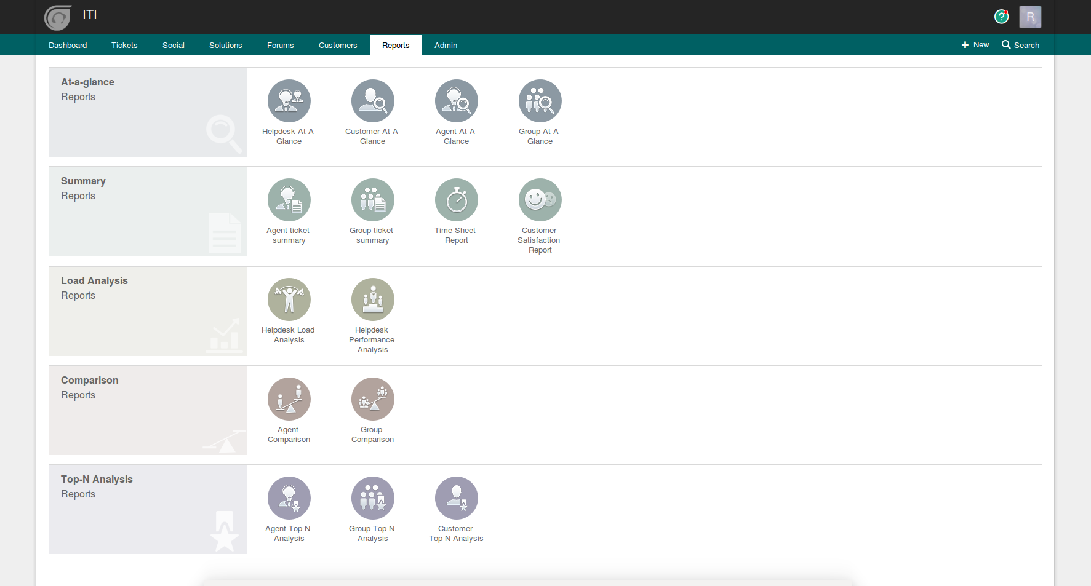

Get Summary report and Analysis Report .

5)
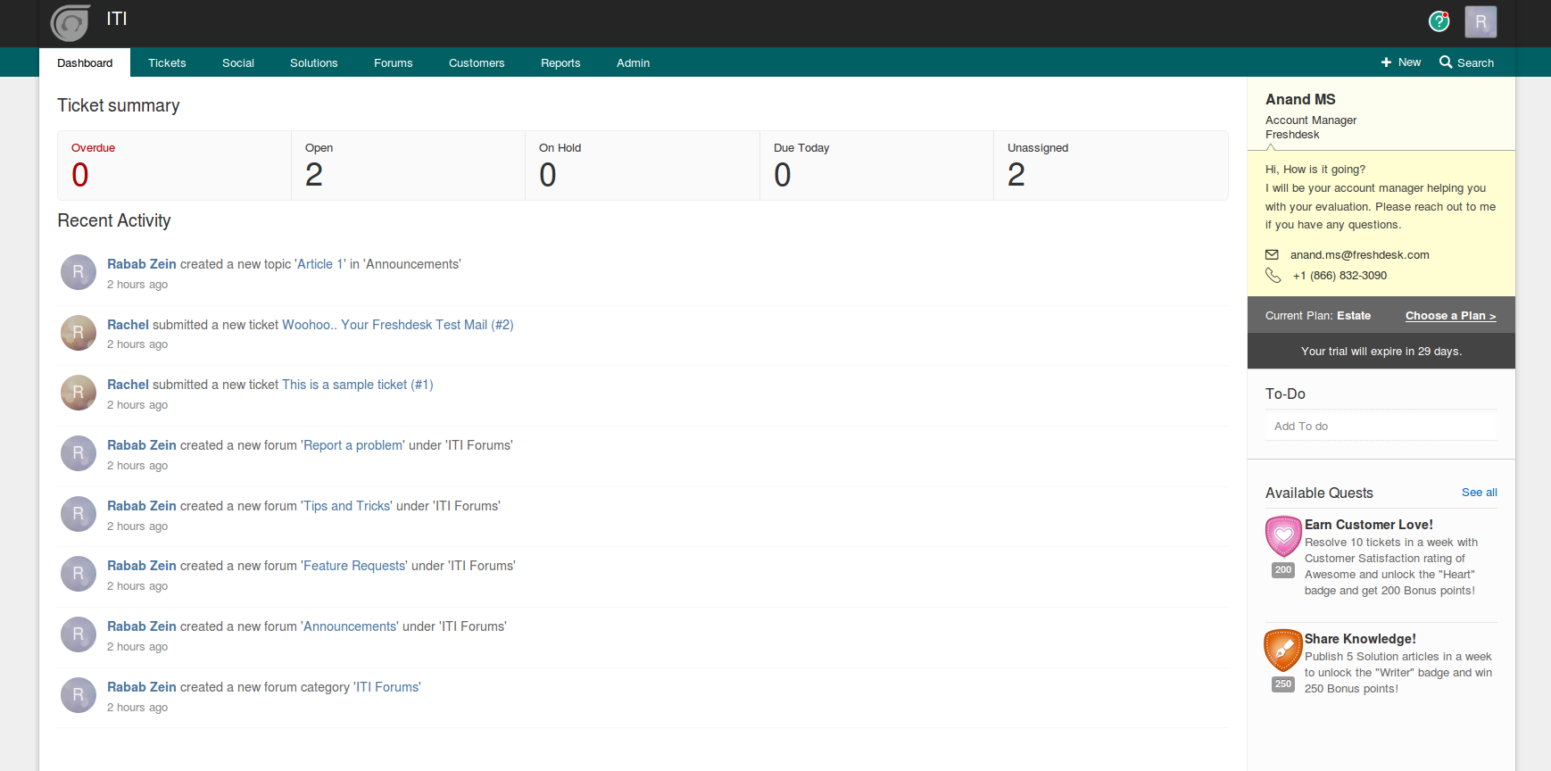

Get Tickets Summary .
Get Recent Activity of Admins or Technicals or Customers .
Chapter 3: Functionality :

Client Side :

1) Client Account :

a) Registration :

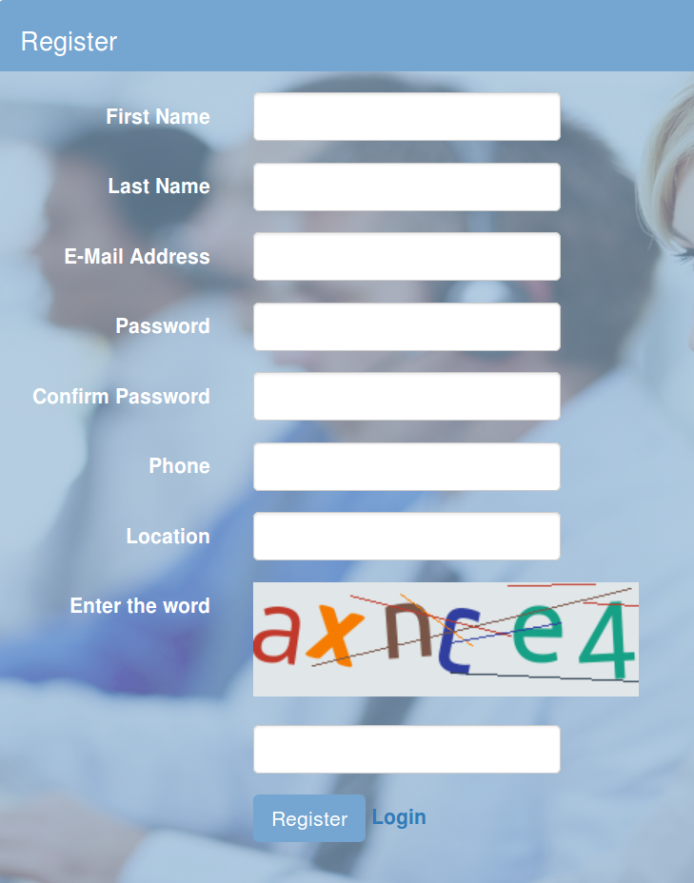

- Client Can create an account it the web system by enter full informations about himself .

- Captcha : To be sure that the user is human not robot .

- If he already has account and enter this page by mistake he can return back to Login page .

- Validation :

- There are validation about every field in the registration form .

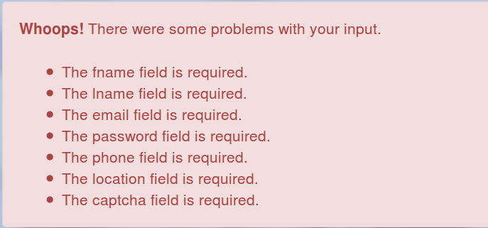

- Email must be unique .

- password must be secuire (more than 6 letter) .



- Can't enter letters in Phone .

b) Login :
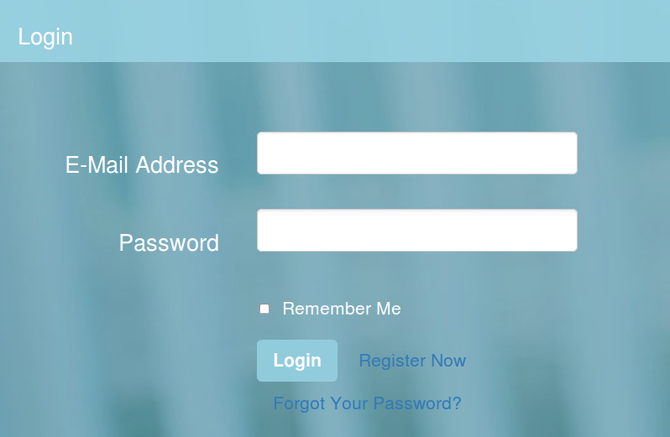

- Client can Login if he has an account to access his profile .

- If he forget his password he can get it .

- If he hasn't account , he can create one .

- If he want automatic login he can choose remember me .

- Validation :

- If user enter his email or password wrong , he get this message .

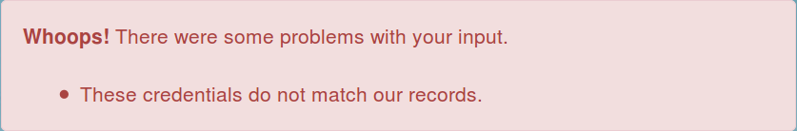

- If user is spam , he get this message .

c) Forget Password :
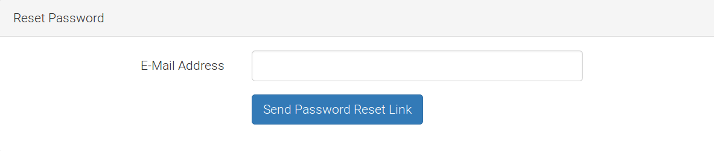
- First : Enter your email address to get link to enter your new password .

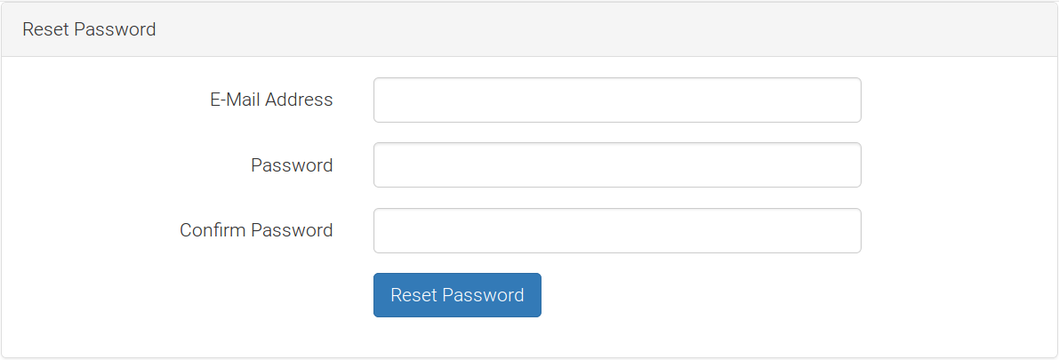
- Second : Renter your Email , New password and Confirm it .

d) Remember Me :


- When you choose Remember Me , You can access direct you account every time you has problem or want to see the solution of your problem without Login .

2) Client Home Page :

- It is group of Articles under different sections and categories , of common problems write by admins of the web system to help users to get the solution very fast .

3) Client Profile :

- From it can see all his personal information and update it if he want .

4) Client Tickets :

- From it , Client can see list of all his tickets , All details about it : under any category and its priority .

- Also he can edit in it or close it if he get a satisfied solution .

- Can control of all details of his tickets that are appear to him by select columns that he want to see it .

- Can quick search by subject of ticket and auto-complete .

- Can search by closed tickets , unclosed tickets or all .

- Can Sort his tickets by Ticket's Subject , deadline , Created Date and priority .

5) Page of every Ticket :

- From it , Client can see all details about his ticket : under any category and Section , its priority , Start date , deadline of solving it and Who it was assigned to .

- Can Write any comment about the problem or the solution of it .

- Can close it if he get a satisfied solution .

- Can reopen it if there are any problem in the solution or his problem repeated .

6) Create New Ticket.

- From Home page or Tickets page , Client can create new ticket .

7) Menu par :

- From his name that appear in menu par he can access his personal profile .
- Can Logout .

- Can go to home page .

- Can access all his tickets page .

- From the logo of the site he can access the Home page .

Technical Side :

1) Technical Home Page :

After Login , Home page appear :

In it he can see al articles that descript the common problems in the site .

And also can see special articles from admin to him that descript secret problems in the system , can't be seen by clients .

2 – Tickets :
From this page technical can see all tickets that assign to him by admin .

- All details about it : under any category and its priority .

- Also he can close it if he solve the problem .

- Can control of all details of his tickets that are appear to him by select columns that he want to see it .

- Can quick search by subject of ticket and auto-complete .

- Can search by closed tickets , unclosed tickets or all .

- Can Sort his tickets by Ticket's Subject , deadline , Created Date and priority .

3) Page of every Ticket :

- From it , Technical can see all details about ticket that assign to him : under any category and Section , its priority , Start date , deadline of solving it .

- Can Write any comment about the problem or the solution of it .

- Can close it if he solve the problem .

4) Technical Profile :

- From it can see all his personal information and update it if he want .

5) Menu par :

- From his name that appear in menu par he can access his personal profile .
- Can Logout .

- Can go to home page .

- Can access all tickets page that assign to him .

- From the logo of the site he can access the Home page .

Chapter 1

Introduction

1.1.0. Project Description:

