ASSIGNMENT NO :4

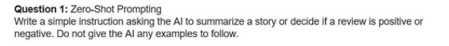
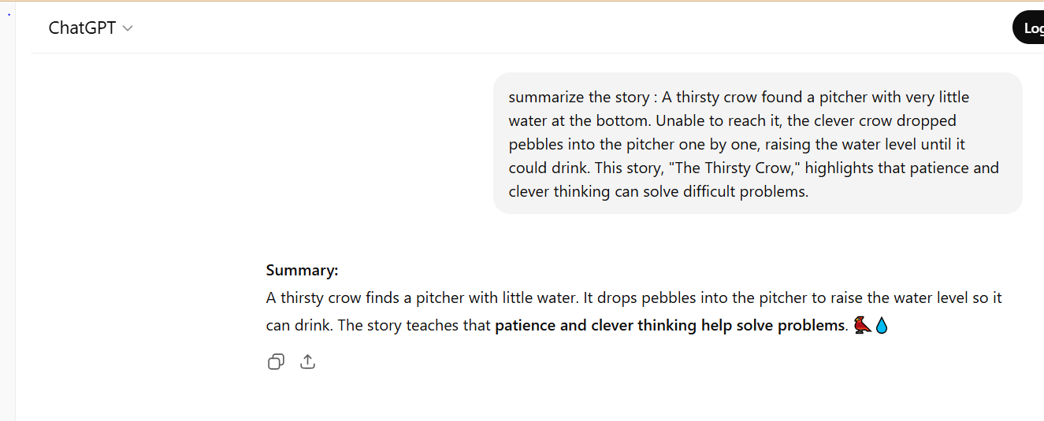
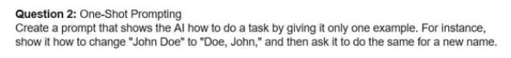
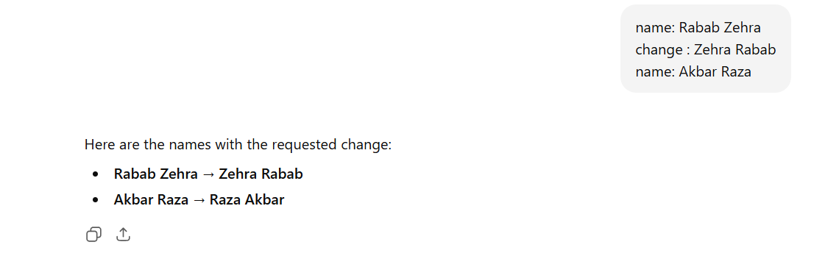
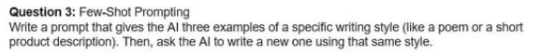
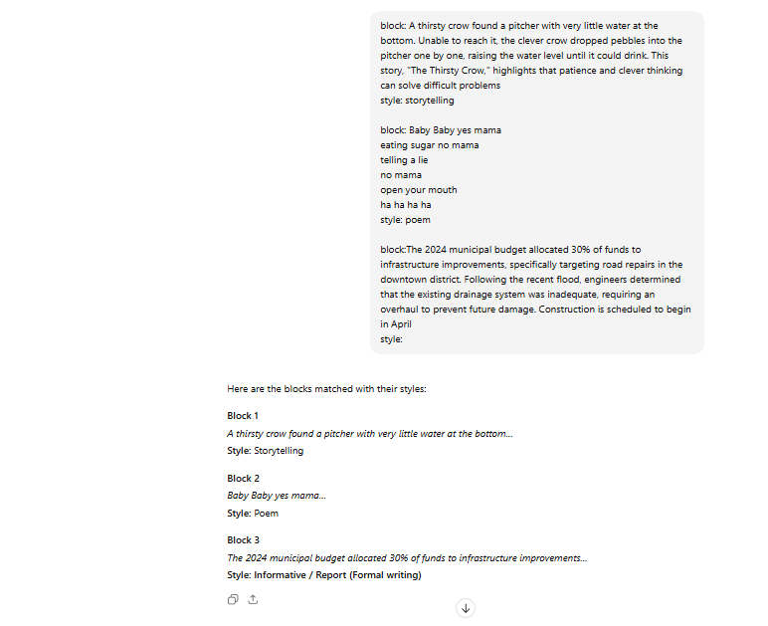
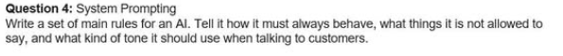
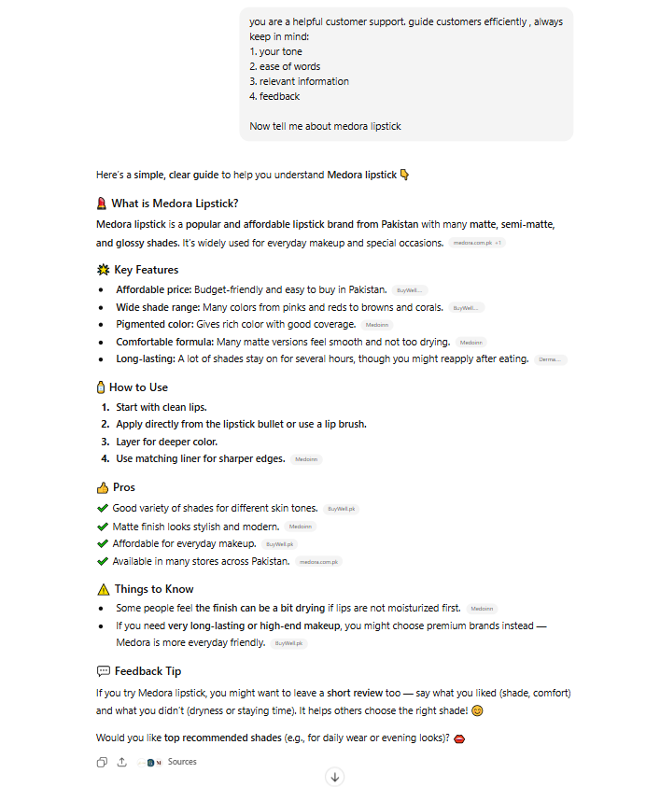
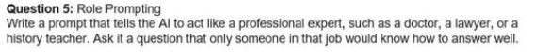
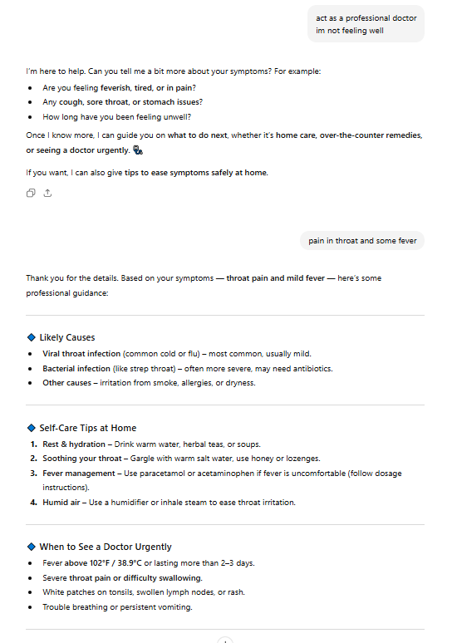
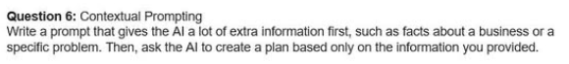
Context:make a business strategy for a startup, easy to work on.
I’m starting my new business of online home schooling
Absolutely! Let’s create a simple, practical business strategy for your online homeschooling startup. I’ll keep it easy to follow and actionable.

1. Define Your Target Market
- Focus on students and parents looking for flexible online learning.
- Consider specific age groups (e.g., K-12, high school, exam prep).
- Identify pain points: lack of quality local tutors, rigid school schedules, personalized learning needs.

2. Value Proposition
- Highlight what makes your service different:
  - Personalized lesson plans.
  - Flexible scheduling.
  - Affordable pricing compared to private tutors.
  - Access to quality teachers from anywhere.

3. Services & Products
- Core offerings:
  - Live online classes via Zoom or Google Meet.
  - Recorded lessons for self-paced learning.
  - Study materials & practice exercises.
  - Parent progress reports.
- Optional extras: exam preparation modules, extra-curricular courses, or coding classes.

4. Marketing Strategy
- Social Media: Instagram, Facebook, TikTok for tips, short learning videos, and testimonials.
- Word of Mouth: Offer referral discounts to attract more students.
- Free Trial: Give 1–2 free classes to let parents see the quality.
- Partnerships: Collaborate with local schools, education blogs, or influencers.

5. Technology & Platform
- Start simple:
  - Zoom or Google Meet for classes.
  - Google Classroom or Notion for organizing lessons.
  - Payment via PayPal, Stripe, or local bank transfers.
- Later, you can develop your own app or portal as you grow.

6. Revenue Model
- Monthly subscription: Access to live classes & recorded lessons.
- Pay-per-class: Flexible for casual users.
- Bundles: Exam prep + regular classes at a discount.

7. Operations & Team
- Start lean:
  - You + a few qualified teachers.
  - Part-time admin for scheduling & support.
- Use free or low-cost tools to manage:
  - Trello / Notion (lesson planning)
  - Google Calendar (scheduling)
  - Canva (marketing materials)

8. Feedback & Improvement
- Ask parents/students for feedback after each module.
- Track attendance, grades, and satisfaction.
- Use this feedback to improve teaching methods and materials.

✅ Simple 30-Day Action Plan
- Week 1: Define target audience, create social media pages, finalize courses.
- Week 2: Prepare lesson plans & materials; recruit 1–2 teachers.
- Week 3: Launch free trial classes; start marketing on social media.
- Week 4: Collect feedback; finalize pricing & subscription plans.

If you want, I can also draft a visual one-page strategy plan for your startup that’s easy to share and follow daily. This works like a roadmap for your first 3 months.
Do you want me to do that?

