**Web& app development:-**

**Title:-mobile shop handling by online web**

**Features:-**

* In this web user have one search bar to search particular model according their requrment ,using that save user time and provide user friendly environment.
* Inside bar show model catagori to according mobile or laptop typle like gaming guru,camera expert ,budget killer,low budget,high budget etc
* In main part we have model shows is available or tranding currently.

**Major tech parts:-**

* Search bar at nav bar like youtube.
* Side bar like

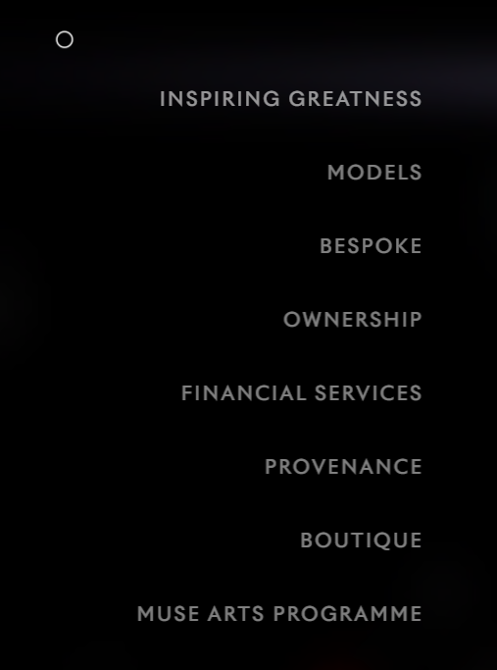

* Main box like youtube or flipkard or amazon shows mobile banner box and click on this to show mobile details and reviews.
* In this web only those mobiles are avalablieon my shop or online provide not all mobile are show
* One section for repaired ,2nd hand or refurbies mobiles .
* Footer show all copyright polices.