- zzCreate ASP.NetCore
- Install referances on which project depend on
Add
- Microsoft.EntityFrameworkCore.SqlServer
- Microsoft.EntityFrameworkCoreTools

Steps
- Create models folder è create class for each model
Note once there is a class has relation with another class such “one to many”
. Like in vehicles relation between make and models
. make has multiple models
. so, it is best practice if we initialize collection of models in the constructor of make
d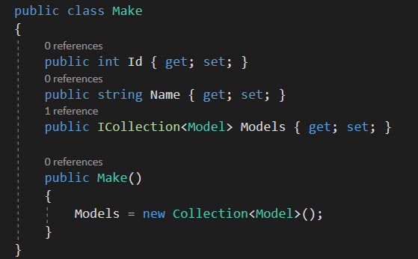
. create constraints on properties in model class
- Create AppDBContext class that use entity frame work to generate database
. register AppDBContext as a service for dependency injection
. soon the controller will use AppDBContext and inject it through its constructor and entity framework core will make instance of this class and pass it to the constructor of controller

Populate model with reference data
Notes:-
. when you implement up method in migration è you should implement down method
Because if we “update database previous migration” the down method will executed
. closed circle between related classes
- Classes in domain (interior APP) è include implementation details
- Classes in interface (boundary APP) èinclude only the data will appeared to the client
So, we use AutoMapper (source type, target type)
\
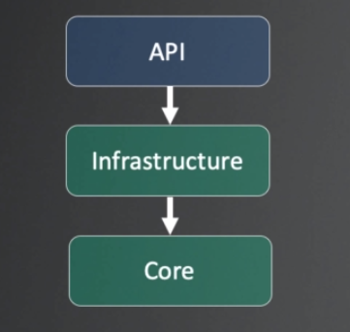
Projects need to build our Application
- API è receive HTTP requests and respond on them
- Infrastructure è will communicate with DB, send queries and get data
- Core è contain the business entities [class entities]
Steps to create new application by using command line
- mkdir skinet
- cd skinet
- dotnet [command] è dotnet new (used for create project or file)
- dotnet new sln
- dotnet new webapi -o API ç for creating webapi application and put them in folder
- dotnet sln add API [path]ç add project to solution [may has more than one project dotnet sln list ç to list projects inside sln

API [application programming interface] responsible for having end point things that the client will hit

Startup class
@ the constructor inject the Iconfiguration interface and by configuration
We can access the key in the appsetting.json file
- ConfigureServices èas dependency injection container, any services that we want to make available to other parts of our application, we will add it inside this configure service method
- Configuration

Steps to create API
- Create new controller
Add this attributes for the controller è [ApiController],[Route(“api/[controller]”)]
The controller will cause error with methods(GetProducts & GetProduct) so we will add route properties to [HttpGet{“id”}]
- Create Entities folder for model
- Create Data folder è create StoreContext class inside it
Steps to create model and save it as a table in database by using object relation mapper(Entity Framework)
- Create class for model in entities folder è Product
- Create DBSet property to generate a table of model type èProducts
- Determine connection string of database that the entity frame work will generate in appsetting.json
- Add DBContextService @ ConfigureService @startup class and pass to it the connection string
- Adding migrations to create database in sqlserver
- add-migration name
- update-database

when inject the Appcontext in controller è to determine the lifetime for instance of Appcontext, by default lifetime is scoped (means that only one instance created when HTTP request is received)

saving our project into source control using “git hub”, commands that used to track changes and add repository
- git add .
- git add commit -m “Initial commit”
- git remote add origin https://github.com/rabazit/skinet.git

- git push -u origin master

API Architecture

- API è it is our startup application and it contains our dependency injection container and our middleware, also responsible for routing any incoming request to controllers
- Infrastructure è contains [Repository, Dbcontext, services] responsible for sending queries to database
- Core è contains [entities and interfaces]

Repository pattern goals
- Decouple business code from data access è for this reason we don’t put AppDBcontext inside API controllers, this will lead to a lot of duplicate code because they will use same query logic
- Separation of concerns è from API contollers and also from DBcontext
- Minimize duplicate query logic è if we have more than one controller that need to product list
- Testability è easier to create mock repository
- Increased level of abstraction
- Increased maintainability, flexibility, testability è if there is any change in DBcontext, we have to change only repositories rather than controllers that use DBcontext
- More classes/interfaces – less duplicate code

Notes:-
So, create IRepository interface @ core project
Create Repository class that implement IRepository @ infrastructure project
Add service @ startup class èthere are several types of instance lifetime that created and injected through the controller :-
- Service.AddScoped() è is created when we send HTTP request to the API “Be alive for the lifetime of the request” when the request is finished both the controller and repository will disposed
- Service.AddTransient() è it is instantiated for individual method not for the request itself
- Service.AddSingleton() è created the first time when the application starts and never be destroyed until the application(server) shuts down

Configure migration (extra configuration for entities beside to configuration created by entity framework)
- Create class that implement IEntityTypeConfiguration interface and add constaints to properties of model
- Add this class to “OnModelCreating” method in DBcontext class
Applying the migration and creating the database at startup

