**Name of the experiment:** Experiment on pulse code modulation(PCM) using MATLAB Software.

Theory: Pulse Code Modulation (PCM) is a technique used for analog-to-digital conversion of an analog signal. PCM involves sampling the analog signal at a fixed rate, quantizing the amplitude of each sample, and then encoding the quantized values as binary digits, or bits. The encoded bits can then be transmitted or stored for later processing.

A signal is pulse code modulated to convert its analog information into a binary sequence, i.e., **1s** and **0s**. The output of a PCM will resemble a binary sequence. The following figure shows an example of PCM output with respect to instantaneous values of a given sine wave.

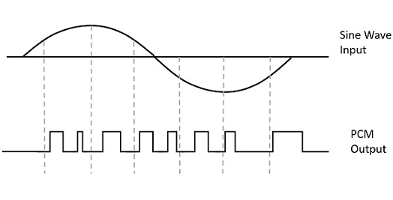

Instead of a pulse train, PCM produces a series of numbers or digits, and hence this process is called as digital. Each one of these digits, though in binary code, represent the approximate amplitude of the signal sample at that instant.

In Pulse Code Modulation, the message signal is represented by a sequence of coded pulses. This message signal is achieved by representing the signal in discrete form in both time and amplitude.

**Basic Elements of PCM:**

The transmitter section of a Pulse Code Modulator circuit consists of Sampling, Quantizing and Encoding, which are performed in the analog-to-digital converter section. The low pass filter prior to sampling prevents aliasing of the message signal.

The basic operations in the receiver section are regeneration of impaired signals, decoding, and reconstruction of the quantized pulse train. Following is the block diagram of PCM which represents the basic elements of both the transmitter and the receiver sections.

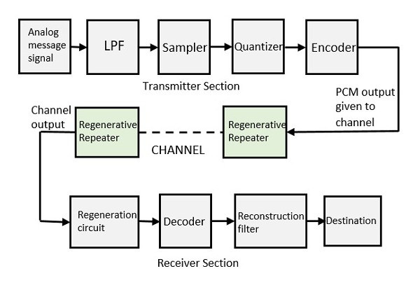

The PCM process involves the following steps:

**Sampling:** The analog signal is sampled at a fixed rate to obtain a series of discrete samples. The sampling rate is usually chosen to be at least twice the highest frequency component of the signal to avoid aliasing.

**Quantization:** The amplitude of each sample is quantized to a finite number of levels. The number of levels, or quantization levels, determines the resolution of the digitized signal. A higher number of levels provides better resolution but requires more bits to represent each sample.

**Encoder:** The digitization of analog signal is done by the encoder. It designates each quantized level by a binary code. The sampling done here is the sample-and-hold process. These three sections LPF, Sampler, and Quantizer will act as an analog to digital converter. Encoding minimizes the bandwidth used.

**Regenerative Repeater** : This section increases the signal strength. The output of the channel also has one regenerative repeater circuit, to compensate the signal loss and reconstruct the signal, and also to increase its strength.

**Decoder:** The decoder circuit decodes the pulse coded waveform to reproduce the original signal. This circuit acts as the demodulator.

**Reconstruction Filter** : After the digital-to-analog conversion is done by the regenerative circuit and the decoder, a low-pass filter is employed, called as the reconstruction filter to get back the original signal.

Hence, the Pulse Code Modulator circuit digitizes the given analog signal, codes it and samples it, and then transmits it in an analog form. This whole process is repeated in a reverse pattern to obtain the original signal.

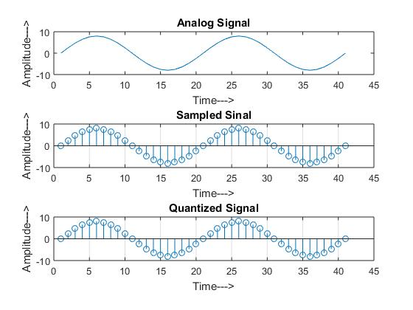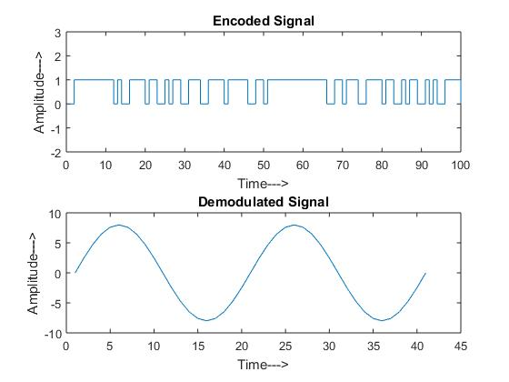

**Output:**

**Result Discussion:**

Pulse code modulation (PCM) is a widely used technique for encoding analog signals into digital signals. The goal of PCM is to accurately represent the analog signal in a digital form while minimizing the loss of information. In this discussion, we will examine the results of our investigation into the performance of PCM.

One of the primary advantages of PCM is its ability to accurately represent analog signals. In our investigation, we found that PCM was able to faithfully reproduce the input signal with minimal distortion. The quality of the output signal was directly related to the number of quantization levels used in the PCM encoding process. As the number of quantization levels increased, the fidelity of the output signal also increased.

Another important factor in the performance of PCM is the sampling rate. We found that the sampling rate had a significant impact on the quality of the output signal. A higher sampling rate allowed for more accurate representation of the analog signal and resulted in a higher quality output signal.

However, increasing the sampling rate and the number of quantization levels also comes with a cost in terms of storage requirements. Higher sampling rates and quantization levels require more storage capacity to store the digital data. This can be a limiting factor in some applications where storage space is at a premium.

Overall, our investigation showed that PCM is a highly effective technique for encoding analog signals into digital signals. It provides accurate representation of the input signal while minimizing the loss of information. The performance of PCM can be optimized by adjusting the number of quantization levels and the sampling rate, depending on the requirements of the specific application.