

**Proposal / Application**

**for**

**Final Year Project**

**Computer & Information Systems Engineering Department**

**Satellite Internet Traffic Optimization And Internet Security**

**Hafiz Abdur Rahman Rahim (CS-030)**

**Mohmmad Ruhail (CS-023)**

**Mohammad Yousuf (CS-24)**

**NED University of Engineering & Technology**

# 

# Project Identification

1. **Reference Number** (for office use only)

|  |  |  |  |  |  |  |
| --- | --- | --- | --- | --- | --- | --- |
| **C** | **S** | **-** |  |  |  |  |

1. **Project Title**

**Satellite internet traffic optimization and internet security**

1. **Project Internal Advisor**

|  |  |
| --- | --- |
| Name | Dr. Asad Arfeen |
| Designation | Assistant Professor and Director IT department |

1. **Project Internal Co-Advisor**

|  |  |
| --- | --- |
| Name |  |
| Designation |  |

1. **Project External Advisor**

|  |  |  |
| --- | --- | --- |
| Name |  | |
| Designation |  | |
| Organization |  | |
| Mobile # |  | Email |

1. **Student Team**

|  |  |  |  |
| --- | --- | --- | --- |
| **S. No.** | **Roll No.** | **Name** | **Email** |
| 1. | CS-030 | Hafiz Abdur Rahman Rahim | arrahim30@yahoo.com |
| 2. | CS-023 | Mohammad Ruhail | ruhailned@yahoo.com |
| 3. | CS-24 | Mohammad Yousuf | mohammadyousufansri.may@gmail.com |

*Please write down the name of group lead at S. No. 1*

1. **Sponsoring Organization**

* Wateen Telecom
* Cybernet

1. **Abstract**

Satellite is an ideal primary form of connectivity if you live in remote location. It can act as an excellent back up option in places where the quality of terrestrial access is unreliable and poor. As it becomes popular, many companies like riverbed, xiplink have set up and working on the reliability for satellite internet to give its best services to its customer. But these services are very expensive for the public and thus unreachable for many people. Also, the TCP connections provide by these companies are limited and hardwired. Therefore, we will going to make an economical model which will less expensive and provide more TCP connections.

1. **Motivation and Need**

The project is very significant. It will be used in disasters like earthquakes, floods to cope m with the situation. It will also be beneficial for marine sector like navy and it can also be m used in remote areas and fishery places.

1. **Objectives**
2. To provide an economical model which is less expensive.
3. Optimize the limit of TCP connections which is hardwired on the hardware.
4. Compress data at real time to overcome latency issue and provide effective bandwidth.
5. Encrypt data at real time.
6. Use cloud based proxy to provide more security to the user.
7. **DIAGRAMATIC REPRESENTATION**

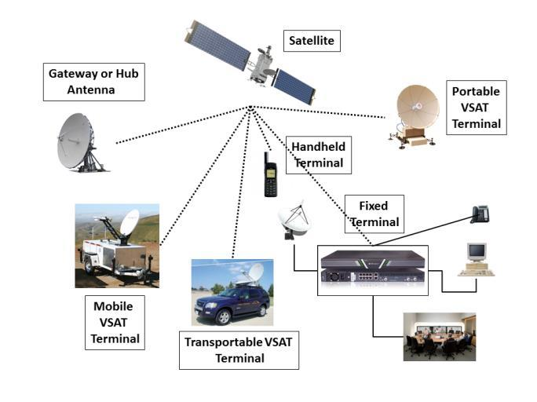

1. **Equipment/Tools**

* **Hardware**

|  |  |  |
| --- | --- | --- |
| **HARDWARE** | **ABBREVIATION** | **WORK** |
| ANTENNA |  | Antennas receive the uplink signal and transmit to downlink signals |
| BUC | Block UpConverter | BUC is a device that convert radio signals from a lower frequency to a higher frequency. BUCs are used in satellite uplink transmissions in order to transfer data from a ground based unit to a satellite in orbit |
| LNB | Lower-Noise Block | It is the device on the front of a satellite dish that receives the very low level microwave signal from the satellite, amplifies it, changes the signals to a lower frequency band and sends them down the cable to the indoor receiver. |
| Modem |  | A satellite modem's main function is to transform an input bitstream to a radio signal and vice versa. |

* **Software**
* Linux

1. **Key Milestones and Deliverables**

|  |  |  |  |  |
| --- | --- | --- | --- | --- |
| **No.** | **Elapsed time (in months) from start of the project** | | **Target** | **Deliverables** |
| 1. | | 1st Month | Learning about the accelators and learn techniques about the TCP optimization | Requirement gathering and modification |
| 2. | | 2nd Month | Working on the hardware | Hardware set up for satellite internet |
| 3. | | 3rd to 4th Month | Working on real time compression | effective bandwidth |
| 4. | | 5th to 6th Month | Working on real time encryption | Secure data |
| 5. | | 7th Month | Working on cloud based proxy | Minimize intrusion and increase more security |
| 6. | | 8th Month | Testing and validation | System Completed |

1. **GANTT CHART**

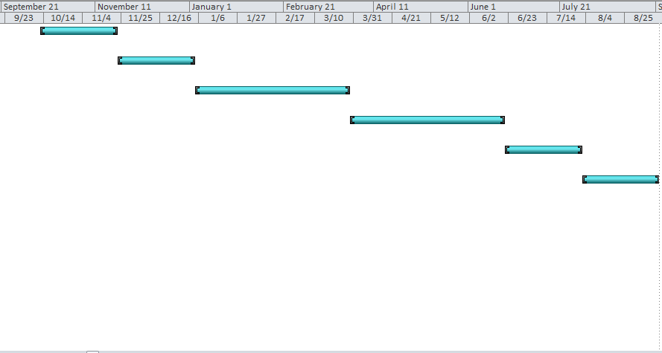

1. **Expected Outcome**
2. Reliability of satellite internet increases.
3. Less expensive as compare to the present services provide by the companies
4. Optimized TCP connections
5. Reduced latency
6. Effective bandwidth
7. Better security for the user
8. **Consent of Advisors**

**Consent of the Internal Advisor** Signature:

**Consent of the Co-Internal Advisor** Signature:

**Consent of the External Advisor (if any)** Signature:

1. **Reviewers Committee’s Comments**

|  |
| --- |
|  |
|  |
|  |
|  |
|  |
|  |
|  |
|  |
|  |
|  |
|  |
|  |
|  |
|  |
|  |
|  |
|  |
|  |
|  |

1. **Project Approval Certificate**

**Recommendation of FYP Coordinator** Signature:

**Approval by the Chairman** Signature: