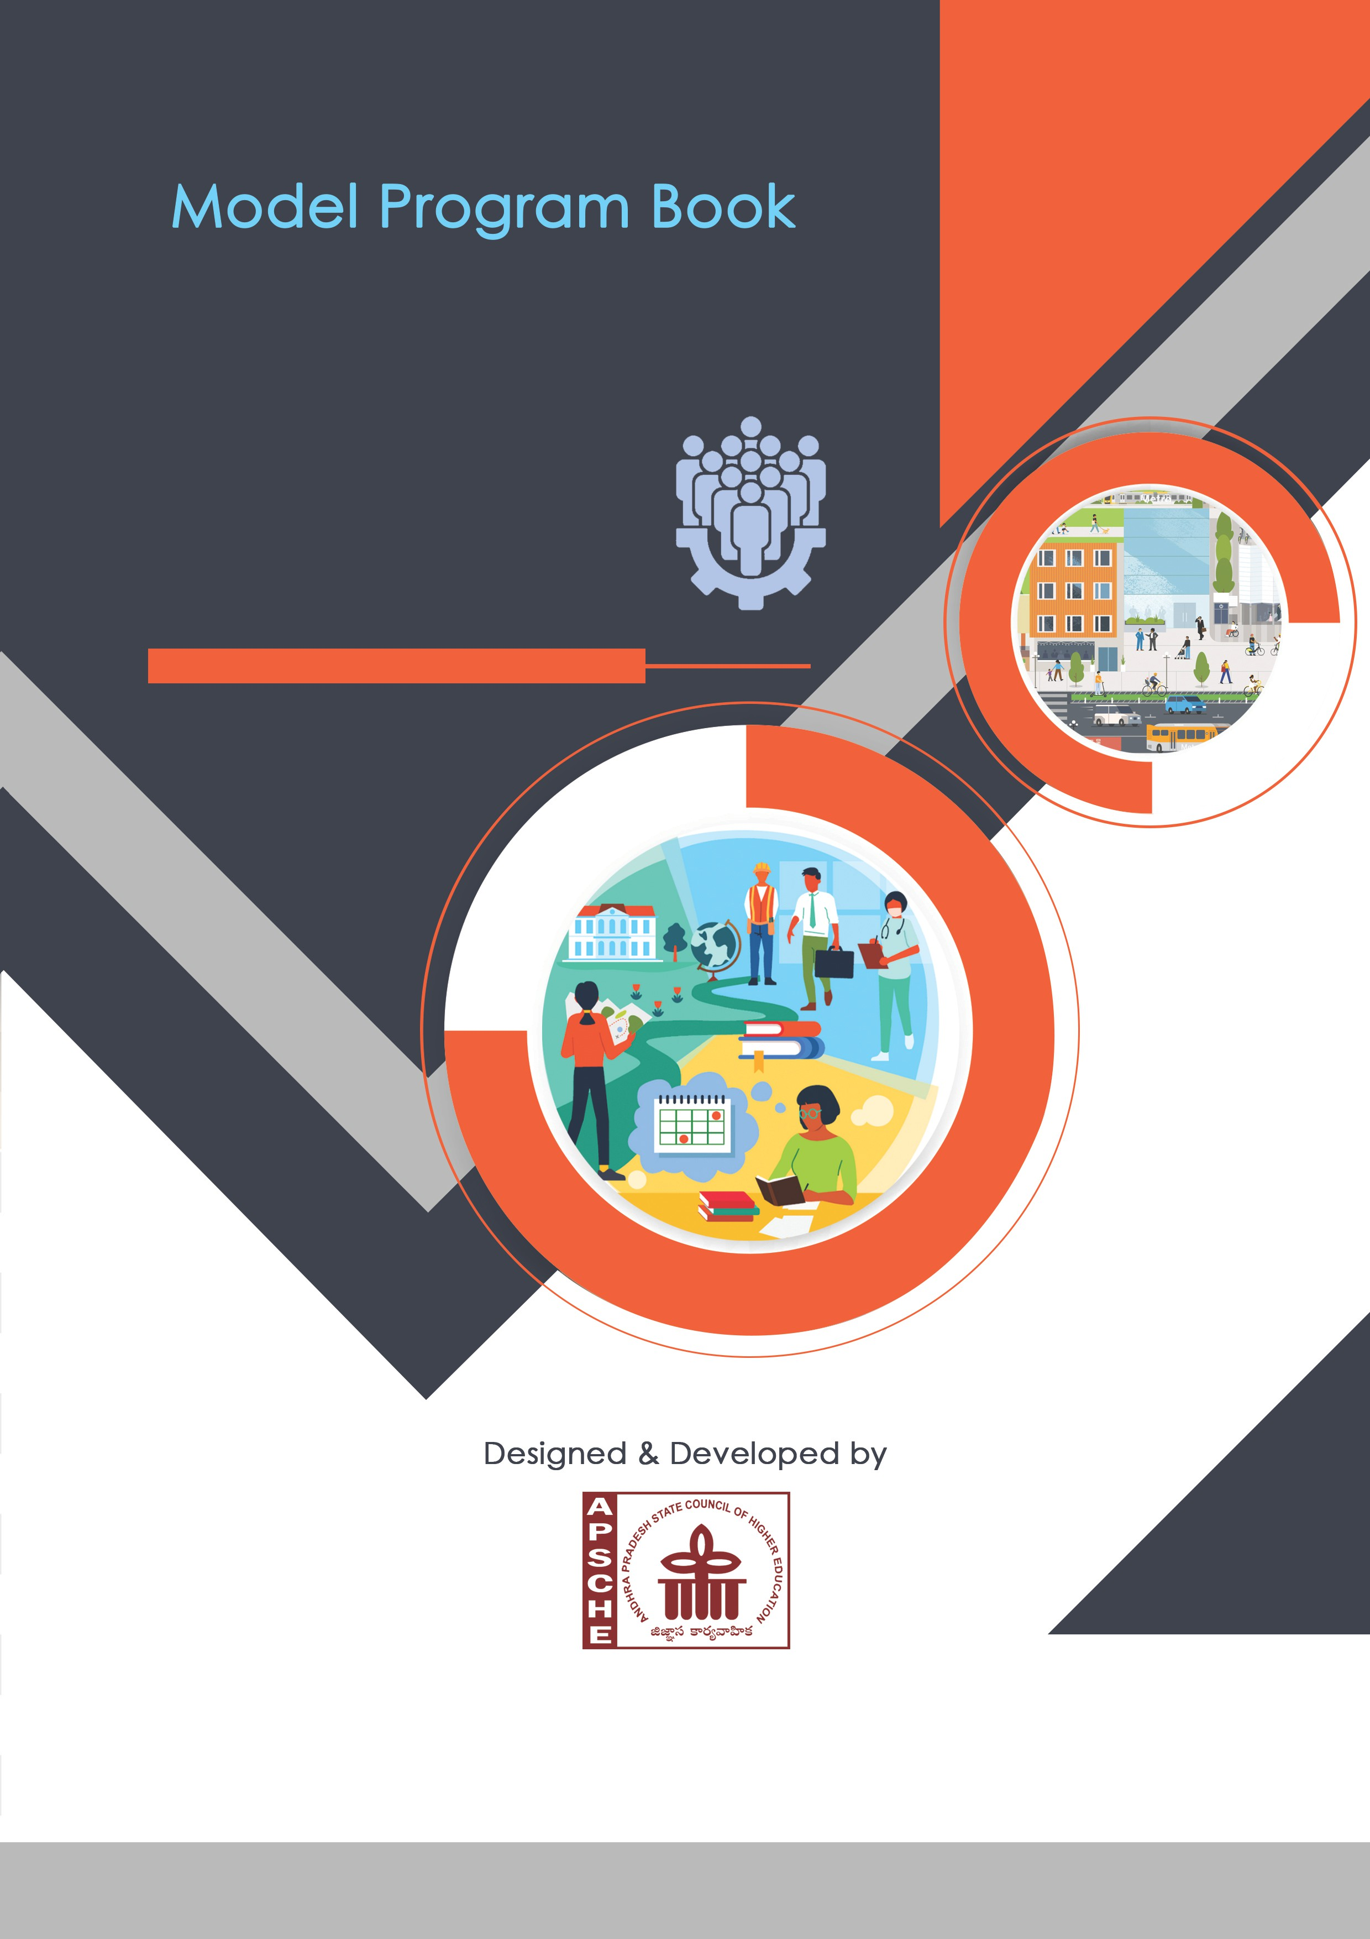COMMUNITY SERVICE PROJECT

**ANDHRA PRADESH**

**STATE COUNCIL OF HIGHER EDUCATION**

(A STATUTORY BODY OF GOVERNMENT OF ANDHRA PRADESH)

**PROGRAM BOOK FOR**



**COMMUNITY SERVICE PROJECT**

Yerur Shaik Raziya Sultana

Gates Institute of Techonology

23F21A3182

July 2025

June 2025

Anjuman street 10/22, Guntakal

**Gates Institute Of Technology University**

2024-2025

### Instructions to Students for Community Service Project

**Please read the detailed Guidelines on Community Service Project hosted on the website of AP State Council of Higher Education** [**https://apsche.ap.gov.in**](https://apsche.ap.gov.in/)

**Link:** [**https://apsche.ap.gov.in/Pdf/Guidelines%20for%20the%20OJT%20Internship**](https://apsche.ap.gov.in/Pdf/Guidelines%20for%20the%20OJT%20Internship%20Community%20Service%20Project.pdf)

[**%20Community%20Service%20Project.pdf**](https://apsche.ap.gov.in/Pdf/Guidelines%20for%20the%20OJT%20Internship%20Community%20Service%20Project.pdf)

1. It is mandatory for all the students to complete 2 months (180 hours) of Community Service Project as a part of the 10-month mandatory internship/on the job training.
2. Consider yourself a committed volunteer in the community, you work with.
3. Every student should identify the village/community/habitation for Community Service Project (CSP) in consultation with the College Principal/the authorized person nominated by the Principal.
4. Report to the community/habitation as per the schedule given by the College. You must make your own arrangements for transportation to reach the community/habitation.
5. You will be assigned a Faculty Guide from your College. He/She will be creating a WhatsApp group with your fellow volunteers. Post your daily activity done and/or any difficulty you encounter during the programme.
6. You should maintain punctuality in attending the CSP. Daily attendance is compulsory.
7. You are expected to learn about the community/habitation and their problems.
8. Know the leaders and the officials of the community/habitation.
9. While in the project, always wear your College Identity Card.
10. If your College has a prescribed dress as uniform, wear the uniform daily.
11. Identify at least five learning objectives in consultation with your Faculty Guide. These learning objectives can address:
    * Information about the community, including the realities and

problems of the society.

* + Need for creating awareness on socially relevant aspects/programs.
  + Acquiring specific Life Skills.
  + Learning areas of application of knowledge and technologies related to your discipline.
  + Identifying developmental needs of the community/habitation.

1. Practice professional communication skills with team members, and with the leaders and officials of the community. This includes expressing thoughts and ideas effectively through oral, written, and non-verbal communication, and utilizing listening skills.
2. **Be regular in filling up your Program Book. It shall be filled up in**

**your own handwriting. Add additional sheets wherever necessary.**

1. At the end of Community Service Project, you shall be evaluated by the person in-charge of the community/habitation to whom you report to.
2. There shall also be an evaluation at the end of the community service by the Faculty Guide and the Principal.
3. Do not indulge in any political activities.
4. Ensure that you do not cause any disturbance to the inhabitants or households during your interaction or collection of data.
5. Be cordial but not too intimate with the people you come across during your service activities.
6. You should understand that during this activity, you are the ambassador of your College, and your behavior during the community service programme is of utmost importance.
7. If you are involved in any discipline related issues, you will be withdrawn from the programme immediately and disciplinary action shall be initiated.
8. Do not forget to keep up your family pride and prestige of your College.
9. Remember that you are rendering valuable service to the society and your role in the community development will become part of the history of the community.

# Community Service Project Report

*Submitted in accordance with the requirement for the degree of* *Bachelor of Technology (B.Tech) in Computer Science and Artificial Intelligence*

Name of the College: Gates Institute of Technology

Department: Computer and Artificial Intelligence

KC Dhanunjay

Name of the Faculty Guide:

Duration of the CSP: From: June 2025 To: July 2025

Yerur Shaik Raziya Sultana

Name of the Student: Programme of Study: Year of Study: Register Number: Date of Submission:

23F21A3182

2024-2025

Awareness on Health and Hygiene

Awareness on Health and Hygiene

# Student’s Declaration

I, Yerur Shaik Raziya Sultana, a student of Bachelor of Technology (B.Tech), Reg.No. 23F21A3182 of the Department of Computer and Artificial Intelligence, Gates Institute Of Technology College do hereby declare that I have completed the mandatory community service from June 2025 to July 2025 in Awareness on Health and Hygiene under the Faculty Guideship of KC Dhanunjay Department of Computer and Artificial Intelligence in Gates Institute Of Technology College

***(Signature and Date)***

**Endorsements**

*Faculty Guide*

*Head of the Department*

*Principal*

# Certificate from Official of the Community

This is to certify that Yerur Shaik Raziya SultanaReg. No 23F21A3182 of Gates Institute of Technology underwent community service in Awareness on Health and Hygiene from June 2025 to July 2025. The overall performance of the Community Service Volunteer during his/her community service is found to be Satisfactory

*Authorized Signatory with Date and Seal*

**Acknowledgements**

We are very much thankful to our beloved Correspondent Smt V.K. Padmavathamma garu for providing the necessaries in completion of the course.

We wish to thank Sri G. Raghunatha Reddy M.Tech., our beloved managing director & Smt. V.K. Srivani Director providing us all facilities that are required for our project.

We cordially thank to our principal Dr.Aravind M.Tech, Ph.D, DIT, MIE, CSI for providing the necessaries in completion of the project.

We wish to thank our HOD Mr. Mr K. Ramesh M.Tech., Ph.D for providing us all facilities that are required for completing of our project.

We express our sincere thanks to our project guide Mr. KC Dhanunjay M.Tech., Ph.D of Computer Science of Artificial Intelligence department, GATES Institute of Technology, Gooty, Anantapur, without innovative and imaginative approach, regular monitoring and timely advice, this project would never have been realized.

We thank our teaching and non-teaching staff of the department of Computer Science of Artificial Intelligence department, GATES Institute of Technology, Gooty, for their constant corporation for completion of the project.

**Contents**

|  |  |  |  |
| --- | --- | --- | --- |
| **S. No** | **Name of the Content** | **Page No** | |
| 1 | CHAPTER 1: INTRODUCTION | **1** |
| 2 | CHAPTER 2: OVERVIEW OF THE AWARENESS PROGRAM | **3** |
| 3 | CHAPTER 3: COMMUNITY SERVICE PART | **6** |
| 4 | CHAPTER 4: ACTIVITY LOGS | **9** |
| 5 | CHAPTER 5: OUTCOMES DESCRIPTION | **21** |
| 6 | CHAPTER 6: RECOMMENDATIONS AND CONCLUSIONS OF THE MINI PROJECT | **25** |
| 7 | Student Self-Evaluation for the Community Service Project | **27** |
| 8 | Evaluation by the Person in-charge in the Community / Habitation | **28** |
| 9 | PHOTOS & VIDEO LINKS | **29** |
| 10 | EVALUATION | **31** |
| 11 | MARKS STATEMENT | **35** |

## CHAPTER 1: EXECUTIVE SUMMARY

**Abstract**

This awareness program aims to educate and empower individuals and communities across Hyderabad, Telangana, about fundamental and often underestimated health and hygiene practices. In the dynamic and rapidly developing urban landscape of Hyderabad, characterized by its growing population, evolving lifestyles, and diverse socio-economic strata, maintaining optimal public and personal health is not merely crucial but paramount. Unfortunately, this vital aspect is frequently overlooked or inadequately addressed due to a confluence of factors, including high population density, rapid lifestyle changes, existing knowledge gaps, and varying levels of awareness regarding the direct impact of hygiene on well-being.

This comprehensive program is meticulously designed to cover essential aspects of holistic health. It will delve into the critical domain of personal hygiene, encompassing best practices for daily cleanliness and self-care. Furthermore, it will extensively address environmental sanitation, emphasizing the importance of clean surroundings, proper waste management, and the safeguarding of public spaces. Beyond hygiene, the program will also underscore the indispensable importance of a balanced and nutritious diet, along with the benefits of an active and healthy lifestyle, as foundational pillars of good health.

Through engaging and interactive sessions, complemented by practical demonstrations and the dissemination of easily accessible and understandable information, participants will be guided towards a deeper and more profound understanding of how consistently adopting good hygiene habits can dramatically reduce the incidence of preventable diseases. This will, in turn, lead to a significant improvement in overall individual and community well-being, fostering a healthier and more resilient society. The ultimate, overarching goal of this initiative is to cultivate and embed a robust culture of health consciousness within the communities of Hyderabad. This sustained focus is intended to inspire and facilitate sustainable behavioral changes, leading to a marked improvement in the quality of life for all residents and contributing to the long-term public health of the region.

**Learning Objectives**

Upon completion of this awareness program, participants will be able to:

1. **Define Key Concepts:** Clearly explain the definitions of health, hygiene (personal, food, environmental), and their interconnectedness.
2. **Identify Personal Hygiene Practices:** Recognize and describe essential personal hygiene practices, including proper handwashing techniques, oral hygiene, body cleanliness, and care for clothing.
3. **Understand Food Hygiene Principles:** Identify the fundamental principles of safe food handling, storage, and preparation to prevent foodborne illnesses.
4. **Recognize Environmental Sanitation Importance:** Explain the significance of maintaining clean surroundings, proper waste disposal, and safe water sources for community health.

**Outcomes**

As a result of participating in this awareness program, individuals will be able to:

1. **Demonstrate Improved Personal Hygiene:** Consistently practice proper handwashing, maintain oral hygiene, and ensure personal cleanliness, leading to a reduced risk of infections.
2. **Apply Safe Food Handling Techniques:** Implement safe food preparation and storage methods at home, minimizing the incidence of foodborne diseases within their households.
3. **Contribute to Cleaner Environments:** Actively participate in proper waste segregation and disposal, and advocate for cleaner public spaces in their neighbourhoods.
4. **Adopt Disease Prevention Behaviours:** Make informed decisions and adopt behaviours that prevent the transmission of common infections, such as avoiding touching their face, covering coughs/sneezes, and seeking vaccination

## CHAPTER 2: OVERVIEW OF THE COMMUNITY

**The Community: School Engagement in Guntakal, Andhra Pradesh**

Our "Health and Hygiene Awareness Program" was primarily conducted in schools within **Guntakal, Andhra Pradesh**, aiming to reach young minds directly. This strategic choice was made to inculcate good health practices from an early age, ensuring a sustainable impact on the students, their families, and the wider community. We targeted diverse schools, ranging from government institutions to private schools, ensuring broad reach across different socio-economic backgrounds within the urban and peri-urban areas of **Guntakal**. This included schools in areas, reflecting the project's roots and reach within the region.

The focus on schools allowed for structured engagement with children, who are powerful agents of change. By educating them, we aimed to create a ripple effect, where the knowledge and practices learned in school would be taken home and shared with families, thereby amplifying the program's reach and impact.

**Demographics of the Engagement:**

Our sessions engaged a significant number of students, typically across primary and middle school grades (e.g., Grades 3-8), ranging in age from approximately 8 to 14 years. The total number of students reached varied per school, with efforts to include both male and female students in roughly equal proportions. The language of instruction was primarily Telugu and English, depending on the school's medium of instruction, ensuring effective communication and understanding.

**Program Modalities:**

The awareness sessions were designed to be highly interactive and engaging, moving beyond traditional lecture formats. Our primary methods included:

1. **Quizzes:** Interactive quizzes were a core component, designed to test existing knowledge and reinforce new concepts about health and hygiene in a fun and competitive manner. Questions covered topics like proper handwashing steps, identifying unhealthy food items, and understanding disease transmission.
2. **Storytelling:** Engaging stories, often with relatable characters and scenarios, were used to convey important messages about personal hygiene, environmental cleanliness, and the benefits of healthy habits. This method proved particularly effective in capturing the attention of younger students and making complex ideas accessible.
3. **Demonstrations:** Practical demonstrations were conducted for key hygiene practices, such as the correct technique for handwashing with soap and water, proper tooth brushing, and safe food handling. Visual and hands-on learning significantly enhanced comprehension and retention.
4. **Interactive Discussions:** Open forums and group discussions encouraged students to share their experiences, ask questions, and brainstorm solutions to hygiene challenges in their daily lives.
5. **Educational Games:** Simple games were incorporated to make learning enjoyable and memorable, reinforcing messages about sanitation and healthy living.

**BRIEF EXPLANATION ON AWARENESS ON HEALTH AND HYGIENE**

Health and hygiene awareness is a broad category that covers simple yet profound practices essential for individual and community well-being. Our program emphasized that in an urban environment like **Guntakal**, where population density and lifestyle choices can easily impact public health, maintaining high standards of hygiene is paramount. The importance of health and hygiene becomes even more critical in preventing the widespread transmission of communicable diseases and fostering a healthier lifestyle for all. The foundational knowledge and practices imparted are beneficial for all human beings, contributing to a healthier and more productive life. Human activities often overlook hygiene, leading to preventable illnesses and a diminished quality of life. Therefore, our awareness program focused on the concept of "stay healthy and live a full life."

**The Need for Health and Hygiene Awareness**

It comes as no surprise that health and hygiene are among the most essential elements for the survival and flourishing of any lifeform on Earth. The presence of good health and the absence of disease distinguish a thriving community. The need to maintain consistent health and practice good hygiene stems from its vitality for the survival and well-being of all individuals within a community. Just as a portion of the human population has easy access to health information and resources, we frequently observe a lack of basic hygiene practices or understanding, often forgetting why hygiene is so important. Poor hygiene is not merely a personal issue for individuals; our careless practices are also affecting the health of those around us, including family members, peers, and the broader community. There are serious consequences of neglected hygiene, ranging from common infections to more severe public health crises.

**Ways to Practice and Promote Health and Hygiene**

Health and hygiene are essential and can be done by everyone. We can all contribute to creating a healthier environment and preventing disease. Even those who appear healthy should understand and promote good hygiene practices.

Several key techniques and practices for promoting health and hygiene were discussed and demonstrated during our school visits:

* **Careful Handwashing:** Keep hands clean by washing them frequently with soap and water, especially before eating, after using the restroom, and after playing or touching common surfaces. We demonstrated the step-by-step process of effective handwashing, emphasizing scrubbing for at least 20 seconds.
* **Don't Run the Faucet to Clean Fruits and Vegetables:** While washing produce, gather all items before turning on the water, or use a basin to conserve water while ensuring cleanliness. Always dispose of peels and unwanted parts in a bin, not the sink.
* **Check for Cleanliness:** Regularly clean and disinfect high-touch surfaces at home and in school (e.g., doorknobs, desks, light switches). Leaks in understanding about hygiene can cause significant health problems if left unchecked. So, consistently reinforce hygiene habits.
* **Promote Healthy Eating Habits Smartly:** While eating, ensure food is clean and prepared hygienically. Emphasize eating a balanced diet with plenty of fruits and vegetables to boost immunity. Avoid excessive consumption of unhealthy snacks.
* **Reduce Water Waste During Bathing/Brushing, etc.:** While bathing or taking a shower, make sure not to let the water run down unnecessarily. Similarly, turn off the tap while brushing teeth, shaving, or scrubbing dishes. This saves water and encourages mindful consumption.
* **Timely Rest and Activity:** Promote adequate sleep for overall health and recommend regular physical activity (e.g., playing outdoors) to keep the body strong and active.
* **Rethink Waste Disposal:** Use dustbins for all waste instead of littering. Compost bins or proper waste segregation can be encouraged at home and school to manage organic waste effectively and prevent pest breeding.
* **Maintenance of Personal Belongings:** Ensure personal items like clothes, bags, and shoes are clean and well-maintained to prevent the spread of germs.
* **Promote Social Distancing and Respiratory Etiquette:** During periods of illness, encourage students to cover coughs and sneezes with their elbow or a tissue and avoid close contact to prevent the spread of germs.
* **Awareness on Clean Drinking Water:** Emphasize drinking safe, filtered water and avoiding unhygienic water sources.
* **Plant Trees and Green Spaces:** While not direct hygiene, promoting green spaces and trees contributes to cleaner air, which is vital for respiratory health. This subtly links to a holistic approach to well-being.

## CHAPTER 3: COMMUNITY SERVICE PART

**ACTIVITIES UNDERTAKEN IN THE COMMUNITY:**

The primary objective of our community service initiative was to raise awareness about crucial health and hygiene practices among school students in **Guntakal, Andhra Pradesh**. Recognizing that good hygiene is fundamental for the survival and flourishing of any individual and community, our program aimed to instill these vital habits from an early age. The presence of good health and the absence of preventable diseases are what truly distinguish a thriving society. The need to maintain constant vigilance over health and practice consistent hygiene stems from its direct impact on the vitality and well-being of all students and their families. This awareness program, conducted within the school environment, focused on the concept of "stay healthy and live a full life" by promoting preventative measures.

**Ways to Conserve Health and Promote Hygiene:**

Health and hygiene are essential and can be done by everyone. We believe that small-scale changes, consistently practiced, can lead to significant improvements in public health. Even those who appear healthy should actively understand and promote good hygiene practices.

Several key techniques and strategies for promoting health and hygiene were discussed and demonstrated during our school visits:

* **Spread Awareness to Students:** Our core activity involved direct engagement with students through interactive sessions.
* **Spread Awareness to Teachers:** We also provided information and resources to teachers, empowering them to reinforce hygiene messages in the classroom.
* **Spread Awareness to School Staff:** Custodial and canteen staff were included, emphasizing their critical role in maintaining a hygienic school environment.
* **Spread Awareness to Parents (indirectly):** By educating children, we aimed for a ripple effect, where students would carry these messages home to their families, thereby spreading awareness to parents and guardians.
* **Spread Awareness to Public (indirectly through students):** The ultimate goal was for students to become advocates for health and hygiene in their local communities beyond the school gates.

**Values, Life Skills, and Technical Skills the Student Acquired (from the program perspective):**

Our health and hygiene awareness program aimed to impart not just knowledge but also essential values and life skills to the participating students:

* **Human Values:** Fostering empathy and responsibility towards personal health and the health of others in the community.
* **Ethical Values:** Understanding the moral imperative of maintaining cleanliness for collective well-being and preventing disease spread.
* **Critical Thinking:** Encouraging students to analyze information about health risks and make informed decisions about their hygiene practices.
* **Creative Thinking:** Stimulating innovative ideas for practicing hygiene in daily life and for communicating these ideas to others (e.g., through posters, jingles, stories).
* **Decision Making:** Empowering students to make conscious choices regarding their diet, personal cleanliness, and environmental sanitation.
* **Problem Solving:** Equipping students to identify hygiene-related problems in their immediate environment and think of practical solutions.
* **Communication Skills:** Enhancing their ability to articulate concepts of health and hygiene, allowing them to effectively share knowledge with peers and family.
* **Teamwork:** Promoting collaborative learning during group activities, quizzes, and discussions on hygiene.
* **Community Engagement:** Encouraging active participation in school and community-level initiatives aimed at improving sanitation and health.
* **Self-Management:** Developing personal discipline in adhering to hygiene routines.
* **Learning to Learn:** Cultivating a continuous curiosity and desire to learn more about health and wellness.

**Awareness for people:**

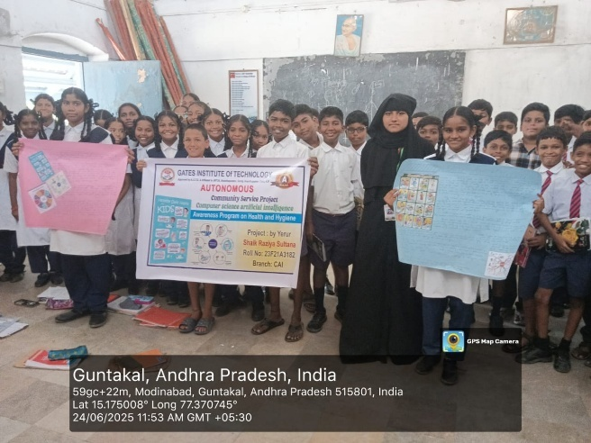I visited various schools in **Guntakal, Andhra Pradesh**, and met many students and classes. After starting communicating with people, I introduced myself as being from Gates Institute of Technology, coming to give awareness on health and hygiene.

One of the key strategies discussed for **Personal Hygiene** was the importance of regular handwashing with soap and water, especially before meals and after using the toilet. We demonstrated proper handwashing steps. Another crucial aspect was **Oral Hygiene**, stressing the importance of brushing teeth twice daily. For **Environmental Sanitation**, we emphasized keeping surroundings clean, proper waste disposal, and avoiding littering. We also highlighted the dangers of contaminated food and water, discussing basic **Food Hygiene** principles like covering food and washing fruits and vegetables before consumption. Many students in **Guntakal** may not have continuous access to purified water, so the importance of boiling water if its source is questionable was also discussed, along with keeping containers clean.

Another strategy in health promotion was to discuss **disease prevention**.

When unhygienic practices occur, germs proliferate and lead to illness. Contamination of food, water, and surfaces can lead to the spread of diseases like diarrhea, typhoid, and cholera, common in many areas. Contamination due to unmanaged waste, overflowing drains, and poor personal habits decreases the overall health of the community. Therefore, taking preventive measures by protecting oneself from germ contamination through good hygiene is an important aspect of health awareness.

Our fundamental goal was to promote universal health and hygiene standards. The prevalence of hygiene-related issues varies significantly worldwide, but local awareness is key. Recent studies have estimated that significant improvements in public health can be achieved through basic hygiene education. Although individual hygiene practices are often personal, promoting communal responsibility is vital. The Environmental Protection Agency (or local health authorities like the Guntakal Municipal Corporation) emphasizes that basic hygiene awareness alone can reduce disease transmission. In addition to raising consumer awareness of personal and environmental cleanliness, education is an important way to identify and localize potential health risks. Health metering through regular check-ups and community health surveys can benefit society by providing a basis for targeted health interventions.

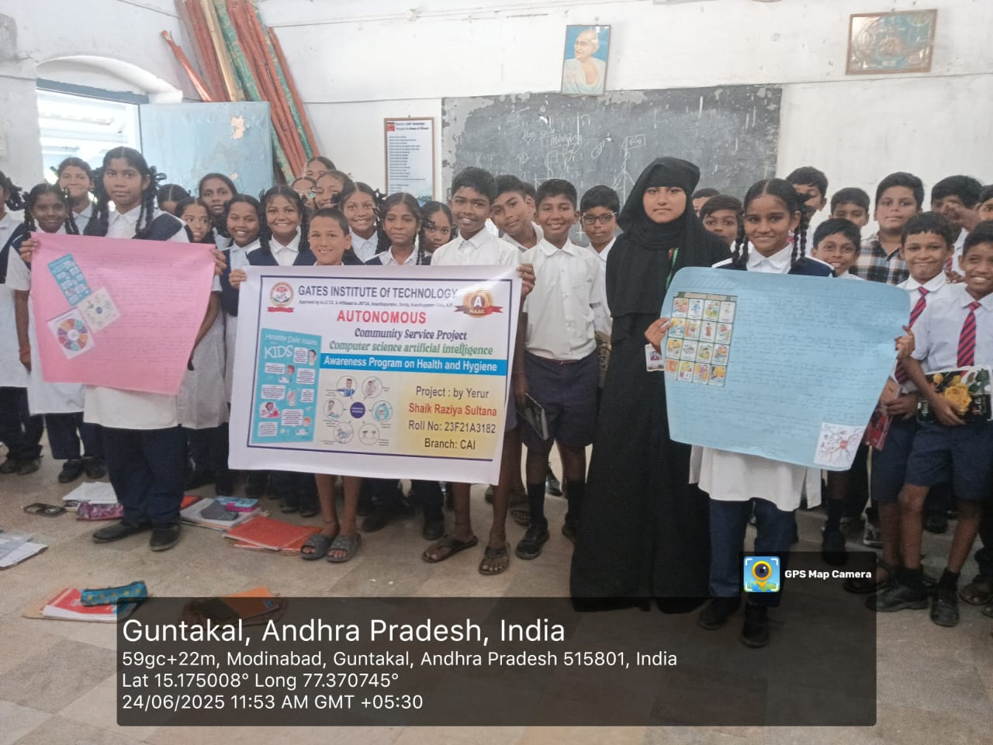

Figure: Visted School and Met with Teachers and Students

**ACTIVITY LOG FOR THE FIRST WEEK**

**CHAPTER 4: ACTIVITY LOGS**

|  |  |  |  |
| --- | --- | --- | --- |
| **Day & Date** | **Brief description of the daily activity** | **Learning Outcome** | **Person In- Charge Signature** |
| Day – 1 | Orientation and introduction to the health & hygiene program | Understood project scope and objectives |  |
| Day - 2 | Discussion on hygiene topics; poster creation | Developed teamwork and communication skills |  |
| Day – 3 | Visited Govt. School – Session on handwashing and cleanliness | Gained real-world teaching experience |  |
| Day – 4 | Oral hygiene session – Demonstrated brushing techniques | Understood importance of dental care |  |
| Day – 5 | Nail care and personal grooming awareness session | Learned health presentation skills |  |
| Day –6 | Interactive hygiene quiz with students | Improved public interaction |  |

**WEEKLY REPORT**

**WEEK – 1 (From Dt 26-05-2025 to Dt 31-05-2025)**

|  |
| --- |
| **Objective of the Activity Done:** To initiate planning, prepare awareness materials, and |
| coordinate with school authorities for the Health and Hygiene Awareness Program. |
|  |
| **Detailed Report:** The week focused on creating educational materials and planning the |
| schedule for the upcoming sessions. I contacted local schools and finalized timings for |
| sessions. The initial phase of this community service project was dedicated to meticulous |
| preparation and logistical coordination, spanning a crucial week of focused effort. This period |
| primarily centered on the conceptualization and creation of educational materials tailored We |
| specifically for school-aged children, ensuring they were both informative and captivating. |
| a diverse range of resources, including visually appealing posters illustrating proper |
| handwashing techniques and the importance of clean surroundings, simple yet impactful |
| presentation slides, and a bank of engaging quiz questions designed to test and reinforce |
| knowledge on various hygiene topics. Additionally, age-appropriate storytelling scripts were |
| crafted to convey health messages in an accessible and memorable format, alongside ideas for |
| demonstrations. Simultaneously, significant effort was invested in planning the detailed |
| schedule for the upcoming awareness sessions. This involved sketching out a realistic |
| timeline, assigning specific dates and times for visits to different schools and classes, and |
| estimating the optimal duration for each session to maximize student engagement without |
| causing undue disruption to their regular academic schedule. Considerations were given to |
| the number of students per session and the varying age groups, ensuring the content delivery |
| Would be adapted accordingly. |
|  |

**ACTIVITY LOG FOR THE SECOND WEEK**

|  |  |  |  |
| --- | --- | --- | --- |
| **Day & Date** | **Brief description of the daily activity** | **Learning Outcome** | **Person In- Charge Signature** |
| Day – 1 | Storytelling about “Clean Habits” | Improved educational storytelling skills |  |
| Day - 2 | Skit rehearsal with students on ‘Germs and Cleanliness’ | Practiced engaging health communication |  |
| Day – 3 | |  | | --- | | Conducted skit and hygiene pledge |  |  | | --- | |  | | Encouraged behavioral change |  |
| Day – 4 | |  | | --- | | School clean up drive with students |  |  | | --- | |  | | Understood environmental hygiene |  |
| Day – 5 | Demonstration on proper toilet usage and sanitation | Learned importance of sanitation education |  |
| Day –6 | Drawing activity on “My Clean Day” | Boosted visual learning methods |  |

**WEEKLY REPORT**

**WEEK – 2 (From Dt 02-06-2025 to Dt 07-06-2025)**

|  |
| --- |
| **Objective of the Activity Done:** Engage students using creative tools to reinforce hygiene. |
| **Detailed Report:** This phase of the program was dedicated to the interactive delivery of our |
| health and hygiene messages, employing a variety of creative pedagogical tools to ensure |
| maximum student engagement and retention. We understand that for young minds, passive |
| Listening is less effective than active participation and fun. |
| **Storytelling:** We extensively utilized storytelling as a powerful medium. Narratives were crafted |
| around relatable characters facing common hygiene dilemmas, such as "The Boy Who Forgot to |
| Wash His Hands" or "The Clean Village Challenge." These stories, often accompanied by |
| expressive narration and simple props, vividly illustrated the consequences of poor hygiene (e.g., |
| getting sick) and the benefits of good practices (e.g., staying healthy to play). Students were |
| encouraged to identify with the characters and discuss the "moral" of each story, which |
| invariably revolved around a key hygiene principle. |
| **Role-Plays:** Interactive role-playing sessions were a cornerstone of our engagement. Students |
| were invited to act out scenarios demonstrating proper hygiene. For instance, one common role- |
| play involved enacting the correct 7-step handwashing technique, with students mimicking the actions |
| as we guided them |
|  |
|  |
|  |
|  |
|  |
|  |

**ACTIVITY LOG FOR THE THIRD WEEK**

|  |  |  |  |
| --- | --- | --- | --- |
| **Day & Date** | **Brief description of the daily activity** | **Learning Outcome** | **Person In- Charge Signature** |
| Day – 1 | Observed school surroundings for hygiene issues | Developed observational and analytical skills |  |
| Day - 2 | Clean-up activity: playground and classrooms | Learned team coordination in field |  |
| Day – 3 | Waste segregation activity with bins | Understood waste management principles |  |
| Day – 4 | Painted awareness messages on school walls | Learned visual advocacy techniques |  |
| Day – 5 | Class-to-class awareness drive on environmental hygiene | Practiced spontaneous communication |  |
| Day –6 | Displayed charts and posters | Understood public information presentation |  |

**WEEKLY REPORT**

**WEEK – 3 (From Dt 09-06-2025 to Dt 14-06-2025)**

|  |
| --- |
| **Objective of the Activity Done:** school hygiene and environmental cleanliness. |
| **Detailed Report:** Focused on campus hygiene and involved students in clean-up efforts and. |
| awareness drives. This phase of our program shifted focus from theoretical knowledge to |
| practical application, emphasizing the critical role of a clean environment in maintaining overall |
| health. The activity was specifically designed to address **campus hygiene and environmental** |
| **cleanliness**, transforming the school grounds into a living classroom for hygiene practices. |
| We initiated the activity by first discussing the direct link between a clean school environment |
| and the prevention of diseases. This included pointing out common areas where germs could |
| thrive if neglected – such as classrooms, corridors, playgrounds, and especially washrooms and |
| drinking water stations. Students were shown how litter, stagnant water, and overflowing bins |
| contribute to pest infestations and the spread of illness. |
|  |
|  |
|  |
|  |
|  |
|  |
|  |
|  |
|  |
|  |
|  |

**ACTIVITY LOG FOR THE FORTH WEEK**

|  |  |  |  |
| --- | --- | --- | --- |
| **Day & Date** | **Brief description of the daily activity** | **Learning Outcome** | **Person In- Charge Signature** |
| Day – 1 | Special session on puberty and hygiene (girls) | Understood gender-sensitive teaching |  |
| Day - 2 | Distributed sanitary kits and explained their usage | Gained trust-building skills |  |
| Day – 3 | Session on common myths and facts about periods | Learned how to address taboos effectively |  |
| Day – 4 | Boys’ hygiene session on body care and confidence | Promoted inclusive hygiene education |  |
| Day – 5 | Health Talk: Common infections and how to avoid them | Strengthened health education delivery |  |
| Day –6 | Q&A session with senior students | Enhanced listening and response skills |  |

**WEEKLY REPORT**

**WEEK – 4 (From Dt 16-06-2025 to Dt 21-06-2025)**

|  |
| --- |
| **Objective of the Activity Done:** Focus on personal hygiene and menstrual hygiene |
| education. |
| **Detailed Report:** Gender-sensitive hygiene topics were addressed through private group |
| sessions with appropriate age information. This segment of our awareness program was |
| specifically designed to delve into more intimate and often less discussed aspects of hygiene: |
| personal hygiene and menstrual hygiene education. Recognizing the sensitive nature of these |
| topics, particularly for adolescent students, we adopted a targeted approach through private |
| group sessions. For general personal hygiene, separate sessions were conducted for boys and |
| girls, allowing for discussions on topics relevant to their specific needs. This included |
| reinforcing the importance of daily bathing, proper oral care, nail and hair hygiene, and the |
| necessity of wearing clean clothes. The emphasis was on building self-care routines that |
| contribute to overall health and confidence |
|  |
|  |
|  |
|  |
|  |
|  |
|  |

**ACTIVITY LOG FOR THE FIFTH WEEK**

|  |  |  |  |
| --- | --- | --- | --- |
| **Day & Date** | **Brief description of the daily activity** | **Learning Outcome** | **Person In- Charge Signature** |
| Day – 1 | Conducted recap quiz on hygiene topics | Evaluated student understanding |  |
| Day - 2 | Poster competition: “Healthy Habits” | Encouraged creative expression |  |
| Day – 3 | Debate activity: Clean vs Dirty Habits | Enhanced public speaking among students |  |
| Day – 4 | Song and poem recital on cleanliness | Discovered diverse teaching methods |  |
| Day – 5 | Selected top posters and gave appreciation | Learned evaluation techniques |  |
| Day –6 | Organized hygiene carnival (games, booths) | Managed event planning and coordination |  |

**WEEKLY REPORT**

**WEEK – 5 (From Dt 23-06-2025 to Dt 28-07-2025)**

|  |
| --- |
| **Objective of the Activity Done:** Review and reinforce concepts with fun and evaluation. |
| **Detailed Report:** Used quizzes, competitions, and recap activities to reinforce learning and |
| evaluate student understanding. This was achieved through a strategic combination of |
| interactive tools designed for review, reinforcement, and evaluation. We conducted a series of |
| interactive quizzes that served as both a fun challenge and an assessment tool. These included: |
| **Rapid-fire Q&A sessions:** Covering topics such as the seven steps of handwashing, types of healthy |
| foods, or simple disease prevention methods. |
| **Picture-based quizzes:** Where students identified correct hygiene practices from visual cues. |
| **True or False statements:** Testing their understanding of common hygiene myths versus facts. |
| These quizzes not only helped us gauge student comprehension but also acted as a dynamic way to |
| revisit key concepts, correcting any misunderstandings on the spot and reinforcing accurate. |
| information |
|  |
|  |
|  |
|  |
|  |
|  |
|  |
|  |
|  |
|  |

**ACTIVITY LOG FOR THE SIXTH WEEK**

|  |  |  |  |
| --- | --- | --- | --- |
| **Day & Date** | **Brief description of the daily activity** | **Learning Outcome** | **Person In- Charge Signature** |
| Day – 1 | Final recap session and hygiene chant | Reinforced all concepts taught |  |
| Day - 2 | Distributed hygiene kits and bookmarks | Learned appreciation and reward practice |  |
| Day – 3 | Final Q&A and thank-you session with students | Practiced gratitude and closure techniques |  |
| Day – 4 | Debriefing with school principal and teachers | Understood stakeholder feedback |  |
| Day – 5 | Completed final documentation and report writing | Developed formal report writing |  |
| Day –6 | Team reflection and sharing experiences | Built personal awareness and emotional skills |  |

**WEEKLY REPORT**

**WEEK – 6 (From Dt 30-07-2025 to Dt 05-07-2025)**

|  |
| --- |
| **Objective of the Activity Done:** Program conclusion, feedback collection, and kit |
| distribution. |
| **Detailed Report:** We concluded with hygiene kit distribution and final feedback. Reflected on |
| the entire experience. The program formally concluded with a brief closing address in each |
| participating school, where we reiterated the core messages of personal and environmental |
| hygiene and expressed gratitude for the students' enthusiastic participation and the school |
| authorities' invaluable support. This served as a final reinforcement of the importance of |
| maintaining good health habits. |
| A key highlight of this concluding phase was the hygiene kit distribution. To provide tangible |
| tools for continued practice and to serve as a constant reminder of the lessons learned, we |
| distributed small, practical hygiene kits to all participating students. These kits typically |
| contained essential items such as a bar of antiseptic soap, a toothbrush and toothpaste, and for |
| adolescent girls, a small pack of sanitary pads. The distribution aimed not just at providing |
| materials, but at empowering students with the means to consistently practice the hygiene habits |
| we had promoted throughout the program. This practical gesture was met with considerable |
| enthusiasm and appreciation from the students and teachers alike |
|  |
|  |
|  |
|  |
|  |
|  |

**CHAPTER 5: OUTCOMES DESCRIPTION**

**Details of the Socio-Economic Survey of the Village/Habitation Attach the questionnaire prepared for the survey.**

In this community service project I gained a lot of information about Health and Hygiene, specifically focusing on:

1. How to prevent the spread of diseases?
2. How to maintain personal hygiene during different seasons and situations?
3. How to promote hygiene at School?
4. How to ensure clean water and food safety?
5. How to integrate hygiene practices into daily life?

**DESCRIPTION OF THE COMMUNITY AWARENESS PROGRAMMES CONDUCTED W.R.T THE PROBLEMS AND THEIR OUTCOMES.**

The goal of our community awareness program on Health and Hygiene was to significantly increase the community's knowledge of fundamental health practices, available public health programs, and services offered. This was accomplished by informing the public

Community Service Raises Social Awareness.

Community Service Establishes Contacts and Friendships.

Community Service Helps Improve Your Skills.

It Benefits Your Career Prospects.

Community Service Helps Connect to the Community.

**Describe the problems you have identified in the community**

During the preliminary phase of our community service project and through initial interactions in Guntakal, several key problems related to health and hygiene were identified within the school communities and their immediate vicinities. These observations underscored the urgent need for a targeted awareness program:

1. Limited Awareness of Basic Hygiene Practices:
   * Many students, particularly in younger age groups, demonstrated inconsistent knowledge of fundamental personal hygiene practices, such as the correct steps for handwashing, the importance of daily bathing, or proper oral care.
   * There was a noticeable gap in understanding the direct link between these daily habits and the prevention of common illnesses.
2. Inadequate Personal Hygiene Practices:
   * Observation suggested that consistent handwashing, especially before eating and after using the restroom, was not a universal practice among all students.
   * Instances of unkempt nails, unwashed uniforms, or neglected oral hygiene indicated a need for greater emphasis on personal cleanliness routines.
3. Challenges with Environmental Sanitation around Schools:
   * Littering was observed in some schoolyards and surrounding public spaces, leading to unhygienic conditions and attracting pests.
   * Improper waste disposal mechanisms or a lack of consistent waste segregation practices contributed to general untidiness and potential health hazards.
   * Stagnant water bodies, even small ones, were sometimes found near school premises, posing a breeding ground for mosquitoes and other disease vectors.
4. Misconceptions and Lack of Open Discussion on Menstrual Hygiene (for Girls):
   * Many adolescent girls showed a limited understanding of proper menstrual hygiene management, including the correct use and disposal of sanitary products.
   * There appeared to be prevailing cultural taboos or a general reluctance to openly discuss menstruation, leading to a lack of accurate information and sometimes unhygienic practices driven by misinformation. This could contribute to discomfort, infections, and even absenteeism from school during periods.
5. Risk of Communicable Diseases Due to Poor Hygiene:
   * The identified gaps in personal and environmental hygiene directly contributed to an increased risk of common communicable diseases such as diarrheal diseases, skin infections, and respiratory illnesses within the school community.
   * There was an observed need to educate students on how diseases spread and the simple preventive measures they could take.
6. Unsafe Food and Water Handling Practices (General Community):
   * While the program was school-focused, anecdotal evidence and general observations in the broader Guntakal community suggested that not all households consistently followed safe food handling and storage practices.
   * Awareness regarding the importance of clean drinking water sources and safe water storage at home needed reinforcement to prevent waterborne diseases.
7. Limited Awareness of Health Resources:
   * Students and, by extension, their families, might not have been fully aware of local public health services, government initiatives related to sanitation, or easily accessible medical facilities for common hygiene-related ailments.

**Short-term and long-term action plan for possible solutions for the problems identified and that could be recommended to the concerned authorities for implementation.**

**Description of the Community awareness programme/s conducted w.r.t the problems and their outcomes.**

**CHAPTER 6: RECOMMENDATIONS AND CONCLUSIONS OF THE MINI PROJECT**

**Conclusion**

The "Health and Hygiene Awareness Program" conducted in various schools across Guntakal, Andhra Pradesh, proved to be a profoundly impactful and successful mini project. Our primary objective of educating and empowering young minds on fundamental health and hygiene practices was largely achieved through a series of interactive and engaging activities, including quizzes, storytelling, role-plays, clean-up drives, and targeted educational sessions on personal and menstrual hygiene.

The project successfully illuminated the critical link between daily hygiene habits and overall well-being, demonstrating how simple, consistent practices can significantly reduce the incidence of preventable diseases. We observed a notable increase in students' understanding of basic concepts like proper handwashing, safe waste disposal, and the importance of a clean environment. The enthusiastic participation of students in clean-up efforts and their readiness to discuss sensitive topics like menstrual hygiene highlighted a growing awareness and a willingness to adopt healthier behaviors. The distribution of hygiene kits further reinforced these lessons with practical tools. This initiative has not only fostered a greater sense of personal responsibility but also underscored the potential for students to become agents of positive change within their families and broader communities. The project reaffirmed that early intervention and engaging educational approaches are crucial for building a foundation of health consciousness that can lead to sustainable improvements in public health.

Recommendations

Based on the observations, successes, and challenges encountered during this mini project, the following recommendations are put forth to further enhance and sustain health and hygiene awareness in Guntakal and similar communities:

1. Integration into School Curriculum: Encourage schools to formally integrate basic health and hygiene education into their regular curriculum. This would ensure consistent reinforcement of messages beyond one-off awareness programs.
2. Formation of Hygiene Clubs: Facilitate the establishment of student-led "Hygiene Clubs" within schools. These clubs could regularly organize clean-up drives, awareness campaigns, and peer-to-peer education, fostering sustained engagement and leadership.
3. Parent and Community Engagement: Develop strategies to actively involve parents and the wider community. Workshops for parents on home hygiene, safe food practices, and waste management could amplify the program's reach and ensure consistent practices beyond the school environment.
4. Sustainable Provision of Hygiene Resources: Explore partnerships with local government bodies, NGOs, or corporate social responsibility (CSR) initiatives to ensure continued access to essential hygiene resources, such as soap, clean water facilities, and sanitary pads in schools, especially for underprivileged students.
5. Periodic Follow-up and Monitoring: Implement a system for periodic follow-up visits to assess the long-term impact of the program, identify persisting challenges, and offer refresher sessions. This data can inform future interventions.
6. Teacher Training: Provide comprehensive training for teachers on effective methods of delivering health and hygiene education. Empowering teachers ensures the sustainability of the awareness efforts within the school system.
7. Expansion to More Schools and Rural Areas: Given the positive response, consider expanding this awareness model to more schools within Guntakal and neighboring rural areas, where hygiene challenges might be even more pronounced.
8. Leveraging Digital Tools: Explore the use of simple, engaging digital content (e.g., animated videos, educational apps) that can be easily shared and accessed by students and parents, making learning interactive and widespread.

This mini project serves as a testament to the power of focused community service in addressing fundamental public health needs. By acting upon these recommendations, we can collectively work towards a healthier, more hygienic, and ultimately more prosperous Guntakal.

#### Student Self-Evaluation for the Community Service Project

**Student Name:**

**Registration No:**

**Period of CSP: From: To: Date of Evaluation:**

**Please rate your performance in the following areas:**

**Rating Scale: Letter grade of CGPA calculation to be provided**

|  |  |  |  |  |  |  |
| --- | --- | --- | --- | --- | --- | --- |
| 1 | Oral communication | 1 | 2 | 3 | 4 | 5 |
| 2 | Written communication | 1 | 2 | 3 | 4 | 5 |
| 3 | Proactiveness | 1 | 2 | 3 | 4 | 5 |
| 4 | Interaction ability with community | 1 | 2 | 3 | 4 | 5 |
| 5 | Positive Attitude | 1 | 2 | 3 | 4 | 5 |
| 6 | Self-confidence | 1 | 2 | 3 | 4 | 5 |
| 7 | Ability to learn | 1 | 2 | 3 | 4 | 5 |
| 8 | Work Plan and organization | 1 | 2 | 3 | 4 | 5 |
| 9 | Professionalism | 1 | 2 | 3 | 4 | 5 |
| 10 | Creativity | 1 | 2 | 3 | 4 | 5 |
| 11 | Quality of work done | 1 | 2 | 3 | 4 | 5 |
| 12 | Time Management | 1 | 2 | 3 | 4 | 5 |
| 13 | Understanding the Community | 1 | 2 | 3 | 4 | 5 |
| 14 | Achievement of Desired Outcomes | 1 | 2 | 3 | 4 | 5 |
| **15** | **OVERALL PERFORMANCE** | **1** | **2** | **3** | **4** | **5** |

**Date: Signature of the Student**

#### Evaluation by the Person in-charge in the Community / Habitation

**Student Name: Registration No:**

**Period of CSP: From: To: Date of Evaluation:**

**Name of the Person in-charge: Address with mobile number:**

Please rate the student’s performance in the following areas:

Please note that your evaluation shall be done independent of the Student’s self- evaluation

Rating Scale: 1 is lowest and 5 is highest rank

|  |  |  |  |  |  |  |
| --- | --- | --- | --- | --- | --- | --- |
| 1 | Oral communication | 1 | 2 | 3 | 4 | 5 |
| 2 | Written communication | 1 | 2 | 3 | 4 | 5 |
| 3 | Proactiveness | 1 | 2 | 3 | 4 | 5 |
| 4 | Interaction ability with community | 1 | 2 | 3 | 4 | 5 |
| 5 | Positive Attitude | 1 | 2 | 3 | 4 | 5 |
| 6 | Self-confidence | 1 | 2 | 3 | 4 | 5 |
| 7 | Ability to learn | 1 | 2 | 3 | 4 | 5 |
| 8 | Work Plan and organization | 1 | 2 | 3 | 4 | 5 |
| 9 | Professionalism | 1 | 2 | 3 | 4 | 5 |
| 10 | Creativity | 1 | 2 | 3 | 4 | 5 |
| 11 | Quality of work done | 1 | 2 | 3 | 4 | 5 |
| 12 | Time Management | 1 | 2 | 3 | 4 | 5 |
| 13 | Understanding the Community | 1 | 2 | 3 | 4 | 5 |
| 14 | Achievement of Desired Outcomes | 1 | 2 | 3 | 4 | 5 |
| **15** | **OVERALL PERFORMANCE** | **1** | **2** | **3** | **4** | **5** |

**Date: Signature of the Supervisor**

**PHOTOS & VIDEO LINKS**

**Video Link**

https://drive.google.com/file/d/110VwlS9jMWgLR1heRmvgQo6RXgXi0vtE/view?usp=drivesdk

# EVALUATION

### Internal Evaluation for the Community Service Project

**Objectives:**

* To facilitate an understanding of the issues that confront the vulnerable / marginalized sections of society.
* To initiate team processes with the student groups for societal change.
* To provide students an opportunity to familiarize themselves with the urban

/ rural community they live in.

* To enable students to engage in the development of the community.
* To plan activities based on the focused groups.
* To know the ways of transforming society through systematic programme implementation.

**Assessment Model:**

* There shall only be internal evaluation.
* The Faculty Guide assigned is in-charge of the learning activities of the students and for the comprehensive and continuous assessment of the students.
* The assessment is to be conducted for 100 marks.
* The number of credits assigned is 4. Later the marks shall be converted into grades and grade points to include finally in the SGPA and CGPA.
* The weightings shall be:
  + Activity Log 20 marks
  + Community Service Project Implementation 30 marks
  + Mini Project Work 25 marks
  + Oral Presentation 25 marks
* Activity Log is the record of the day-to-day activities. The Activity Log is assessed on an individual basis, thus allowing for individual members within groups to be assessed this way. The assessment will take into consideration the individual student’s involvement in the assigned work.
* While evaluating the student’s Activity Log, the following shall be

considered -

1. The individual student’s effort and commitment.
2. The originality and quality of the work produced by the individual student.
3. The student’s integration and co-operation with the work assigned.
4. The completeness of the Activity Log.

* The assessment for the Community Service Project implementation shall include the following components and based on Weekly Reports and

**Outcomes Description**

1. Details of the Socio-Economic Survey of the village/habitation.
2. Problems identified.
3. Community Awareness Programs organized.

e. Suggested Short-Term and Long-Term Action Plan.

**MARKS STATEMENT**

**(To be used by the Examiners)**

**INTERNAL ASSESSMENT STATEMENT**

**Name Of the Student: Programme of Study: Year of Study:**

**Group:**

**Register No/H.T. No: Name of the College: University:**

|  |  |  |  |
| --- | --- | --- | --- |
| ***Sl.No*** | ***Evaluation Criterion*** | ***Maximum Marks*** | ***Marks Awarded*** |
| 1. | Activity Log | 20 |  |
| 2. | Community Service Project Implementation | 30 |  |
| 3. | Mini Project Work | 25 |  |
| 4. | Oral Presentation | 25 |  |
|  | GRAND TOTAL | 100 |  |

Date: **Signature of the Faculty Guide**

**Certified by**

Date: **Signature of the Head of the Department/Principal**

Seal:

