Smart Parking Platform
Project Management Plan
WE ARE $oftware Corp.
Version 1.6
Prepared by: Rayyan
CIS 4374 - Information Systems Project Management
University of Houston

Table of Contents
Contents
Table of Contents 2
Existing Software Landscape/Competitive Analysis 3
Vision and Scope 4
Software Requirements Specifications 5
Work Breakdown Structure (WBS) 9
Project Schedule 11
Product Backlog and Sprint Planning 12
Risk, Quality, and Communication Management 13

Existing Software Landscape/Competitive Analysis

Driver-Facing Reservation Platforms: The most popular consumer parking apps are ParkMobile, SpotHero, and ParkWhiz. ParkMobile is the biggest by coverage in the United States, focusing mainly on pay-per-session payments for on-street meters and municipal lots, where they charge a small convenience fee per transaction. SpotHero and ParkWhiz specialize in reservations at commercial garages and lots, using book-ahead pricing to offer discounted rates compared to drive-up prices, and are popular for event and stadium parking. However, these platforms' inventories are very limited to commercial garages and lots, they generally don't support smaller, independently operated parking facilities. They also don't provide any tools for the facility operators themselves.

Operator-Facing Management Platforms: Platforms such as AirGarage and similar parking management systems serve garage and lot operators rather than drivers. These systems combine occupancy tracking, pricing methods, license plate recognition, and centralized analytics dashboards, allowing operators to monitor performance and adjust pricing. These tools have shown noticeable revenue increases for operators through demand-based pricing. However, these platforms are built for the operator use only, they don't offer a client side reservation experience, and are often bundled into full-service management contracts rather than being available as standalone software an independent garage could use.

Market Gap and Differentiation: The competitive landscape reveals a clear divide: driver-facing apps handle discovery, reservation, and payment, while operator-facing platforms handle occupancy monitoring and analytics, but few, if any, products combine them into a single platform available directly to individual/small-scale parking operators. The Smart Parking Platform is made to close this gap by offering a single system that gives drivers availability, interactive maps, reservations, and payments, while also giving parking operators an administrative dashboard for occupancy reporting and analytics, without needing them to adopt a large-scale, vendor-managed enterprise solution like AirGarage's model.

Product | Type | Main focus | Limitation
Park Mobile | Driver-side | Meter/lot payments | No operator dashboard
SpotHero | Driver-side | Garage reservations | No operator dashboard
ParkWhiz | Driver-side | Garage reservations/events | No operator dashboard
AirGarage | Operator-side | Occupancy, pricing, enforcement | No consumer-side app, full service model

Vision and Scope
Project Acquisition
WE ARE $oftware Corp. is a (fictitious) software development studio with unlimited resources and budget, founded to take on client projects without the usual funding constraints. This project was acquired through a direct client engagement: a coalition of city transportation departments and independent parking garage operators approached the studio after struggling with fragmented, old parking systems that couldn't really communicate. The client wanted a single platform that could serve both drivers looking for a spot and the operators running the garages, which the current market doesn't offer in one program. WE ARE $oftware Corp. won the engagement by proposing a unified system rather than another single-purpose app.

Company Overview
WE ARE $oftware Corp. builds custom software solutions for clients across industries, with a focus on systems that connect different types of users (customers, operators, administrators) into a single product rather than juggling separate tools for each. The studio operates with cross-functional teams built around the specific needs of each engagement rather than fixed departments, letting it staff up quickly for a project like this one.

Project Overview
The Smart Parking Platform is a web browser and mobile system that lets drivers find, reserve, and pay for parking spaces in real time, while giving parking operators a dashboard to manage availability, pricing, and occupancy analytics. Drivers get an interactive map showing live availability, the ability to reserve and pay ahead of time, and data that shows past reservations and receipts. Operators get tools to monitor how their facility is being used, generate reports, and manage listings without needing a separate management system. The platform is meant to combine the tools that exist as two completely separate products into one cohesive program.

Software Requirements Specifications
1. Introduction

1.1 Purpose

This document defines the requirements for the Smart Parking Platform, a system that lets drivers locate, reserve, and pay for parking in real time while giving parking operators tools to manage availability and track occupancy.

1.2 Scope

The platform covers driver-facing features (registration, real-time availability, interactive map, reservations, payment processing, reservation history) and operator-facing features (an admin dashboard, occupancy reporting, and analytics). It's built as a software layer on top of existing garage infrastructure and integrates with third-party mapping and payment providers. Out of scope: physical hardware installation (sensors, cameras, gates) and building payment processing or mapping services from scratch instead of integrating with existing providers.

2. Overall Description

Users

- Drivers/vehicle owners looking to find and reserve parking
- Parking facility operators managing one or more garages/lots
- System administrators
- Finance/billing personnel
- Third-party payment providers (system-level integration, not direct users)

System Environment

Web-based and mobile application (iOS and Android), with a shared backend API serving both.

Constraints

- Must comply with security and privacy requirements, plus applicable city ordinances and laws
- Depends on third-party mapping/navigation and payment provider APIs
- Fixed semester timeline (theoretical unlimited budget per the studio's setup)

Assumptions

- Users have internet access on their device
- Parking facilities have some existing way to track physical occupancy (sensors, gate counters, or manual entry) that the platform can pull from or interface with
- Drivers have a valid payment method to link to their account

3. Functional Requirements

FR1: The system shall allow drivers to register and log in securely using email or a linked account.
FR2: The system shall display real-time parking space availability for all connected facilities.
FR3: The system shall show an interactive map with available parking locations near the driver's current or searched location.
FR4: The system shall let drivers reserve a specific parking space for a chosen time window.
FR5: The system shall process digital payments for reservations through an integrated third-party payment provider.
FR6: The system shall generate a digital receipt for every completed transaction.
FR7: The system shall let drivers view their reservation history and past receipts.
FR8: The system shall send drivers a notification when a reservation is about to start, end, or is canceled.
FR9: The system shall provide parking operators an administrative dashboard showing real-time occupancy for their facility.
FR10: The system shall let operators generate occupancy and usage reports over a selected date range.
FR11: The system shall let operators update parking space availability, pricing, and facility details from the dashboard.
FR12: The system shall integrate with third-party mapping/navigation services to provide turn-by-turn directions to a reserved space.

4. Non-Functional Requirements

NFR1: The system shall load the interactive map and availability data within 2 seconds for up to 1,000 concurrent users.
NFR2: The system shall update parking space availability within 1 second of a change (new reservation, cancellation, or occupancy update).
NFR3: The system shall maintain 99.9% uptime.
NFR4: The system shall encrypt all payment information in transit and at rest, in compliance with PCI-DSS standards.
NFR5: The system shall support both web (desktop/mobile browser) and native mobile apps (iOS and Android) with consistent functionality across platforms.
NFR6: The system shall allow a new driver to complete registration and their first reservation within 5 steps.
NFR7: The system shall retain reservation history and receipts for at least 12 months.

5. Use Cases

UC1 - Register a New Account
Actor: Driver
Precondition: User has downloaded the app or opened the website and does not yet have an account.
Steps: 1. User selects "Sign Up." 2. User enters email, password, and basic profile info. 3. System verifies email address. 4. User confirms and completes registration.
Postcondition: Account is created and user is logged in.

UC2-Log In to Existing Account
Actor: Driver
Precondition: User has an existing account.
Steps: 1. User selects "Log In." 2. User enters email and password. 3. System validates credentials.
Postcondition: User is authenticated and redirected to the main map/dashboard.

UC3-Search for Available Parking
Actor: Driver
Precondition: User is logged in.
Steps: 1. User enters a destination or enables location access. 2. System queries real-time availability from nearby facilities. 3. System displays a list of available spaces sorted by distance.
Postcondition: Driver sees a list of nearby available parking options.

UC4-View Interactive Map of Available Spaces
Actor: Driver
Precondition: User has searched for parking or opened the map view.
Steps: 1. User opens the map tab. 2. System plots all nearby facilities with real-time availability indicators. 3. User taps a facility marker to see details.
Postcondition: Driver can visually browse and select a facility.

UC5-Reserve a Parking Space
Actor: Driver
Precondition: User has selected an available facility with open spaces.
Steps: 1. User selects a facility and desired time window. 2. System confirms the space is still available. 3. User confirms reservation details.
Postcondition: Space is held for the driver and marked unavailable to others.

UC6-Pay for a Reservation
Actor: Driver
Precondition: User has an active reservation pending payment.
Steps: 1. User selects a saved payment method or enters a new one. 2. System sends payment request to the third-party payment provider. 3. Provider confirms transaction.
Postcondition: Reservation is confirmed and marked as paid.

UC7-Receive Digital Receipt
Actor: Driver
Precondition: Payment for a reservation has been completed.
Steps: 1. System generates a receipt after successful payment. 2. System emails the receipt and stores it in the user's account.
Postcondition: Driver has a record of the transaction accessible in-app and via email.

UC8-View Reservation History
Actor: Driver
Precondition: User is logged in and has at least one past reservation.
Steps: 1. User navigates to "My Reservations." 2. System displays past and upcoming reservations with statuses.
Postcondition: Driver can review or reference any past reservation and receipt.

UC9-Cancel a Reservation
Actor: Driver
Precondition: User has an active, not-yet-started reservation.
Steps: 1. User opens the reservation from "My Reservations." 2. User selects "Cancel." 3. System processes cancellation and any applicable refund.
Postcondition: Space is released back into availability; driver is notified of cancellation status.

UC10-Receive Reservation Notifications
Actor: Driver
Precondition: User has an upcoming or active reservation.
Steps: 1. System monitors reservation timing. 2. System sends a push notification before start time, near end time, and on cancellation events.
Postcondition: Driver stays informed of reservation status changes without checking the app manually.

UC11-Get Directions to a Reserved Space
Actor: Driver
Precondition: User has a confirmed reservation.
Steps: 1. User selects "Navigate" on the reservation. 2. System hands off destination coordinates to the integrated mapping/navigation service. 3. External navigation app opens with turn-by-turn directions.
Postcondition: Driver is routed to the correct facility and space.

UC12-View Real-Time Occupancy Dashboard
Actor: Parking Facility Operator
Precondition: Operator is logged into the admin dashboard.
Steps: 1. Operator opens the dashboard home screen. 2. System displays current occupancy, available spaces, and active reservations for the facility.
Postcondition: Operator has an up-to-date view of facility status.

UC13-Generate Occupancy and Usage Report
Actor: Parking Facility Operator
Precondition: Operator is logged in and the facility has reservation/occupancy history.
Steps: 1. Operator selects "Reports." 2. Operator chooses a date range. 3. System compiles and displays occupancy, revenue, and usage statistics for that period.
Postcondition: Operator receives a report that can inform pricing or operational decisions.

UC14-Update Facility Pricing
Actor: Parking Facility Operator
Precondition: Operator is logged in and has an existing facility profile.
Steps: 1. Operator navigates to facility settings. 2. Operator updates hourly/daily rates. 3. System saves and applies new pricing to future reservations.
Postcondition: Updated pricing is reflected immediately for new driver searches and reservations.

UC15-Update Facility Details
Actor: Parking Facility Operator
Precondition: Operator is logged in and has an existing facility profile.
Steps: 1. Operator navigates to facility settings. 2. Operator edits details such as address, total space count, or hours of operation. 3. System validates and saves changes.
Postcondition: Updated facility information is visible to drivers searching the platform.

Work Breakdown Structure (WBS)

1. Authentication & User Management

1.1 Registration
- Email verification
- Profile creation
1.2 Login
- Credential validation
- Session management
1.3 Account Settings
- Update payment methods
- Update profile info

2. Driver-Facing Features

2.1 Search & Availability
- Real-time availability query
- Interactive map display
2.2 Reservations
- Select facility and time window
- Confirm reservation
- Cancel reservation
2.3 Navigation
- Mapping/navigation service integration
- Turn-by-turn handoff

3. Payment & Billing

3.1 Payment Processing
- Payment provider integration
- Transaction validation
3.2 Receipts & History
- Generate digital receipt
- View reservation history

4. Notifications

4.1 Reservation Alerts
- Start/end reminders
- Cancellation alerts

5. Operator Dashboard

5.1 Facility Management
- Add/edit/remove facility
- Update pricing
5.2 Occupancy Monitoring
- Real-time occupancy view
- Active reservation tracking
5.3 Reporting & Analytics
- Generate usage reports
- Export financial data

6. Testing & Deployment

6.1 QA Testing
- Functional testing
- Load/performance testing
6.2 Release
- Deployment prep
- Launch

Project Schedule

Figure 1Smart Parking Platform Development Timeline.

Product Backlog and Sprint Planning
The product backlog for the Smart Parking Platform was made in Trello. They are: Login, UI, Backend Processes, and Reporting categories, with a Sprint 1 backlog identifying the first set of items to be focused on, mainly authentication for both drivers and operators.
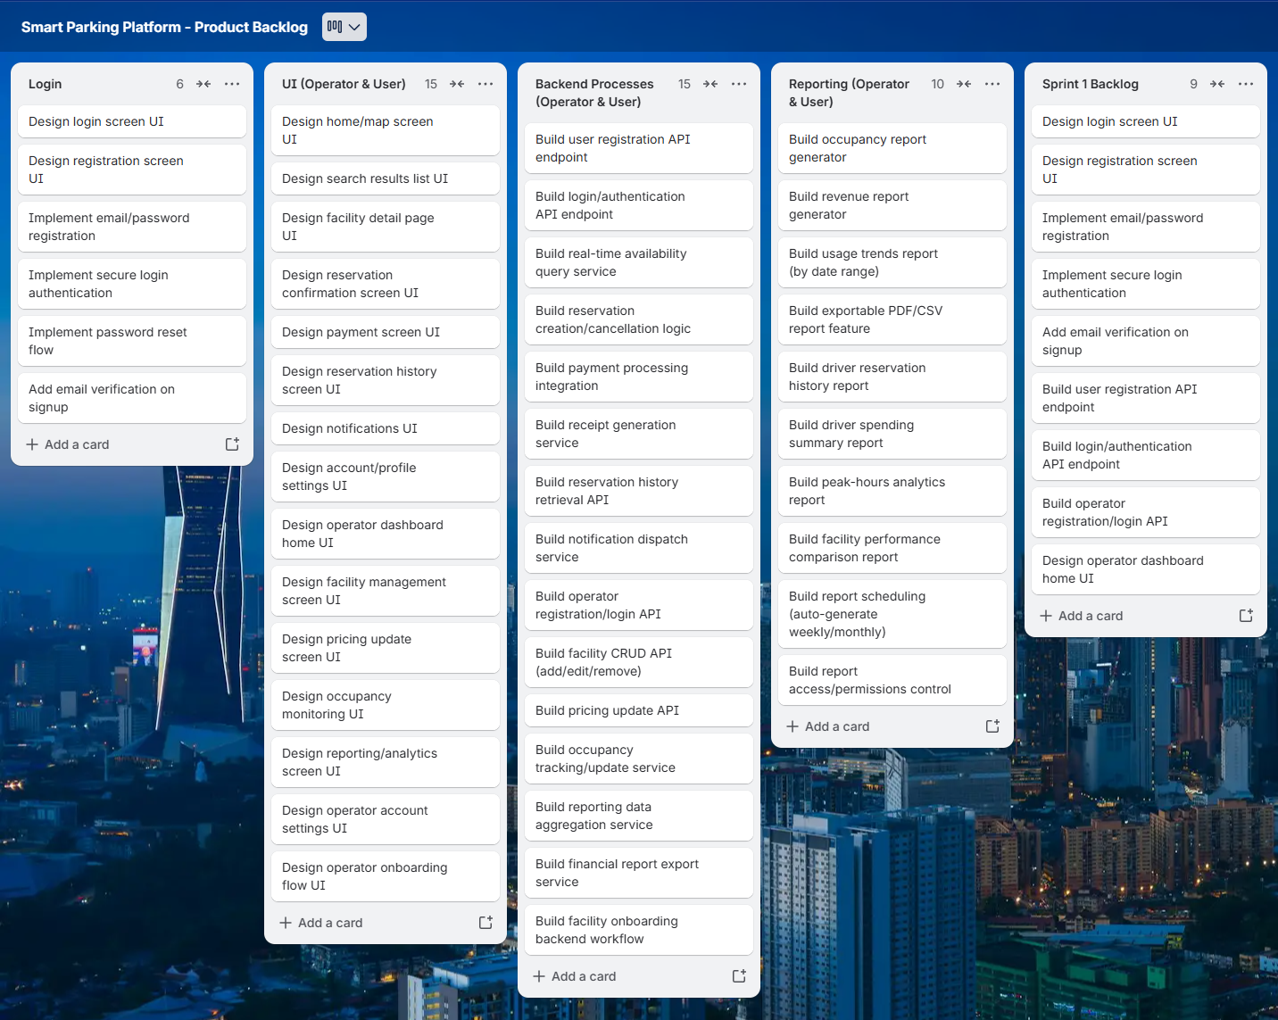
Figure 2 Smart Parking Platform Trello Backlog and Sprint 1 Planning

Risk, Quality, and Communication Management
Identified Risks:
Technical:
- Third-party mapping/navigation API downtime or unreliability
- Payment provider integration failure or unexpected API changes
- Real-time occupancy data sync issues between facility sensors and the platform
- Mobile app compatibility issues across iOS/Android versions
Schedule:
- Payment integration takes longer than estimated due to gaps in third-party API documentation
- Operator Dashboard delayed since it depends on driver-side reservation logic being finished first
- Testing uncovers bugs that push back the release date
- Scope creep from stakeholders requesting mid-project feature changes
Financial:
- Third-party API costs (mapping, payment processing) exceed initial assumptions
- Need for additional QA/testing resources not originally planned
- Delays driving up labor costs despite the studio's theoretical unlimited budget
- Cost of meeting city compliance and data security requirements
People:
- Key developer leaves mid-project
- Miscommunication between the Mobile, Web, Backend, and Payment Integration teams causing duplicated or conflicting work
- Skill gaps in specialized areas like payment security compliance or mapping API integration
- Team conflict over feature prioritization between driver-side and operator-side work

