NAME BIBI RABBIA
04072313042
LAB TASK 4
PART 1 :
void step1() {
print('--- Step 1 ---');
var item1 = Dish();
item1.name = menu[u];
item1.price = priceOf(u);

var item2 = Dish();
item2.name = menu[(u + 1) % 10];
item2.price = priceOf((u + 1) % 10);
item2.price = item2.price - u;

print('Step 1: ${item1.name} Rs ${item1.price}');
print('Step 1: ${item2.name} Rs ${item2.price}');
}
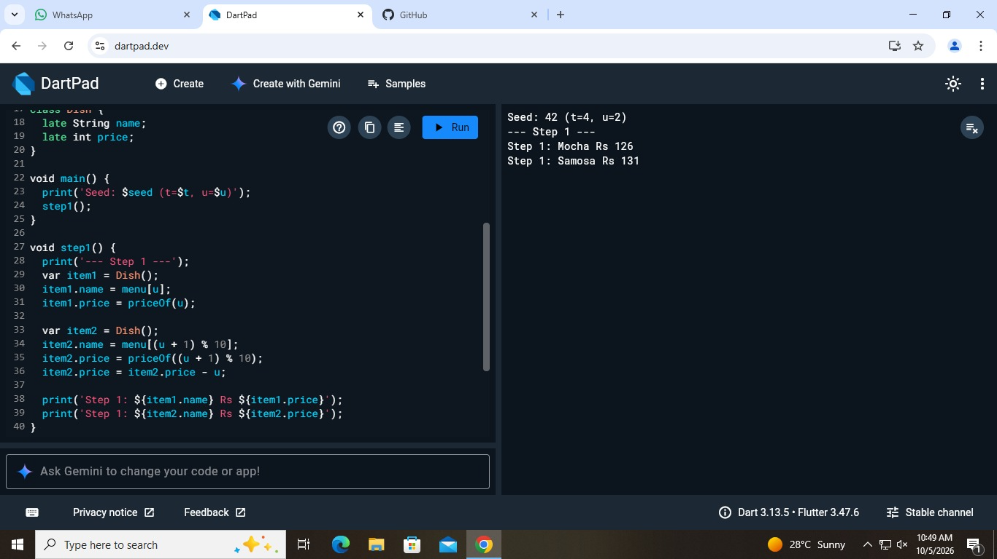

PART 2: void step2() {
print('--- Step 2 ---');
var a = MenuItem(menu[u], priceOf(u));
var b = MenuItem('Test Special', 15 * u);
print('Step 2: ${a.name} Rs ${a.price}');
print('Step 2: Test Special Rs ${b.price}');
}
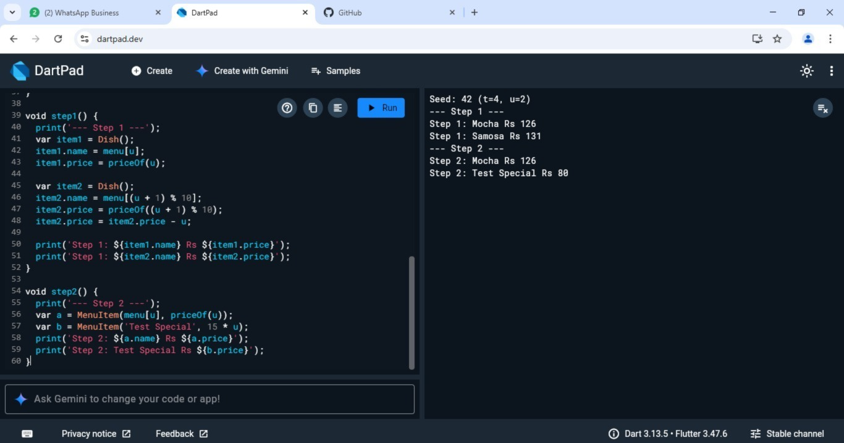

PART 3:
void step3() {
print('--- Step 3 ---');
var freebie = MenuItem.free('Water');
int i = (u + 2) % 10;
var parsed = MenuItem.fromString('${menu[i]}:${priceOf(i)}');
print('Step 3: ${freebie.name} Rs ${freebie.price}');
print('Step 3: ${parsed.name} Rs ${parsed.price}');
print('Step 3: floor=$priceFloor, free price=${freebie.price}');
}
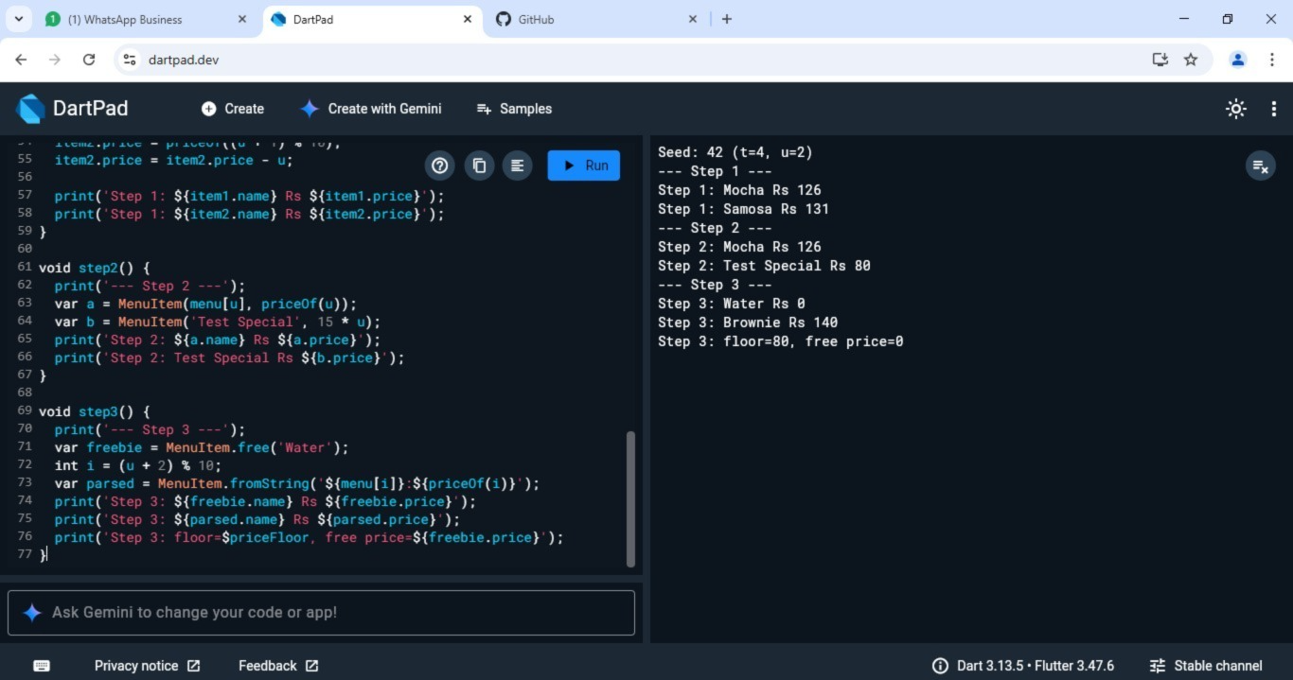

PART 4:
void step4() {
print('--- Step 4 ---');
var log1 = OrderLog();
var log2 = OrderLog();
for (int i = 1; i <= u + 2; i++) {
String msg = 'order #${100 * t + i}';
if (i.isOdd) {
log1.add(msg);
} else {
log2.add(msg);
}
}
print('Step 4: same object? ${identical(log1, log2)}');
print('Step 4: entries = ${log1.entries.length}');
print('Step 4: last = ${log2.entries.last}');
}
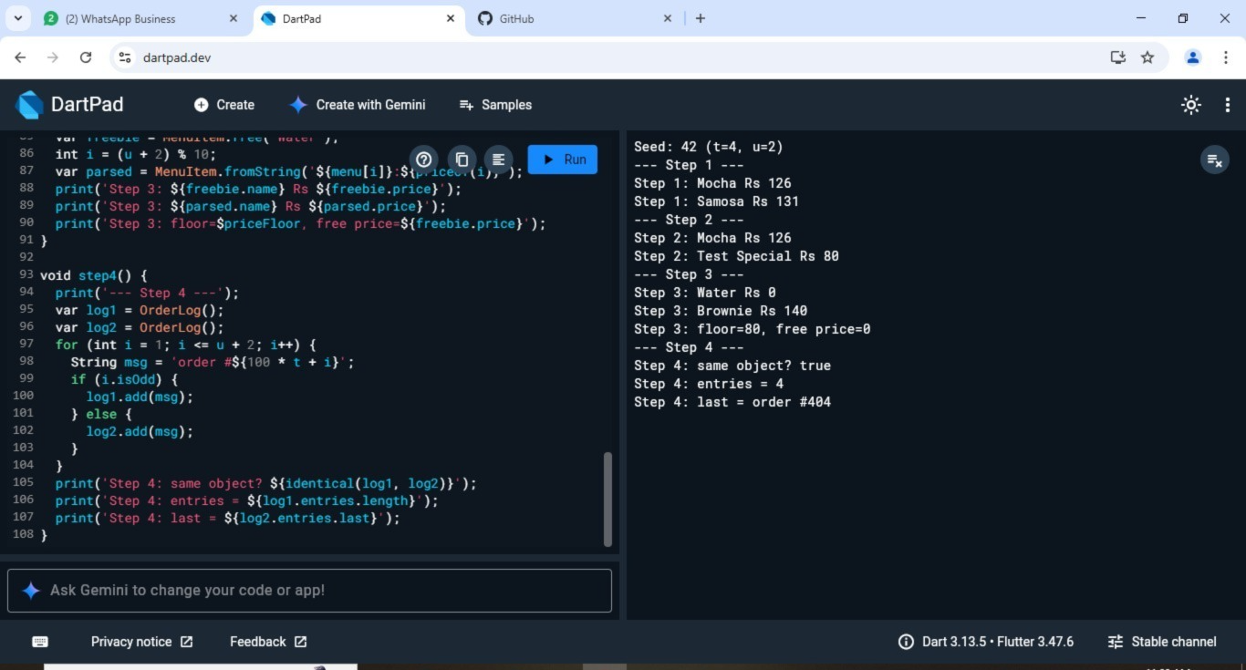

PART 5:
void step5() {
print('--- Step 5 ---');
var line = mainOrder();
print('Step 5: ${line.item.name} x${line.qty}');
print('Step 5: total=${line.total} tax=${line.tax}');
try {
OrderLine(line.item, 0);
print('Step 5: assert did NOT fire');
} on AssertionError {
print('Step 5: assert fired');
}
}
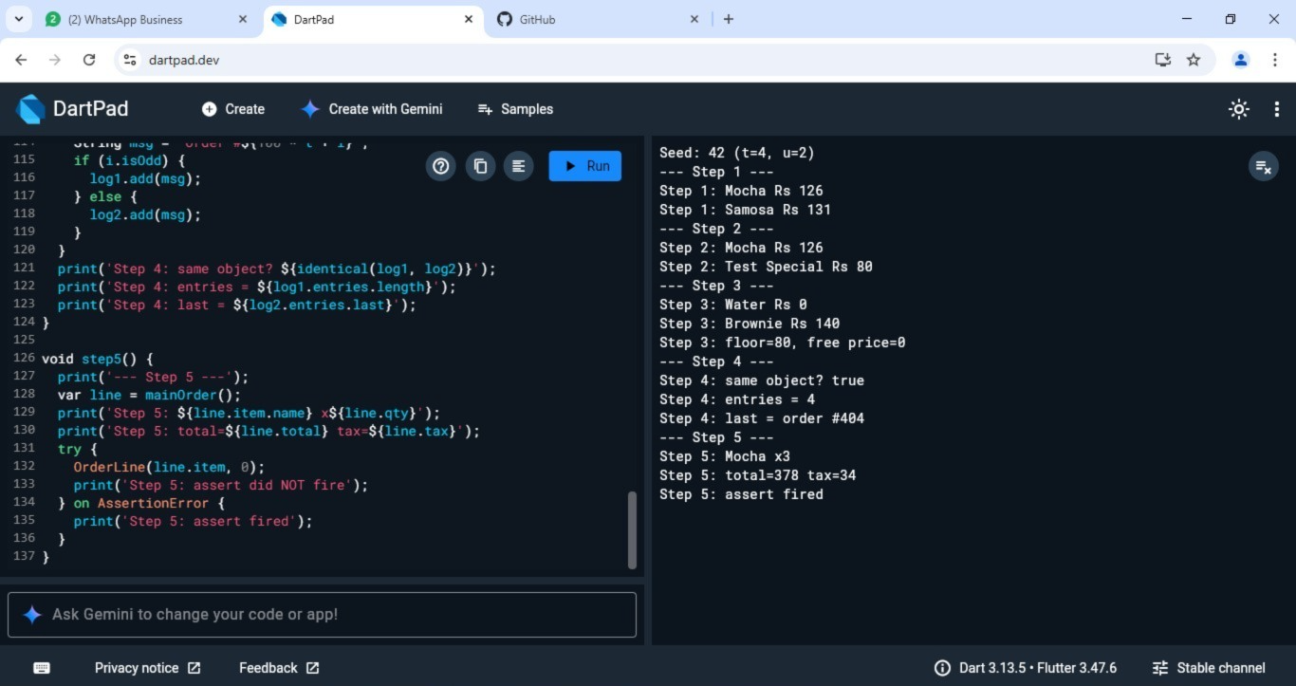

Part 6:
void step6() {
print('--- Step 6 ---');
var line = mainOrder();
print('Step 6: grand=${line.grand}');
print('Step 6: big order? ${line.isBigOrder} (limit $bigOrderLimit)');
print('Step 6: label=${line.label}');
}
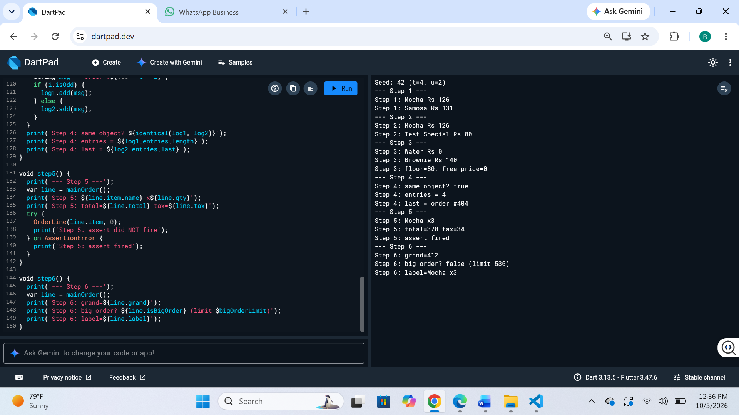

Part 7:
void step7() {
print('--- Step 7 ---');
var card = StudentCard('S$seed');

card.balance = seed * 10 + 50;
print('Step 7: topped up -> ${card.balance}');

card.balance = -seed - 1;
print('Step 7: bad value -> ${card.balance}');

card.balance = balanceCap - u;
print('Step 7: reset -> ${card.balance}');

card.balance = card.balance - mainOrder().grand;
print('Step 7: paid order -> ${card.balance}');
}

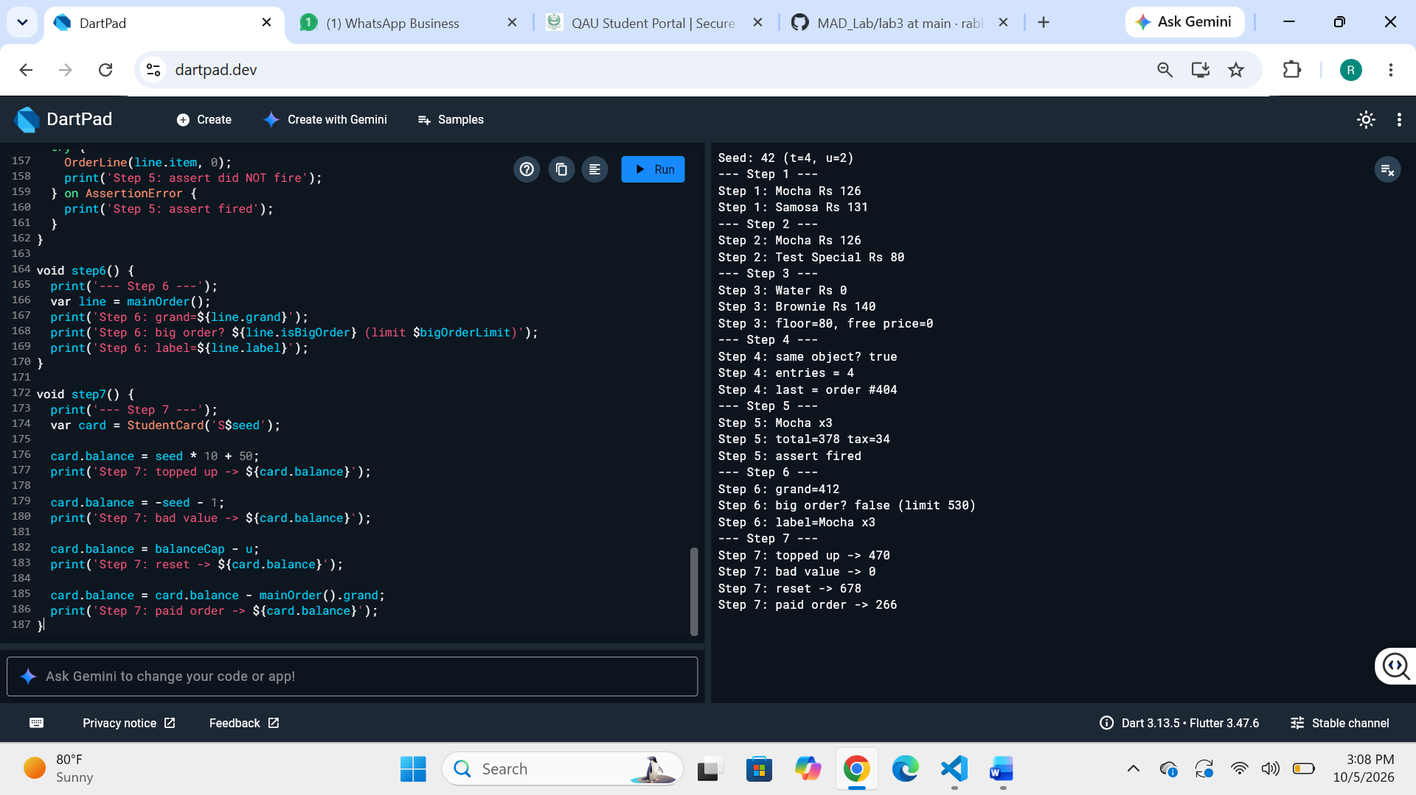
Part 8:
void step8() {
print('--- Step 8 ---');
var items = buildMenu();
var priciest = items.reduce((a, b) => a.price >= b.price ? a : b);
var sum = items.fold(0, (s, e) => s + e.price);
print('Step 8: menu = $items');
print('Step 8: priciest = ${priciest.name}');
print('Step 8: sum = $sum');
}
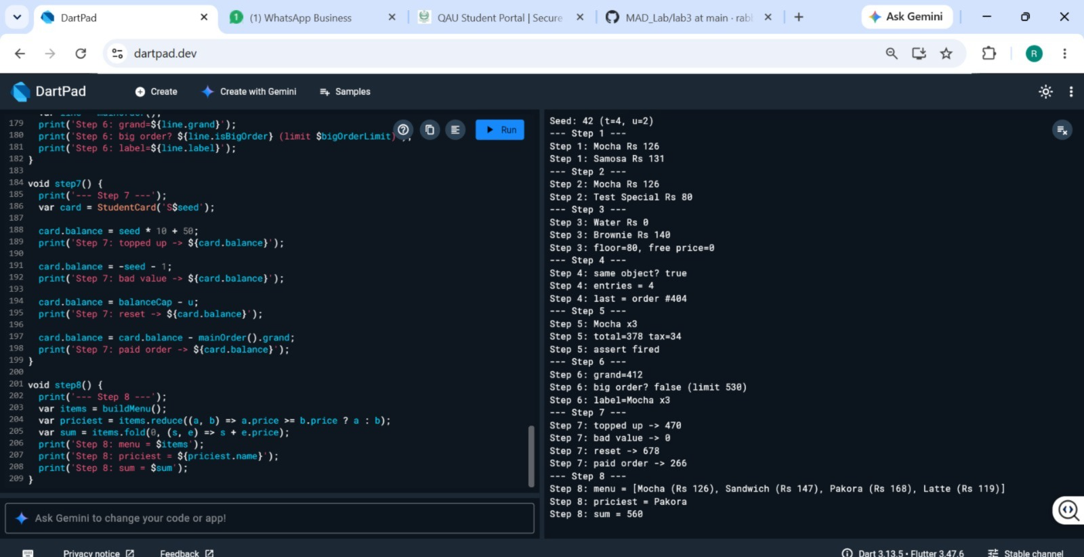

Part 9:
void step9() {
print('--- Step 9 ---');
var receipt = buildReceipt();
int sum = 0;
for (var line in receipt) {
print('Step 9: ${line.label} = ${line.grand}');
OrderLog().add('receipt: ${line.label}');
sum += line.grand;
}
print('Step 9: receipt total = $sum');
print('Step 9: log size = ${OrderLog().entries.length}');
}
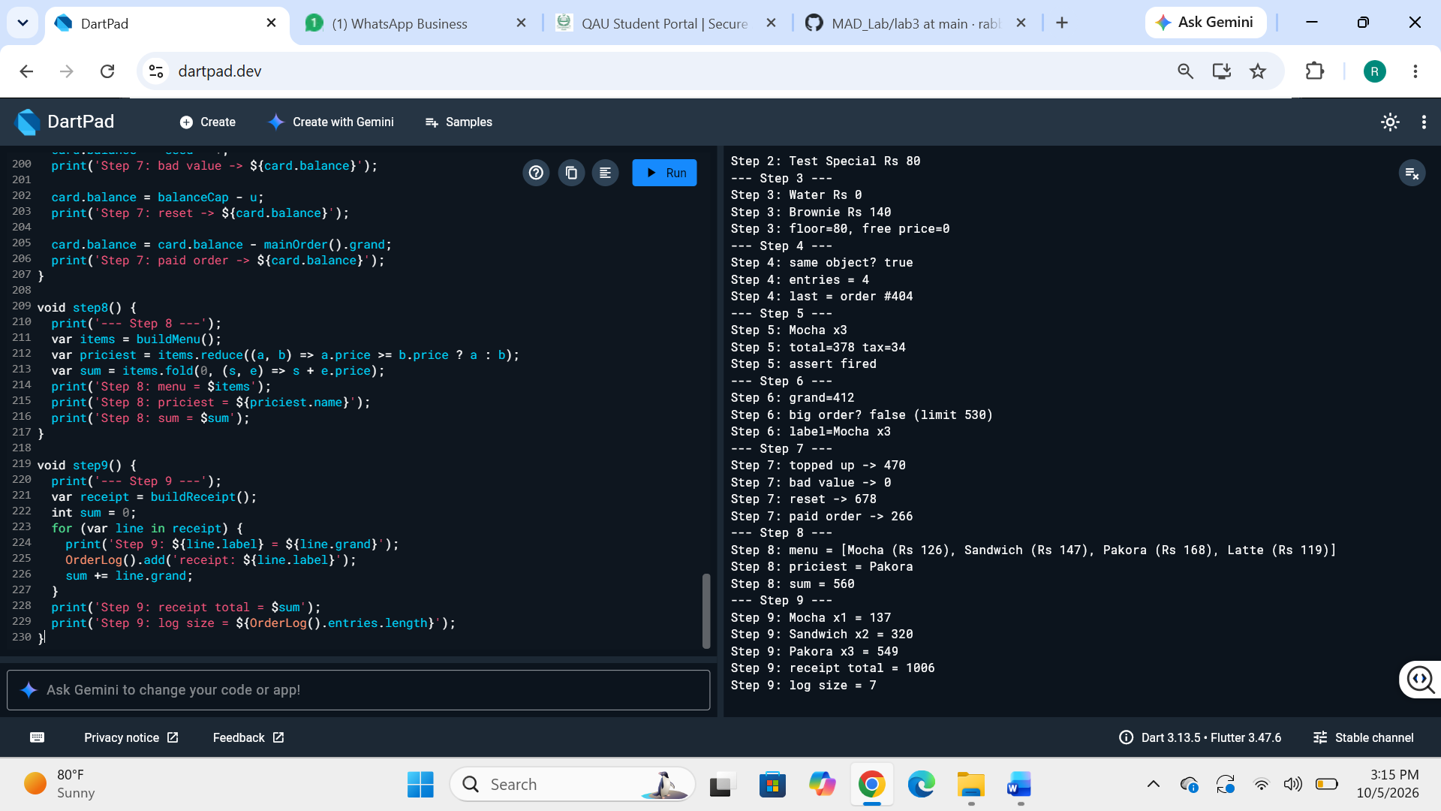

Part 10:
void step10() {
print('--- Step 10 ---');
var code = 'CAFE${seed.toString().padLeft(2, '0')}';
var c1 = Coupon.fromCode(code);
var c2 = Coupon.fromCode(code);
int receipt = buildReceipt().fold(0, (s, line) => s + line.grand);
int discount = c1.discountOn(receipt);
print('Step 10: ${c1.code} gives ${c1.percent}% off, min spend ${c1.minSpend}');
print('Step 10: cached? ${identical(c1, c2)}');
print('Step 10: receipt $receipt, discount $discount, payable ${receipt - discount}');
}
