Application: DragonFruit
An Intelligent Cybersecurity Assistant

Use Cases

Use Case: UI Preview
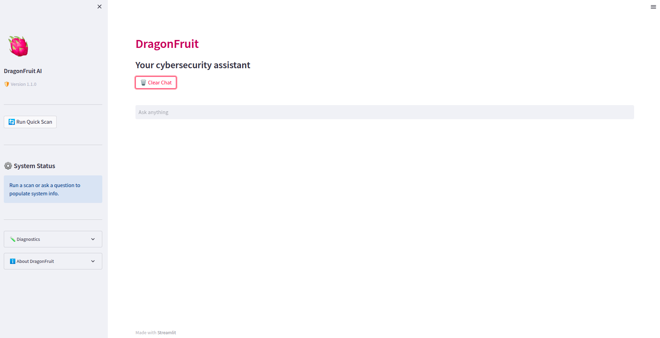

Use Case: AI response to a user query
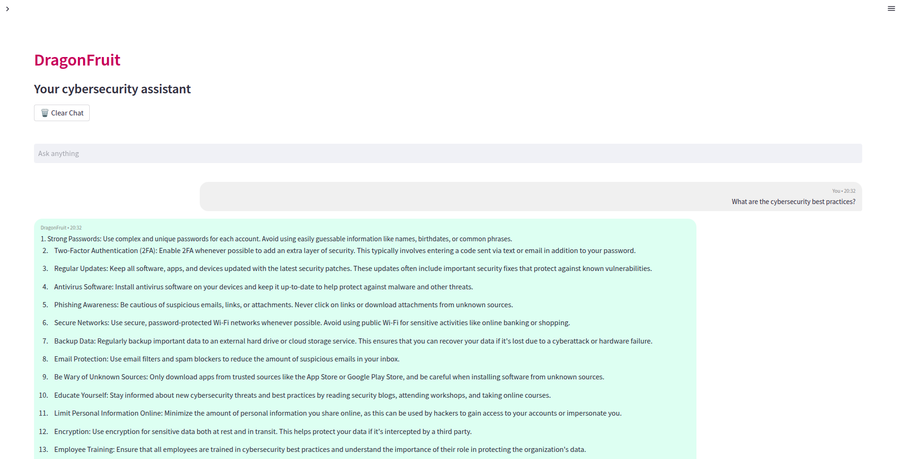

Use Case: Rule based response as detected by NLP
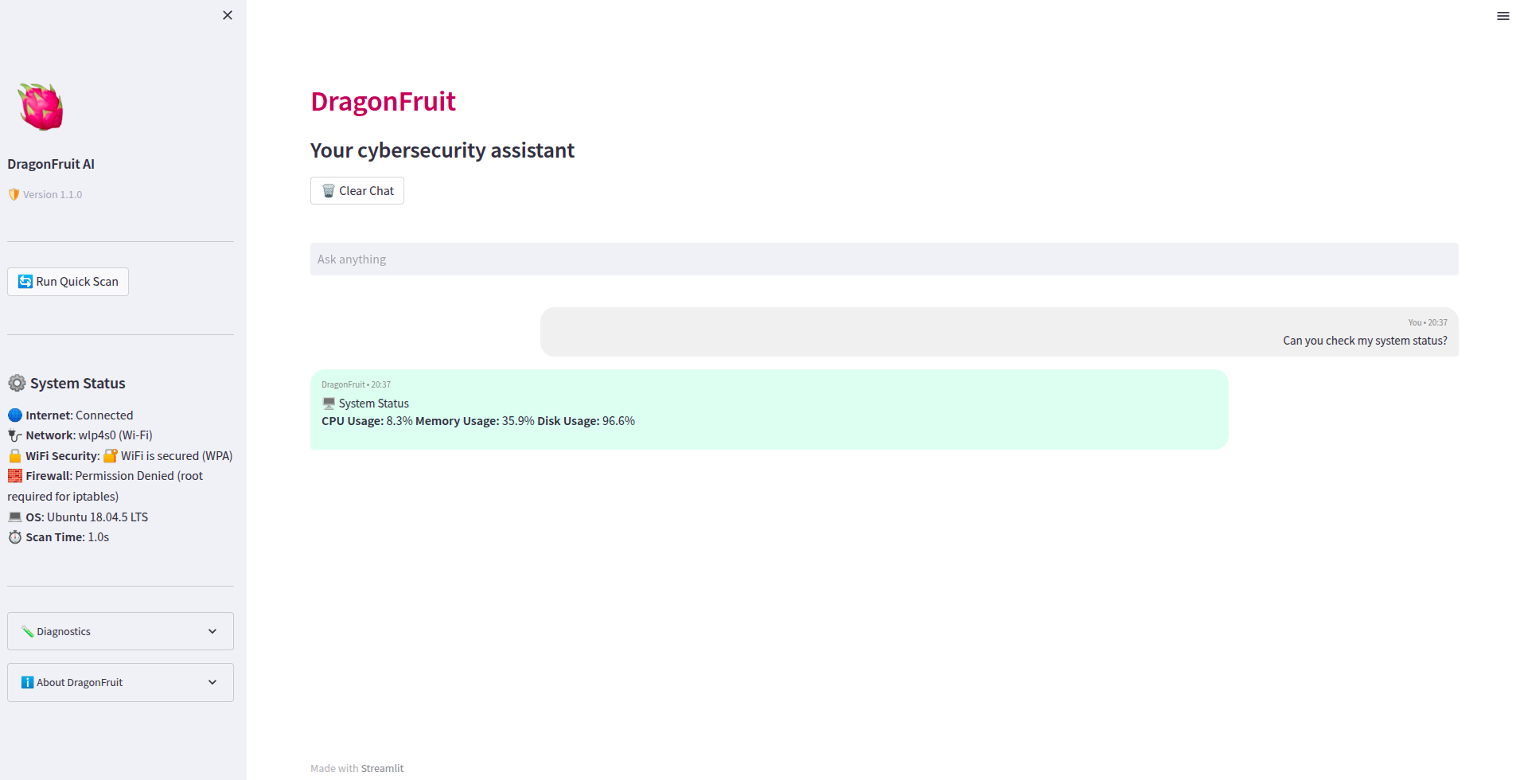

Use Case: Provides network watchdog report upon query
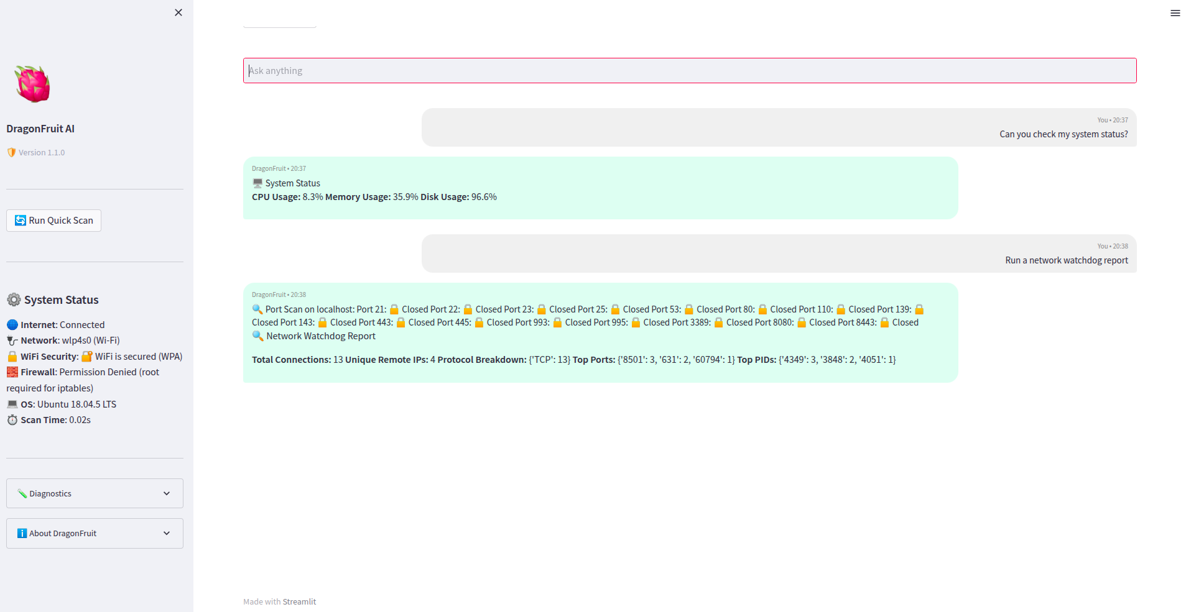

Use Case: Performs CVE lookup by CVE ID
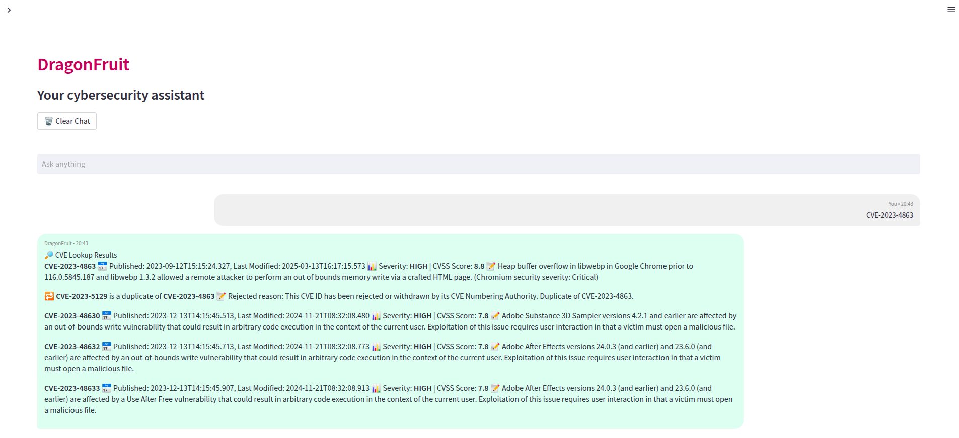

Use Case: About section
