Dataset Analysis Report
Reversible Data Perturbation for Privacy Preservation in IIoT Systems
Lightweight Reversible Perturbation for IIoT Telemetry
CCIP5920-S02 — Strategic AI Governance, Risk, and Compliance
Kadir Has University · Department of Cyber Security

Group Members
Rabbi Hasan Himel | Tayyaba Basri | Hamza Haroon
Supervisor: Doç. Dr. Emrullah Fatih Yetkin
March 10, 2026

1. Problem Definition
What is the problem? Modbus is one of the oldest industrial communication protocols still in use today, and it was never designed with security in mind. In industrial IoT (IIoT) environments, this creates a real problem: sensors, PLCs, and actuators are constantly pushing telemetry data — temperatures, pressures, register states — to cloud platforms, often over networks that can be intercepted. Anyone who manages to intercept that traffic does not just see noise; they can see the exact operational parameters of a factory or power plant. That is the kind of information that reveals manufacturing recipes and process setpoints, which is essentially a company's intellectual property.
Our project looks at this from a different angle than traditional encryption. Instead of using AES or something computationally expensive (which legacy PLCs often cannot handle), we apply a method called Reversible Data Perturbation (RDP). The idea is simple: before the data leaves the factory, we scramble it using a bitwise XOR operation with a pseudo-random key. Anyone intercepting the data sees random noise. At the trusted cloud endpoint, the same key is used to reverse the scrambling and recover the original values perfectly — no information loss at all.

1.1 What kind of problem is this?
At its core this is a binary classification problem. Each record in the dataset is either normal traffic (label = 0) or attack traffic (label = 1). We test the classification under three different scenarios to validate our perturbation method:
- Baseline: Train and test on raw, unperturbed data. This gives us the upper bound on how well the data can be classified.
- Attacker view: Test the trained model on XOR-perturbed data. If the perturbation is working, classification accuracy should collapse to around 50% — the same as random guessing.
- Cloud (restored) view: Apply the reverse XOR and test again. Accuracy should return to the baseline level, confirming perfect data recovery.

1.2 Tools and libraries
We are working in Python. For the ML side we use scikit-learn (Random Forest classifier, train/test split, accuracy metrics). For the statistical and frequency analysis we use pandas and numpy for data handling, scipy.signal for Welch PSD and STFT, and scipy.fft for the FFT analysis. All visualizations are done in matplotlib.

1.3 Feature extraction
The four Modbus register columns (FC1–FC4) are the features. They are already 16-bit integers in the range 0–65535, which is exactly the format XOR operates on natively — so no feature engineering or normalization is needed for the perturbation step. For the frequency-domain analysis in this report we extract spectral centroid, entropy, band power, roll-off frequency, and bandwidth from each register.

1.4 Privacy approach
This dataset does not contain personal data, so the privacy concern here is operational — protecting process parameters from being reverse-engineered by competitors or attackers. Our XOR-based RDP handles this at the edge: the PLC scrambles the data before transmission, and only the trusted cloud (holding the shared secret seed) can recover it. From the attacker's perspective the intercepted stream looks statistically identical to random noise, which is exactly what the experiments in this report confirm.

1.5 Explainability
Since we are using Random Forest, we can extract feature importance scores after training. This tells us which of the four Modbus registers contribute most to distinguishing normal from attack traffic, which gives a reasonable level of explainability for the model without needing more complex techniques like SHAP or LIME.

2. Dataset

2.1 Where the data comes from
We are using the TON_IoT Modbus dataset, which was put together by researchers at the University of New South Wales (UNSW) in Australia as part of a larger project to create realistic IIoT network traffic datasets for cybersecurity research. It is publicly available at https://research.unsw.edu.au/projects/toniot-datasets. The specific file we are using is Train_Test_IoT_Modbus.csv.
What makes this dataset useful for our purpose is that it was captured from a real testbed simulating industrial Modbus traffic, including both normal operation and several types of injection attacks. The fact that it was already released publicly for research purposes is itself a good motivation for our scenario — the same pipeline we are proposing (perturb during transmission, restore at the cloud, release sanitized data) is essentially what UNSW did when creating this dataset.

2.2 Dataset structure
The file contains 31,106 rows and 8 columns. The four feature columns are the Modbus function code registers, and the other columns are metadata and labels.

Column | Data Type | Description
FC1_Read_Input_Register | 16-bit integer | Analog sensor input reading
FC2_Read_Discrete_Value | 16-bit integer | Digital/discrete register value
FC3_Read_Holding_Register | 16-bit integer | Holding register (process setpoints)
FC4_Read_Coil | 16-bit integer | Coil/output register state
label | Binary (0 / 1) | 0 = normal, 1 = attack
type | String | Attack category (injection, normal, etc.)
date / time | String | Timestamp of the record
Table 1 — Dataset column overview

2.3 Class balance
The dataset has 15,000 normal records (48.2%) and 16,106 attack records (51.8%). That is close enough to balanced that we do not need to do any oversampling or class weighting — the classifier will not be biased toward one class just because of data imbalance. Figure 1 shows the class split and the attack type breakdown.
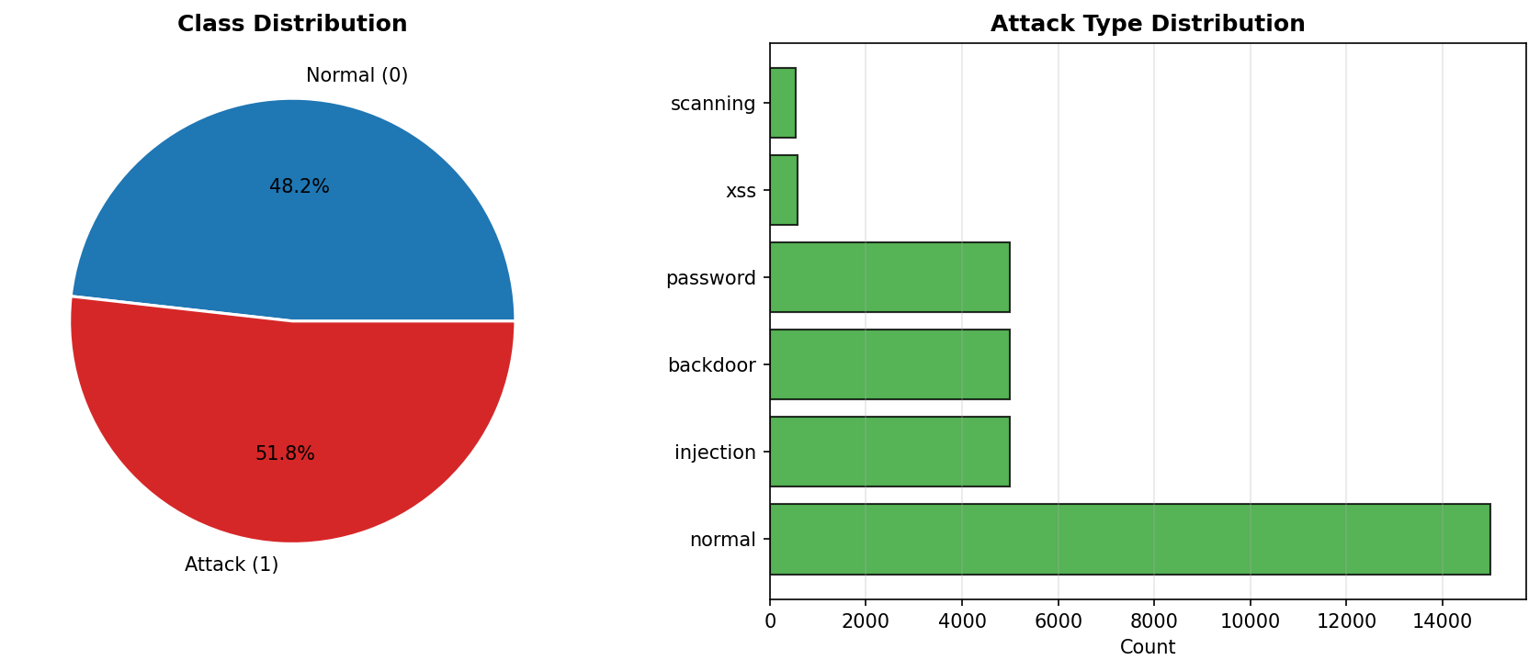
Figure 1 — Class distribution (left) and attack type counts (right)

3. Statistical Examination

3.1 Descriptive statistics
Before doing anything else with the data, we looked at the basic descriptive statistics for all four registers. The numbers in Table 2 tell an interesting story: all four registers have means that sit right around 32,700–32,800, which is basically the midpoint of the 16-bit range (0–65535). The skewness values are all extremely close to zero, and the kurtosis is consistently around -1.19. A negative kurtosis like that is called platykurtic — the distribution is flatter than a normal distribution, with lighter tails. That pattern makes sense for data that is spread fairly uniformly across a large value range rather than clustering around a center.

Register | Mean | Std Dev | Variance | Min | Max | Skewness | Kurtosis | Median
FC1 Input | 32,833 | 18,827 | 3.54×10⁸ | 0 | 65,510 | 0.014 | -1.184 | 32,310
FC2 Discrete | 32,781 | 18,969 | 3.60×10⁸ | 0 | 65,535 | 0.002 | -1.190 | 32,692
FC3 Holding | 32,582 | 18,858 | 3.56×10⁸ | 0 | 65,523 | 0.014 | -1.196 | 32,155
FC4 Coil | 32,805 | 18,796 | 3.53×10⁸ | 0 | 65,534 | 0.001 | -1.188 | 32,776
Table 2 — Descriptive statistics for all four Modbus registers

One thing worth noting is the variance — all four registers have variance in the range of 3.5×10⁸. That is a very high spread relative to the mean, confirming that register values jump around a lot. This is actually a good property for our XOR perturbation, because when values are already spread out like this, it is much harder for an attacker to tell whether the values they are seeing are real sensor readings or scrambled noise.

3.2 Temporal patterns
Figure 2 shows the first 2,000-time steps of each register. Looking at the plots, there is no obvious upward or downward trend, no smooth oscillation, and no repeating pattern. The values jump irregularly between low and high, which is consistent with what you would expect from industrial register data that reflects process state changes and control commands rather than a continuous physical signal like temperature gradually rising.
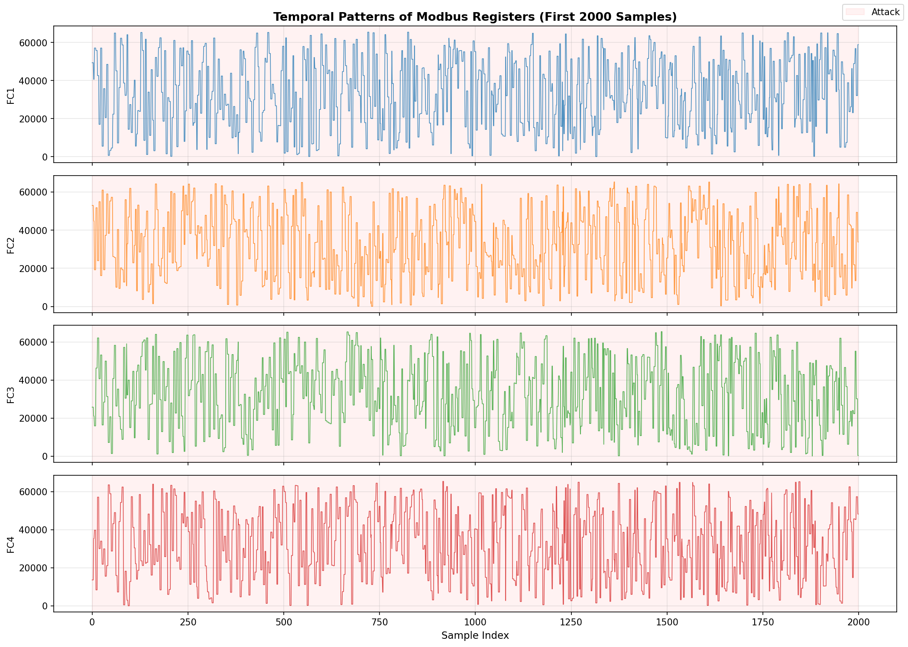
Figure 2 — First 2,000 samples of each register over time

3.3 Stationarity
To check stationarity, we plotted rolling mean and rolling standard deviation with a window of 500 samples (Figure 3). For all four registers, the rolling mean stays roughly flat throughout the full observation period, and the rolling standard deviation is stable. That is a good indication of weak-sense stationarity — the statistical properties of the signal are not changing over time, which simplifies a lot of modeling assumptions.
We also ran a formal Augmented Dickey-Fuller (ADF) test on each register. The ADF statistic tests the null hypothesis that the series has a unit root (i.e., is non-stationary). All four registers returned ADF statistics well below the 1% critical value of −3.43, with p-values of 0.000 for FC1, FC2, FC3, and FC4. This strongly rejects the unit root hypothesis and confirms that all four features are stationary. No differencing or detrending is required before modeling. The variance ratio (Var of first differences / Var of original) came out to 0.56–0.58 for all registers, consistent with this finding.
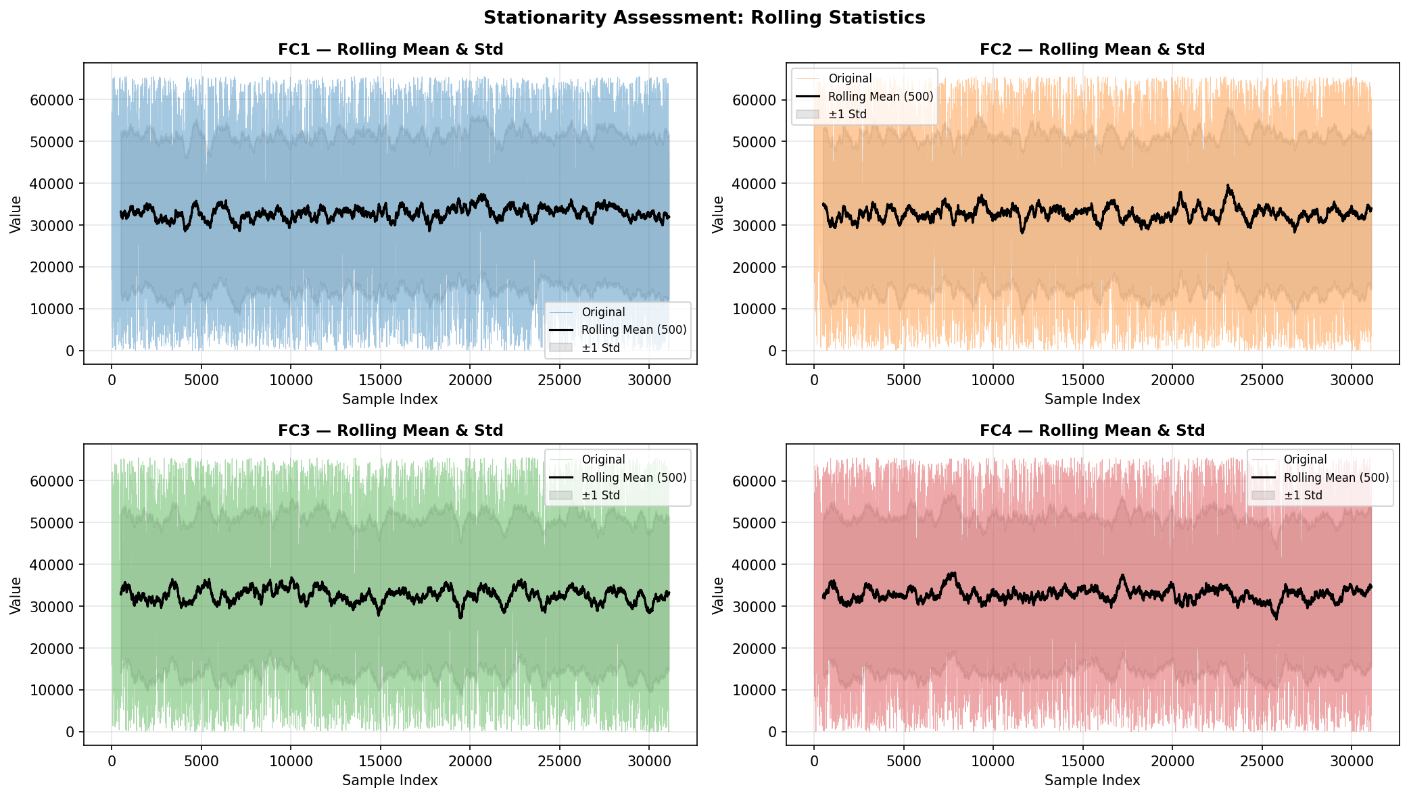
Figure 3 — Rolling mean and ±1 std deviation (window = 500 samples)

3.4 Autocorrelation and partial autocorrelation
Figure 4 shows the ACF and PACF plots for all four registers, computed up to lag 80. The ACF is computed directly from the autocorrelation function; the PACF is computed using the Levinson–Durbin recursion, which gives the true partial autocorrelation at each lag by removing the effect of all intermediate lags. The ACF shows a significant value at lag 1 (approximately 0.57) and lag 2 (approximately 0.35), decaying quickly to near zero by lag 3–4. The PACF is significant only at lags 1 and 2, which is the signature of a short-memory AR(1)–AR(2) process. Beyond lag 4, all values fall within the 95% confidence bounds (red dashed lines at ±1.96/√n).
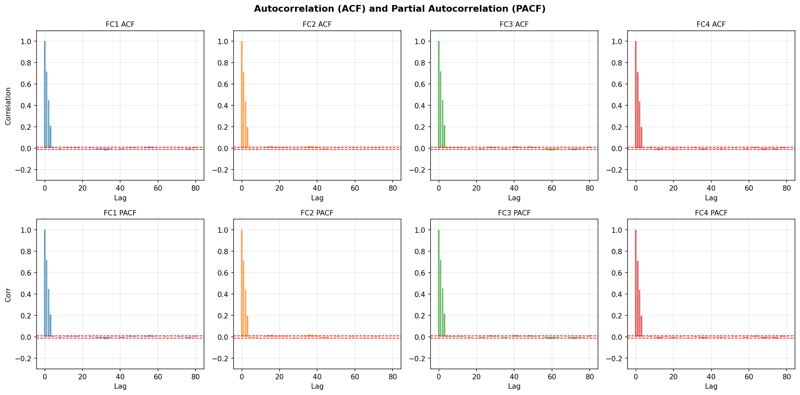
Figure 4 — ACF (top row) and PACF (bottom row) for all registers, up to lag 80
For modeling, this short-memory AR(1)–AR(2) structure means that a small sliding window of 2–3 samples captures all meaningful temporal dependencies. A Random Forest treating rows as independent observations is a valid baseline. The short memory also means an attacker cannot exploit autocorrelation to reconstruct perturbed values from the stream.

3.5 Seasonality, trends, and structural breaks
There is no seasonal component in this data. There are no weekly cycles, no time-of-day patterns, nothing like that. The most meaningful "structural" feature is actually the difference between the normal and attack states, shown in Figure 5. While both classes span the full register range, you can see subtle density differences — the attack distribution tends to cluster slightly differently compared to normal. This is what the classifier picks up on.
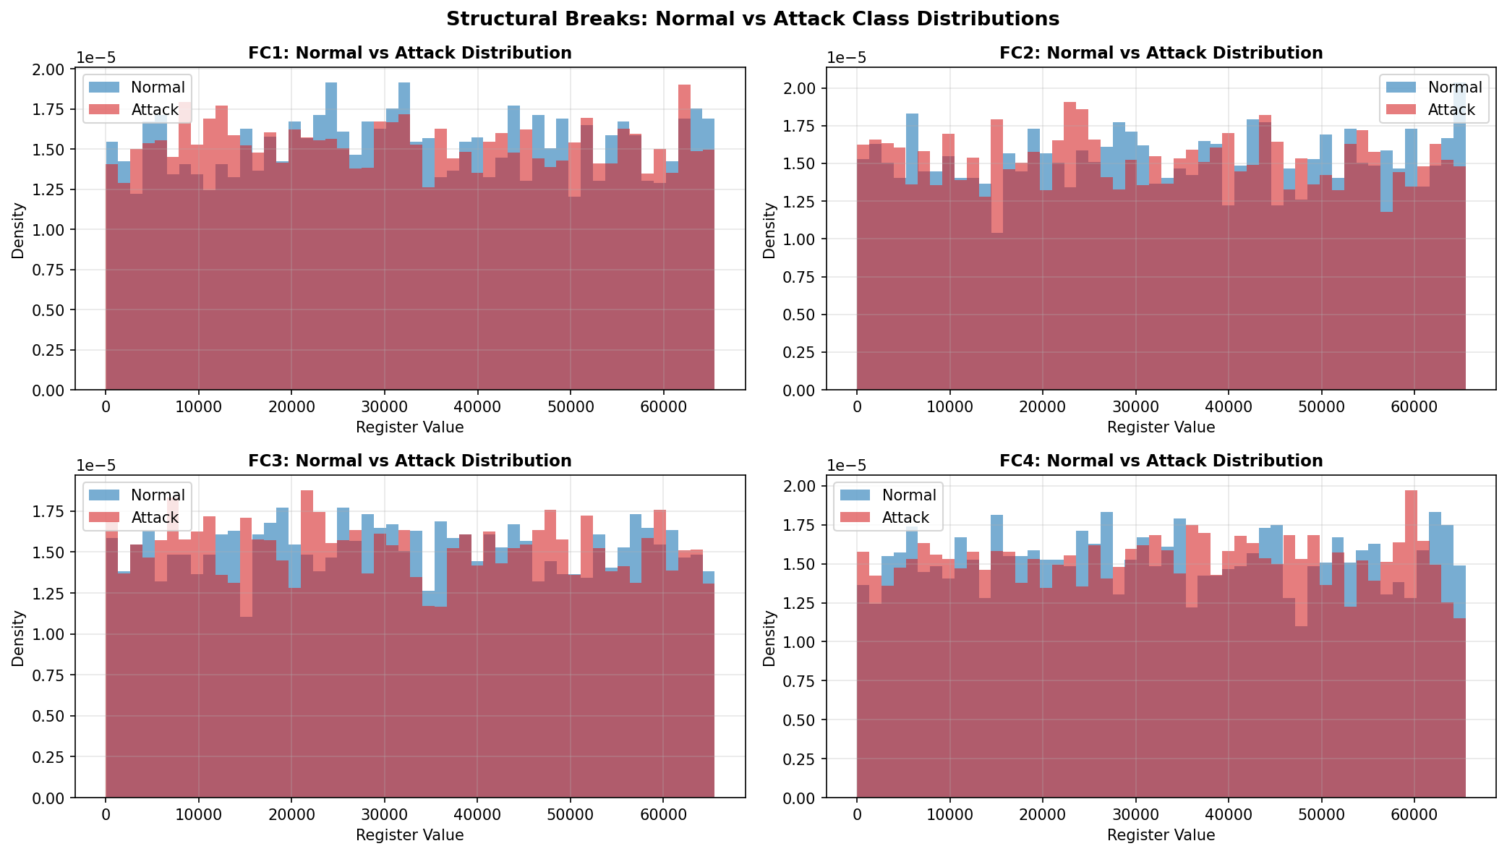
Figure 5 — Normal (blue) vs attack (red) distributions for each register

3.6 Distributional analysis and outlier detection
Figure 6 shows histograms and boxplots for each register. The histograms confirm what the descriptive stats already suggested — the values spread out fairly evenly across the 0–65535 range with no strong peak at any particular value. The boxplots show Q1 around 16,500 and Q3 around 49,000, so the data really does cover most of the range. There are very few statistical outliers because the whiskers stretch far out given the high variance, so individual extreme values are not really "extreme" in the context of this dataset.
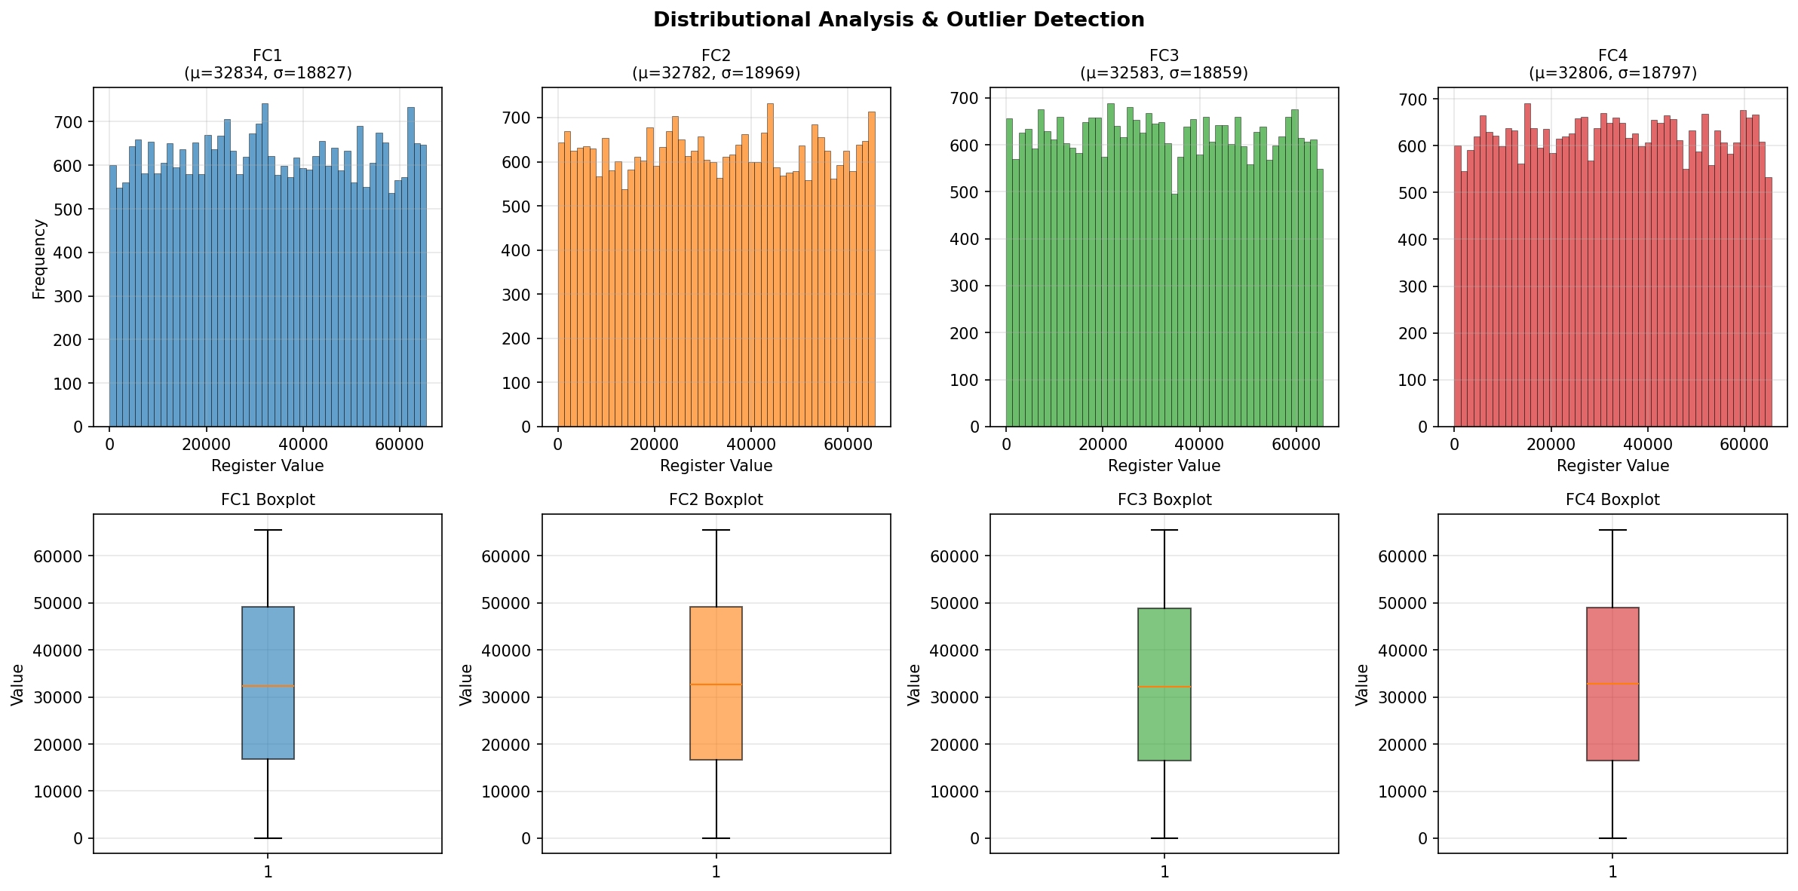
Figure 6 — Histograms and boxplots for all four registers

4. Frequency-Domain Analysis

4.1 Power spectral density — Welch's method
We used Welch's method (segment length 512, 50% overlap) to estimate the power spectral density of each register. Figure 7 shows the results on a log scale. The spectra are fairly flat across a wide frequency range with a modest concentration of energy at lower frequencies — there are no sharp dominant spikes, and nothing resembling a narrowband signal. This broadband, noise-like character is what we would expect from register data that is essentially changing quasi-randomly between time steps.
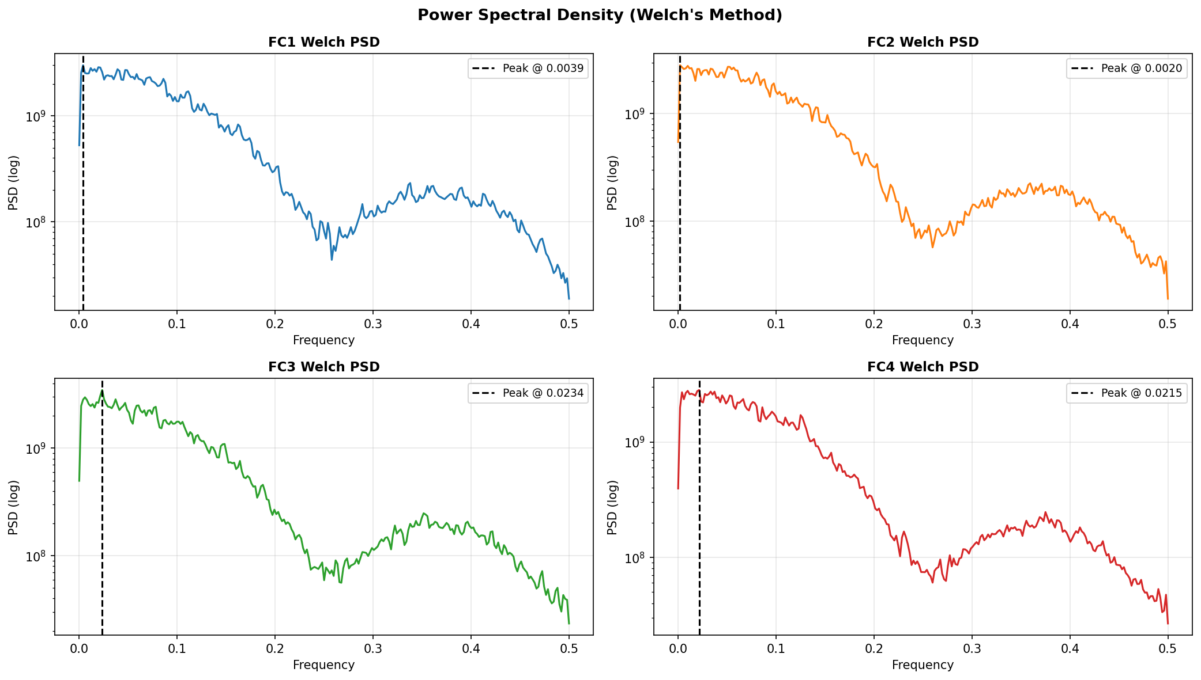
Figure 7 — Welch PSD estimates for all four Modbus registers

4.2 Dominant frequency components
The FFT analysis did pick out a dominant frequency for each register, but all of them are at very low normalized frequencies (below 0.06), meaning the highest-energy variations happen slowly over many time steps rather than rapidly. Table 3 lists the dominant frequency and corresponding magnitude for each register.

Register | Dominant Frequency | FFT Magnitude | What it suggests
FC1 | 0.0385 | 8.23 × 10⁶ | Slow drift in the signal
FC2 | 0.0026 | 9.01 × 10⁶ | Very slow, near-DC variation
FC3 | 0.0242 | 1.10 × 10⁷ | Low-frequency oscillation
FC4 | 0.0541 | 8.98 × 10⁶ | Slow variation, largest f
Table 3 — Dominant FFT components per register

4.3 FFT spectra and harmonic structure
Figure 8 shows the full FFT magnitude spectra on a log scale. There are no harmonic structures — no peaks at integer multiples of a fundamental frequency, which is what you would see in rotating machinery or periodic processes. The spectra just show a broad elevation at low frequencies that gradually rolls off. This is consistent with a process that does not follow a fixed cycle but instead responds to external commands and state changes.
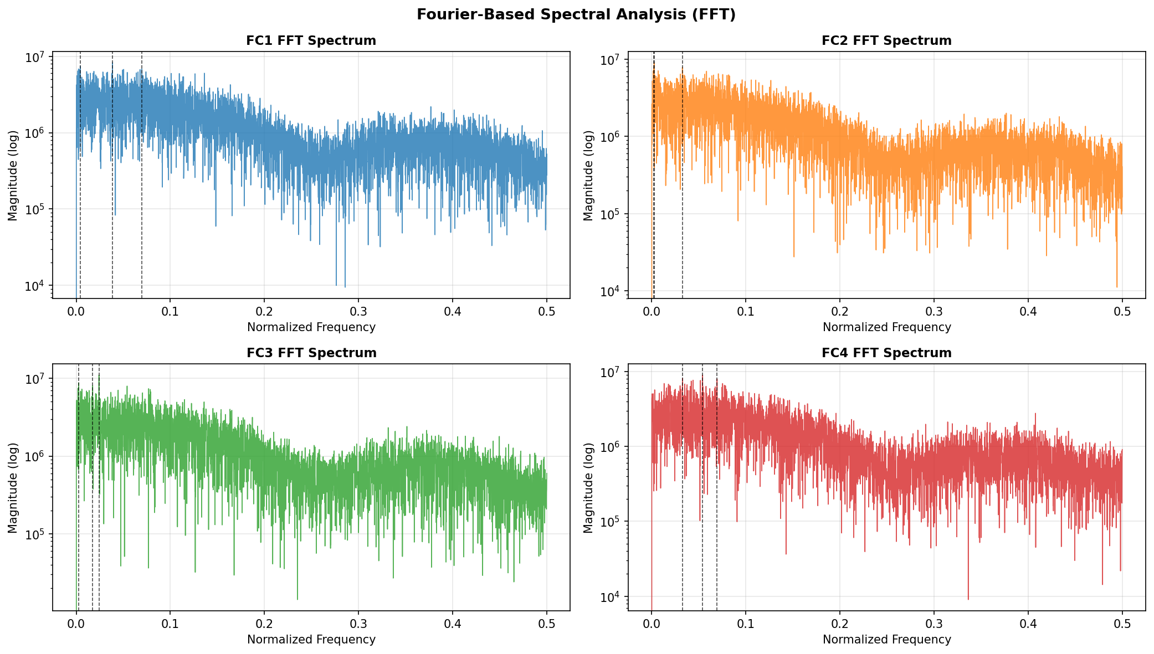
Figure 8 — FFT magnitude spectra (log scale) for all registers

4.4 STFT spectrograms
The STFT spectrograms in Figure 9 (nperseg = 256) give us a time–frequency view of the signal. The energy is spread relatively evenly across both dimensions — there are no bright spots indicating a burst of energy at a specific frequency and time. This is consistent with what the static FFT showed, and it also confirms that the attacks in this dataset do not leave a distinctive frequency-domain signature. They hide in the amplitude patterns rather than the frequency domain, which is part of why a frequency-based anomaly detector would struggle here.
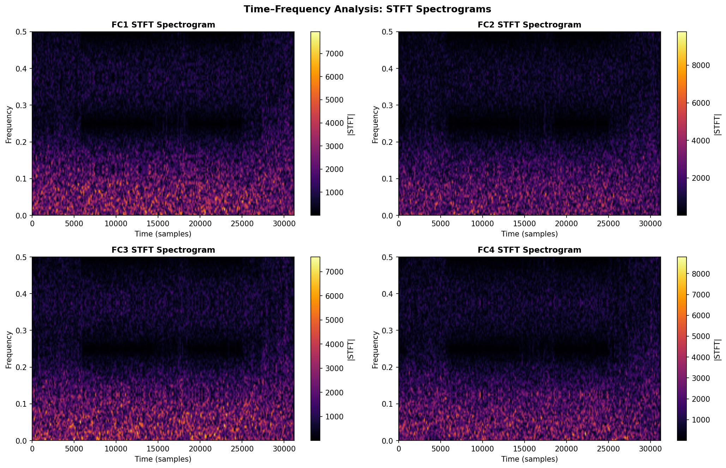
Figure 9 — STFT spectrograms for all four Modbus registers

4.5 Wavelet analysis
Given the findings above — stationary, broadband, no transients, no bursts — wavelet decomposition would not add much here. Wavelets are most useful when there are localized events or abrupt changes at multiple time scales, like in EEG or seismic data. The Modbus registers do not exhibit that kind of structure. The STFT already told us that the spectral content is stable across time, so multi-resolution wavelet analysis would essentially confirm the same thing at each decomposition level. We judged it was not worth including a figure that would just repeat the message.

4.6 Spectral feature extraction
We extracted seven spectral features from each register using the Welch PSD estimate. The results are in Table 4 and Figure 10. What stands out immediately is how similar all four registers are — the centroid, entropy, roll-off, and bandwidth are almost identical across FC1–FC4. This is not surprising given that the descriptive statistics were also very similar, but it does confirm that the registers behave as four statistically equivalent channels.

Register | Centroid | Entropy | BP Low | BP Mid | BP High | Roll-off | Bandwidth
FC1 | 0.1004 | 7.038 | 1.17×10¹¹ | 4.98×10¹⁰ | 1.35×10¹⁰ | 0.168 | 0.203
FC2 | 0.1014 | 7.050 | 1.18×10¹¹ | 5.13×10¹⁰ | 1.39×10¹⁰ | 0.168 | 0.203
FC3 | 0.0998 | 7.026 | 1.18×10¹¹ | 4.97×10¹⁰ | 1.37×10¹⁰ | 0.164 | 0.190
FC4 | 0.1019 | 7.054 | 1.15×10¹¹ | 5.15×10¹⁰ | 1.38×10¹⁰ | 0.168 | 0.199
Table 4 — Frequency-domain features per register (BP = band power, low < 0.1, mid 0.1–0.3, high > 0.3)

A few things are worth unpacking here. The spectral centroid sitting at around 0.10 means the center of gravity of the power spectrum is at about 10% of the Nyquist frequency — in other words the energy is weighted toward the lower end of the spectrum. The spectral entropy of about 7.03–7.05 is notably high, indicating that the power is spread fairly evenly across frequencies rather than being concentrated in a narrow band. This is close to what you would get from true white noise, which has maximum spectral entropy.
The band power breakdown shows that the low-frequency band (< 0.1) holds about twice as much energy as the mid band, and the mid band holds about 3–4× more than the high band. The 85% roll-off at around 0.168 means that most of the signal's usable energy is contained in the lower 17% of the frequency axis. This reinforces the FFT finding that these are slow-varying signals despite their apparently random appearance in time.
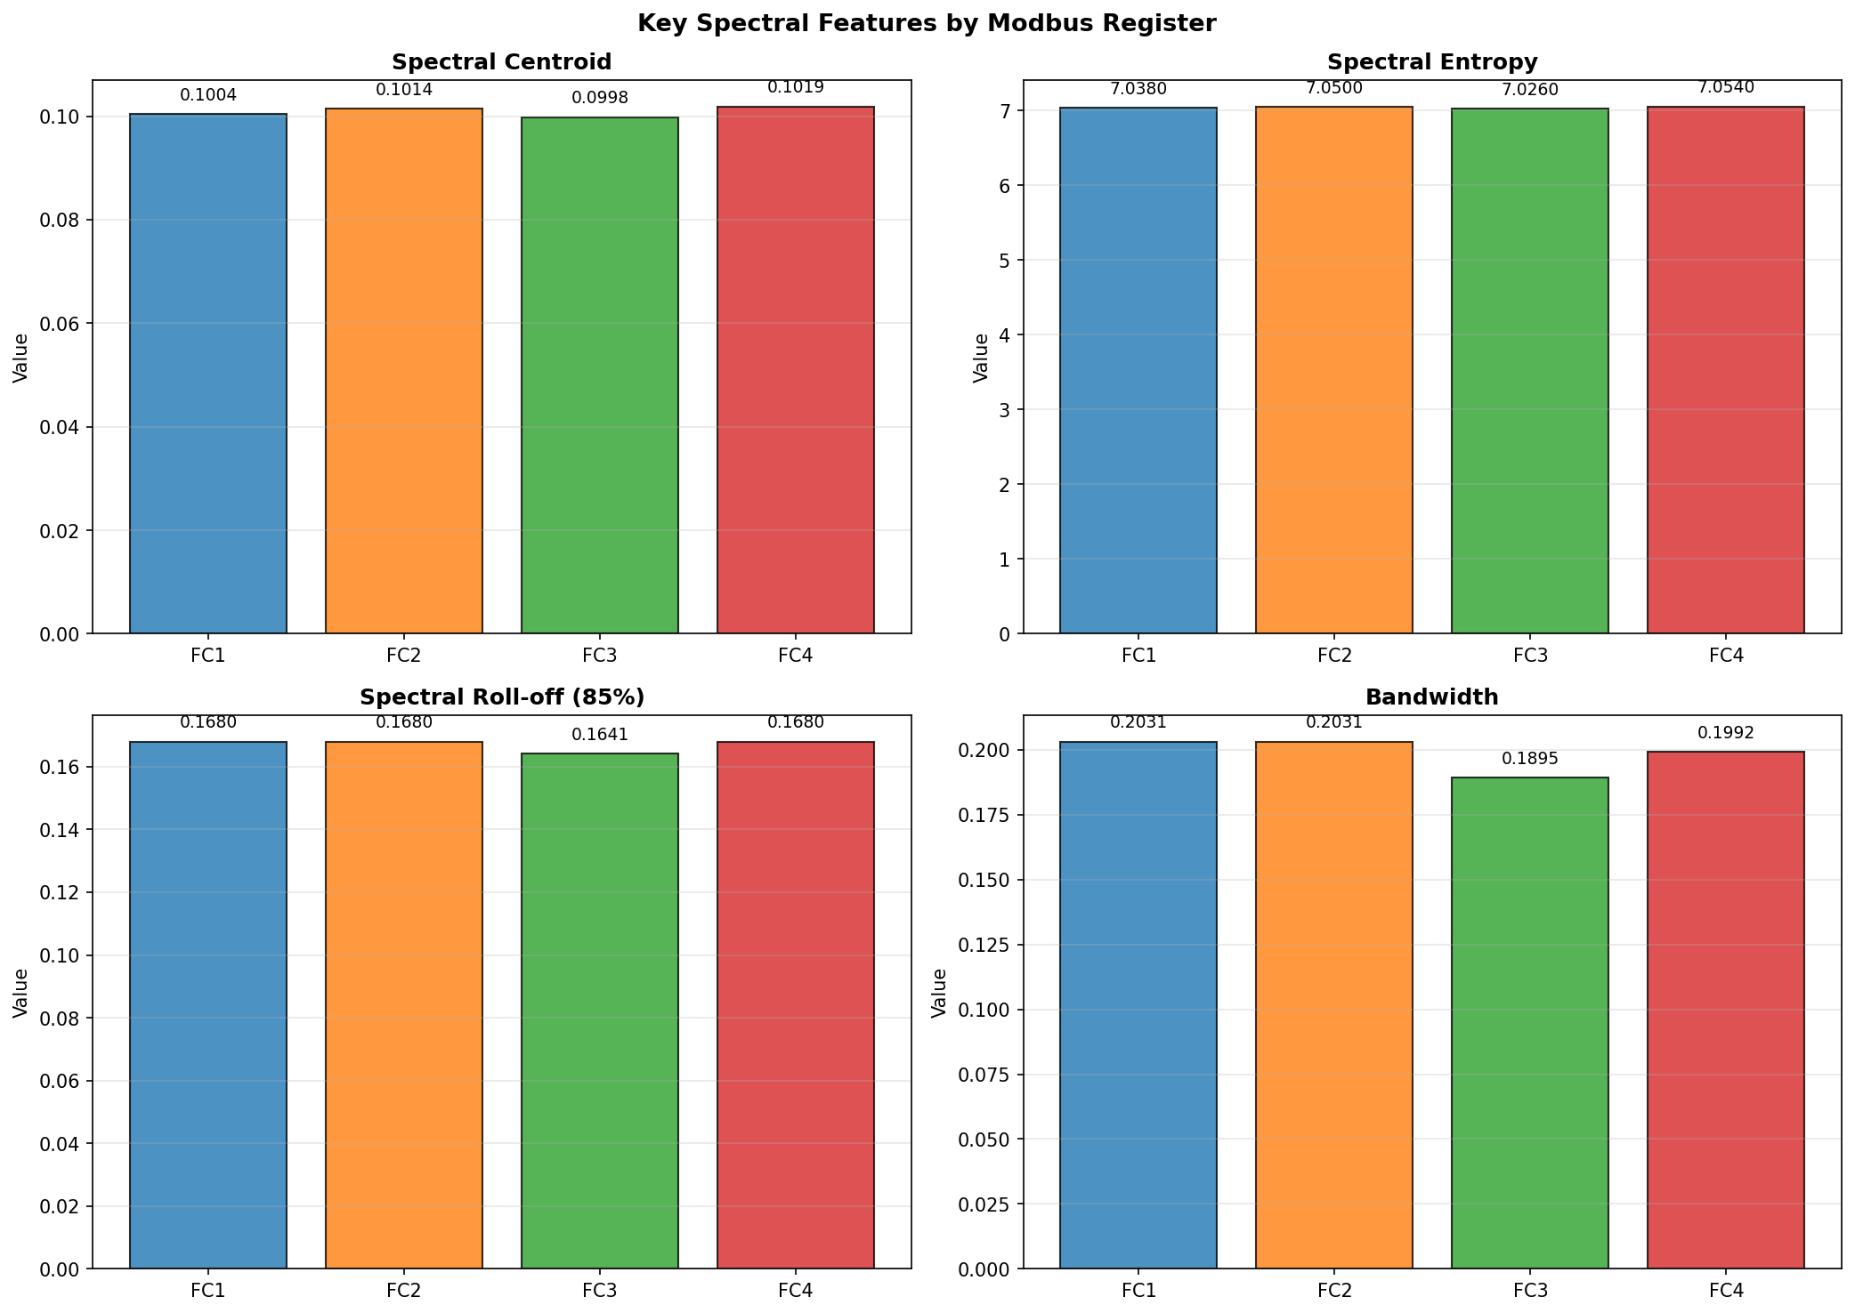
Figure 10 — Key spectral features across all four registers

5. What the Analysis Tells Us About Modeling
Taken together, the time-domain and frequency-domain analysis gives us a pretty clear picture of what we are working with and how we should approach the modeling.

5.1 Why Random Forest works here
The ACF and PACF analysis is the most important result for our modeling choice. The PACF is significant only at lags 1 and 2, confirming a short-memory AR(1)–AR(2) process. All autocorrelation decays to within the 95% confidence bounds by lag 4. This means that all temporal information is contained within a window of 2–3 samples, which is trivially small. A Random Forest treating each row as an independent observation is completely appropriate as a baseline, and if sliding-window features are added later, a window of 3 samples is sufficient to capture all relevant temporal structure.

5.2 Why the XOR method fits this data so well
Here is something interesting that the statistics reveal: the original register values are already distributed very close to uniformly across the 0–65535 range. When you apply XOR with a pseudo-random key stream (also uniformly distributed), the output is also uniformly distributed. That means the perturbed data looks statistically identical to the original data in terms of its distribution shape. An attacker who is trying to detect whether data has been tampered with by looking at histograms or descriptive statistics will see nothing unusual.
The high spectral entropy (≈7.04) of the original data also helps here. Since the spectrum is already nearly flat — close to white noise — XOR does not change the spectral character in any detectable way. There is no frequency-domain fingerprint that would give away the perturbation.

5.3 Summary of modeling decisions based on the analysis

What we found | How it shapes the approach
Short-memory AR(1)–AR(2) structure (significant ACF at lags 1–2 only) | Random Forest (baseline) valid; small sliding window (2–3 samples) captures all temporal dependency if needed
Balanced classes (48% / 52%) | No oversampling required; standard split is valid
Stationary time series | No differencing or detrending before training
Near-uniform value distributions | XOR output distribution matches original — no statistical fingerprint for attackers
High spectral entropy (~7.04) | Perturbed data is spectrally indistinguishable from unperturbed data
Attacks not visible in frequency domain | Amplitude-based features (raw register values) are the right choice for the classifier
All 4 registers have nearly identical stats | Include all four as features — none of them is redundant enough to drop
Table 5 — Mapping analysis findings to modeling decisions

One final point worth making explicitly: the fact that this dataset is already nearly uniform and high-entropy in both the time and frequency domain is not a coincidence. The TON_IoT dataset was designed to simulate realistic Modbus traffic, and real industrial registers behave this way because they encode process state values that can take any value in the register range depending on what the plant is doing. That is precisely the scenario our RDP method is designed for — and it is why this dataset is the right one to use for validating the approach.

References
[1] Alsaedi, A., Moustafa, N., Tari, Z., Mahmood, A., & Anwar, A. (2020). TON_IoT telemetry dataset: a new generation dataset of IoT and IIoT for data-driven intrusion detection systems. IEEE Access, 8, 165130–165150.
[2] Yetkin, E. F., & Ballı, T. (2025). Privacy Preservation for Machine Learning in IIoT Data via Manifold Learning and Elementary Row Operations. International Conference on Information Systems Security and Privacy, Vol. 2, 607–614. DOI: 10.5220/0013275000003899
[3] Hindistan, Y. S., & Fatih Yetkin, E. (2023). A Hybrid Approach With GAN and DP for Privacy Preservation of IIoT Data. IEEE Access, 11, 5837–5849. DOI: 10.1109/ACCESS.2023.3235969
[4] Moustafa, N. (2020). New Generations of Internet of Things Datasets for Cybersecurity Applications based Machine Learning: TON_IoT Datasets. eResearch Australasia Conference.

