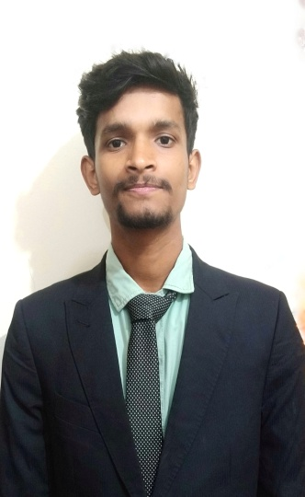 ***CURRICULUM VITAE***

***of***

# *SAGOR KUMAR BISWAS*

**Present Address: Kagmari,Baluhar-7330,Kotchandpur,Jhenaidah**

**E-mail : sagorraj2211@gmail.com**

**Contact No : 01822118939**

CAREER OBJECTIVE:

To pursue a challenging career at top-level management and utilize my skills and experiences to make extensive contribution to company`s long-term goal and to obtain a position in an organization where there is an opportunity to work in an environment of excellence and passion and where honesty,commitment,hard work and performances are the key factors of career development.

EDUCATIONAL QUALIFICATION:

**Bachelor of Businesses Administration (B.B.A)**

University : Islamic University,Khustia.

Major : Finance and Banking

Year : 2021-2022

Result : 3.75 (out of 4.00)

Duration : 4 Years

**Higher Secondary Certificate (HSC)**

Institute : Govt. Keshab Chandra College,Jhenaidah

Group : Business Studies

Result/GPA : GPA-4.57 (out of 5.00)

Passing Year : 2020

Board : Jessore

**Secondary School Certificate (SSC)**

Institute : Kagmari Secondary School

Group : Business Studies

Result/GPA : GPA-4.50 (out of 5.00)

Passing Year : 2018

Board : Jessore.

AWARDS AND SCHOLARSHIP:

1. Volunteered 5 days a week throughout March and April during the Covid-19 pandemic,organizing inventory and distributing food to families in need.
2. I got full free scholarship in Faculty of Business Administration in JIANGSHU UNIVERSITY,CHINA.

EXTRA CURRICULAR ACTIVITIES:

General Member,Islamic University Career Club

Higher leadership

Presentations

Contact with customers

Giving instructions

Making announcements

Believe in self-dignity

Well communication skill

**Computer Literacy:**

Operating Systems : Windows 98/2000/XP/7/8.1

Software Application :

Microsoft Word

Microsoft Excel

Microsoft PowerPoint

Digital Marketing(SEO,SEM)

Cloud Computing

Machine Learning and AI

Troubleshooting & Graphics Design.

Internet Access Capability :

Typing Speed 70 (per minutes)

Internet Browsing

E-mail Checking

**Language proficiency:**

English : Fluent in speaking and writing.

Bengali : Mother tongue.

**Hobbies:**

Traveling

Reading

Playing Cricket

Playing Football

PERSONAL DETAILS:

Name : SAGOR KUMAR BISWAS

Father’s Name : MAHADEB BISWAS

Mother’s Name : BEJLEE BISWAS

Date of Birth : 03.02.2002

Blood Group : B(+)

Nationality : Bangladeshi (by birth)

Mailing Address : Vill:Kagmari, P.O:Baluhar-7330, P.S:Kotchandpur,

Dist:Jhenaidah.

Permanent Address : Vill:Kagmari, P.O:Baluhar-7330, P.S:Kotchandpur,

Dist:Jhenaidah.

Religion : Hinduism

Sex : Male

Marital Status : Unmarried

REFERENCE:

**1. Dr. SUTAP KUMAR GHOSH**

Associate Professor

Department of Finance and Banking

Islamic University,Kushtia.

Cell Number:01722262048

Email :sutapkumarghoshfb1@gmail.com

**2.MITHUN BAIRAGI**

Lecturer

Department of Finance and Banking

Islamic University,Kushtia.

Cell Number:01722262049

Email :mithunbairagifb1@gmail.com

I hereby assure you that all the information supplied in this curriculum vitae is true,and if any inconsistency found then you have right to reject it.

Signature

I hereby assure you that all the information supplied in this curriculum vitae is true, and if any inconsistency found then you have right to reject it.

C:\Users\CF\AppData\Local\Temp\ksohtml5444\wps12.pngSignature