ADC0804 interfacing with 8051

Introduction
Analog to digital converters find huge applications as an intermediate device to convert the signals from analog to digital form. These digital signals are used for further processing by the digital processors. Various sensors like temperature, pressure, force, etc. convert the physical characteristics into electrical signals that are analog in nature.

ADC 0804
The ADC0804 is a converter from analog to digital 8 bits. This ADC0804 has only one analog input channel with digital output of eight bits that can be 256 values ​​of different measures. The step size is adjusted by setting the reference voltage in pin9 the reference input voltage can be adjusted to allow encoding any smaller range for the entire 8-bit resolution analog voltage. When the voltage reference pin is not connected to the ADC0804, the reference voltage defaults to the operating voltage, ie, Vcc. The step size is 19.53mV 5V (5V / 255), ie, for every increase of 19.53mV at the analog input, the output varies by 1 unit. To establish a determined voltage level as the reference value, this pin is connected to half the voltage. For example, to establish a reference 2V (Vref) is connected to 1V pin9 (Vref / 2), thereby reducing the step size to 7.84mV (2V / 255).
ADC0804 also needs a clock to operate. The conversion time of the analog value to a digital value depends on the clock source. An external clock can be given at the Clock IN pin. ADC 0804 also has an inbuilt clock that can be used in absence of an external clock. A suitable RC circuit is connected between the Clock IN and Clock R pins to use the internal clock.

Features
- 0V to 5V analog input voltage range with single 5V supply
- Compatible with microcontrollers, access time is 135 ns
- Easy interface to all microprocessors
- Logic inputs and outputs meet both MOS and TTL voltage level specifications
- Works with 2.5V (LM336) voltage reference
- On-chip clock generator
- No zero adjust required
- 0.3[Prime] standard width 20-pin DIP package
- Operates ratio metrically or with 5 VDC, 2.5 VDC, or analog span adjusted voltage reference
- Differential analog voltage inputs

Pin Diagram
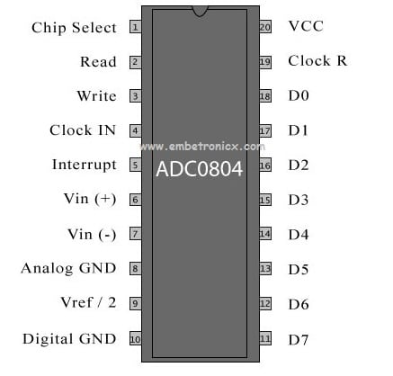
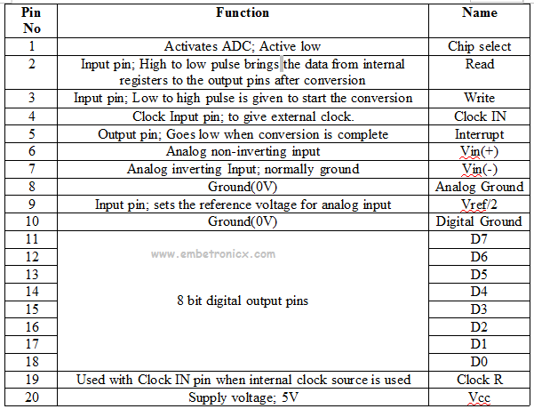

How to use the ADC0804?
- Make Cs(chip select) low(0) to activate the ic. Here we are directly connecting that CS into Ground instead of connecting into 8051.
- Make WR(write) pin low (0).
- Make RD(read) pin high (1).
- Make WR(write) pin high (1) after some delay small delay//This low to high impulse at WR pin starts your conversion.
- Now check the INTR(interrupt) pin if it is high(1) conversion is running if it is low(0) the conversion is over.
- Make RD=low(0) .
This will bring the converted value to the 8 data output pins of ADC 0804.

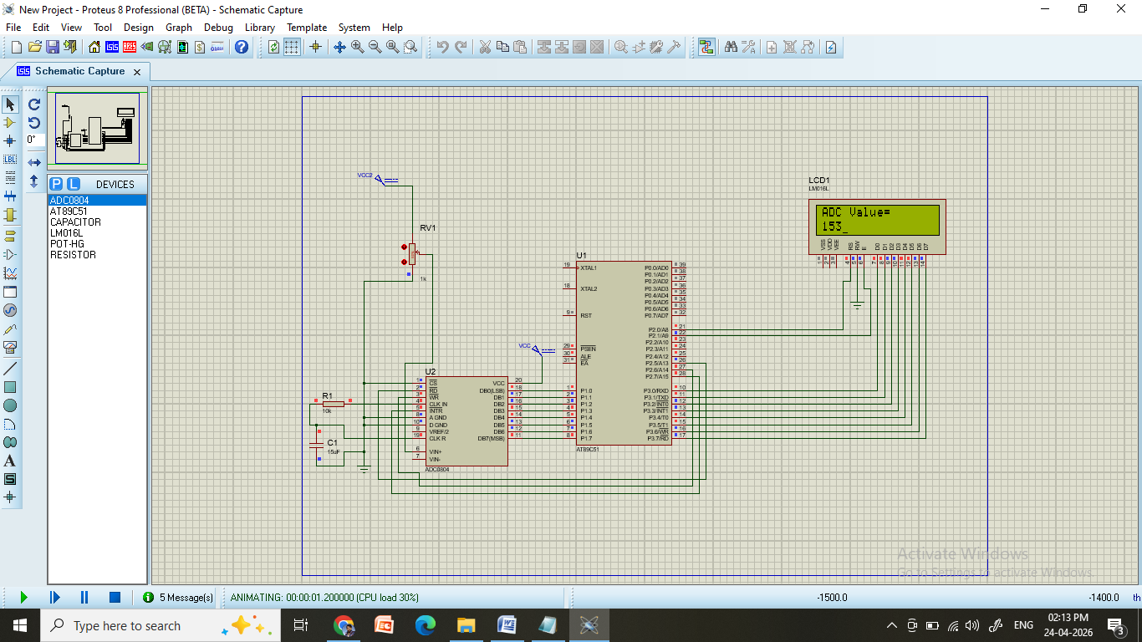
Program:

#include<reg51.h>
sfr mydata = 0x90;
sbit rd= P2^5;
sbit wr= P2^6;
sbit intr= P2^7;
sbit RS = P2^0;
sbit EN = P2^1;
//(0x90)is address of port1, else you can write as : #defintre mydata P1

void delay(int n)
{
int i,j;
for(i=0;i<n;i++)
for(j=0;j<255;j++);
}
void lcd_cmd(char a)
{
P3 = a;
RS = 0;
EN = 1;
delay(10);
EN = 0;
}

void lcd_data(char a)
{
P3 = a;
RS = 1;
EN = 1;
delay(10);
EN = 0;
}

void display(char *ptr)
{
while(*ptr != '\0')
{
lcd_data(*ptr);
ptr++;
}
}
void main()
{
unsigned char value;
char temp[4];
int i=0;
lcd_cmd(0x01); //clear screen
lcd_cmd(0x0E); //Display On, Cursor Blinking
lcd_cmd(0x38); //2 lines and 5*7 matrix
lcd_cmd(0x80); //Force Cursor to beginning of first
display("ADC Value=");
lcd_cmd(0xC0);
//mydata = 0xEF;
intr = 1;
rd = 1;
wr = 1;
while(1)
{
lcd_cmd(0xC0);
wr = 0;
wr = 1;
while(intr==1);
rd=0;
value = mydata;

while(i<3)
{
temp[i] = (value%10) + '0'; // For converting into ASCII
value = value / 10;
i++;
}

for(i=2;i>=0;i--)
{
lcd_cmd(0x06);
lcd_data(temp[i]);
}
i=0;
delay(1000);
rd = 1;
}
}

