Stepper motor interface with 8051

Stepper Motor
Stepper motors are used to translate electrical pulses into mechanical movements. In some disk drives, dot matrix printers, and some other different places the stepper motors are used. The main advantage of using the stepper motor is the position control. Stepper motors generally have a permanent magnet shaft (rotor), and it is surrounded by a stator.
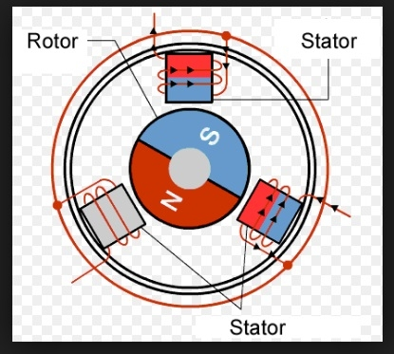

Some parameters of stepper motors −
- Step Angle − The step angle is the angle in which the rotor moves when one pulse is applied as an input of the stator. This parameter is used to determine the positioning of a stepper motor.
- Steps per Revolution − This is the number of step angles required for a complete revolution. So the formula is 360° /Step Angle.
- Steps per Second − This parameter is used to measure a number of steps covered in each second.
- RPM − The RPM is the Revolution Per Minute. It measures the frequency of rotation. By this parameter, we can measure the number of rotations in one minute.
- The relation between RPM, steps per revolution, and steps per second is like below:
- Steps per Second = rpm x steps per revolution / 60
The Unipolar stepper motor works in three modes.
- Wave Drive Mode − In this mode, one coil is energized at a time. So all four coils are energized one after another. This mode produces less torque than full step drive mode.
The following table is showing the sequence of input states in different windings.
Steps | Winding A | Winding B | Winding C | Winding D
1 | 1 | 0 | 0 | 0
2 | 0 | 1 | 0 | 0
3 | 0 | 0 | 1 | 0
4 | 0 | 0 | 0 | 1
- Full Drive Mode − In this mode, two coils are energized at the same time. This mode produces more torque. Here the power consumption is also high
The following table is showing the sequence of input states in different windings.
Steps | Winding A | Winding B | Winding C | Winding D
1 | 1 | 1 | 0 | 0
2 | 0 | 1 | 1 | 0
3 | 0 | 0 | 1 | 1
4 | 1 | 0 | 0 | 1

- Half Drive Mode − In this mode, one and two coils are energized alternately. At first, one coil is energized then two coils are energized. This is basically a combination of wave and full drive mode. It increases the angular rotation of the motor
The following table is showing the sequence of input states in different windings.
Steps | Winding A | Winding B | Winding C | Winding D
1 | 1 | 0 | 0 | 0
2 | 1 | 1 | 0 | 0
3 | 0 | 1 | 0 | 0
4 | 0 | 1 | 1 | 0
5 | 0 | 0 | 1 | 0
6 | 0 | 0 | 1 | 1
7 | 0 | 0 | 0 | 1
8 | 1 | 0 | 0 | 1
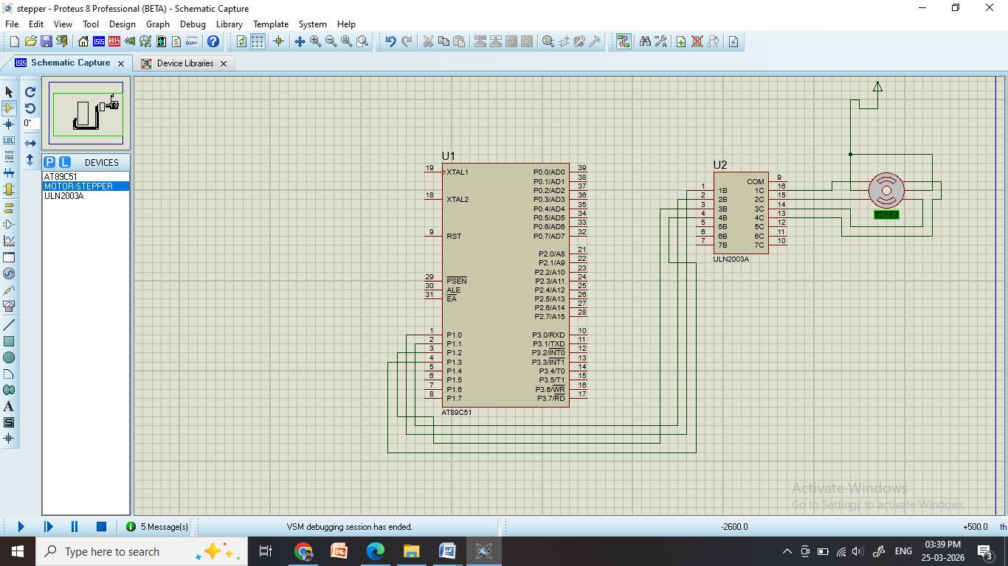

Program:
#include<reg51.h>
void delay(int ms){
unsigned int i, j;
for(i = 0; i<ms; i++){ // Outer for loop for given milliseconds value
for(j = 0; j< 1275; j++){ //execute in each milliseconds;
}
}
}
void main(){
int rot_angle[] = {0x08,0x04,0x02,0x01}; //wave drive mode
//int rot_angle[] = {0x0C,0x06,0x03,0x09}; // full drive mode
//int rot_angle[] = {0x08,0x0C,0x04,0x06,0x02,0x03,0x01,0x09}; //half drive mode
int i;
while(1){

for(i = 0; i<4; i++){
P1 = rot_angle[i];
delay(100);
}
}
}

