1. Logo Change

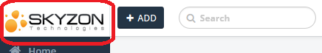

Status: WAITING FOR LOGO

2*.* Disclaimer has to be changed

Replace Skyzon to RABBIT



Status: PENDING

1. Dashboard

Replace Skyzon to RABBIT

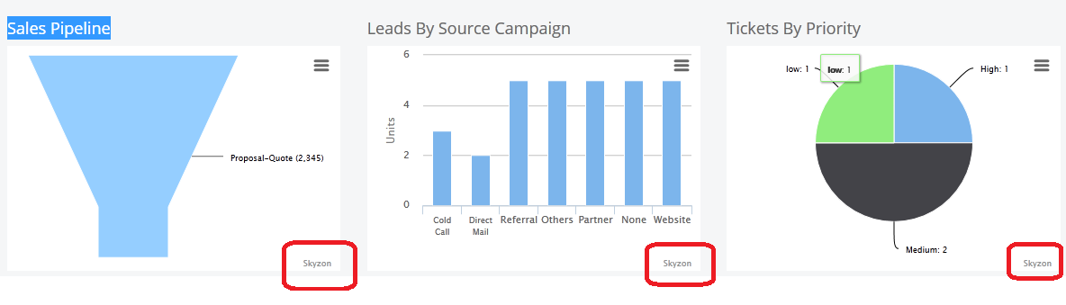

Status: PENDING

1. Spelling Correction

Deals Status (Archieved to Archived)

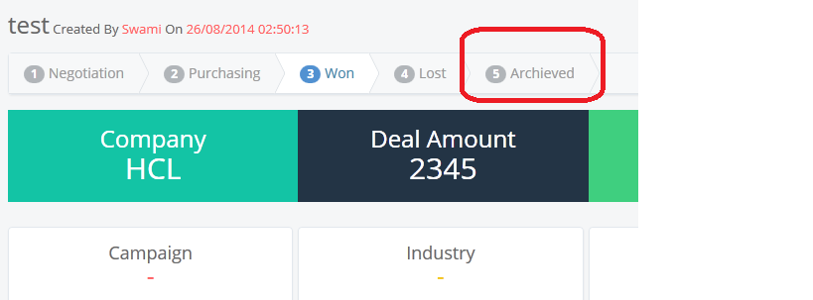

Status: PENDING

1. “Lead” and “Contacts” Edit Page (First name and Last Name Validation Missing)

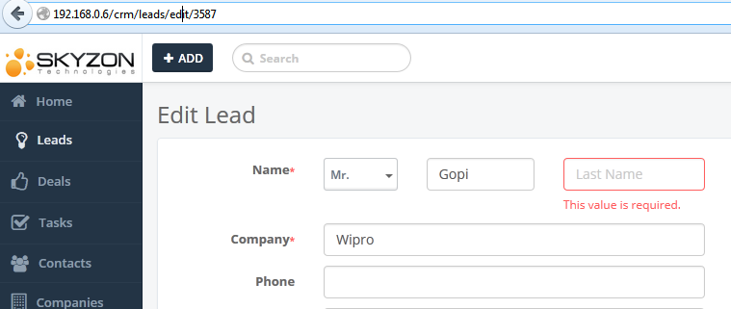

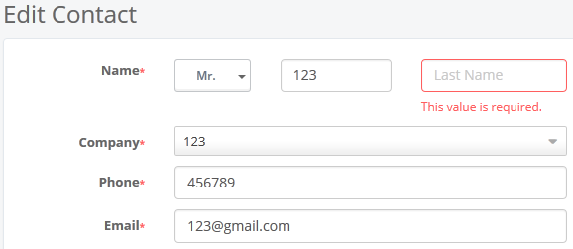 Status: PENDING

1. Replace Skyzon to RABBIT in Activation Mail

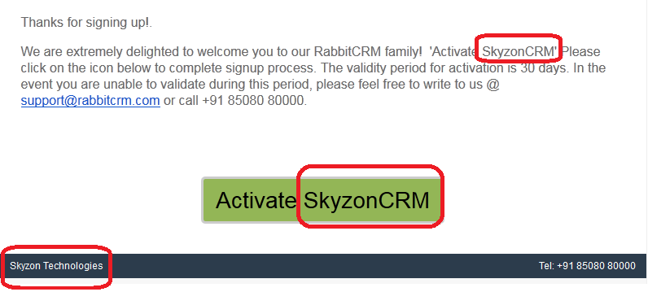

Status: PENDING

1. Add options before exiting the page (Suggestion)



Status: PENDING

1. Add *Login* and *Sign up* options in Home Page

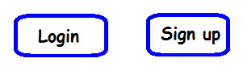

Status: PENDING

1. Change Task menu pattern

Before:

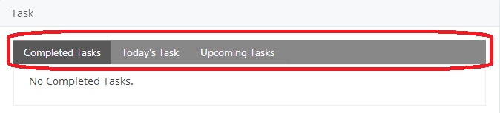

After:

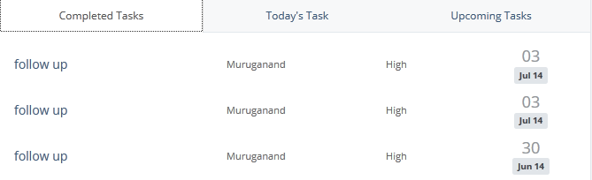

Status: COMPLETED

Comment: Removed Profile picture image icon from Task list

1. Unable to Save “*Organization Information*” more than once in Settings Page

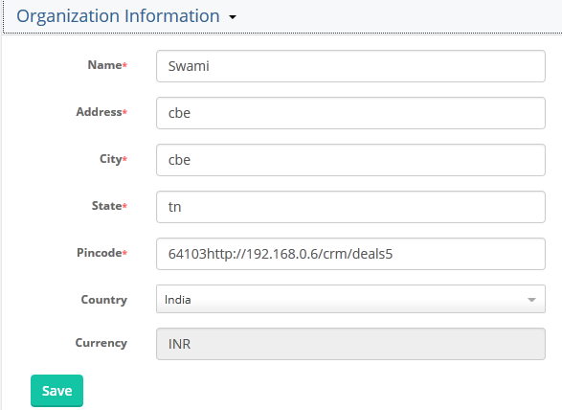

Status: PENDING

1. Add “Assigned To” column and add more “Filters”

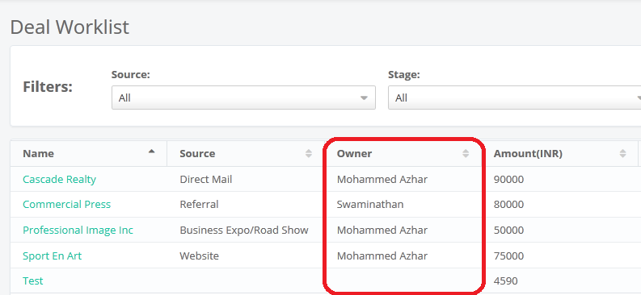

Status: PENDING

1. Need to add "Name" and "Part" Filter in Product Worklist page

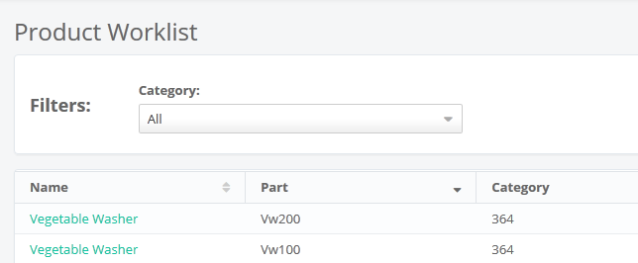

Status: PENDING

1. Data mismatch in Dashboard

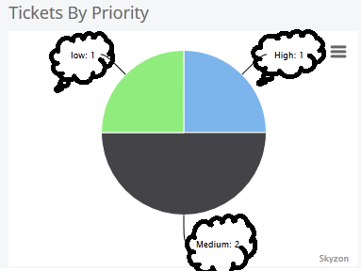

Status: PENDING

1. Replace "Expected Date" &“Target Date” to "Expected Closing Date"

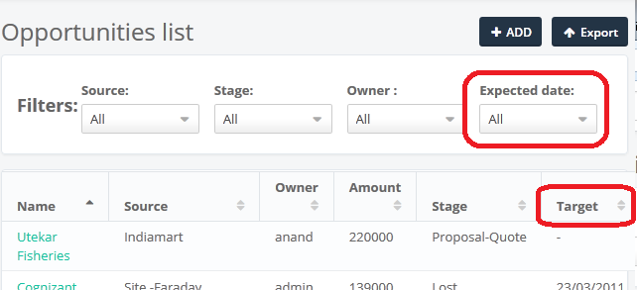

Status: PENDING

1. Set “ADD” option to create Ticket in “Contacts” page

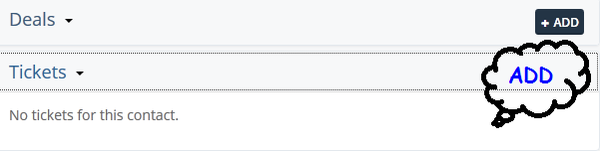

Status: PENDING

1. Add “Company” field in “ADD Ticket” page

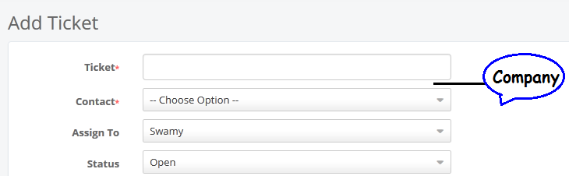

Status: PENDING

1. Set “Inactive”

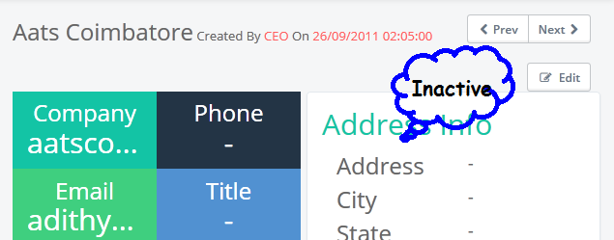

Status: PENDING