# Online Bookstore

## Introduction

The bookstore based on the Web Site, which is responsible for selling books online. Users can search for their interesting books on the website. Besides, users can register on the website to become members, after that they can order their favorite books or release their opinion about books in the comment area. The final aim is to help users reduce the cost of buying books and increase the revenue of booksellers.

## Completed Functions

This table includes the functionality that I have completed.

|  |  |
| --- | --- |
| **Function** | **Description** |
| Register account | A new visitor can register personal information in the system in order to create a member account of Bookshop. |
| Login/Logout account | Members of the book shop can log in the website by using their email and password or log out of the website whenever. |
| Browse book categories | A visitor can open the home page of the website to browse all kinds of books, and the navigation bar can guide the visitor to look through different book categories. |
| Search books | Visitors use the search function to look up their favorite books. The condition of searching keywords includes book name or author name, |
| Display book details | Visitors can browse the detailed information of a book, including book author, book price, book comments and related books. In addition, the members can add the book to the cart. |
| Shopping cart | A member can pick up his/her favorite books on the website, then put them into the shopping cart in order to buy these books. |
| Book order | After a member checks out the items of the cart, a new book order will be generated. |
| Send order email | After members checked out their book orders, a reminder email will be sent to them. |
| Book Comment | Members can post their opinions in the comment section of the book while others can vote on these comments. |

## Future work

This table includes unstarted functionality of Online Bookstore.

|  |  |
| --- | --- |
| **Function** | **Action Description** |
| Login/Logout backend system | An administrator can log in or log out of the backend system whenever. |
| Books manager | An administrator can add, delete, and update the inventory information of books. |
| Advertising | An administrator can push promotion product information to the customer who subscribes to the sale information. |
| Discount information | An administrator can make a discount strategy to sell books. For example, the price of books reduces twenty percent, and so on. |

## Type of User

The user of bookshop online divides into two categories: visitor and member.

### The Actions of the visitor

As a visitor, he can use the functions including register account, browsing books and searching books.

### The Actions of the member

As a member of bookstores, besides having the same functionality as visitors, he can use functions including login / logout account, shopping cart, ordering book.

## Technical Solution

### Software environment

Database: MySQL

Web Server: Tomcat

Language: JavaScript, Java, HTML, CSS

Technology: Java servlet, Ajax, jQuery, ODBC

## System structure

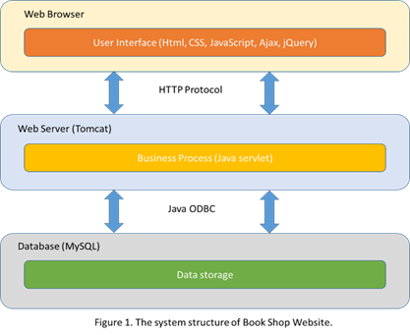

Figure 1 shows the system structure of the online bookstore. The front end is made of web pages that were built by HTML, CSS and JavaScript, which provides the user interface to interact with users. The back end composes of Tomcat and MySQL. Tomcat is a web server which is responsible for processing HTTP requests. Besides, Java servlets are used to implement business processes. MySQL is a database which is responsible for storing different types of data.

Figure 2 shows the module structure of the online bookstore, which consists of user register, user login/logout, book searching, book details/comment, order management and shopping cart.

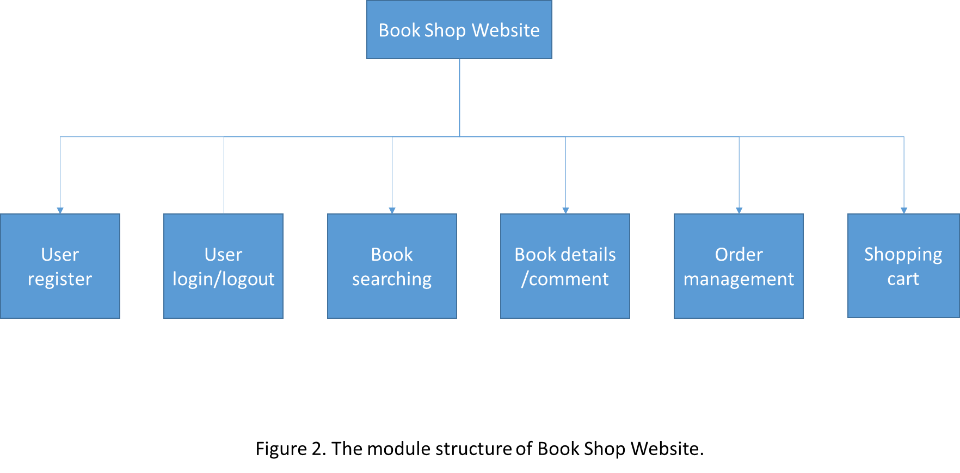

## Challenges

During the development of the project, the challenges I have encountered mainly came from several aspects below:

1) To pass arguments between two HTML pages.

2) To implement asynchronous procedure calls using Ajax.

3) To use Cookie to save user login information.

In order to overcome these technical difficulties, I used technology websites, such as Stack overflow and looked for relevant technical materials to solve these problems.