Rabbit Chain Technical Whitepaper v1.7

Rabbit Chain

Permissionless EVM Layer 1 with Live Consensus Queue
Technical Whitepaper - Public Testnet V2 Edition v1.7 19 October 2026
One wallet. One persistent equal consensus seat.

Document status
Item | Public status
Rabbit Testnet V2 | Live
Chain ID / Network ID | 9280 / 9280
Native test asset | tRAB
Consensus | LCQ with permissionless Work V2 admission
Execution | EVM / EIP-1559
Current Rabbit Core release | v2.4.13
Current source commit | 8e42d4fec6769dd44a593b552bfc570df227a6ac
Liveness V3 activation release | rabbit-core-testnet-v2.3.0
Consensus hardening block | 50000
Consensus stabilization block | 50500
Fairness/Liveness activation block | 73000
Liveness V3 activation block | 77000
Genesis file SHA-256 | 17bfe51321f6e7befe8719ee35c34b1b876fda3e93672204903bd7b6d6bb69ba
Canonical block-0 hash | 0x9b71d7f2922fdf8383a4a12be5594e25938625195e0d84c05c3bd71b7bcf93f7
Public RPC | https://rpc-testnet.rabbitchain.org
Explorer | https://explorer-testnet.rabbitchain.org
Mainnet | Not live; planned chain ID 928
Testnet software and tRAB are experimental. Testnet assets have no promised monetary value. Mainnet parameters, contracts, custody mechanisms and dates are not final unless published through a separate signed release.
Software/protocol distinction. Whitepaper v1.5 remains the Liveness V3 protocol edition. Rabbit Core V2.3.0 is the historical software release that activated Liveness V3 at canonical block 77000. Rabbit Core V2.3.4 is preserved as a prior software release record. Rabbit Core V2.3.6 is a historical Testnet client release; it does not introduce a new scheduled consensus activation block.

Rabbit Core v2.4.13 — verified automatic bootstrap
The current public Testnet client initializes or reuses an encrypted mining wallet before downloading the official multipart blockchain bootstrap. Bootstrap parts are integrity-checked, interrupted downloads can resume, and the node then synchronizes remaining canonical blocks before LCQ participation. Existing operators must preserve their Testnet data directory, keystore, node identity and participation state. This is a software distribution and synchronization improvement, not a new consensus hard fork.
Source commit: 8e42d4fec6769dd44a593b552bfc570df227a6ac. Official packages and SHA-256 checksums: https://github.com/rabbitmainnet/rabbit-geth/releases/tag/v2.4.13

Abstract
Rabbit Chain is a permissionless, EVM-compatible Layer 1 network designed around a simple fairness objective: multiplying mining processes must not multiply a wallet's opportunity to obtain a canonical production seat. The protocol combines computational work, an on-chain participant registry, deterministic ordering, liveness rules, and committee participation in a mechanism called Live Consensus Queue (LCQ).
Traditional proof-of-work systems tend to assign block-production probability in proportion to accumulated hash power. Rabbit Chain instead uses RandomX work for one-time admission into a persistent equal seat. Admitted identities are then ordered deterministically for block production. A participant may run redundant software and hardware, but duplicate work associated with the same wallet cannot create duplicate canonical seats.
The network retains the Ethereum execution model so existing wallets, Solidity contracts, developer tooling, transaction formats, and JSON-RPC conventions can be used with limited adaptation. Consensus, however, is Rabbit-specific. LCQ separates work discovery from scheduled production and distributes protocol rewards between the producer and a selected committee.
Release gates exercised fresh multi-node operation, restart behavior, Work V2 transport, canonical ticket handling and persistent-seat enforcement. The final live lab admitted three independent wallets, activated exactly three persistent equal seats and observed canonical block production from all three participants.

1. Motivation
Public blockchains promise open participation, yet access to meaningful block production often concentrates around capital, specialized hardware, pools, privileged validator sets, or operational scale. Permissionless entry alone does not guarantee equal opportunity after entry.
Rabbit Chain addresses a narrower and measurable problem: process multiplication should not become identity multiplication. If one participant opens three miner processes with the same wallet, the protocol should observe redundancy, not three independent claims to selection.
The design follows five principles:
- Permissionless entry. No manual approval, private validator list, or administrator transaction should be required to begin participating.
- Wallet-bounded opportunity. One non-zero wallet owns at most one persistent equal seat.
- Deterministic verification. Honest nodes given the same canonical history must derive the same registry, eligible set, and queue.
- Recoverable liveness. Temporary inactivity, node failure, or loss of producers should not require a trusted operator to rewrite the chain.
- EVM utility. Consensus innovation should coexist with established smart-contract tooling and account semantics.
These goals do not eliminate every form of concentration. A person may control multiple wallets, and no permissionless protocol can prove unique human identity without additional assumptions. LCQ therefore enforces the precise technical invariant of one persistent equal seat per non-zero wallet; every additional wallet must independently complete public RandomX admission.

2. System overview
Rabbit Chain has four cooperating layers:
- Execution layer: EVM state transition, accounts, transactions, receipts, logs, gas, and smart contracts.
- Consensus layer: LCQ validation, registry snapshots, queue resolution, producer signatures, timeout/fallback handling, and committee selection.
- Work layer: RandomX-backed proof generation and peer-to-peer Work V2 ticket transport.
- Network layer: peer discovery, transaction and block propagation, consensus messages, RPC access, and independently operated infrastructure.
The intended user path is deliberately short:
Download → run → use a wallet → mine.
Admission and activation are protocol-driven. The client resolves the local wallet, submits valid work, waits for canonical activation, and joins the persistent deterministic queue without administrator approval.
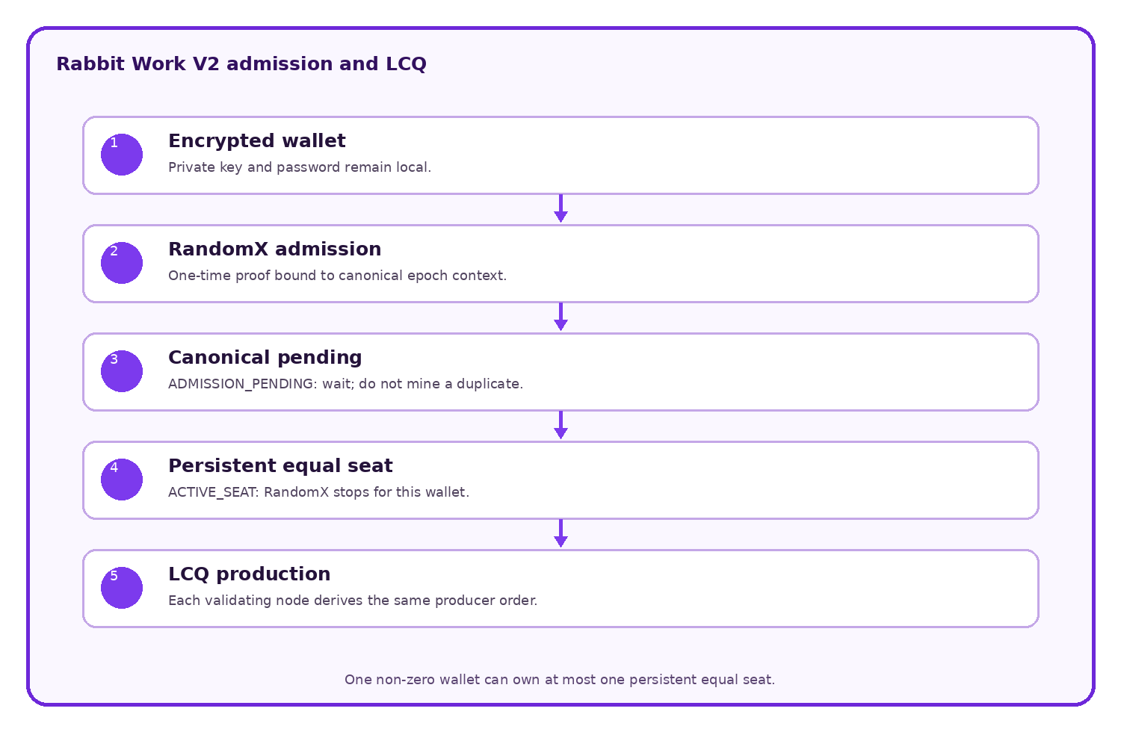
Figure 1. Work qualifies a wallet for a bounded canonical seat; the LCQ queue, rather than a continuing hash race, schedules block production.

2.1 Rabbit Chain at a glance
Question | Short answer
What is Rabbit Chain? | A permissionless EVM Layer 1 with its own LCQ consensus
What is LCQ? | A mechanism that converts valid work into a wallet-bounded position in a deterministic live production queue
What makes it different? | Running more miner processes with the same wallet must not create more canonical seats for that wallet in the same epoch
Is it ordinary PoW? | No. RandomX work qualifies participation; the LCQ queue schedules block production
Is it PoS? | No. Stake weight does not select the next producer
Can anyone join? | Yes. Any compatible non-zero wallet may perform the same public Work V2 admission
Can Ethereum tools be used? | The goal is compatibility with common EVM wallets, Solidity, transactions, contracts, logs, and JSON-RPC tooling
What is the native asset? | RAB on mainnet and valueless tRAB on Testnet V2, used for gas, rewards and protocol accounting
Is the public testnet live? | Yes. Testnet V2 uses chain ID 9280

2.2 LCQ compared with common models
Property | Conventional PoW | Conventional PoS | Rabbit LCQ
Primary admission signal | Computational work | Locked stake | Valid work plus protocol eligibility
Typical selection weight | Hash power | Stake weight | One persistent equal seat per admitted wallet
Block producer | Hash-race winner | Stake-selected validator | Deterministically scheduled eligible wallet
Duplicate processes on one wallet | Usually add hash rate | Usually operational redundancy | May help find the first proof but must not add canonical seats
Capital still matters? | Hardware and energy matter | Stake matters directly | Admission hardware, uptime and multiple wallets can still matter, but one wallet cannot multiply its seat weight
Unique-human guarantee | No | No | No
This comparison is conceptual. Individual PoW and PoS networks differ, and the Rabbit implementation is defined by its released source and configuration.

3. Work V2 and Live Consensus Queue

3.1 Admission is separate from continuing influence
Rabbit Work V2 uses RandomX for permissionless, one-time admission. RandomX admission is not recurring block mining: it is the entry mechanism by which a wallet proves eligibility for one persistent equal LCQ seat. After a valid proof is accepted, the wallet waits for canonical selection and activation. Actual LCQ block-production and committee participation begin only when the wallet becomes LCQ ACTIVE. Faster CPUs may find the initial admission proof sooner, but cannot give an admitted wallet extra seats or recurring consensus weight.
This invariant is wallet-bounded, not person-bounded. LCQ does not prove human identity. A person may operate multiple wallets, but every additional non-zero wallet must independently complete the same public admission process.

3.2 Fresh-network lifecycle
Fresh-chain canonical height | Work V2 state
Blocks 1-127 | Bootstrap history; new admission is not yet active
Block 128 | The first Work V2 admission epoch opens and the 1 GiB RandomX dataset may be prepared
Blocks 129-255 | Accepted admissions wait for canonical selection and activation; Rabbit Miner reports LCQ PENDING
Block 256 | The first canonical admissions may activate as persistent equal LCQ seats
After activation | Rabbit Miner reports LCQ ACTIVE / ACTIVE LCQ seat; RandomX admission work is complete while LCQ participation continues
Blocks 128 and 256 describe the first admission and activation boundaries of a fresh Rabbit Chain network. They are not absolute waiting heights for miners joining an already-running network. On the live Testnet, new wallets follow the current canonical 128-block epochs. Depending on when a wallet joins and when its proof becomes canonical, the admission-to-activation path can cross roughly one to two epoch boundaries. Canonical chain progress, not a local timer, controls activation; a paused or slower network therefore takes longer.

3.3 Miner messages
Rabbit Miner presents the admission and activation lifecycle in user-facing states:
- Mining: WAITING means the node is synchronizing or waiting for the canonical state required for admission.
- Preparing RandomX 1 GiB dataset means Work V2 admission preparation is in progress. This is admission work, not LCQ block mining.
- Searching for this wallet's Work V2 admission proof means the wallet is performing its one-time RandomX admission search.
- Work V2 admission proof accepted means the proof was accepted; duplicate admission mining is unnecessary.
- LCQ PENDING means admission has been accepted but the persistent seat is still waiting for canonical selection and activation.
- LCQ ACTIVE / ACTIVE LCQ seat means the wallet owns one persistent equal consensus seat and is actively participating in LCQ.
- PRODUCER marks a canonical block produced by the wallet.
- COMMITTEE marks a committee reward detected for the wallet.

3.4 Canonical enforcement
The canonical snapshot rejects a participant that already owns a persistent seat. Multiple processes, restarts, faster CPUs or repeated proofs for the same wallet cannot multiply that wallet's consensus weight. Nodes independently validate the proof, signature, canonical context and seat state.
The private key and password remain local. Only the participant address, nonce, proof hash and signature are relayed.

4. RandomX admission
RandomX is a CPU-oriented proof algorithm used for Work V2 admission and recovery, not for recurring proportional block-production weight. Testnet V2 uses a 1 GiB dataset and derives each challenge from canonical epoch context. A valid proof is signed by the participant wallet and independently verified by receiving nodes.
The released genesis, source and client are authoritative for challenge construction, difficulty and validation. Production activation is guarded by network identity and genesis markers so a laboratory configuration cannot silently activate on another chain.

5. Block production and liveness

5.1 Scheduled producer
For a given height, nodes independently derive the expected producer from the canonical queue and active rules. The producer constructs an EVM block, includes valid transactions, respects gas and fee rules, and signs the LCQ header material with the participant key.

5.2 Producer authentication
Rabbit headers carry LCQ-specific extra data and a producer seal. Nodes verify the seal against the expected participant and canonical header fields. A locally configured coinbase address is not sufficient authorization; the signature and queue-derived role must validate.

5.3 Timeout and fallback
If the scheduled producer does not publish a valid block within its slot, fallback rules advance liveness through subsequent allowed positions and bounded timing windows. Stale candidates are rejected against current canonical context. The objective is to preserve deterministic agreement while avoiding dependence on one online producer.

5.4 Network interruption and recovery
If every producer goes offline, the chain pauses at its last valid canonical block. It does not reset or erase blocks, balances, transactions or persistent seats. After a two-minute canonical halt, permissionless recovery admission opens. Any compatible non-zero wallet may find and submit a valid RandomX recovery proof. The recovery identity advances the existing chain until normal persistent-seat LCQ operation resumes.
Recovery still requires verifiable work and propagation. Deleting history or appointing a trusted emergency producer is not part of the protocol.
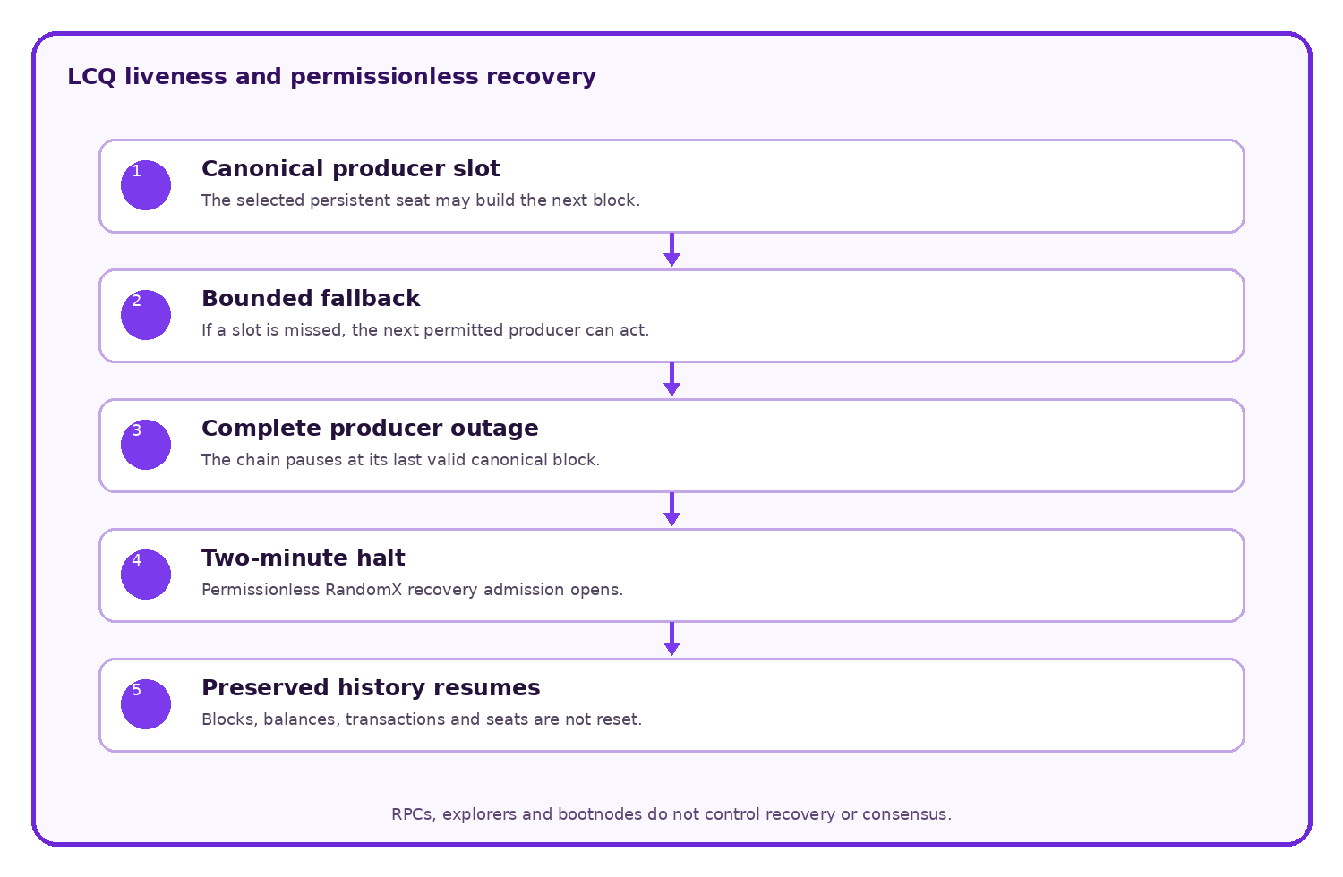
Figure 2. A missed producer advances through public fallback rules. If no eligible participant remains, the chain waits and later resumes from preserved canonical history.

5.5 Testnet consensus hardening at block 50000
Rabbit Core Testnet V2.2.2 schedules a required Rabbit Testnet consensus upgrade at canonical block 50000. Historical blocks through 49999 retain their existing validation behavior.
Beginning at block 50000:
- allowed future timestamp tolerance is reduced from 30 seconds to 1 second;
- temporarily unavailable WorkSeats move deterministically behind ready seats;
- persistent WorkSeat ownership is preserved;
- penalized seats remain eligible as emergency fallback when no ready seat can produce;
- seats automatically return to the ready queue after the deterministic penalty period;
- producer, fallback, committee and reward selection continue from one canonical queue.
This is an in-place hard fork, not a network restart. It does not replace block 0, erase history, reset balances or contracts, replace wallets or keystores, delete WorkSeats, or require existing participants to register again.

5.6 Testnet consensus stabilization at block 50500
Rabbit Core Testnet V2.2.3 schedules the stabilization activation of this Testnet upgrade sequence at canonical block 50500. This activation does not replace the block-50000 consensus-hardening history. Blocks through 50499 retain the rules applicable at their canonical heights.
V2.2.3 was released from source commit 42ed7d943bad9143d23ae821d6d23c332b46e1b7. The stabilization release incorporates the recovery and persistent-seat corrections required after live Testnet observation, including preservation and recovery of canonical WorkSeats across restart/recovery paths and permissionless resumption of canonical LCQ production.
The activation is an in-place upgrade. It does not create a new chain, replace block 0, erase balances or transactions, delete contracts, replace wallets or keystores, or intentionally delete existing persistent WorkSeats.
After activation, nodes running pre-V2.2.3 consensus rules may remain technically reachable at the P2P transport layer but are not compatible producers for the canonical V2.2.3 chain. Incompatible blocks are rejected by upgraded consensus validation. Operators running an older Rabbit Core release must upgrade before resuming Testnet mining or node operation.
A known compatibility limitation remains in the current Testnet implementation: Rabbit-specific consensus activation heights stored under LQCConfig are not currently encoded into the advertised EIP-2124 ForkID. This allows an older client to remain P2P-connected after a Rabbit-specific consensus activation even though upgraded consensus rejects its incompatible blocks. Rabbit-specific ForkID compatibility enforcement and mixed-version regression tests are required before Mainnet.
The public post-fork validation record is published in docs/Testnet-V2.2.3-Stabilization-Report.md.

5.7 Testnet Fairness/Liveness activation at block 73000
Rabbit Core Testnet V2.2.5 schedules the next in-place Rabbit Testnet consensus upgrade at canonical block 73000. The block-50000 hardening and block-50500 stabilization activations remain part of the preserved canonical history.
Beginning at block 73000, canonical producer opportunity follows the deterministic WorkSeat order without using legacy stale-penalty state to reorder the producer queue. Committee eligibility filtering remains separate from producer ordering. The deterministic fork transition clears legacy MissedTurns and JailedUntil state that would otherwise distort post-activation producer order, and a later valid candidate producing a canonical block does not by itself create a missed-turn/jail penalty for an earlier seat.
The existing fallback timing, permissionless recovery path, persistent WorkSeats, heartbeat model and 70% producer / 30% committee reward allocation remain in place. The upgrade changes fairness/liveness behavior without resetting the Testnet or creating a new chain.
V2.2.5 was built from source commit ed6fb1692392ce93886d112d84142b8aa487fceb. The release also hardens Rabbit Core operation: the launcher preserves the existing Testnet blockchain data and encrypted wallet, reuses the same data directory after node restart, and waits for canonical synchronization before mining resumes. This operational recovery behavior does not replace consensus validation or guarantee recovery from arbitrary storage corruption.
The release and pre-activation record are documented in docs/Testnet-V2.2.5-Fairness-Liveness-Upgrade.md.

5.8 Testnet Liveness V3 activation at block 77000
Rabbit Core Testnet V2.3.0 schedules LQC Liveness V3 at canonical block 77000. This is an in-place upgrade of the existing Rabbit Testnet and does not reset the network, wallet balances, blockchain history or persistent LCQ participation state.
Liveness V3 adds deterministic producer rotation, bounded fallback recovery, canonical committee-participation claims and verified committee reward accounting. The invariant remains one persistent equal canonical seat per eligible non-zero wallet.
When a committee exists, 70% of the configured reward belongs to the producer and 30% forms the committee pool. Verified participants receive deterministic fixed shares; absent shares are not reassigned or issued. When no committee exists, the producer receives the full configured reward.
V2.3.0 was built from source commit 7128cb6db44dbecff608a54b4890a03f5e426647. The verified Windows archive SHA-256 is a23662ee6def886b62336ce0dedd5b0d6bf8daeb0cb12cc96eadae435c12ab0e and the verified Linux archive SHA-256 is e5d75d1b3c71b31420a1999043a369f661bea794afc4aaefdff5e157262ec2ad.
The complete release and activation record is available in docs/Testnet-V2.3.0-Liveness-V3-Upgrade.md.

5.9 Historical Rabbit Core software release: V2.3.4
Rabbit Core V2.3.4 is preserved as a prior public Testnet client release, built from source commit b6fda8e6118d6ac7a6af81119120345e80081249. It is an operational software update on top of the already-active Liveness V3 consensus rules. It does not schedule a new hard fork or a new consensus activation height; canonical block 77000 remains the Liveness V3 activation boundary.
V2.3.4 hardens live peer operation so temporary Rabbit-specific committee context unavailability does not unnecessarily tear down an otherwise useful peer connection, and discovery iteration no longer continuously cycles through configured bootnodes. It also clarifies Rabbit Miner reward activity so producer, committee and full-reward cases are easier for operators to distinguish.
The release preserves the existing Rabbit Testnet blockchain, encrypted wallet, datadir and persistent LCQ participation state. Normal upgrades must not delete the blockchain, keystore or consensus participation state.
Verified V2.3.4 archives:
Platform | Archive SHA-256
Windows AMD64 | 791970d2071191db54cbcc3a1fb5db22ccfc9a771640f30cf7624d6fc10e143f
Linux AMD64 | 9063b3d349172a79e61b89fb6c01c815874c82eaf63741d1034cba330125913c
macOS Intel / AMD64 | 10bda73072fc8a9ddc68cc4e96e569ea76241e77553c17c4b5ca5b7a9c606271
macOS Apple Silicon / ARM64 | 6ee3b40eacd8b94d2b7b95aaa4a0a9219173226f2bd3d239f132f49448d536ba
Official release:
https://github.com/rabbitmainnet/rabbit-geth/releases/tag/v2.3.4
The complete software-release record is available in docs/Testnet-V2.3.4-Software-Release.md.

6. Committee and rewards
Each canonical block divides the configured protocol reward between the producer and an eligible committee:
Recipient | Share
Block producer | 70%
Committee | 30%
The committee is derived deterministically from canonical persistent-seat state. The released genesis and client control the public network; laboratory parameters are not authoritative for Testnet V2.
Committee distribution is intended to spread rewards beyond the single scheduled producer and reward active consensus participation. When a valid committee is available, 70% goes to the block producer and 30% is divided among the committee under the client implementation's deterministic rounding rules. When no valid committee recipient exists, the producer receives 100% of that block's configured reward; no committee share is left unassigned.
Mining rewards produced by the active consensus are credited immediately and are spendable after the block becomes canonical. The legacy first-100,000-block mining lock is not active and must not be presented as part of the live monetary policy. The separate 100,000 RAB testnet participation reserve described in Section 8 is an allocation program, not a lock on protocol mining rewards.

6.1 Era and block-reward schedule
The active reward calculation uses an era length of 8,409,600 blocks. Era boundaries are derived from the canonical block number. Because block 0 is genesis and carries no mining reward, the first paid interval contains blocks 1 through 8,409,599. At block 8,409,600 the second reward level begins.
Reward period | Canonical blocks | Base reward per block | Policy
First reward period | 1-8,409,599 | 1.20 RAB | Initial block reward
Second reward period | 8,409,600-16,819,199 | 0.60 RAB | First halving
Third reward period | 16,819,200-25,228,799 | 0.30 RAB | Second halving
Tail-emission period | 25,228,800 onward | 0.15 RAB | Final reward floor; no further halving
The 0.15 RAB reward continues permanently unless a future consensus change is adopted through a separately published network upgrade. Therefore Rabbit Chain has continuing tail emission and no finite maximum supply under the active schedule. For a block with a valid committee, the table gives the total base reward before the 70%/30% split. Without a valid committee, the producer receives the full amount.

7. RAB economic model
RAB is the planned mainnet native asset used for gas, protocol rewards and network-level economic accounting. The genesis allocation is 15,000,000 RAB. This is the complete block-0 allocation, not a maximum supply: consensus block rewards add new RAB according to Section 6.1, and the permanent 0.15 RAB tail reward means total supply is not finitely capped. The testnet participation reserve is part of the 15,000,000 RAB genesis allocation; it is not additional genesis allocation or a separate mint.
Allocation | RAB | Share
Staking and protocol participation | 10,000,000 | 66.67%
Liquidity | 2,000,000 | 13.33%
Rabbit Club/community | 1,000,000 | 6.67%
Operational costs | 400,000 | 2.67%
Testnet participation rewards | 100,000 | 0.67%
Creator and developers | 1,500,000 | 10.00%
Total genesis allocation | 15,000,000 | 100.00%
Percentages are rounded to two decimal places. The integer RAB amounts, whose sum is exactly 15,000,000 RAB, are authoritative for genesis allocation only. They do not include later protocol issuance.
The earlier 500,000 RAB operational allocation is therefore divided internally as follows:
Component of the former operational allocation | RAB | Rule
General operational costs | 400,000 | Infrastructure, security, legal/compliance, audits, software, communications, and documented project operations
Public-testnet participation program | 100,000 | Reserved exclusively for eligible miners, builders, testers, and valid bug hunters under the published program rules
Combined amount | 500,000 | No change to the 15,000,000 RAB genesis allocation and no separate mint for this program
Genesis-allocation identity: 15,000,000 RAB = 10,000,000 + 2,000,000 + 1,000,000 + 400,000 + 100,000 + 1,500,000 RAB.

7.1 Genesis allocation and supply accounting
The mainnet design must make both components of supply independently verifiable: the 15,000,000 RAB genesis allocation and all later consensus issuance. No allocation table, website, multisig, vault, token interface, or off-chain statement may create balances outside the released genesis and consensus implementation.
Because RAB is the native asset of Rabbit Chain rather than an ordinary ERC-20 token, not every monetary rule belongs in one token contract. Transparency is divided between:
- genesis and consensus rules, which define initial native balances, issuance, rewards, locks, and supply behavior;
- public vault/vesting contracts, which hold allocations that require time-based or rule-based release;
- public treasury contracts, used where human-approved operational spending is unavoidable and governed by disclosed multisig/timelock rules;
- versioned disclosures, which connect every allocation to an address, balance, contract, rule, and responsible signing policy.
The absence of a single ERC-20 contract must never be confused with absence of on-chain verification. Native balances, consensus issuance, contract balances, releases, and transfers remain observable through a validating node and block explorer.

7.2 Allocation enforcement plan
Before mainnet block 1, the final genesis and release package must publish the enforcement method for every allocation. The genesis file creates the native balances, but it does not contain the deployed bytecode of the treasury, reward, liquidity, or vesting contracts. Those contracts are deployed by canonical transactions in the first mainnet blocks, as described in Section 7.3.
Allocation | Amount | Required enforcement and disclosure
Staking and protocol participation reserve | 10,000,000 RAB | Genesis reserve, separate from block-reward issuance. It must remain traceable at disclosed genesis address(es) or a publicly verifiable mechanism. Its custody, staking/participation eligibility, release destinations, authorization, and spending limits must be frozen before mainnet. It is not the source of the 1.20/0.60/0.30/0.15 RAB rewards and must never be counted again as consensus issuance.
Liquidity | 2,000,000 RAB | Dedicated on-chain vault or disclosed address; release conditions, authorized destinations, liquidity transactions, LP-token custody, and any lock disclosed
Rabbit Club/community | 1,000,000 RAB | Dedicated community treasury or distribution vault; purpose, authority, voting/approval process if any, and every transfer visible
Operational costs | 400,000 RAB | Dedicated operations treasury, separate from all other allocations; signer policy and categorized periodic reporting
Testnet participation rewards | 100,000 RAB | Dedicated reward vault; cannot be spent for operations, liquidity, creator compensation, or unrelated community programs
Creator and developers | 1,500,000 RAB | Public vesting vault enforcing the announced cliff and installment schedule
Logical contract names in this paper are descriptions, not deployed addresses. Before mainnet, the registry must publish each precomputed contract address and all inputs needed to reproduce it. Deployment block numbers and transaction hashes can only be filled after the first mainnet blocks are canonical. No placeholder address may be presented as deployed or verified.

7.3 Deterministic deployment in the first mainnet blocks
Rabbit Chain will use a two-stage launch for contract-controlled allocations:
Stage 1 — Genesis reserves the native RAB balances. Each contract-controlled allocation is assigned to a precomputed, contract-creation address. At block 0 that address has the disclosed RAB balance but no contract code and no controlling externally owned account key.
Stage 2 — The first canonical mainnet blocks deploy the contracts. The exact audited creation transactions install the treasury, liquidity, reward, and vesting bytecode at the precomputed addresses. The balance already present at each address then becomes controlled by that contract's verified rules.
This is not a claim that contracts exist before mainnet. A precomputed address is only a deterministic destination. Until the expected bytecode is deployed and verified, its allocation must remain unusable.
The final deployment manifest must publish, for every contract:
- whether CREATE or CREATE2 is used and the exact derivation formula;
- deployer or factory address, deployer nonce or salt, initialization-code hash, compiler version, optimizer settings, libraries, and constructor arguments;
- predicted contract address and its exact genesis RAB balance;
- creation bytecode and expected runtime-bytecode hash;
- deployment order and the permitted first-block deployment window;
- owner, administrator, multisig signers, threshold, timelock, upgrade, pause, and recovery powers;
- deployment transaction, canonical block, resulting runtime-bytecode hash, events, and post-deployment balance.
The procedure must be rehearsed from a fresh candidate genesis before launch. For each deployment, independent checks must prove predicted address = deployed address, expected runtime hash = observed runtime hash, and genesis balance = post-deployment balance before any release, transfer, liquidity action, reward claim, or treasury spending is permitted. A wrong address, wrong bytecode, wrong owner, wrong balance, missing transaction, or deployment outside the published window fails the mainnet launch gate. The affected reserve remains unavailable; it must not be redirected to an undisclosed replacement address.
The planned sequence is:
Stage | Canonical action | Public evidence
Block 0 | Create the 10,000,000 RAB staking/participation reserve and fund the five precomputed contract addresses totaling 5,000,000 RAB | Genesis file, disclosed reserve address/mechanism, hashes, balance proofs, address-derivation manifest
First mainnet blocks | Deploy the exact liquidity, community, operations, testnet-reward, and creator/developer contracts | Transactions, receipts, creation and runtime bytecode, verified source
Verification gate | Compare predicted and actual addresses, code hashes, balances, roles, limits, and timelocks | Reproducible verification report and contract registry
Activation | Permit each contract's intended use only after its verification passes | Public status, activation transaction if applicable, explorer links
Exact deployment block numbers are intentionally not claimed for mainnet. They must be frozen in a signed mainnet deployment manifest after public testnet review and before mainnet genesis is released.

7.4 Creator and developer vesting
The creator/developer allocation is planned to remain locked until six months after official mainnet liquidity begins. Ten percent of that allocation is then scheduled for release, with the remaining ninety percent released over 24 subsequent installments. This is a policy commitment to be encoded or enforced through publicly auditable mechanisms before mainnet.
Applied to 1,500,000 RAB, the intended schedule is:
Stage | Amount | Cumulative released
Initial release after the six-month cliff | 150,000 RAB | 150,000 RAB
Remaining locked balance | 1,350,000 RAB | —
Each of 24 subsequent equal installments | 56,250 RAB | Up to 1,500,000 RAB after installment 24
The final contract must define the installment interval, liquidity-start reference, timestamp/block semantics, beneficiary addresses, rounding behavior, revocability, transferability, and treatment of compromised keys. Until those fields are frozen in verified code, this schedule is an economic commitment but not yet a deployed enforcement claim.

7.5 Transparency standard for contracts and treasuries
Every contract or address holding an allocated RAB reserve must have a public registry entry containing:
- allocation name and exact RAB amount;
- network and chain ID;
- precomputed address, address-derivation inputs, genesis funding proof, deployment address, block, and transaction;
- deployment and funding transaction hashes;
- verified source code and exact Git commit;
- compiler version, optimization settings, constructor arguments, and linked libraries;
- creation-bytecode and runtime-bytecode hashes;
- owner, administrator, guardian, pauser, upgrader, and beneficiary powers;
- multisig signers by public address, signing threshold, and replacement procedure;
- timelock duration and every function exempt from the timelock;
- whether the contract is immutable, upgradeable, pausable, revocable, or recoverable;
- implementation and proxy addresses for any upgradeable design;
- release schedule and machine-readable next-unlock state;
- current balance, released amount, remaining amount, and destination history;
- security review status and known limitations.
Where discretion is unavoidable, Rabbit Chain should use separated allocation addresses, a multisig threshold greater than one signer, and an on-chain timelock appropriate to the action. The existence of a multisig does not by itself make a treasury decentralized; signer concentration and legal/operational relationships must also be disclosed.
No private agreement may override the public rules. Emergency, pause, upgrade, recovery, sweep, recipient-change, arbitrary-call, self-destruct, or token-rescue permissions must be documented prominently rather than hidden in source code.

7.6 Reporting and reconciliation
At launch and at regular intervals, Rabbit Chain should publish an allocation reconciliation that third parties can reproduce:
Network reconciliation: genesis allocations + protocol issuance - burned RAB = observable supply.
For each reserved allocation:
Allocation reconciliation: initial reserve = current balance + released amount + documented burn, if any.
Reports must link to raw addresses and transactions rather than rely only on screenshots or manually entered totals. Corrections must remain in public version history; an incorrect prior report should not be silently replaced.
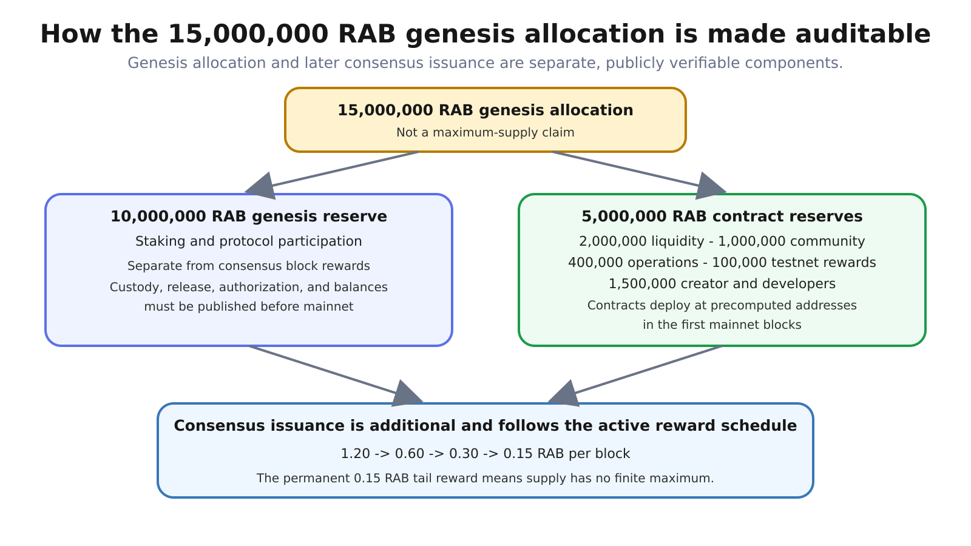
Figure 3. Genesis allocates 15,000,000 RAB and funds deterministic future contract addresses. Consensus rewards then increase total supply under the published era schedule.
The table is a genesis-allocation disclosure, not a maximum-supply claim or forecast of market value. Total issued supply at any block equals genesis allocation plus protocol rewards minus any provable burns. Circulating supply may be lower because of locks, vesting, treasury reserves, and provably inaccessible balances.

8. Testnet participation program
The public testnet is intended to validate real activity from blocks 1 through 100,000. A planned 100,000 RAB mainnet reward pool is reserved from the 15,000,000 RAB genesis allocation described in Section 7. It does not add to that genesis allocation and cannot also be counted as operational spending. This program is separate from protocol block rewards and their era schedule.
Category | Planned pool
Miners | 50,000 RAB
Builders | 30,000 RAB
Testers | 15,000 RAB
Valid bug hunters | 5,000 RAB
Total reserved | 100,000 RAB
Eligibility is intended to use verifiable testnet activity, such as mining, transactions, deployments, use, and accepted bug reports. Likes, follows, reposts, or other social engagement do not determine rewards. Final criteria, wallet-verification procedures, exclusions, anti-abuse rules and dispute handling must be published before any allocation or claim.
Planned distribution occurs six months after official mainnet liquidity begins, subject to the final published program rules and legal review. Testnet assets themselves have no promised monetary value.

8.1 Reward-vault transparency
Before mainnet distribution, the 100,000 RAB must be held in a dedicated public reward vault or equivalently restrictive on-chain mechanism. Its balance must not be commingled with the 400,000 RAB operations treasury.
The recommended claim design is a verified, fixed-cap distribution contract whose total successful claims can never exceed 100,000 RAB. If a Merkle-root claim system is used, Rabbit Chain must publish the complete underlying allocation file so anyone can reconstruct the root and verify their proof. Publishing only a root is not sufficient transparency.
Before testnet block 1, separate program rules must freeze or explicitly define:
- the exact eligibility window: blocks 1 through 100,000, inclusive;
- recognized activity for each category and its measurement method;
- whether one wallet may qualify in multiple categories;
- per-wallet minimums, maximums, ties, rounding, and anti-Sybil treatment;
- prohibited behavior, exclusions, sanctions, and evidence standards;
- bug severity definitions, duplicate-report priority, and disclosure rules;
- preliminary-results publication, challenge procedure, and decision authority;
- final allocation dataset format and cryptographic hash;
- the objective on-chain event or timestamp that starts the six-month delay;
- claim opening, claim deadline, unclaimed-RAB destination, and recovery rules;
- tax, sanctions, jurisdiction, identity, and legal restrictions if applicable.
No social engagement metric may be introduced later as a hidden eligibility factor. Any rule amendment after block 1 must be versioned, dated, justified, and assessed for its effect on participants who acted under the earlier rules.

8.2 Public distribution dataset
The final distribution publication must contain at least:
Field | Purpose
Eligible wallet | Identifies the on-chain recipient
Category | Miner, builder, tester, or valid bug hunter
Measured contribution | Reproducible basis for eligibility
Assigned RAB | Exact mainnet amount
Calculation version | Links the row to the published methodology
Evidence references | Testnet blocks, transactions, deployments, reports, or accepted issues
Claim status | Unclaimed, claimed, rejected, expired, or otherwise resolved
Personal information should not be published merely for transparency. The public dataset should expose what is necessary to verify allocation correctness while avoiding unnecessary identity data.

9. EVM execution and fees
Rabbit Chain preserves the account-based Ethereum execution model and EVM semantics supplied by its versioned go-ethereum foundation. This enables Solidity smart contracts, familiar address formats, signed transactions, logs, receipts, ABI tooling, and standard wallet integration.
The network is designed to support EIP-1559-style dynamic fee transactions and base-fee accounting. Users specify fee limits and priority fees; the protocol calculates block base fees according to canonical gas usage rules. Compatibility claims always apply to the specific Rabbit release and activated fork schedule, not automatically to every future Ethereum change.
Consensus compatibility and EVM compatibility are different claims. Rabbit does not use Ethereum's present consensus protocol, validator set, finality gadget, network ID, or native asset.

10. Networking and infrastructure
Rabbit Chain uses peer-to-peer block, transaction, and consensus propagation. Official infrastructure is intended to provide an initial access path, not an exclusive gateway.
The public-testnet launch plan includes:
- two independently hosted discovery/boot entry points;
- one public HTTP/WebSocket RPC service;
- one block explorer and indexer;
- DNS, TLS, rate limiting, firewalling, monitoring, and backup procedures;
- public instructions for community-operated nodes, RPC endpoints, and explorers.
Bootnodes help peers find one another but do not grant consensus authority. An RPC endpoint exposes node functions but does not define canonical truth. An explorer indexes chain data but is not the chain. Users should be able to verify data using their own node.
Official launch infrastructure must use fresh datadirs, chaindata, node keys, databases, and runtime secrets. Laboratory state is never promoted into the public network. Only audited source, validated binaries, deliberately finalized genesis/configuration, and reproducible deployment procedures may be reused.

10.1 Official Testnet V2 endpoints
Purpose | Public Testnet V2 endpoint | Status
Website | https://rabbitchain.org/ | Active
HTTP RPC | https://rpc-testnet.rabbitchain.org/ | Active
WebSocket RPC | wss://rpc-testnet.rabbitchain.org/ws | Active
Explorer | https://explorer-testnet.rabbitchain.org/ | Active
Source and releases | https://github.com/rabbitmainnet/rabbit-geth | Active
Whitepaper | https://github.com/rabbitmainnet/rabbit-chain-whitepaper | Active
Faucet | https://rabbitchain.org/platform/faucet/ | Active
Official bootnodes:
enode://2fac5ffabae5e2202666279e2d06f86b6f3f11977fa0818ad795889a55b32e2d4bd651bb5860fc6e88072a01cad23df475a36487cdcd496e97932909600b7791@157.245.245.16:30303
enode://d106f46d3e37a5b8487b1a4b70a11519e77cf8c4532065a3508ebf943e44840867eaff2a4fa8e525e4dea6680d1aef7cb1c2824f3613fc3482b92eb026d357d4@24.144.112.140:30303
Bootnodes provide discovery only. They have no consensus or administrative authority, and community operators may publish additional bootnodes.

10.2 Launch identity file
For machine-readable verification, each public network should publish a versioned network-manifest.json from the website and repository containing:
- network name, chain ID, native symbol, and genesis hash;
- canonical genesis/configuration download URL and SHA-256;
- release tag, source commit, binary names, platforms, and SHA-256 hashes;
- official bootnode records;
- HTTP RPC, WebSocket RPC, explorer, faucet where applicable, status, and documentation URLs;
- activation block/epoch for every consensus-relevant feature;
- contract registry URL and hash;
- creation timestamp, manifest version, and signature or equivalent authenticity proof.
Wallet setup pages, explorer metadata, releases, and third-party listings should be generated from or checked against this manifest to reduce copy-and-paste inconsistencies.

11. Security model

11.1 Protected properties
Rabbit's validation rules are designed to protect:
- deterministic agreement on the eligible set and queue;
- a maximum of one canonical seat per wallet per epoch;
- rejection of invalid, stale, replayed, or duplicate work;
- authentication of the expected producer;
- deterministic reward calculation;
- persistence of canonical state across restart;
- separation between laboratory and production activation contexts.

11.2 Sybil resistance and limitations
Canonical wallet deduplication prevents process-level multiplication behind the same address. Independent RandomX admission increases the cost of operating many addresses, but does not make Sybil attacks impossible and does not prove civil identity.
An attacker with many funded, active wallets and sufficient compute may obtain many eligible seats. Security therefore depends on economic parameters, distribution of participants, client correctness, peer connectivity, key safety, and honest validation by independent nodes.

11.3 Key and operational risks
Participants are responsible for wallet and node-key security. Compromise can enable unauthorized signing, reward theft, or network impersonation. RPC operators must disable dangerous administrative namespaces, protect signing interfaces, rate-limit public methods, and separate public traffic from authenticated engine or management interfaces.

11.4 Smart-contract and bridge risks
EVM compatibility permits arbitrary contracts, including unsafe or malicious ones. The base protocol does not audit user contracts. Bridges and wrapped assets introduce separate custody, oracle, validator, liquidity, and upgrade risks. Users must distinguish native RAB from third-party tokens and representations.

11.5 Experimental status
Before mainnet, Rabbit Chain remains experimental software. Testnet results reduce uncertainty but do not prove absence of vulnerabilities. Independent source review, reproducible builds, adversarial testing, incident procedures, and an appropriately scoped bug-bounty process remain necessary.

12. Validation evidence
The Testnet V2 release passed regressions across LCQ, Ethereum networking, downloader, miner, parameters, Rabbit Miner, Rabbit Core and core execution. A persistent three-node live lab demonstrated full peer connectivity, permissionless admission from three wallets, exactly three persistent equal seats, block production by all three participants, persistence across restart, canonical 70/30 rewards, a real EIP-1559 transaction and recovery-state telemetry.
The historical Rabbit Core Testnet V2.3.6 release corresponds to source commit aeac6e0542c22d509ef02d3166e45487509dd0fc. Verified SHA-256 values are: Windows AMD64 c7e02daec00e9782cf0091dfb09bd55684b9f06306e0c0c7cd686ccecc380830; Linux AMD64 7407ad5267c8fef977c03eeba97d3244f4cd35b0d50e3c3db3b5a24ff4ba8ae7; macOS AMD64 0cdc0e8bd2be31b843b8dae85e46aaa8068e1f209b7e428a6d779d59858ac9ab; and macOS ARM64 391b0c97f2ce2a8e813ffe6cec057a526a45870750fe289efdcb09aebfb1d6e8. V2.3.6 updates official bootstrap and P2P discovery infrastructure only: it does not reset Testnet V2 and does not introduce a new consensus activation. V2.3.4, V2.3.0, V2.2.5 and V2.2.3 remain preserved as historical release records.
The V2.2.3 upgrade path was exercised against an existing Windows datadir and encrypted mining wallet. Rabbit Core rebuilt canonical LCQ state, reused the same wallet and chain history, restored the existing active WorkSeat, synchronized automatically and resumed canonical LCQ participation. The public RPC and Explorer nodes crossed block 50500 on the same canonical chain. A direct post-fork comparison at block 50698 returned the same hash 0xc128c9aa7c35d631c090514e60f9db48fce7411b02ac6d66f824945363ab4606 from both nodes. A later 40-block RPC sample measured a 10.22-second mean, 10-second median, 13-second maximum and zero intervals above 20 seconds. Validation is evidence, not proof that defects are impossible; Testnet V2 remains experimental.

13. Governance and upgrades
Rabbit Chain's consensus should not depend on an administrator contract or an undisclosed privileged key. Protocol evolution occurs through public source changes, reviewable releases, explicit activation rules, and community adoption of compatible clients.
During the initial public-testnet phase, the founding development team coordinates official releases and infrastructure. This practical coordination is a disclosed centralization risk. The protocol objective is to reduce dependency on official infrastructure through independent nodes, miners, RPC operators, explorers, developers and reviewers.
Any consensus upgrade should publish:
- motivation and security analysis;
- exact source diff and release commit;
- activation network and block/epoch;
- backward-compatibility and rollback implications;
- reproducible binaries and hashes;
- test evidence and migration instructions.

14. Roadmap and launch gates

Public Testnet V2 completed
- Work V2 permissionless admission and persistent-seat regressions;
- fresh three-node network, first bootstrap admission/activation boundaries at blocks 128/256, and multi-producer operation;
- producer/committee 70/30 economic audit and real EIP-1559 transaction;
- reproducible Windows, Linux and macOS release archives;
- public RPC, archive node, explorer, bootnodes and frozen genesis identity;
- complete mining, wallet-backup and recovery documentation.

Continuing testnet work
- real public miner and node diversity;
- long-duration availability, recovery, partition and adversarial testing;
- independent builds, audits, issue reports and infrastructure;
- final publication of any testnet participation-program rules.

Required before mainnet
Mainnet requires a separate frozen genesis, signed artifacts, independent review, final allocation custody, verified contracts, signer and timelock disclosures, legal/risk review, mainnet infrastructure and a reproducible launch manifest. Testnet V2 does not imply mainnet readiness.

15. Reproducibility and verification
A professional release must allow third parties to connect documents to executable artifacts. Each release should publish:
- Git commit and signed tag;
- genesis and configuration hashes;
- source archive hash;
- binary hashes by operating system and architecture;
- compiler, toolchain, build flags, dependencies, and build script;
- audit/gate evidence hashes;
- network identifiers, bootnode records, and official domains.
Users should verify downloaded binaries against published hashes and obtain hashes through more than one official channel where possible.

16. Testnet V2 parameters snapshot
Parameter | Released value
Testnet chain ID / network ID | 9280 / 9280
Planned mainnet chain ID | 928
Target block time | 10,000 ms
Epoch length | 128 blocks
Fresh-chain first admission height | 128
Fresh-chain first activation height | 256
Recovery halt threshold | 2 minutes
Consensus-hardening activation | Block 50000
Consensus-stabilization activation | Block 50500
Fairness/Liveness activation | Block 73000
Liveness V3 activation | Block 77000
Future timestamp tolerance before block 50000 | 30 seconds
Future timestamp tolerance from block 50000 | 1 second
Producer / committee reward | 70% / 30%
Current Testnet base reward | 1.20 tRAB
Reward era length | 8,409,600 blocks
Reward schedule | 1.20 -> 0.60 -> 0.30 -> 0.15 RAB
Tail emission | 0.15 RAB per block
Work proof | RandomX / Work V2
RandomX dataset base size | 1 GiB
Seat rule | At most one persistent equal seat per non-zero wallet
On the public Testnet, user-facing mining rewards are denominated in tRAB, the test asset with no promised monetary value. References to RAB in the monetary-policy sections describe the protocol reward schedule; the Testnet uses the corresponding test denomination tRAB.

17. How to participate
- Open https://rabbitchain.org/mining and download the current Rabbit Core Testnet V2.4.13 release.
- Download the appropriate Windows AMD64, Linux AMD64, macOS AMD64 or macOS ARM64 package and verify its published SHA-256 before running it.
- Start Rabbit Core, create a strong local password and back up the exact encrypted UTC--... keystore file it prints. Keep the password separately.
- Keep Rabbit Core open while it automatically connects to the Rabbit Testnet P2P network and synchronizes the canonical blockchain. No public RPC, WebSocket endpoint or manual peer configuration is required to begin mining.
- After synchronization, Work V2 may prepare the 1 GiB RandomX dataset and search for the wallet's one-time admission proof. This is admission work, not recurring LCQ block mining.
- After the proof is accepted, Rabbit Miner reports LCQ PENDING. No duplicate admission proof is needed; keep Rabbit Core running while canonical selection and activation progress.
- When Rabbit Miner reports LCQ ACTIVE / ACTIVE LCQ seat, the wallet owns one persistent equal consensus seat and is actively participating in LCQ.
- Keep Rabbit Core online. PRODUCER identifies blocks produced by the wallet, while COMMITTEE identifies committee rewards detected for it.
Operating system | Main Rabbit Core directory
Windows | %APPDATA%\RabbitChain\TestnetV2
Linux | ${XDG_CONFIG_HOME:-$HOME/.config}/RabbitChain/TestnetV2
Within that directory, the wallet is under keystore/UTC--..., chain data under rabbit/chaindata, and logs under logs/rabbit-node.log. The .rabbit-session-password-* file is temporary and is not a backup.

17.1 Required upgrade for existing participants
The current recommended Rabbit Core Testnet release is V2.4.13. Releases older than V2.3.0 are not compatible canonical producers beyond the Liveness V3 activation at block 77000. V2.3.6 itself does not add a new consensus activation; it updates the official bootstrap and P2P discovery infrastructure.
- Stop the older Rabbit Core normally.
- Download the official V2.4.13 package from https://rabbitchain.org/mining/.
- Verify the published package SHA-256.
- Extract the new release into a new program folder.
- Keep the existing Rabbit Testnet datadir, encrypted wallet, keystore, WorkSeat state and password.
- Start V2.4.13 using the normal Rabbit Core launcher.
- Keep Rabbit Core open while it reuses the existing local chain state and synchronizes to canonical history.
- Wait for canonical synchronization and LCQ ACTIVE before treating the wallet as an active canonical participant.
Do not delete the blockchain, datadir, keystore or WorkSeat state as part of this upgrade. V2.4.13 preserves the existing Testnet V2 chain and consensus history.
Never give a password, private key, seed phrase or keystore to a website, RPC, explorer, faucet, administrator or support agent.

18. Frequently asked questions

Is the public testnet live?
Yes. This edition documents the live Rabbit Testnet V2, chain ID 9280, its Work V2 admission lifecycle, the block-50000 consensus hardening, the block-50500 stabilization activation, the block-73000 Fairness/Liveness activation, the block-77000 Liveness V3 activation and the current Rabbit Core Testnet V2.4.13 release identity.

Does a seat guarantee blocks or income?
No. A seat provides equal deterministic consensus weight, not guaranteed production, reward, uptime or profit.

Can several processes using the same wallet create several seats?
No. Canonical validation rejects a participant that already owns a persistent seat.

Can one person create multiple wallets?
Yes. LCQ does not prove human identity. Every wallet must independently complete admission, but Sybil risk is not eliminated.

What happens when no miner remains online?
The chain pauses. After a two-minute canonical halt, permissionless recovery admission can resume the preserved history.

What happens if the official RPC or explorer stops?
Independent nodes can continue when peers and producers remain online. Anyone may run a node, RPC, explorer or bootnode; official services have no consensus authority.

Are testnet tokens valuable?
No promised monetary value. Any separate participation program follows its final published rules.

19. Glossary
Term | Meaning in Rabbit Chain
Admission | One-time RandomX process by which a wallet seeks a persistent seat
Bootnode | Peer-discovery entry point without consensus authority
Canonical chain | History accepted under active validation rules
Committee | Deterministically eligible seats sharing the committee reward
Epoch | Fixed 128-block interval organizing Work V2 admission and selection
LCQ | Live Consensus Queue, Rabbit's deterministic production protocol
Persistent seat | One equal canonical consensus position owned by a non-zero wallet
Producer | Seat selected to construct and sign a particular block
RandomX | CPU-oriented proof algorithm used for admission and recovery
Recovery admission | Permissionless admission opened after a two-minute complete halt
RPC | Remote node interface for wallets and applications
Ticket | Signed Work V2 proof submission bound to canonical context

20. Conclusion
Rabbit Chain proposes a specific change to permissionless block production: computational effort admits a wallet into a persistent deterministic live queue, while canonical state prevents that wallet from multiplying seats by multiplying processes. LCQ combines this wallet-bounded opportunity with EVM execution, RandomX work, deterministic producer authentication, committee rewards, fallback rules, and recoverable canonical state.
The project should be judged by reproducible code and observable network behavior, not slogans. The current milestone is the fresh public Testnet V2 deployment whose genesis, binaries, infrastructure, rules, and evidence can be independently inspected from block 1.

References
- Rabbit Chain source repository: https://github.com/rabbitmainnet/rabbit-geth
- Rabbit Chain website: https://rabbitchain.org/
- Rabbit Chain community: https://discord.gg/TBWspuEZss
- RandomX source and documentation: https://github.com/tevador/RandomX
- Ethereum Yellow Paper: https://ethereum.github.io/yellowpaper/paper.pdf
- EIP-1559 specification: https://eips.ethereum.org/EIPS/eip-1559

Version history
Version | Date | Description
1.6 | 26 September 2026 | Rabbit Core Testnet V2.3.6 operational release edition: refreshed official bootstrap and P2P discovery infrastructure, current Windows/Linux/macOS release identity and SHA-256 hashes, preserved Testnet V2 chain history, and no new consensus activation
1.5 | 16 September 2026 | Rabbit Core Testnet V2.3.0 Liveness V3 edition: block-77000 activation, deterministic producer rotation, bounded fallback recovery, committee participation claims, verified reward accounting and non-destructive upgrade
1.4 | 14 September 2026 | Rabbit Core Testnet V2.2.5 Fairness/Liveness edition: block-73000 activation, deterministic producer-order fairness, preserved committee filtering and fallback/recovery, in-place upgrade, hardened Rabbit Core restart behavior, and verified Windows/Linux release hashes
1.3 | 11 September 2026 | Rabbit Core Testnet V2.2.3 post-stabilization edition: block-50500 activation, preserved in-place wallet/datadir/WorkSeat upgrade, Windows/Linux release hashes, canonical RPC/Explorer convergence, post-fork 10-second cadence evidence, deterministic fork-recovery observation and disclosed ForkID compatibility limitation
1.2 | 9 September 2026 | Rabbit Core Testnet V2.2.2 required hard-fork upgrade: block-50000 activation, deterministic WorkSeat liveness, one-second future timestamp tolerance, preserved chain/wallet/WorkSeat upgrade path, release hashes and public infrastructure validation
1.1 | 4 September 2026 | Rabbit Core Testnet V2.1 alignment: final release identity, live-network 128-block epoch clarification, RandomX admission versus LCQ participation, LCQ PENDING / LCQ ACTIVE miner states, and updated participation flow
1.0 | 2 September 2026 | Public Testnet V2: Work V2 admission, persistent equal seats, fresh-network 128/256 activation, two-minute recovery, public endpoints and release identity
0.9-r4 | 30 August 2026 | Repository-wide consistency correction: regenerated allocation PNG, synchronized machine-readable version, separated the 10,000,000 RAB genesis reserve from consensus issuance, and clarified activation-delay observability
0.9-r3 | 30 August 2026 | Monetary-policy reconciliation: 15,000,000 RAB genesis allocation, active era schedule, permanent 0.15 RAB tail emission, immediate mining rewards, and committee zero-recipient behavior
0.9 | 29 August 2026 | Public Testnet V2 technical edition; LCQ architecture, 15,000,000 RAB genesis allocation, 100,000 RAB testnet reserve sourced from the former operations allocation, contract/treasury transparency framework, validation evidence, risks, launch gates, participation guide, FAQ, and glossary

Contact and official channels
- Website: https://rabbitchain.org/
- GitHub: https://github.com/rabbitmainnet
- X: https://x.com/rabbit_mainnet
- Discord: https://discord.gg/TBWspuEZss
© 2026 Rabbit Chain contributors. Distribution permitted with attribution. Protocol behavior remains governed by the applicable open-source license and versioned source code.

