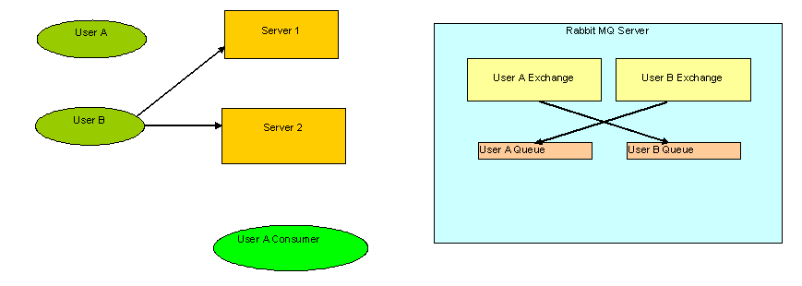

Initial State

Intially UserA Exchange is bound to UserB Queue and User B exchange is bound to User A Queue. UserB is connected to both servers.

Cases:

Case1: User B sending his message to UserB Exchange which will route message to User A queue but User A is not connected to any of servers. At this point of all messages sent to Queue A should be dropped.

Case2: User A connected to server 1 but UserA consumer is not yet subscribed to UserA queue. If UserB sends any message to its exchange which is routed to Queue of UserA. At this moment of time I want all messages to be stored in queue.

Case3: User A is connected to both servers and UserA consumer is subscribed to UserA queue. If UserB sends any message to its exchange which is routed to Queue of UserA. At this moment of time I want all messages stored in queue to be delievered plus any other incoming message should also be routed.

Case4: User A is connected to both servers and UserA consumer is subscribed to UserA queue. Now User disconnects from Server 2. If UserB sends any message to its exchange which is routed to Queue of UserA. Again I want to store all messages.

Case5: If user A is disconnected from both servers. Initial state is achieved again.

