**Demonstration**:

1. This is the UI of the technique challenge (Figure 1)

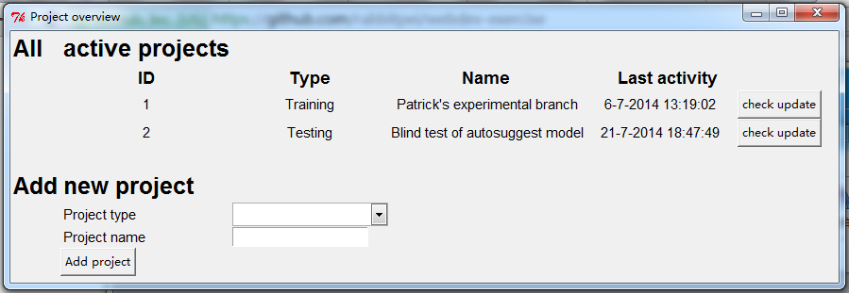

Figure 1

1. All the active projects are listed in the zone “All active projects”. If Alice wants to add a new project, select one project type (training, testing, analysising), and input the project name.
2. If Alice inputs a project which doesn’t exist in Github, shown in Figure 2, a popout appears “Didn’t find the project in Github, please re-enter the info!”

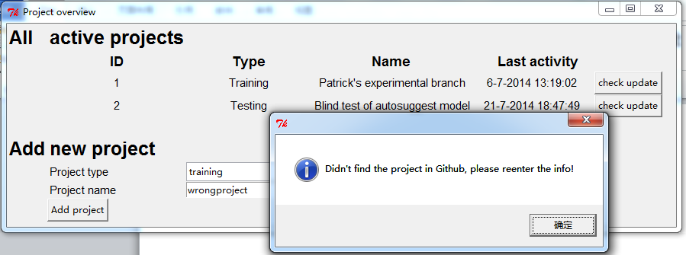

Figure 2

1. If Alice inputs a project which is a branch in <https://github.com/quixey/webdev-exercise>, shown in figure 3, the project “baseline-branch” will be added in “All active projects” list.

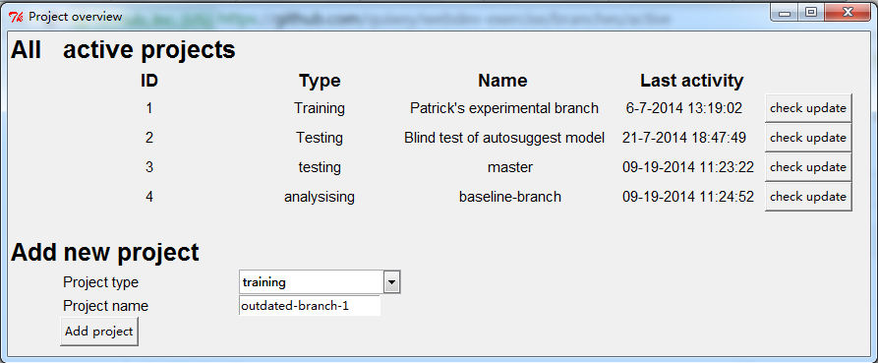

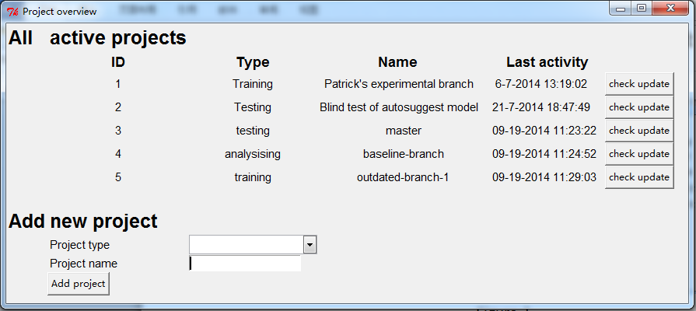

Figure 3

1. Alice can check the status of each project by clicking the button “check update”, as shown in Figure 4.

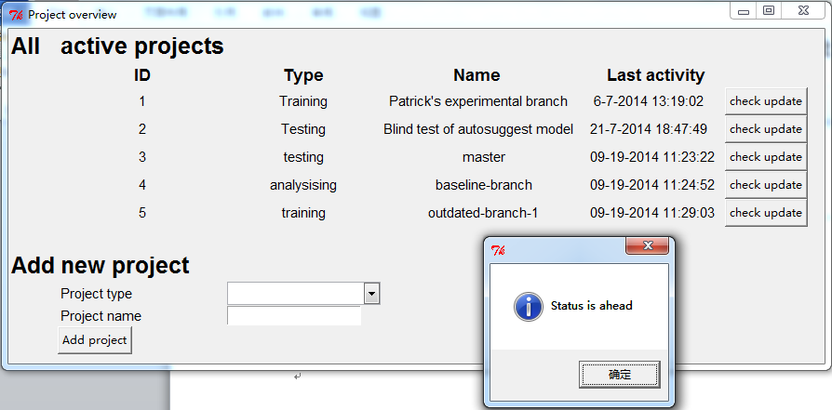

Figure 4

**Tips**:

1. I use two categories of API, one is for the input project checking (whether it's in Github), the other is for the status checking of a project (whether it needs to be updated).
2. Each project can be added only once.
3. I have two versions in total. I think the python one is perfect, however, sometimes the API doesn’t response in the Javascript one, or sometimes the webpage refreshes somehow.