First you need to successfully log in to the software: -

Follow the steps below to add a new installment: -

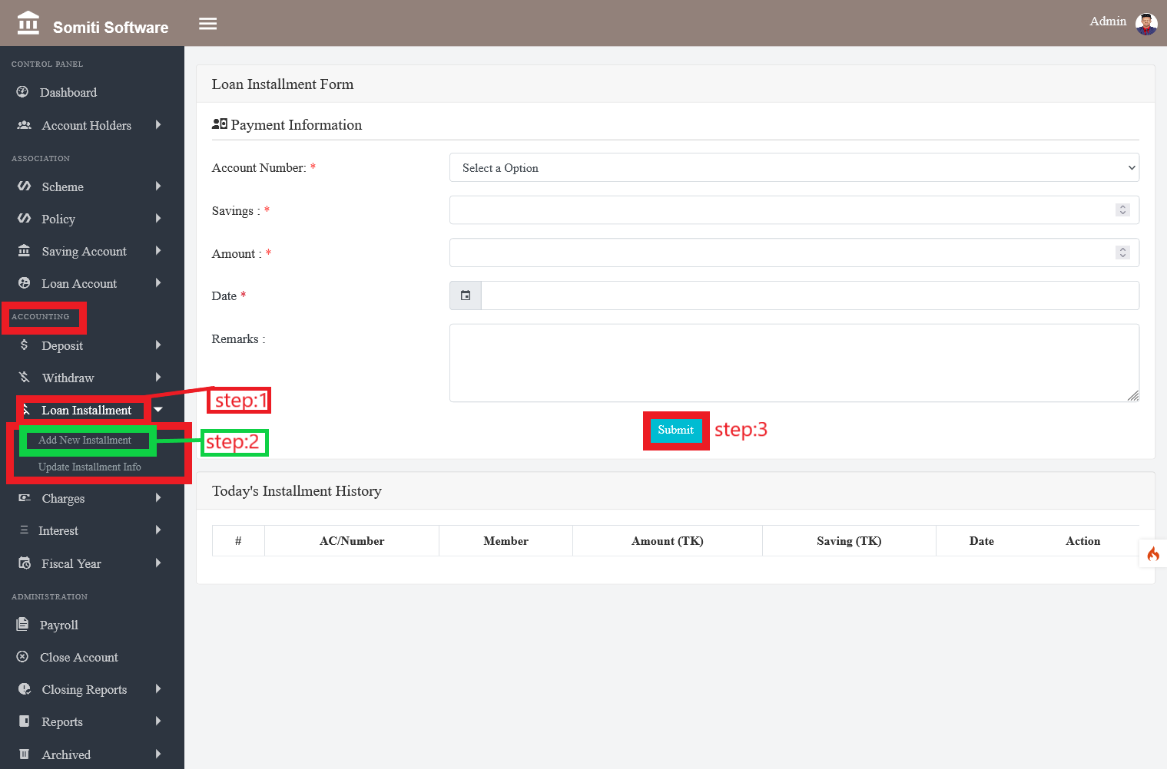

Step-1

Click on the **installment** section of the loan repayment from the **accounting**.

Step-2

After clicking on the installment section of the loan repayment a new list will appear. From there click on the **new installment** section.

Clicking on the section will bring up a form. Provide all the information required in the form accurately.

Step-3

When you have finished providing the information, click on the **submit** button.