First you need to successfully log in to the software: -

Follow the steps below to add interest.

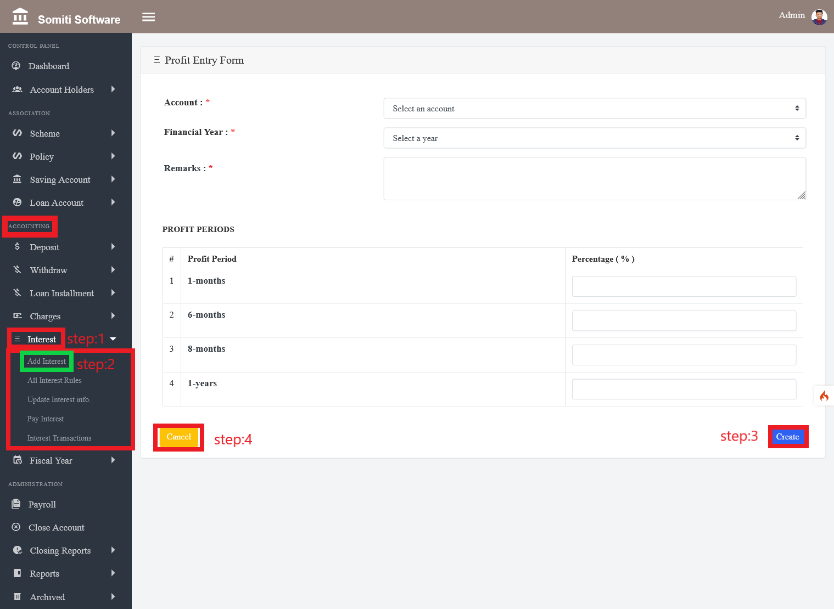

**Step-1**

Click on the **Interest** section from **Accounting.**

**Step-2**

After clicking on the interest section a new list will appear. From there click on the **add interest** section.

Clicking on the section will bring up a form. We provide all the required information in the form accurately.

**Step-3**

When the information is finished, click the **create** button.

**Step-4**

If you want to delete all the information given in the form then click on **cancel** button.