First, successfully login to the software.

Follow the steps below to add a new branch:

First select the **payroll** from **the administration**.

A new list will then appear.

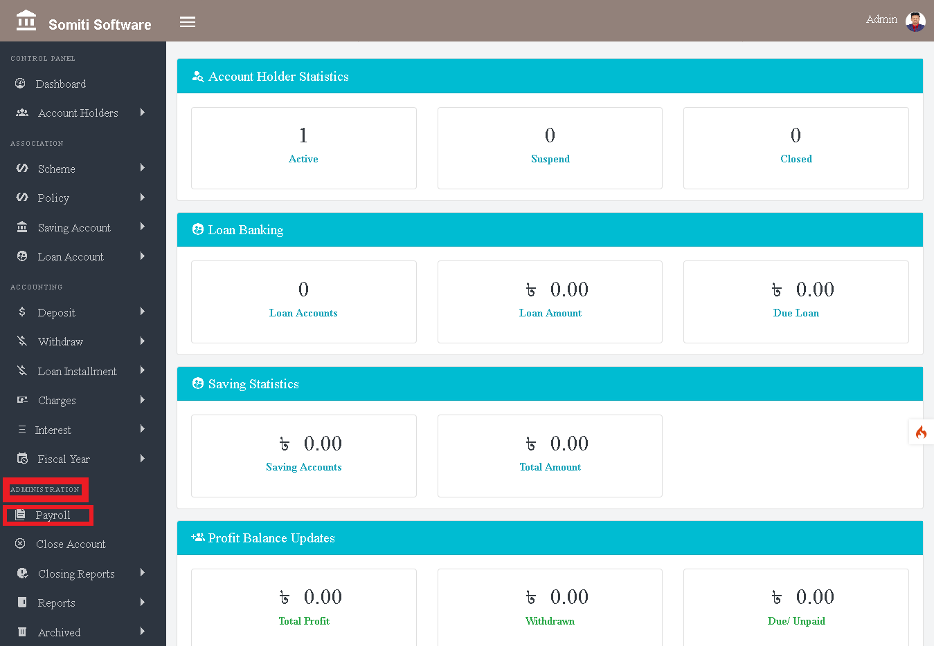

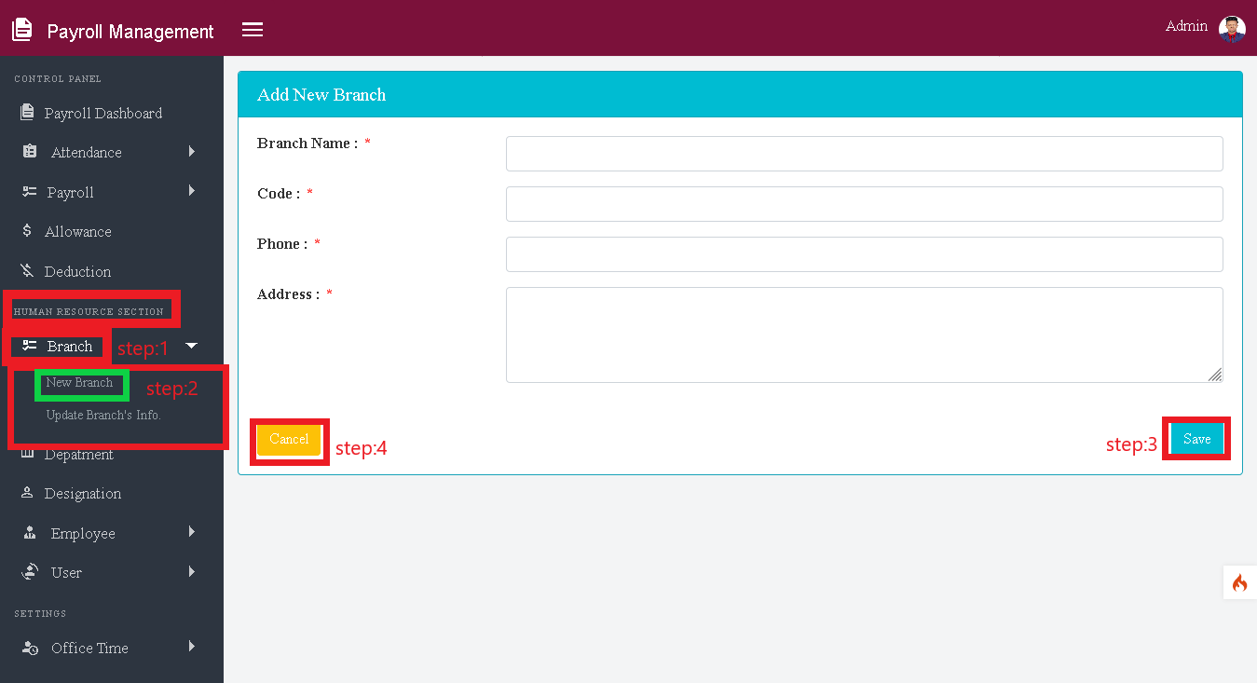

**Step:1**

After selecting the section, a new list will appear.

Select the **Branch** section from **the Human Resources section** of the list.

**Step:2**

A new list will appear after selecting the section.

Select **the new branch** section from the list.

A form will appear after clicking on the new branch section.

Fill out the form correctly.

**Step:3**

Click the save **button** when finished.

**Step:4**

If you want to undo the information given in the form, click the **Cancel** button.