First you need to successfully log in to the software: -

Follow these steps to add a new financial year: -

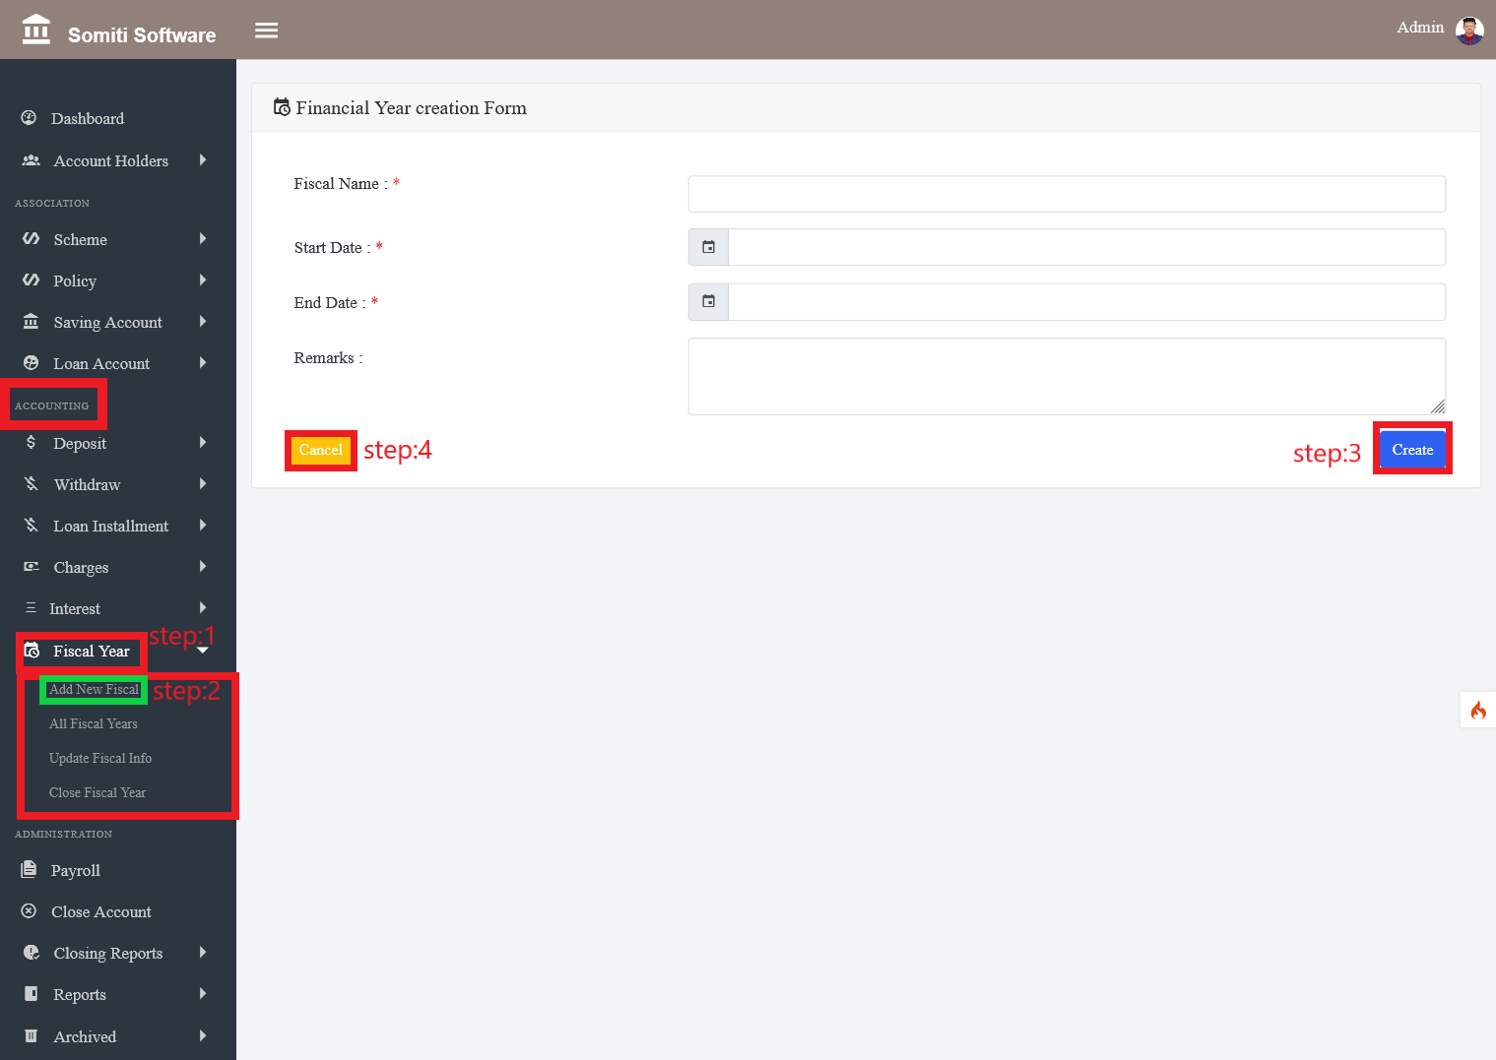

**Step-1**

From **Accounting**, click on the  **financial Year** section.

**Step-2**

After clicking on the financial year section, a new list will appear. From there, click on the **new financial year** section.

**Step-3**

After clicking on the section a form will come up.

**Step-4**

Fill out the form and click the **create** button.

**Step-5**

If you want to delete all the information given in the form, click the **Cancel** button.