First you need to successfully log in to the software: -

Follow the steps below to add a new policy.

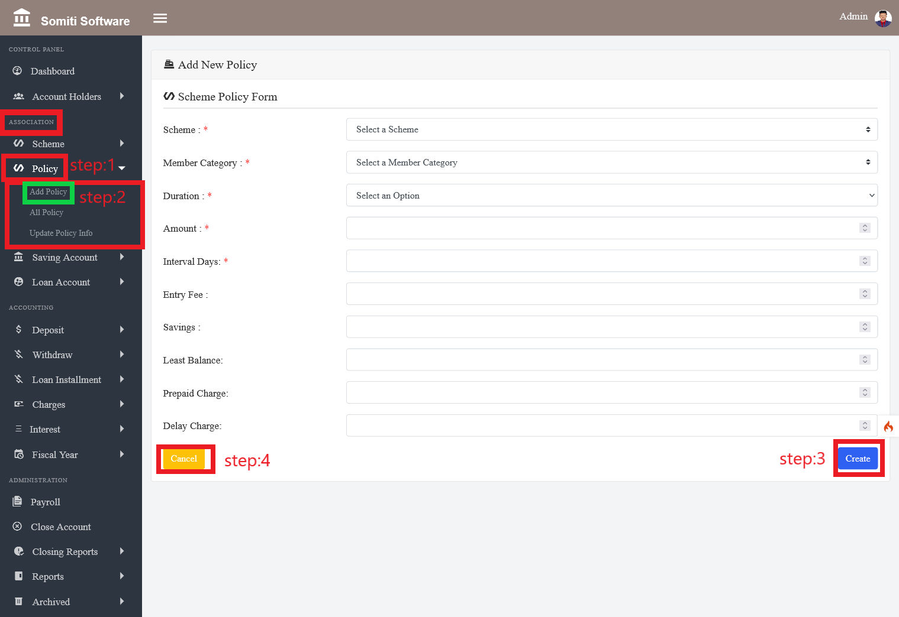

**Step-1**

Click on the **policy** section from the **association**:

**Step-2**

After clicking on the **policy** section a new list will appear. From there click on the **add policy** section.

Clicking on the section will bring up a form. Provide all the information required in the form accurately.

**Step-3**

When the information is finished, click the **create** button.

**Step-4**

If you want to delete all the information given in the form, click the **Cancel** button.