To view a list of all account holders, follow the steps below: -

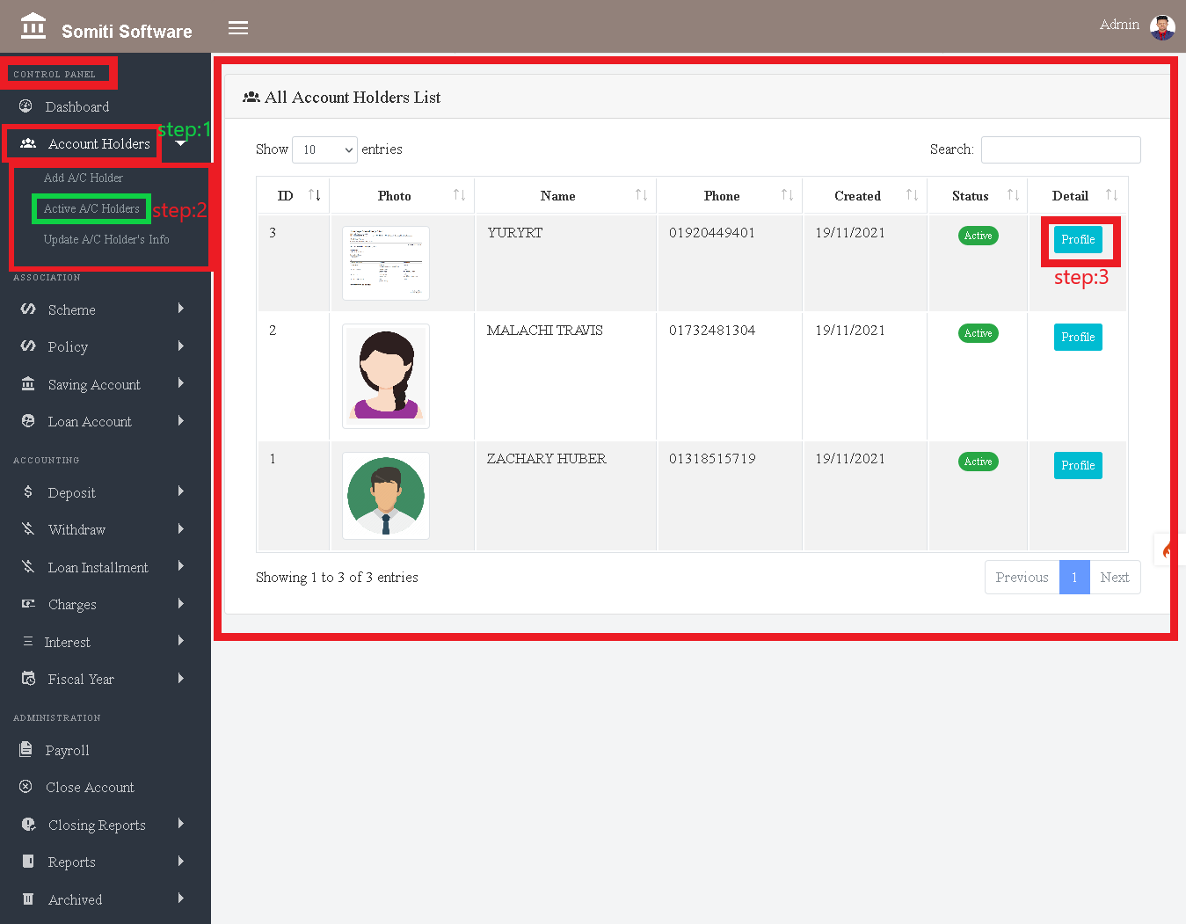

**Step-1**

First select the Account Holder option from **Control Panel.**

After clicking on the account holder option a new list will appear.

**Step-2**

From the list, click on the **Active A / C Holder** option.

After clicking on the Active A / C Holder option, a list of all the account holders can be seen.

Step-3

Click the **Profile** button to view information about a specific member from the list.

After clicking on the profile button, all the information of the specified member will be displayed.