You must first successfully log in to the software.

Follow the steps below to view all the rules of interest.

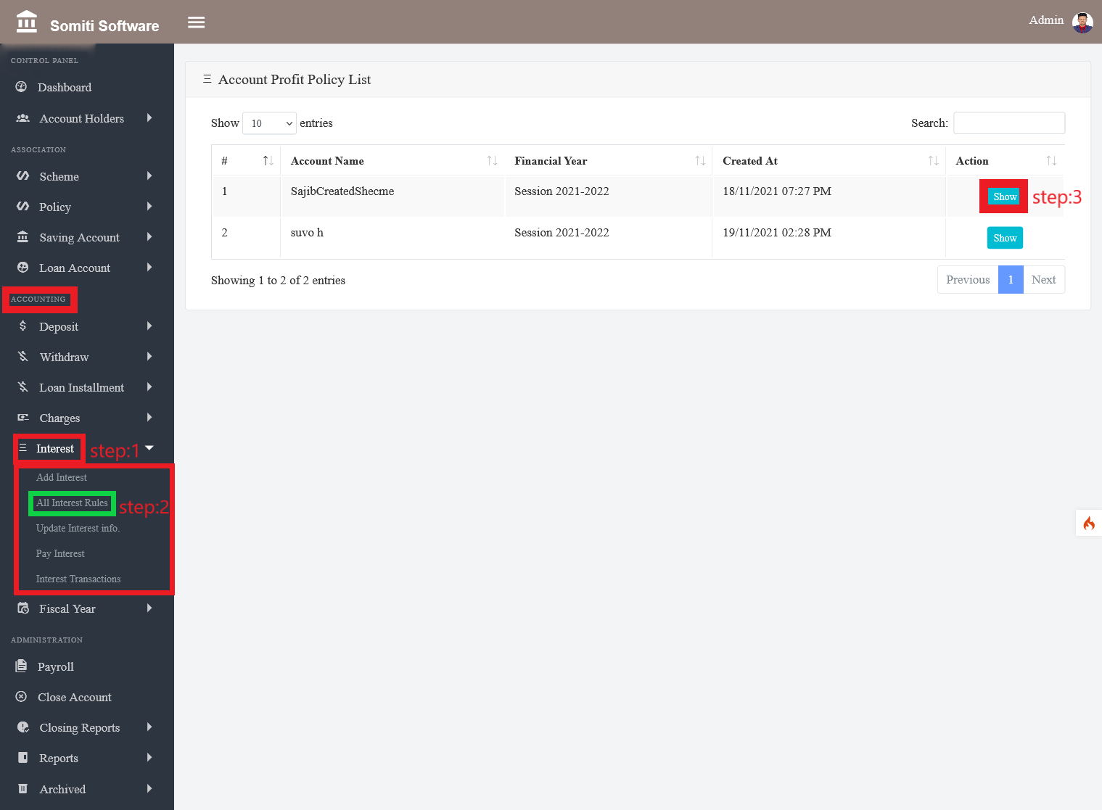

**Step-1**

Click on the **Interest** section from **Accounting**.

**Step-2**

After clicking on the interest section, a new list will appear. From there, click on the **All Interest Rules** section.

After clicking on the section, a list of all the account holders can be seen.

**Step-3**

Click the **show** button to view specific account information.

After clicking on the Show button, all the rules of interest can be seen.