To view the All Loan account, follow these steps: -

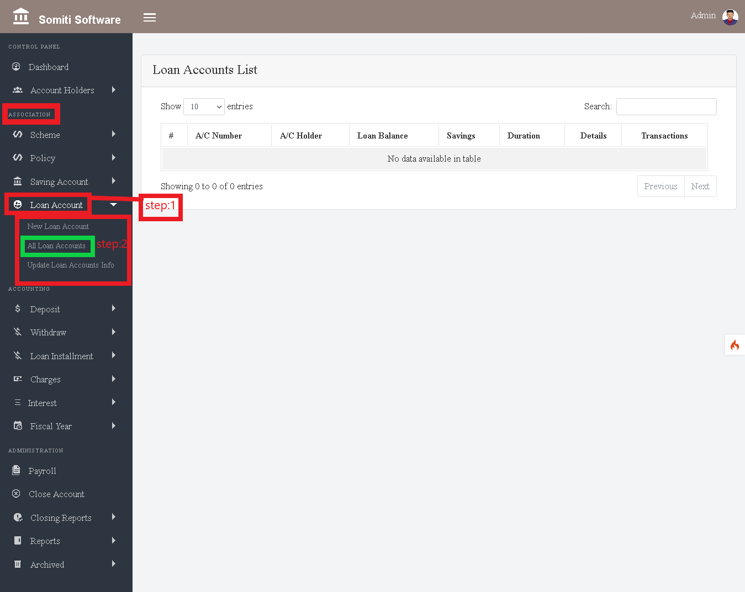

**Step-1**

Click on the **Loan Accounts** section from the Association.

**Step-2**

After clicking on the Loan Accounts section, a new list will appear from there

Click on **All Loans Accounts** section.

**Step-3**

Click the **Details** button to view a specific member's information from the list.

After clicking on the Details button, all the information of the specified member will be displayed.

**Step-4**

Click the **History** button to view the transaction history of specific members.