EWU Campus Wallet — Smart Campus
A multi-role digital super-app for East West University, unifying campus payments, dues & fines, and shop transactions into one wallet.
🔗 Live: cse-mocha.vercel.app
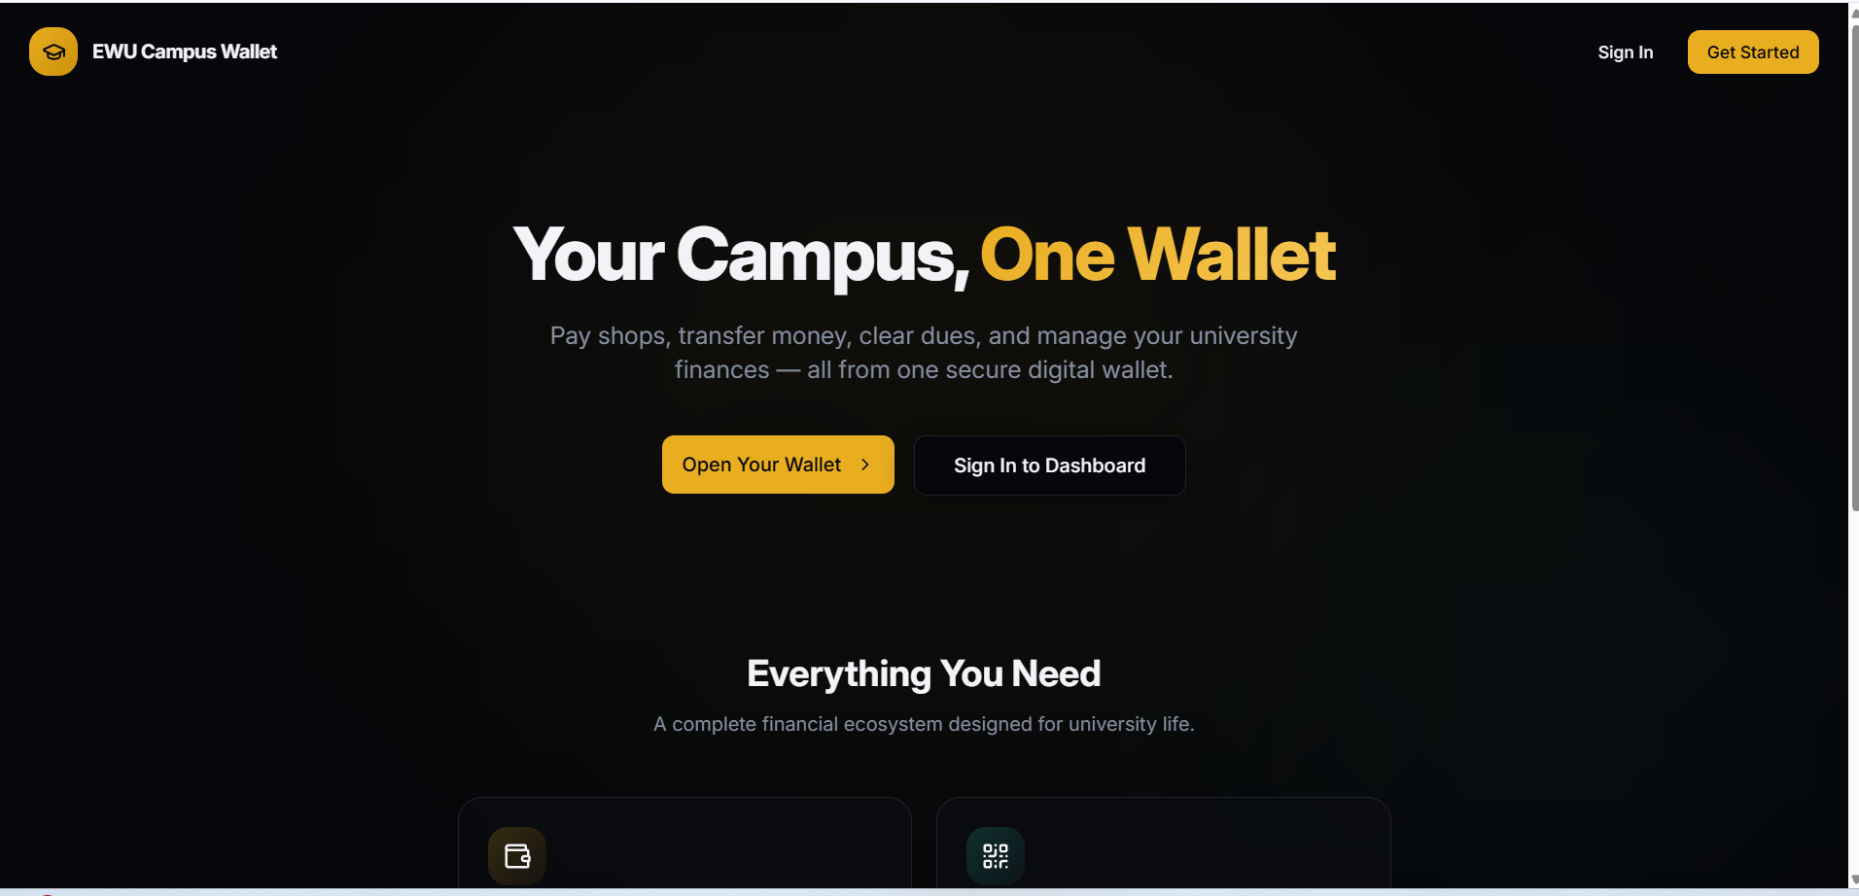

📌 Problem Area
University campuses typically run on fragmented, semi-manual systems for student finances: semester dues tracked on paper or spreadsheets, library and disciplinary fines settled in person, and canteen/shop purchases handled in cash only. This causes long queues, inconsistent record-keeping, no single view of what a student owes across departments, and heavy manual overhead for Admin, Accounts, and Library staff. EWU Campus Wallet solves this by giving every stakeholder — students, Admin Office, Library, Accounts Office, and campus shops — one digital platform to issue, pay, and track obligations in real time.

📖 Project Summary
EWU Campus Wallet is a multi-role university super-app built around a central digital wallet. Students top up and spend from one wallet across campus — covering semester dues, library fines, disciplinary fines, and shop/canteen bills, with an option to pay later on shop purchases — while five separate role-based dashboards (Student, Admin Office, Library, Accounts Office, Shop) give staff the tools to issue, track, and resolve those obligations against the same wallet. The UI follows a premium, dark-themed fintech aesthetic, aiming to make a university utility feel as polished as a real banking app.

✨ Features

🔐 Authentication & Onboarding
- Sign in with an EWU email/Student ID and a password, or a wallet PIN
- One-tap Google Sign-In
- Optional PIN-Tab quick-auth mode for faster repeat logins
- Password recovery and new-account creation
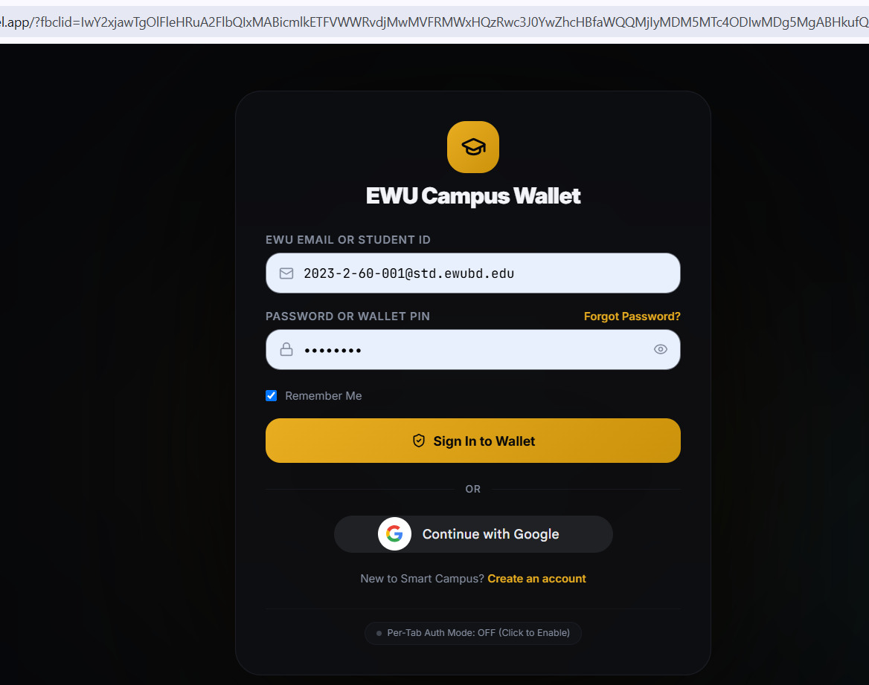

💳 Digital Wallet & Home Dashboard
- One wallet per student with a live balance and a single Add Money action
- Quick-access grid to every module — Shop, Scan & Pay, Money Transfer, Fund, Semester Fee, Administrative Fee, Library Fine, Ledger, Profile, Settings
- A Recent Activity feed that unifies every transaction type — top-ups, fee payments, fines, and shop purchases — in one chronological list
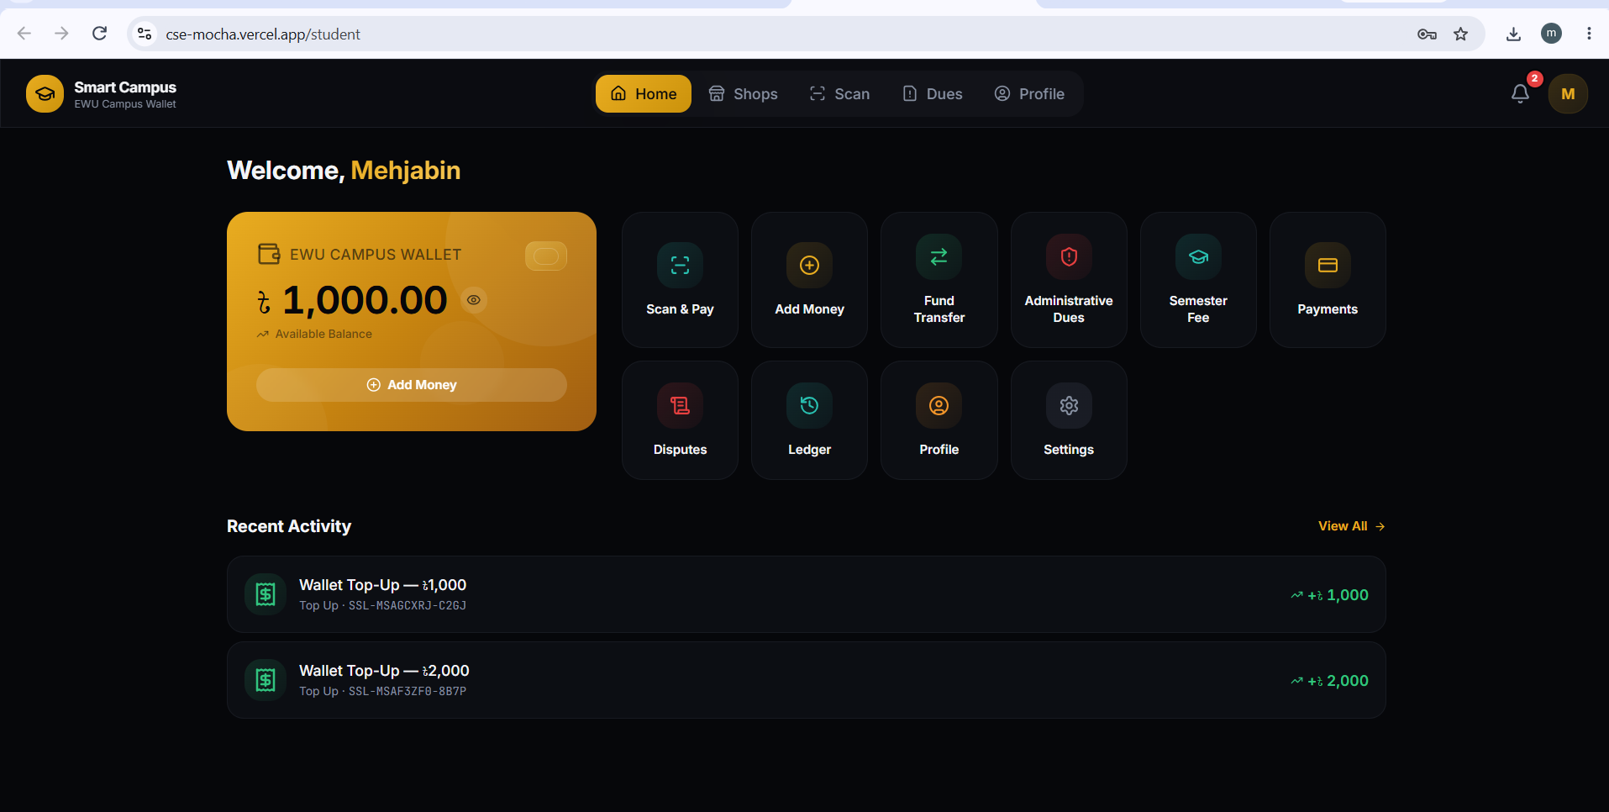

💰 Wallet Top-Up
- Top up via bKash, Nagad, Rocket, Visa, Mastercard, or AMEX
- One-tap quick amounts (৳500 / ৳1,000 / ৳2,000 / ৳5,000) or a custom value
- A confirmation summary step before any money moves
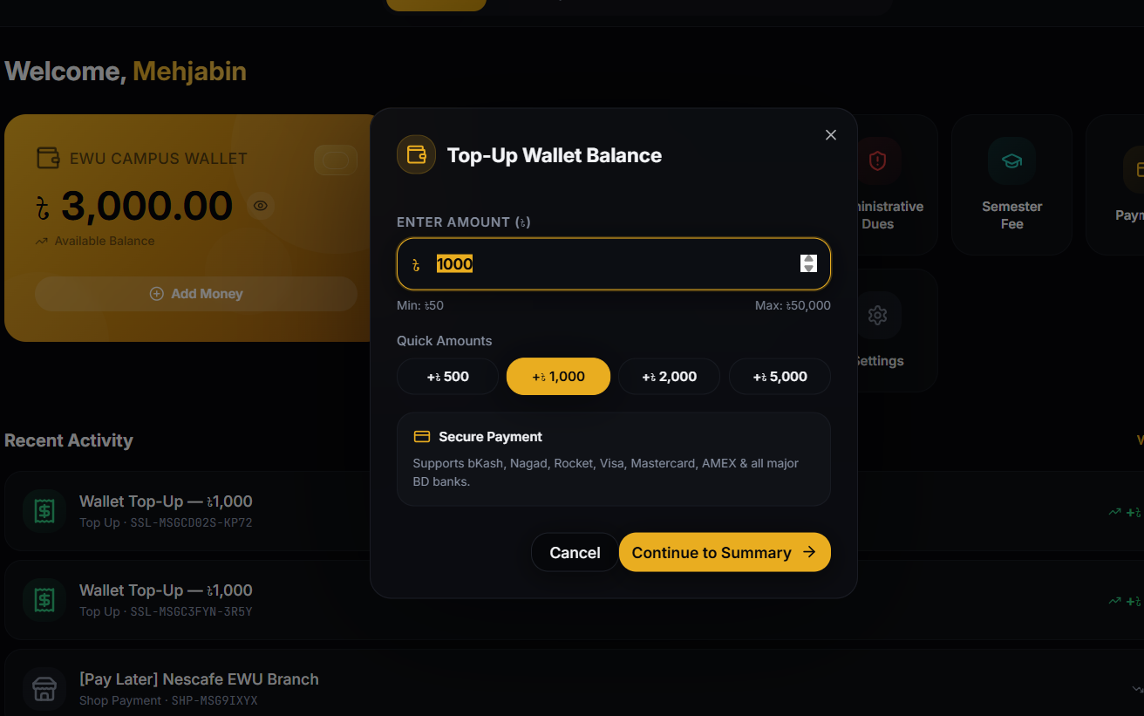

🧾 Payments & Digital Receipts
- Real-time Payment Successful confirmation with a gateway reference number
- An auto-generated itemized receipt — transaction ID, gateway transaction ID, validation ID, date/time, amount, payment method, and student ID — downloadable any time
- Raise Dispute directly from a completed payment if something looks wrong
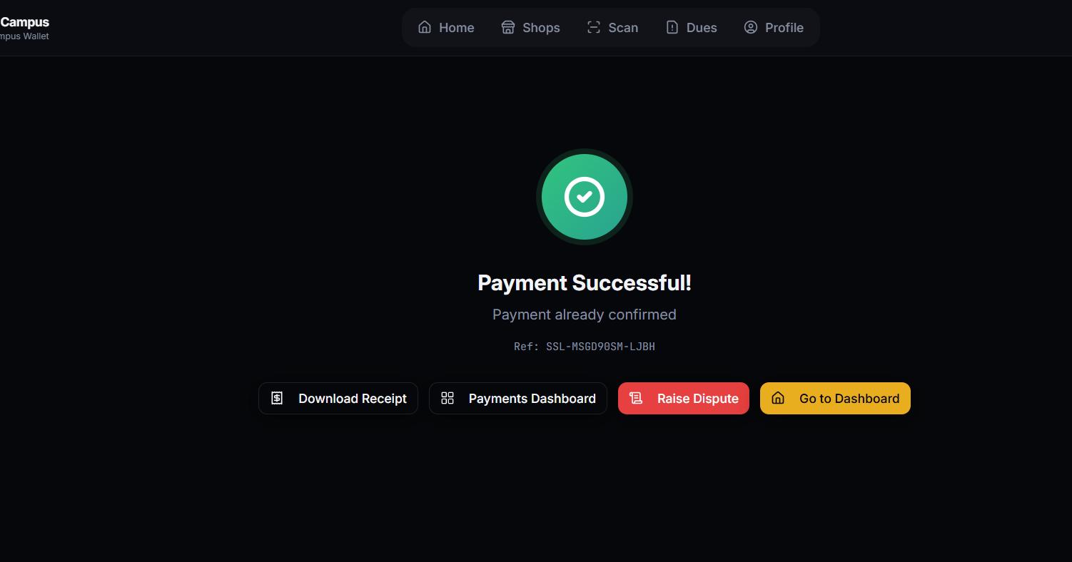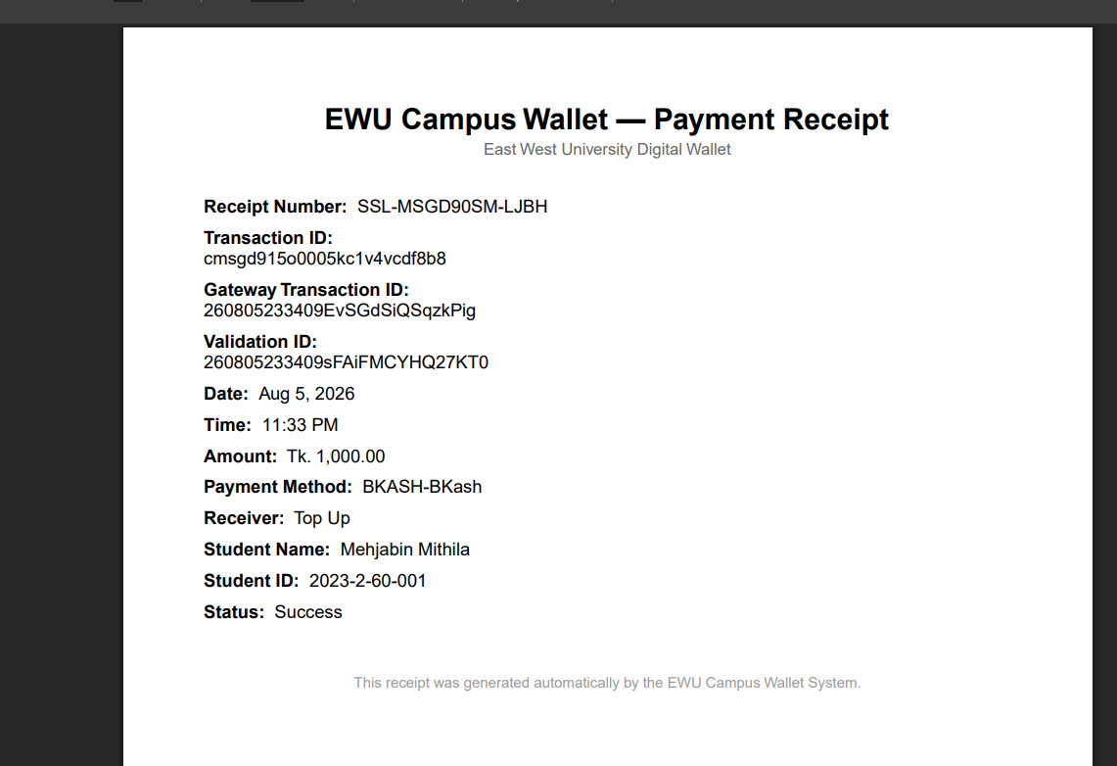

⏳ Pay Later
Students can defer payment on a shop purchase instead of paying at checkout. The purchase posts immediately to the wallet’s Recent Activity, clearly tagged — e.g. [Pay Later] Nescafe EWU Branch — under its own Shop Payment reference, so a student always knows what’s outstanding and to which shop. Unsettled Pay Later purchases accumulate into that shop’s Pending Settlement balance, which the Admin Office later reconciles with the shop — giving students payment flexibility without slowing down the counter.

🎓 Dues & Fines Management
Three independent fine/fee sources, each with its own resolution path, unified under one obligations model so a student always sees a single picture of what they owe:
- Admin Office (disciplinary) fines — staff assign a fine with a reason, amount, and incident date; students can formally appeal it.
- Library fines — lost-book fees and counter payments, resolved directly with library staff, with a dedicated Waivers flow for cancelling or reducing a fine — no appeal step.
- Accounts Office fees — semester fees pushed in bulk to student accounts; adjustments are resolved directly — no appeal step.
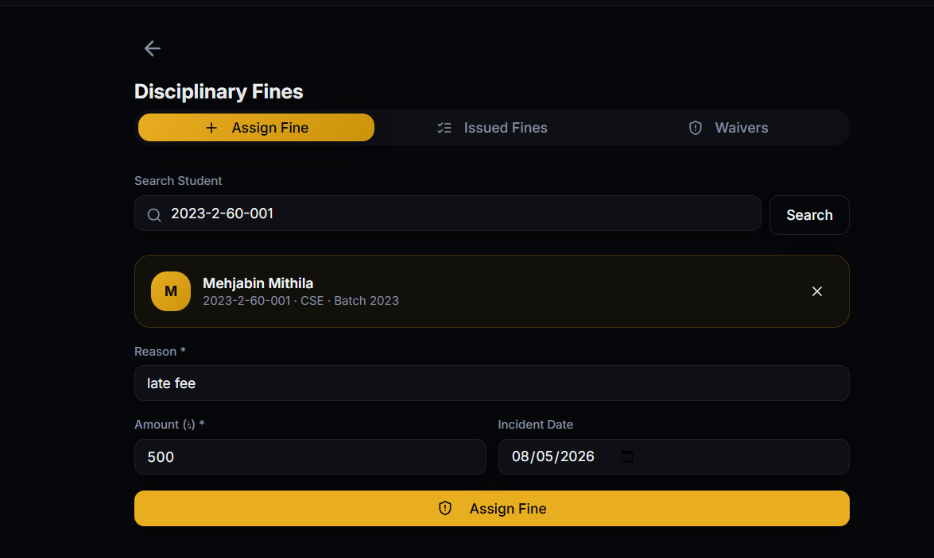

🛍️ Campus Shop Payments
QR-code payments at campus shops and food counters, governed by a prepaid-priority rule — an active prepaid balance is spent down first, before the main wallet is touched — with the Pay Later option above for when a student wants to defer instead.

👤 Admin Office Dashboard
The operational control center for the whole platform:
- At-a-glance stats — total shops, fines awaiting payment, system status — plus a Fines Issued status monitor (pending / paid to Accounts / cancelled)
- Shop Management & Settlement Oversight — activate or deactivate shops and clear each shop’s pending settlement balance
- Staff directory & provisioning — every non-student account (Library, Accounts Office, Admin Office, Shop Staff) is created here and forced through a password reset on first login
- Staff profile pages — read-only core identity plus editable contact details
- Disputes and audit-trail access
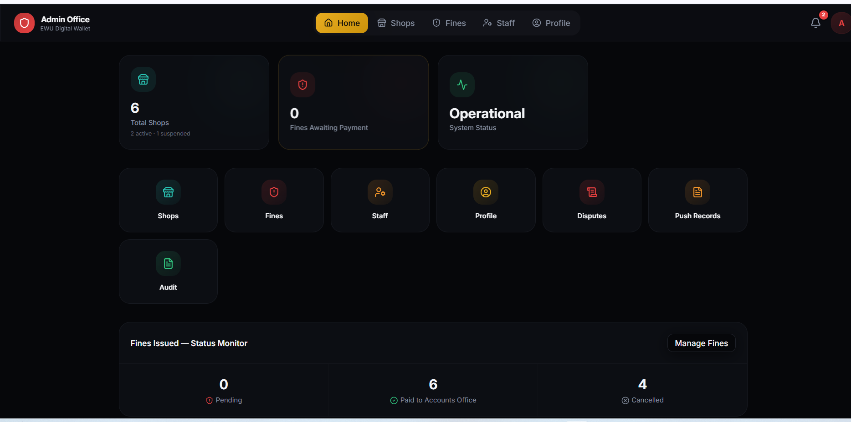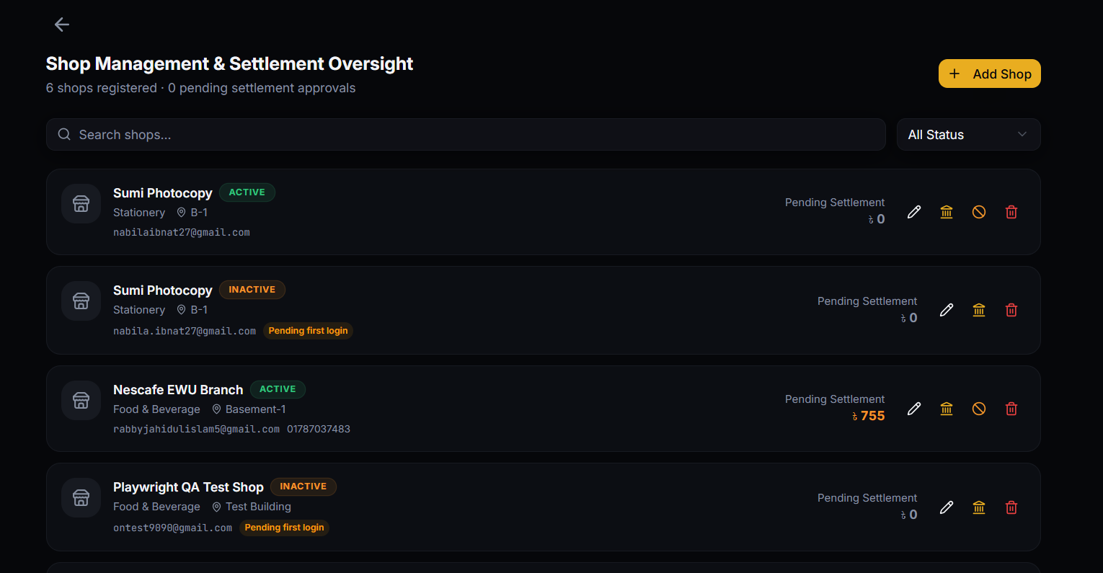
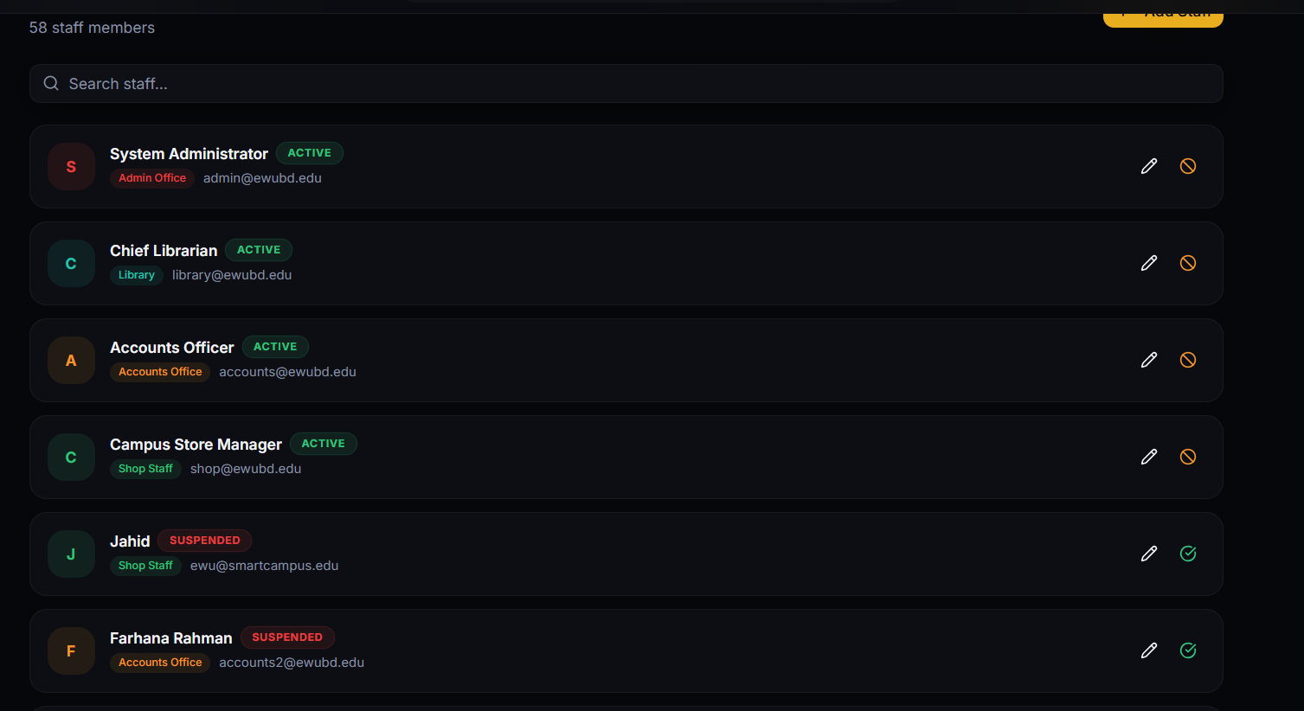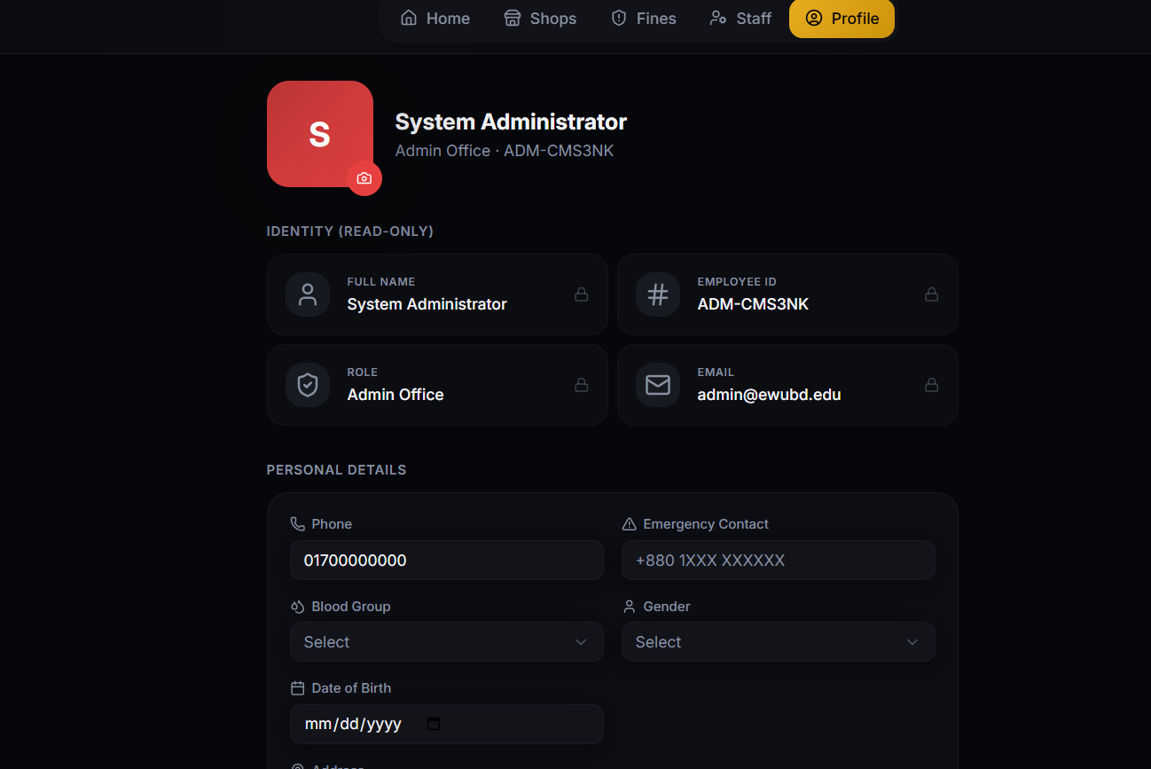

📚 Library Dashboard
- Home overview of outstanding fines and pending clearances
- Library Payment QR Code — a regenerable QR code, plus a walk-up Kiosk Mode, so students can scan and pay a fine on the spot
- Issued Fines and Waivers workspaces for tracking and resolving or reducing a fine
- Live notifications when a fine is paid or a case is forwarded
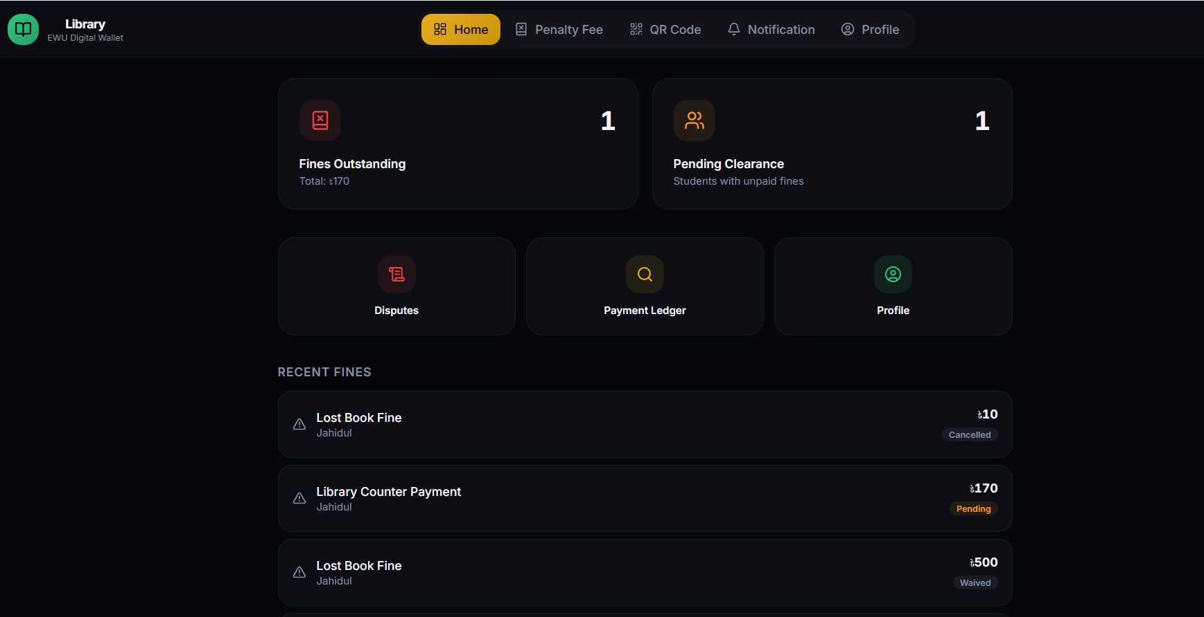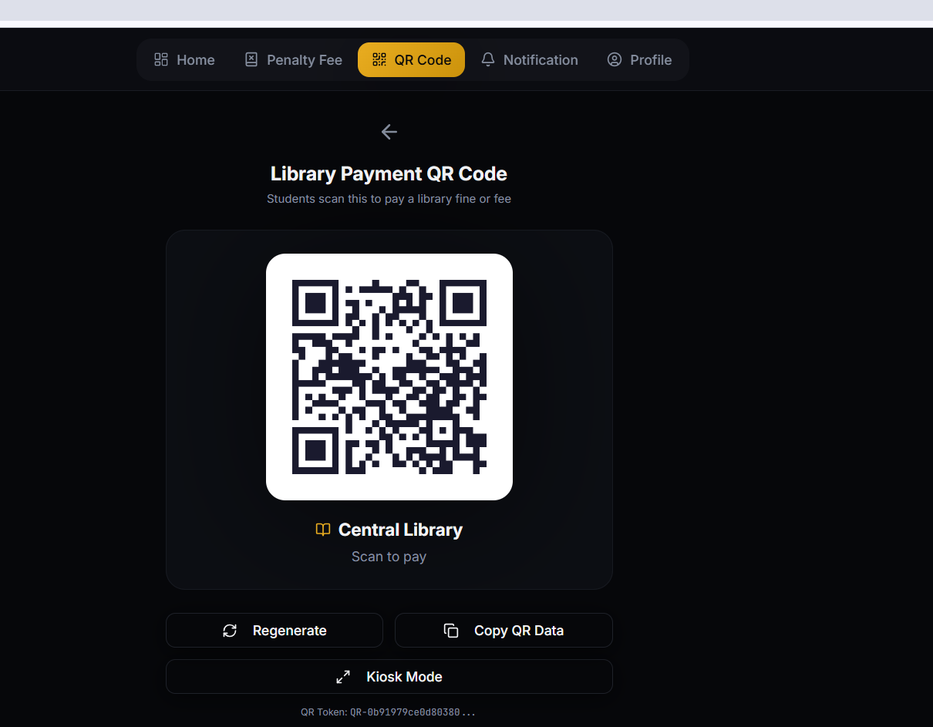
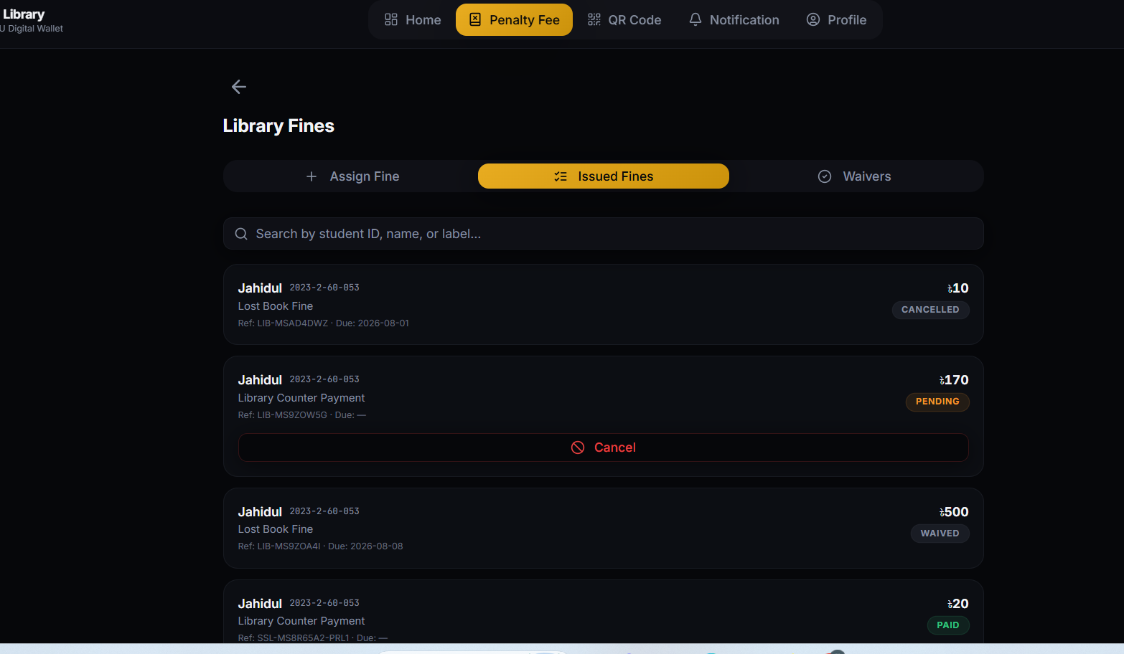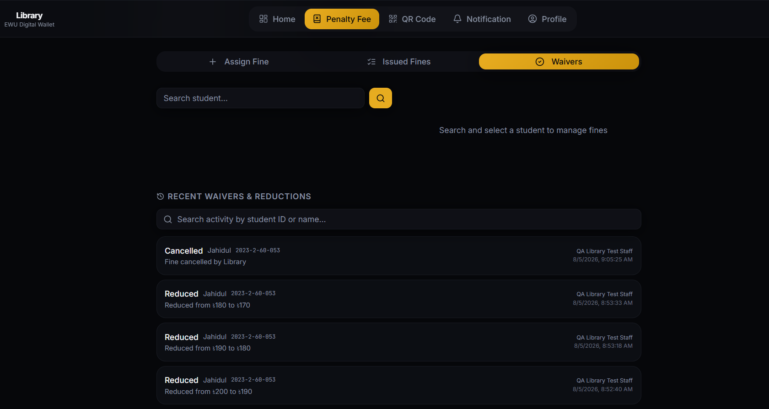
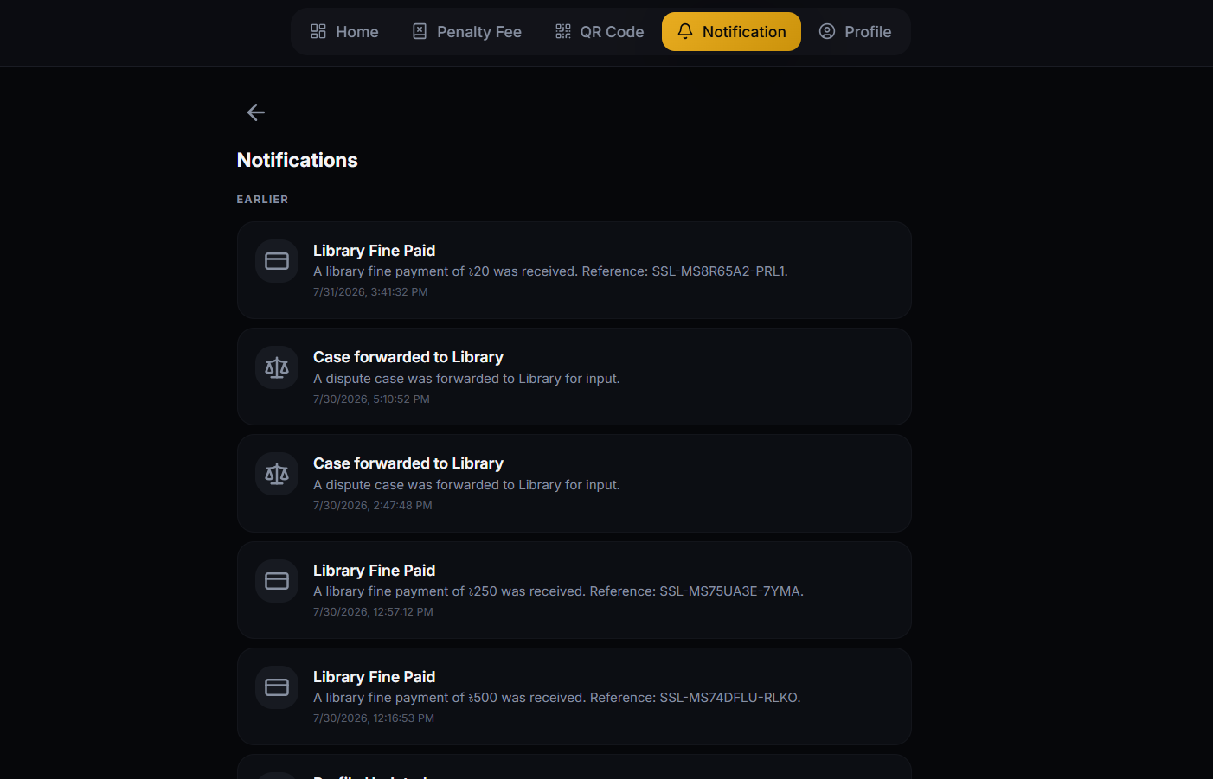

🧮 Accounts Office Dashboard
- Fee Push Records — bulk-push semester fees to the full student list, with per-student amount and status tracking
- Collection Analytics — a live paid-vs-pending breakdown by department, with a % collected rate
- Financial Disputes — review and resolve disputes students raised on a payment
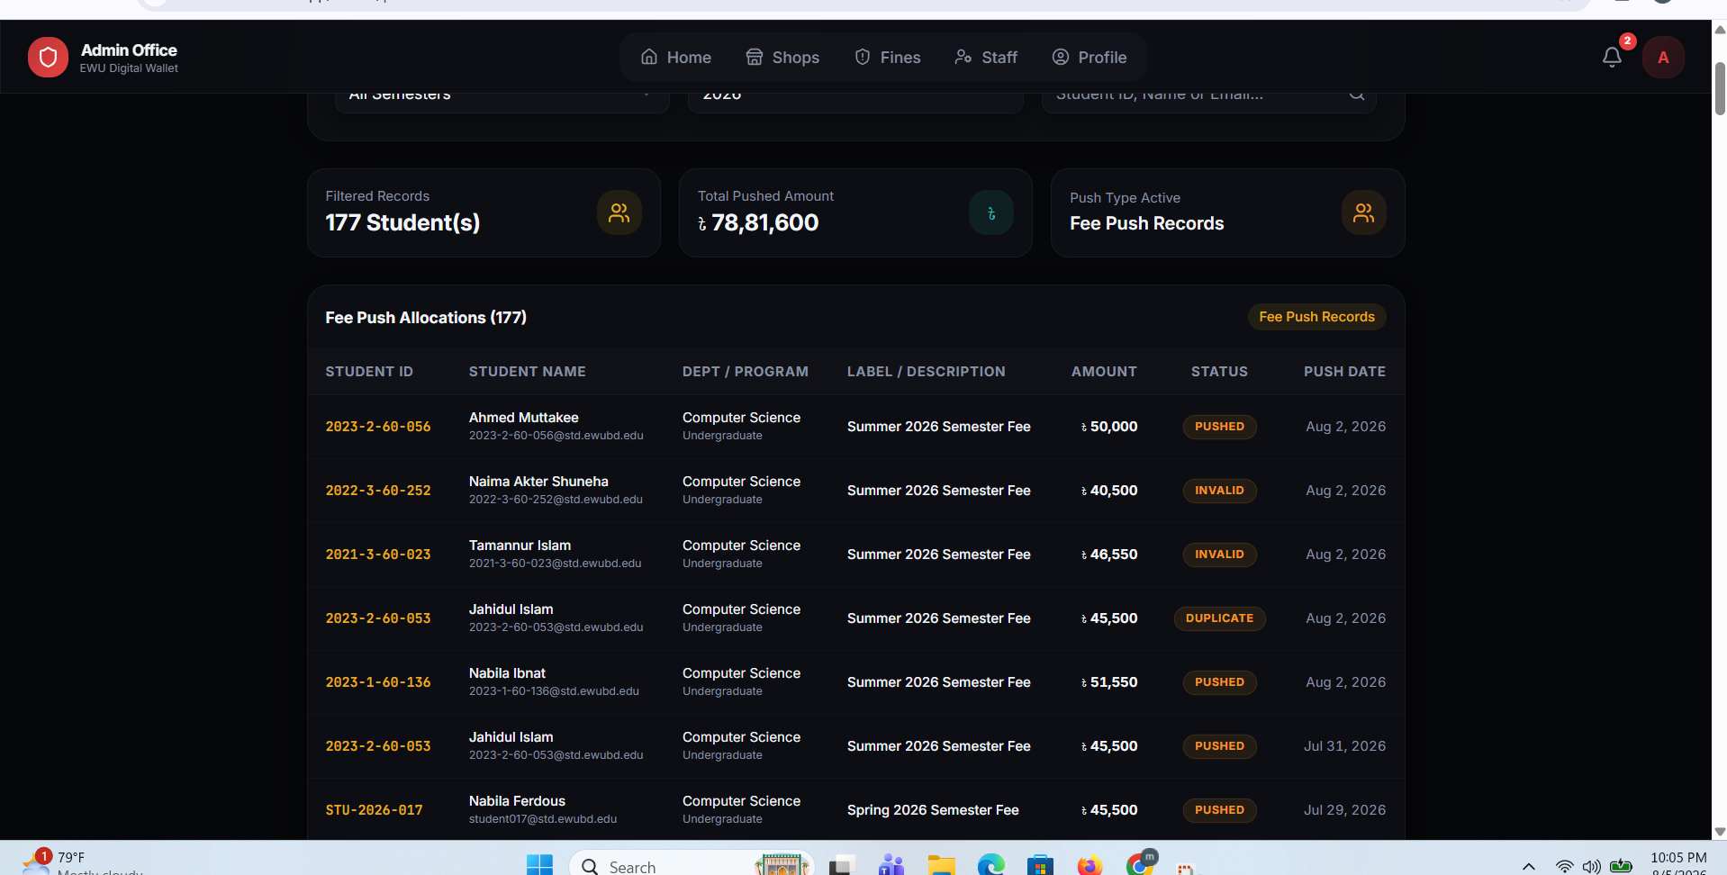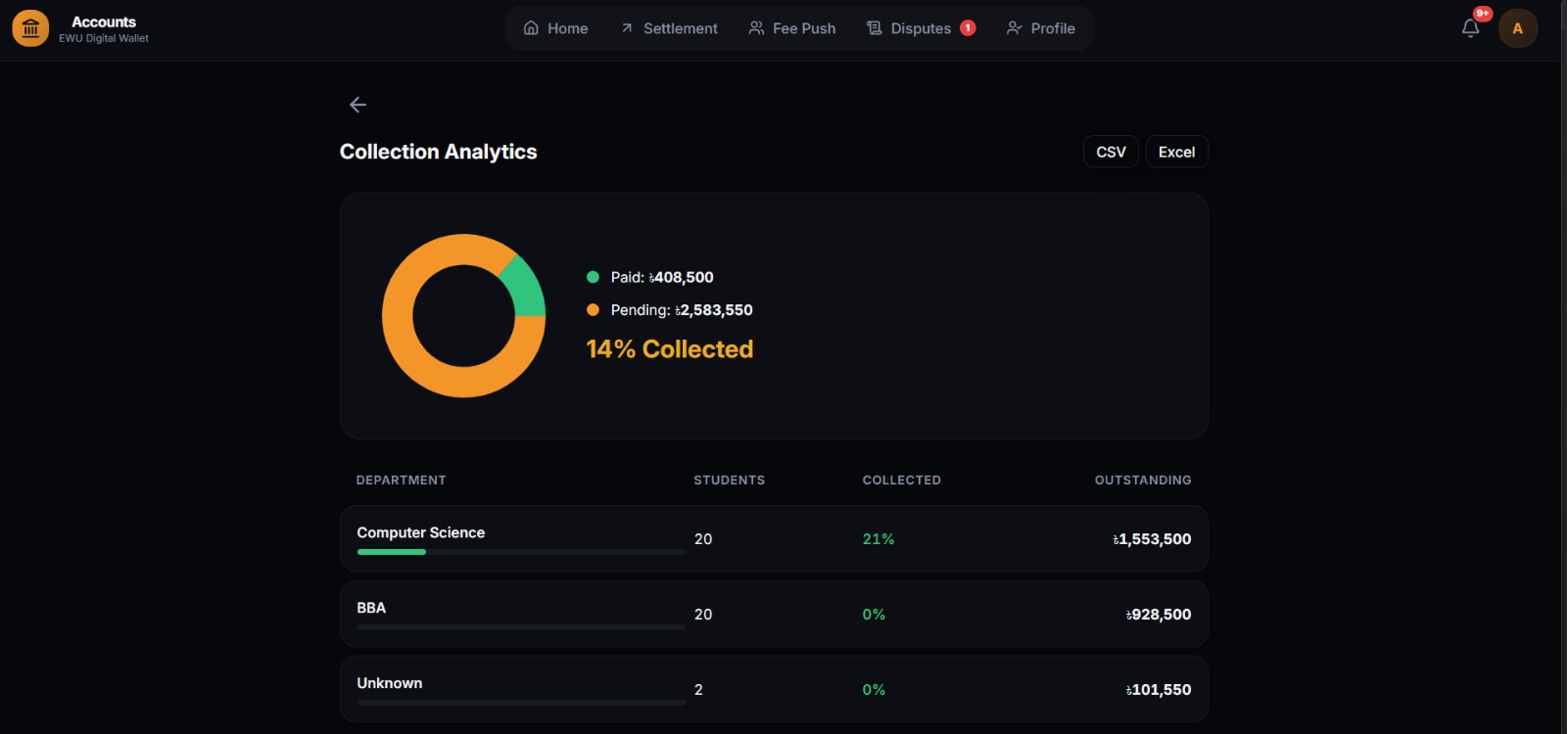
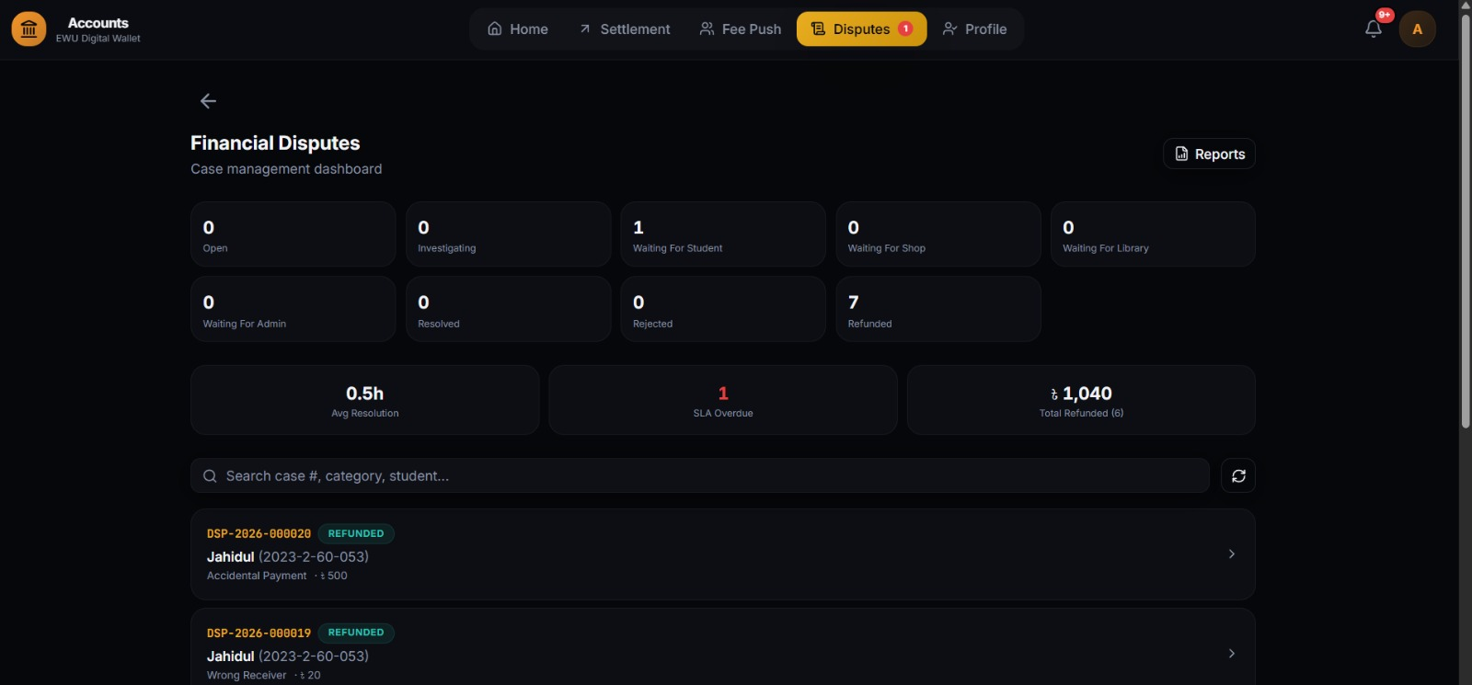

👥 Five Role-Based Dashboards

Role | Purpose
Student | Wallet, top-up, dues/fines, Pay Later, appeals, shop payments
Admin Office | Issue/manage disciplinary fines, handle appeals, provision staff, oversee shops
Library | Fine imposition, QR/kiosk payment, waivers, notifications
Accounts Office | Fee push, collection analytics, dispute resolution
Shop | Per-shop QR payment acceptance & settlement

🛠️ Tech Stack
- Frontend: React, TypeScript, Vite, Tailwind CSS
- Backend: Node.js, Express.js
- Database: PostgreSQL
- Testing: E2E test suite
- Deployment: Vercel

🎥 Demo Video
▶️ https://youtu.be/CLjAjvE5RWI?si=lQRDn7mRHJQyHFhF

