

**Lab Performance**

**Course Code : SE 223**

**Course Tittle : Database Management System Lab**

Submitted By :

Md. Rabby Khan

ID : 0242310005341478

Batch : 40

Section : G

Department of Software Engineering

Daffodil International University

Submitted To :

Kazi Rifat Ahmed

Lecturer

Department of Software Engineering

Daffodil International University

Submission Date : 24 September, 2024

Answer To The Question Number : 1

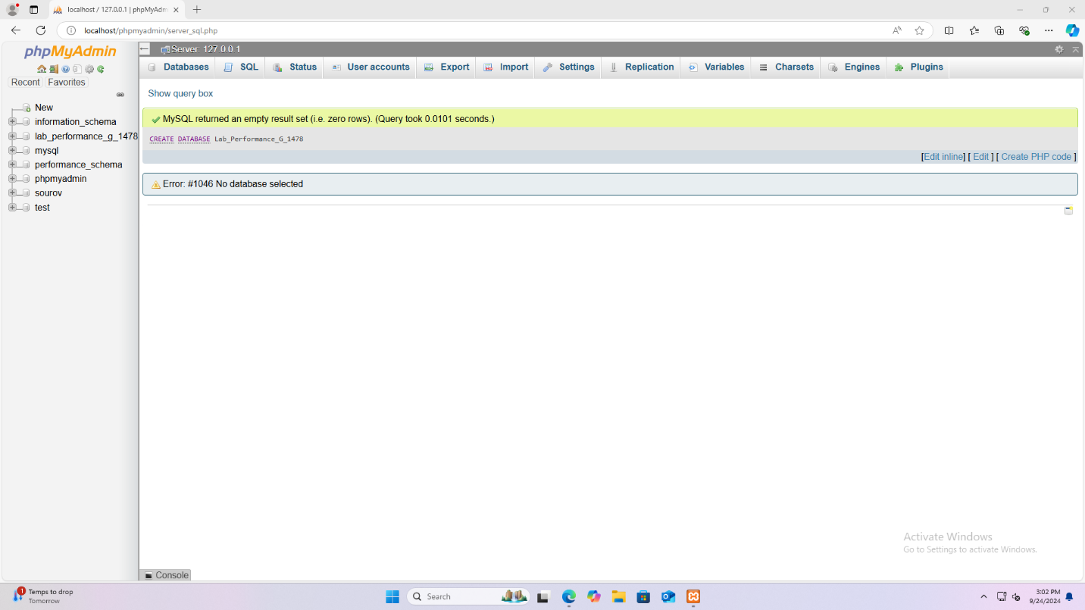

Answer To The Question Number : 2

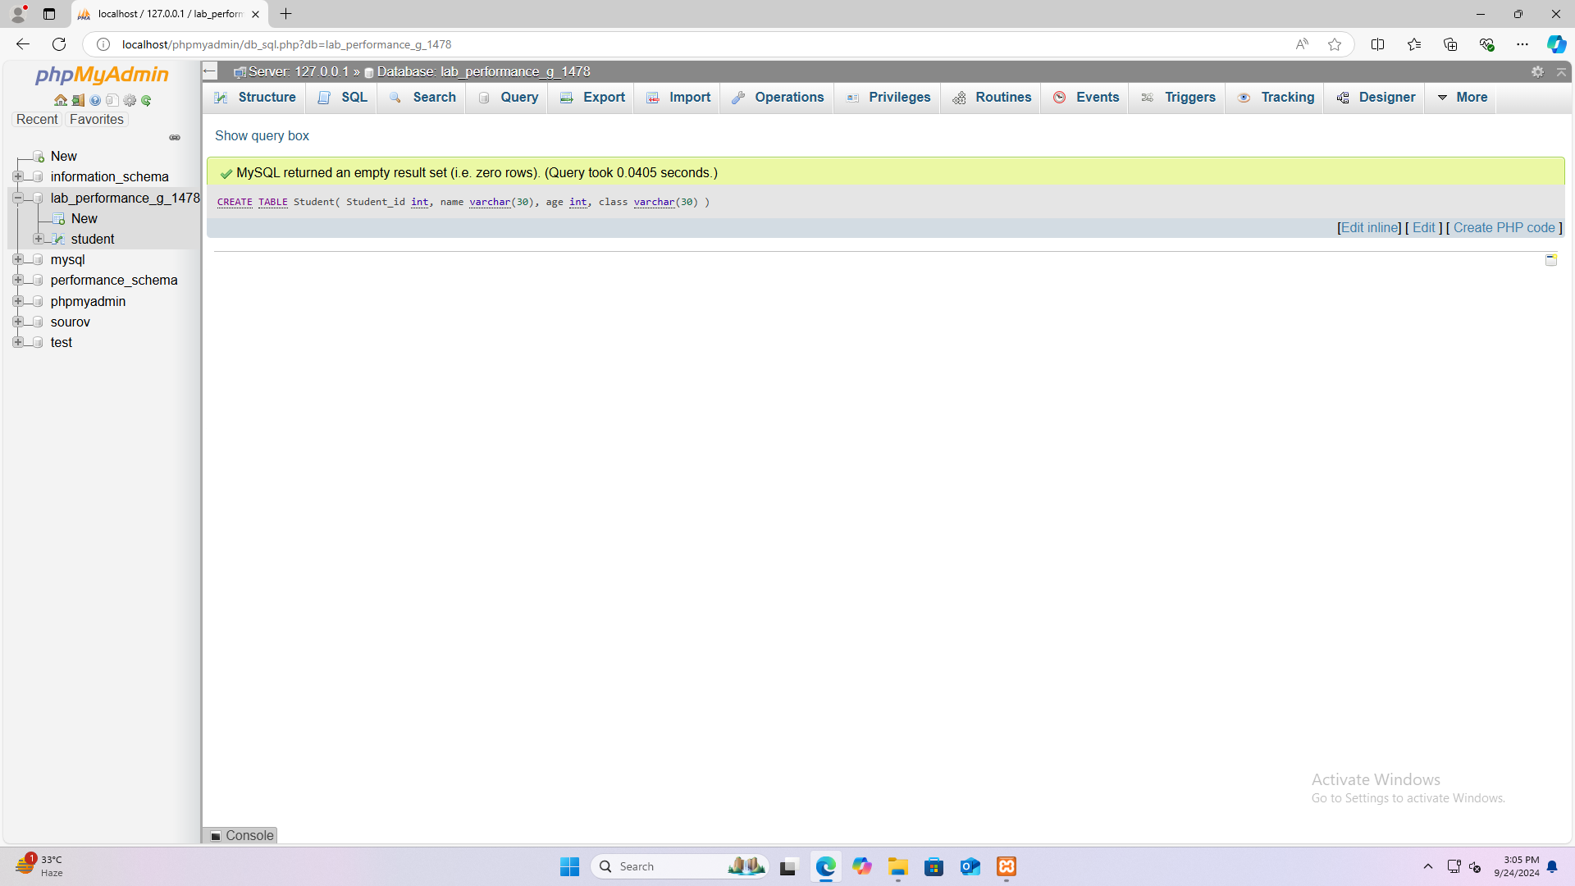

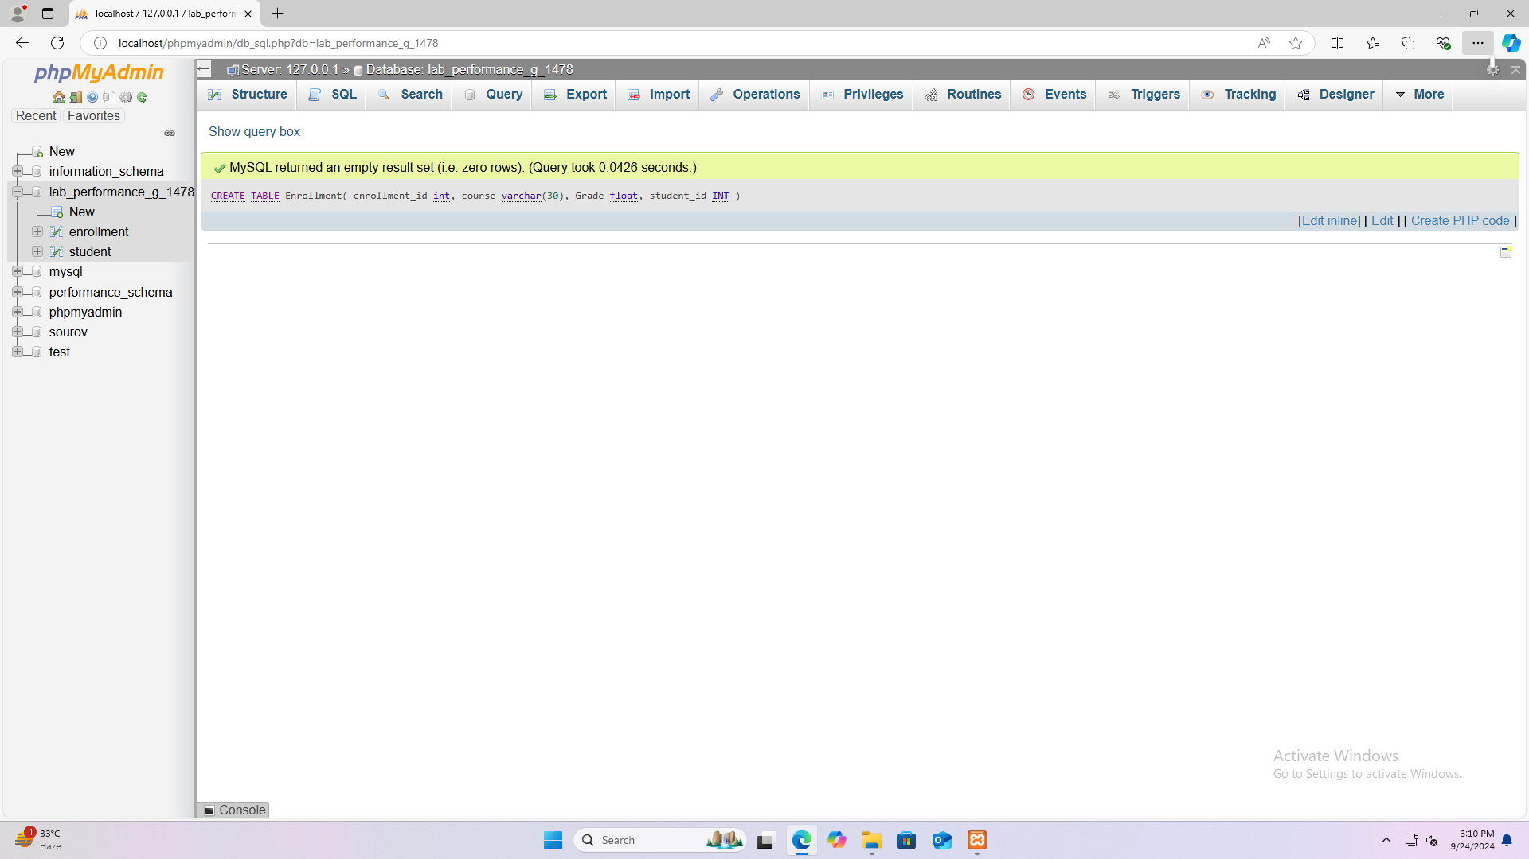

Answer To The Question Number : 3

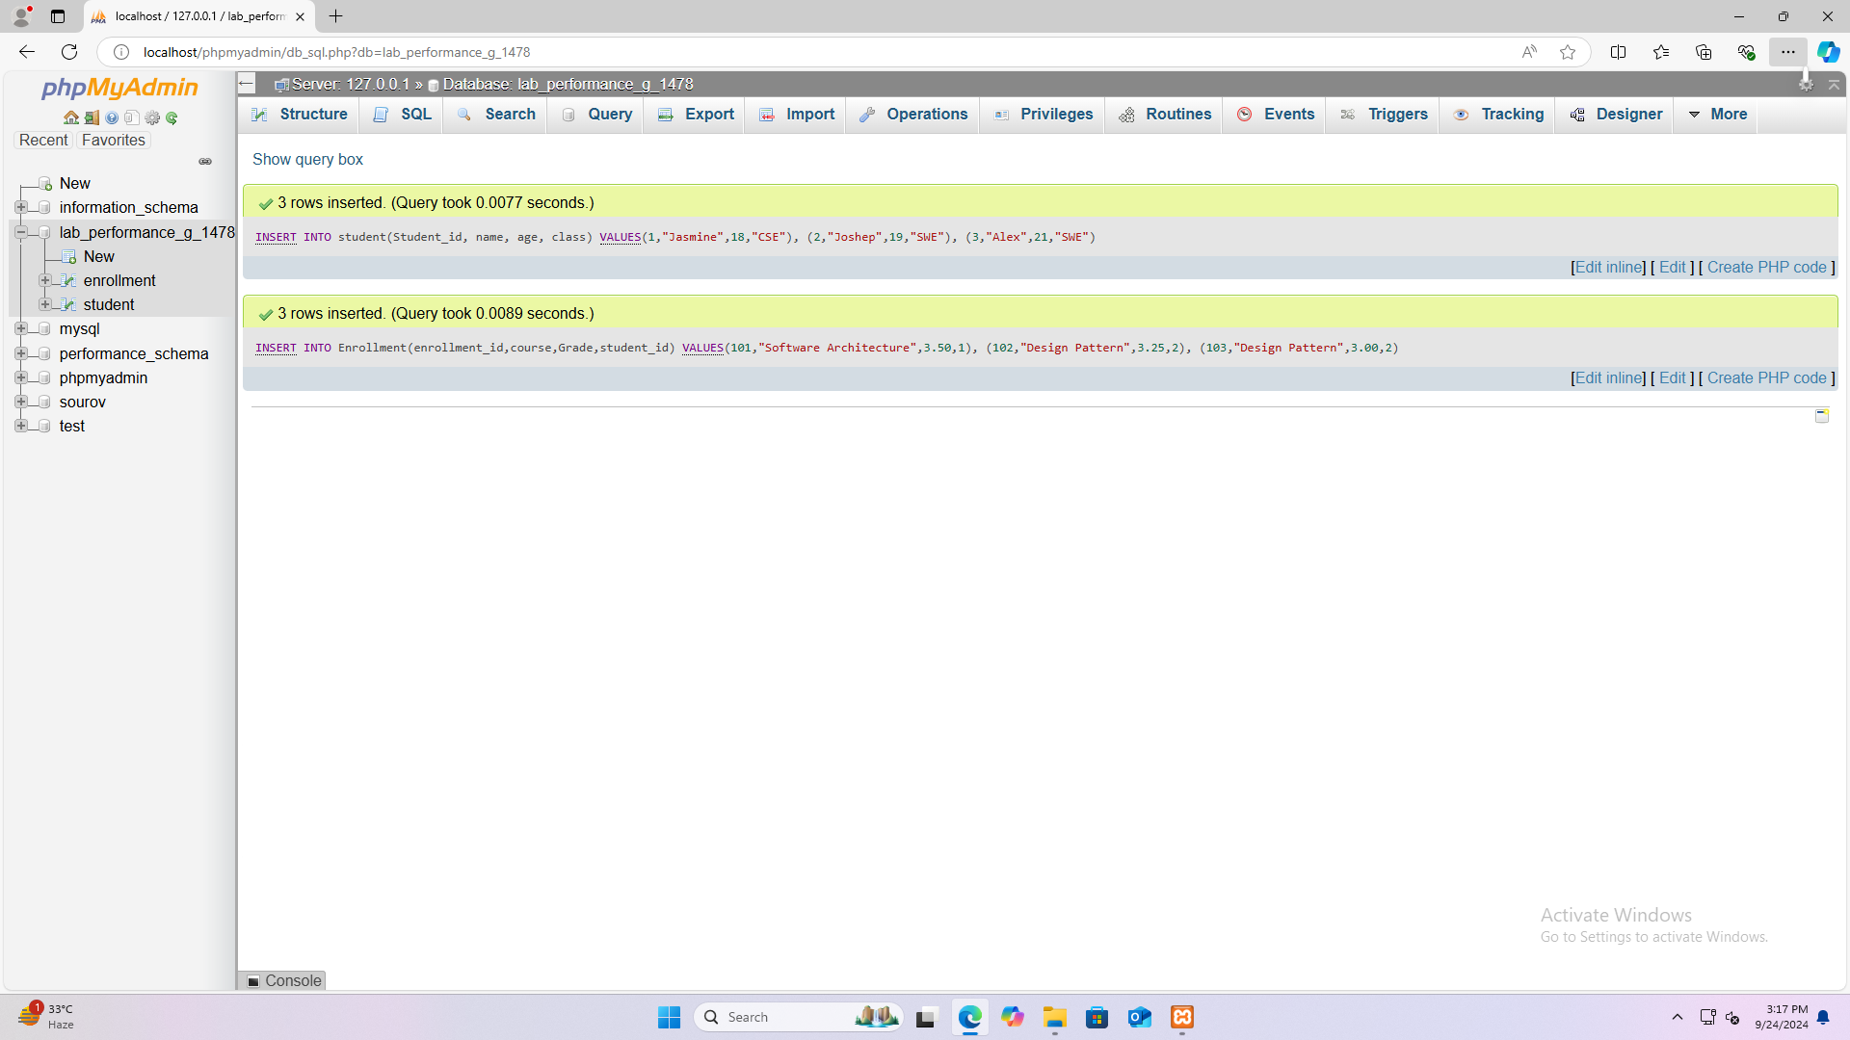

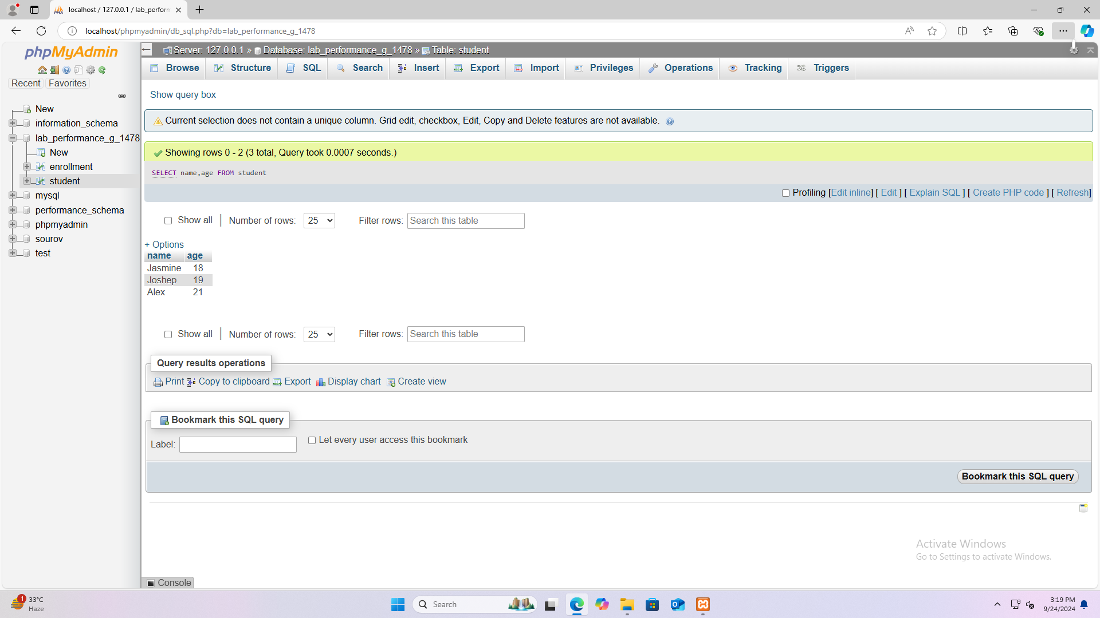Answer To The Question Number : 4

Answer To The Question Number : 5

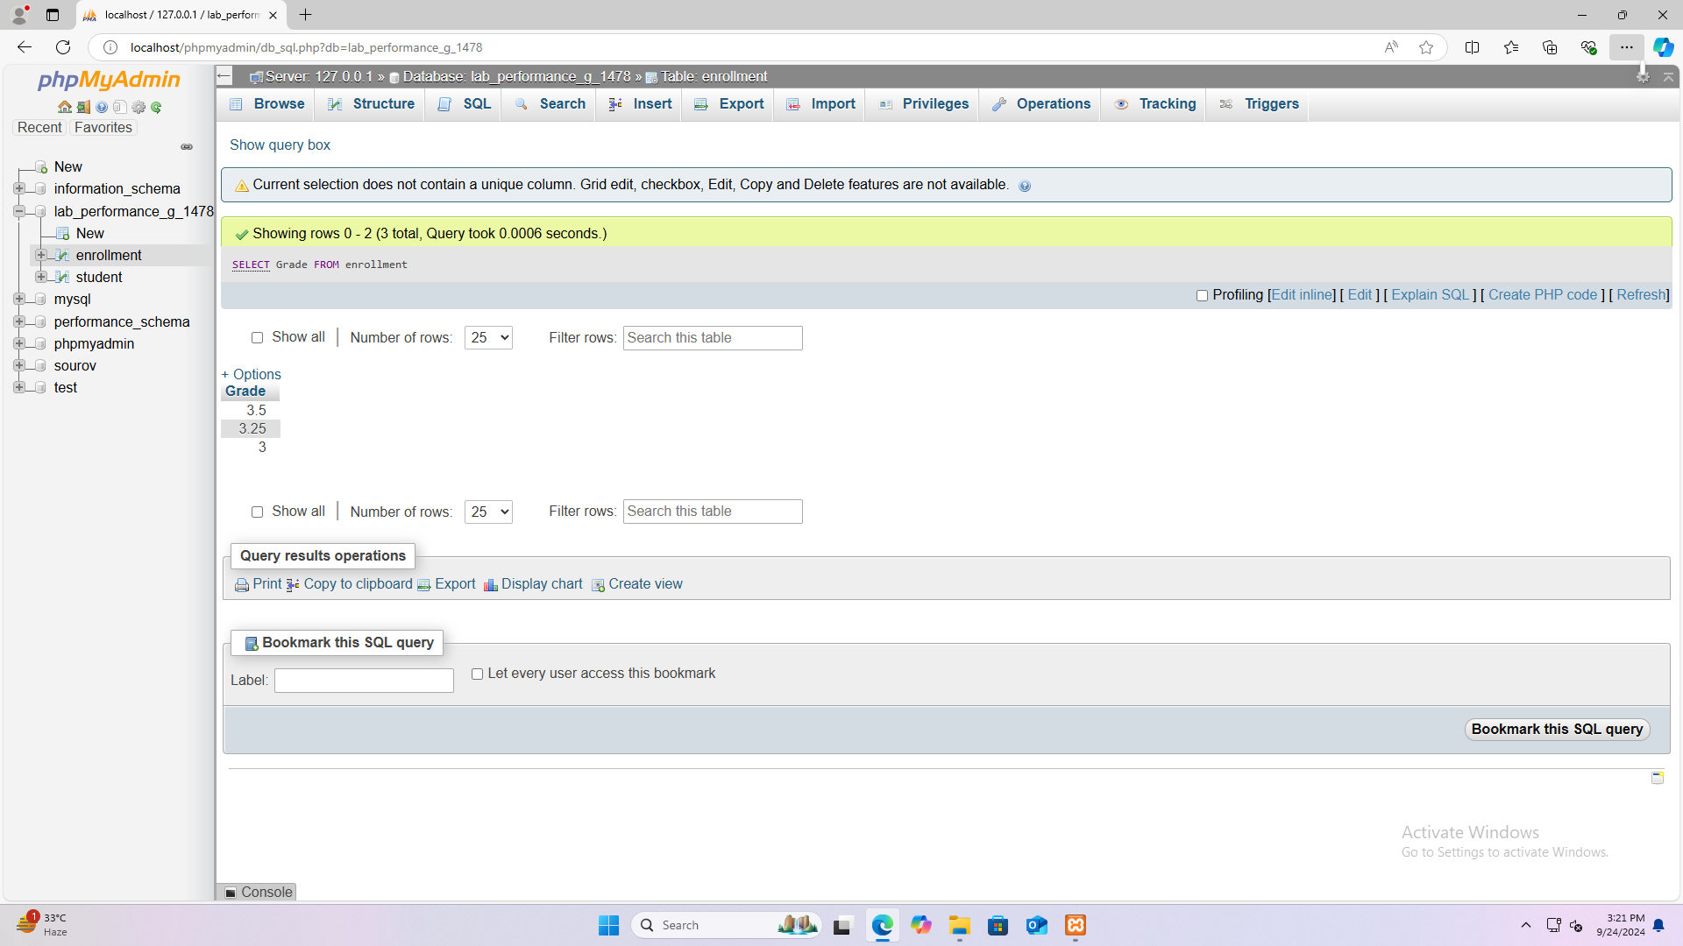

Answer To The Question Number : 6

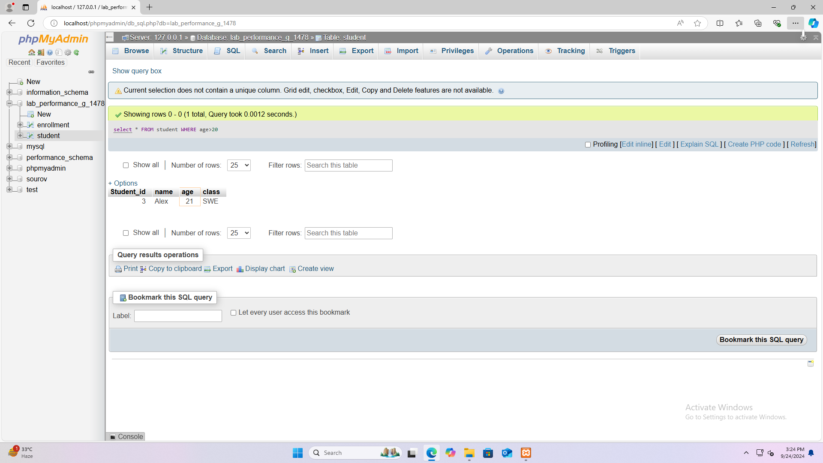

Answer To The Question Number : 7

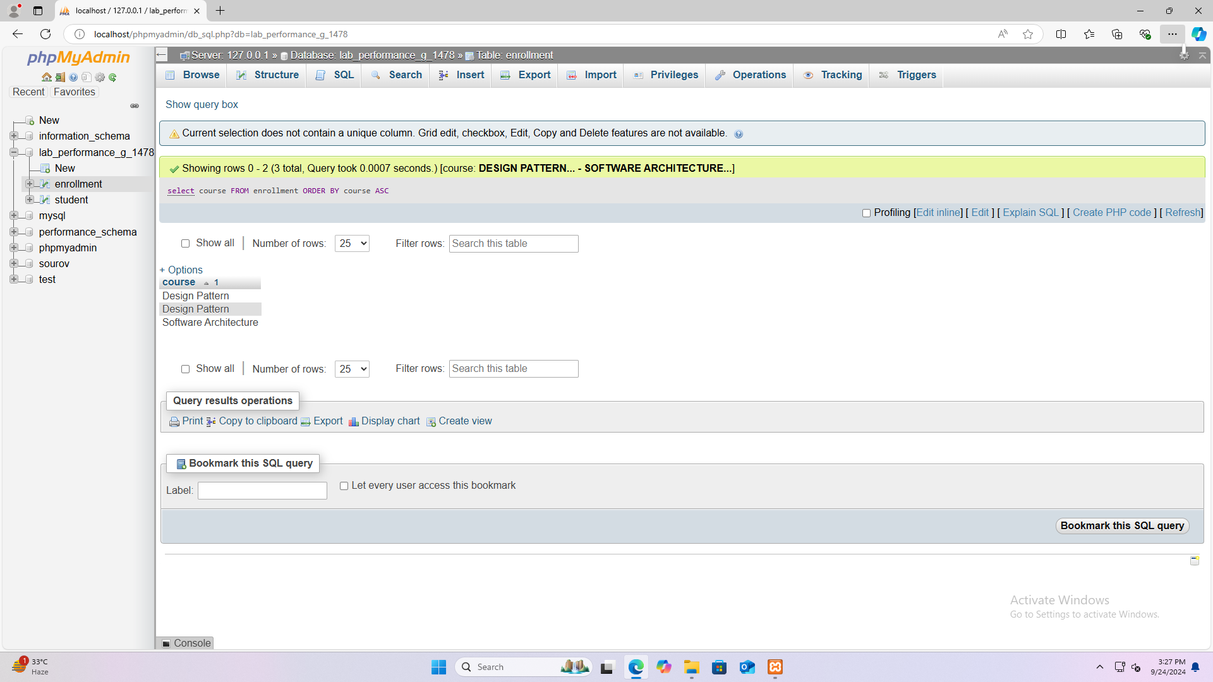

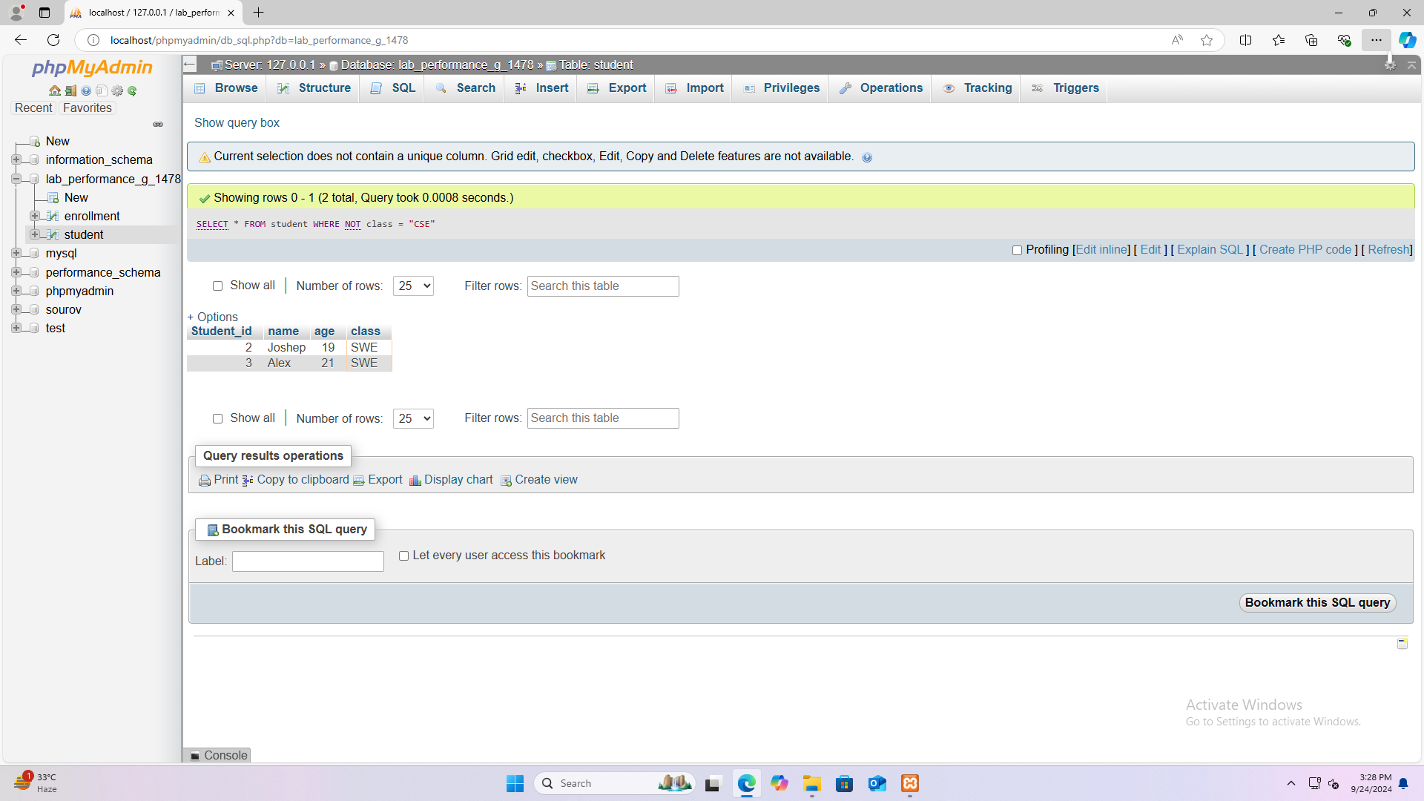Answer To The Question Number : 8

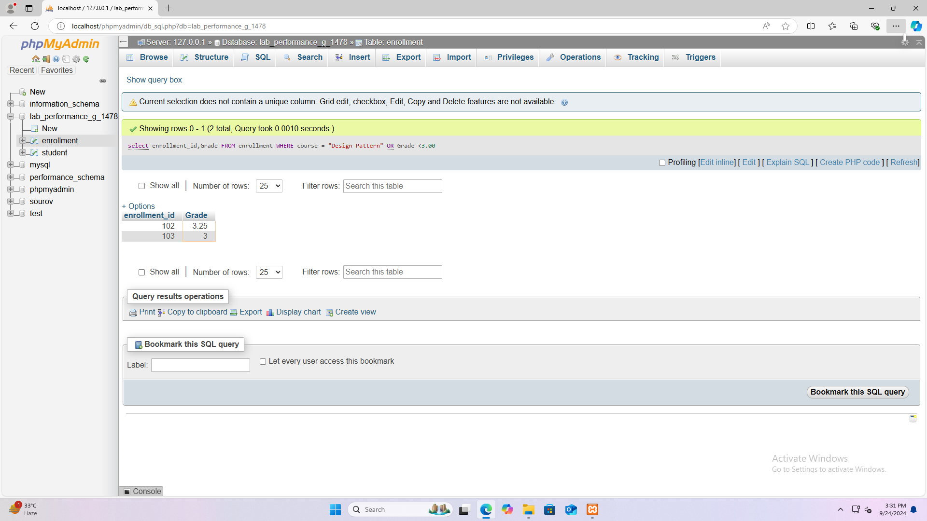Answer To The Question Number : 9

Answer To The Question Number : 10

