**Project Deliverable: Anubis Industries**

CST 2046 System Analysis & Design

Abdur Rehman

5/23/16

Professor Garett

Table of Contents:

Company Description ………………………………………………………………………………. 3

Scope definition …………………………………………………………………………………….. 3

Problem Analysis …………………………………………………………………………………… 4

Requirements Analysis ……………………………………………………………………………… 4

Administration Needs ………………………………………………………………………. 4

Suppliers Needs …………………………………………………………………………….. 4

Clients’ Needs ………………………………………………………………………………. 4

Company’s Operation ………………………………………………………………………. 4

Logical Design ………………………………………………………………………………………. 5

Decision Analysis ……………………………………………………………………………………. 5 - 6

Technical Feasibility ………………………………………………………………………... 5

Operational Feasibility ……………………………………………………………………… 5

Economic Feasibility ………………………………………………………………………... 5 - 6

Scheduling Feasibility ………………………………………………………………………. 6

Physical Design and Integration ……………………………………………………………………... 6 - 8

Data Definition Language …………………………………………………………………... 6 - 7

Customer ………………………………………………………………………….... 6

Car_orders ………………………………………………………………………….. 6

Payment …………………………………………………………………………….. 6

Reservation …………………………………………………………………………. 6

Vehicle ……………………………………………………………………………… 6

Control_Desk ……………………………………………………………………….. 7

Employee …………………………………………………………………………… 7

User Interface ………………………………………………………………………………... 7 - 8

Creating an Account ……………………………………………………………….... 7

Ordering a Taxi ……………………………………………………………………… 8

Construction and Testing ……………………………………………………………………………… 9

Installation and Delivery ………………………………………………………………………………. 9

Project Deliverable: Anubis Industries

1. **Company Description**

Anubis Industries, vision is to change on how we drive today. Currently the old system is implemented in the five boroughs of New York City – Bronx, Brooklyn, Manhattan, Queen, & Staten Island, and the headquarter is located in Manhattan. All of the boroughs where the system is implemented would benefit from, especially Manhattan. Anubis industries generate money by being a taxi company, however all the cars are self-driving cars. A customer can order a taxi whenever he wants to, and can also specify a time and date for the care to pick up the customer, which can be ordered from online, calling us, or from an APP. Currently, they are approximately 200,000 trips per week, yearly that would be approximately 9.4 million trips. Currently the only way to order a taxi would be to call the company, or by hailing a cab on the street. From our old reports we can see that our cars are making around 28000 trips, weekly that turn to 196,000 trips, yearly that pans out to be 9,408,000 million trips. Currently the data throughput requirements are when a customer orders a taxi, that information needs to be recorded such as: first/last name, address of the location, city, state, zip. We also need to record what cab went to pick up what customer along with the id, the length of the trip, and where the car went from pickup to destination. We also need to give our suppliers information as to what cars are broken, the mileage of each cars, how long it will take to repair a car. We also need to archive our data from time to time, and make that is correct. Our employees also need to do customer support for certain customer, so they must be able to edit the customer and the supplier information The clients are the customers who orders taxi, as well the employees who take care of the backend stuff, like backup, doing customer support. The suppliers are the ones who fix our cars when they are broken down, and to see the miles of cars

1. **Scope definition:**
   1. The information that is being designed is to process the transaction fast, and accurately, and to hold larger amount of data every day, since we Anubis Industries will have a minimum of 28000 orders a day. We need this in place, because right now, it takes around 1 minute for the transaction to be completed fully, by implementing this information system that will be reduced to 5 – 10 seconds. It is estimated that it will take 8 – 10 months to design, implement and install the information system. To carry out this information system we will need around 500 people.
2. **Problem Analysis:**
   1. Currently when a customer orders a taxi, it takes around 1 minute to process it. With the new system, it will take around 30 sec
   2. When a customer orders a taxi, and is processed that data get lost, and the customer would need to fill out the transaction process again. With the new system this does not happens
   3. When backing up the server, it would increase the transaction time, and the process of backing up takes too long. With the new system, it will reduce the time of the backups by 30%.
   4. Currently when the customer is logging in, to his web based, or APP to see his itinerary it takes around 1 -2 min. This will be reduced by half.
   5. When there is high traffic the current system cannot handle all the transactions that are taking place, thus it would hang up, or freeze. The new system will have expanded memory, and space to make sure it does not happen.
3. **Requirements analysis:**
   1. Administration needs:
      1. To be able to edit the customers, and the supplier’s information such as: name, address, city, state, zip
      2. To be able to back up customer information and car information.
   2. Suppliers needs:
      1. To see how much the cars mileage.
      2. To see what cars need repairs.
   3. Client’s needs:
      1. To be able to access and order taxi
      2. To be able to log back in, and change their data.
   4. Company’s operation
      1. Generate report daily about transaction that took place. Also monthly and yearly.
      2. Generate reports that shows where are the most transaction are taking place, and what time.
4. **Logical Design**

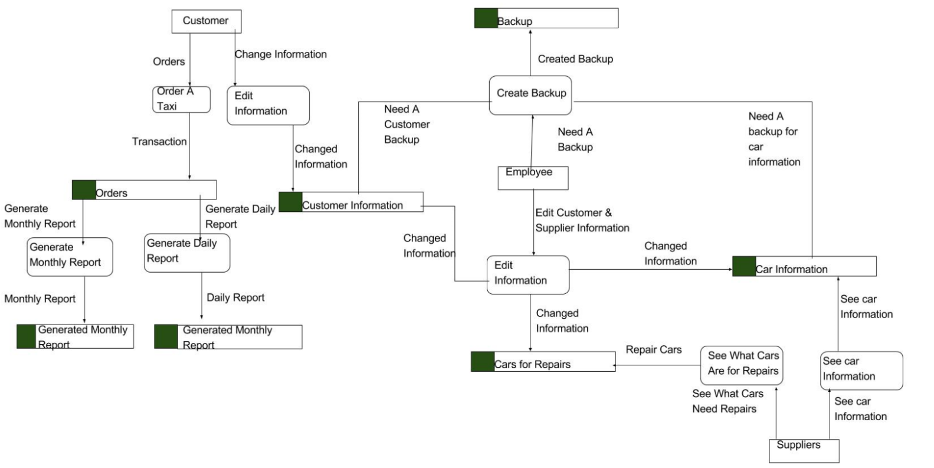

1. **Decision Analysis**
   1. Technical feasibility
      1. The system that is being purposed is not too difficult to build, we will need a one or two senior developer. We will also need around 10 junior developers. Also we will need 3 to 4 database administration, and 3 to 4 web programmer.
   2. Operational feasibility
      1. To build the customer logging webpage, and the APP to see his itinerary page, should take around 4 – 5 weeks. To reduce the timing of the order of a taxi it will take around 3 – 5 weeks. For the new system to handle more transaction, and make that the data is lost, this will take time since we will need to figure out where it needs to improved, and why data is being lost, so we estimate this can take about 3 – 6 months.
   3. Economic Feasibility
      1. Personnel Cost – The salaries of the senior and junior developers, database administration, and web programmers, is estimated to cost between $1.5 million to $2 million.
      2. Computer Usage & Software – We will need to buy a certificate for a database storage mechanism which should cost around $5,000. Also backups will be uploaded to an online vendor, which is going to cost around $500 yearly.
      3. Training – We will also need to retrain our employee since the new system will a have new graphical user interface, and the way to back up the data will also be different. We estimate this will cost around $30,000.
   4. Scheduling Feasibility
      1. Our time table is reasonable, and allows us time to adjust if a problem occurs.
2. **Physical Design and Integration**

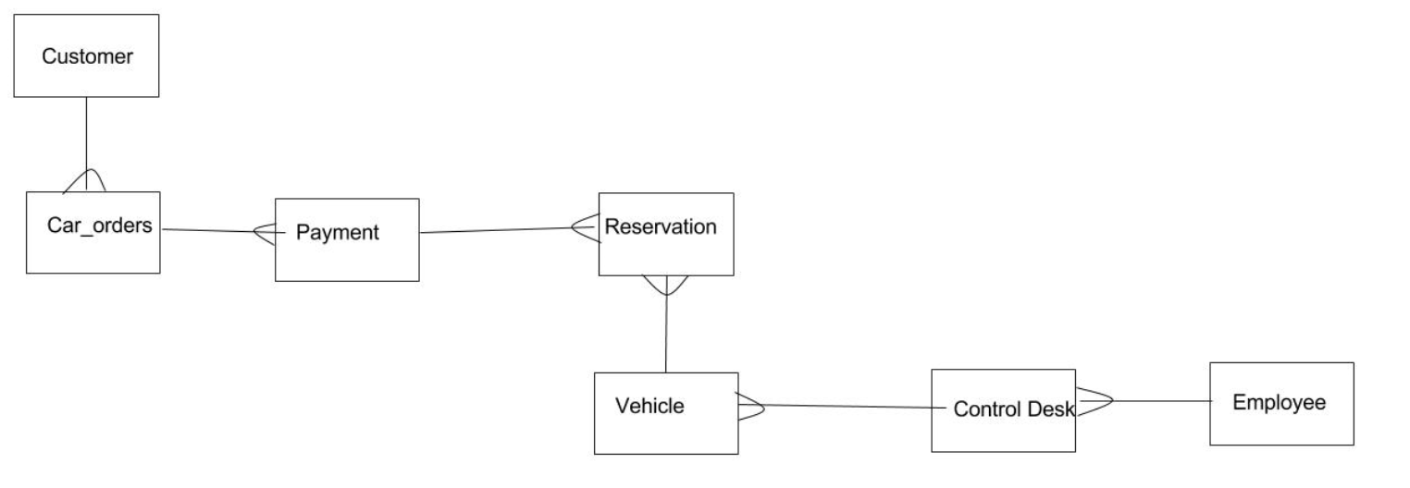

* 1. Data Definition language
     1. Customer: custID number primary key, first_name varchar(50), last_name varchar(50), City varchar (30), State varchar(30), Zip number(5), telephone varchar(13), email varchar(50), password varchar(50), username varchar(30)
     2. Car_Orders: carID number primary key, *custID* number foreign key, vehicleType varchar(50), car_orderd date
     3. Payment: paymentID number primary key, *carID* number foreign key, *custID* number foreign key, ccNumber, ccTypes, ccv number (3)
     4. Resevervation: revID number primary key, *carID* number foreign key, *custID* number foreign key, date_picked_up date, gas number, date_scheducle date, trip_time date, vehicleType varchar (50).
     5. Vehicle: vehicleID primary key number, *controlID* number foreign key, vehicleType varchar (50), vin_number varchar(50)
     6. Control_Desk: controlID number primary key, *empID* number foreign key vin_number varchar(50), city (30)
     7. Employee: empID number primary key, first_name varchar(50), last_name varchar(50), City varchar (30), State varchar(30), Zip number(5), telephone varchar(13), email varchar(50), password varchar(50)
  2. User Interface:
     1. Creating an account

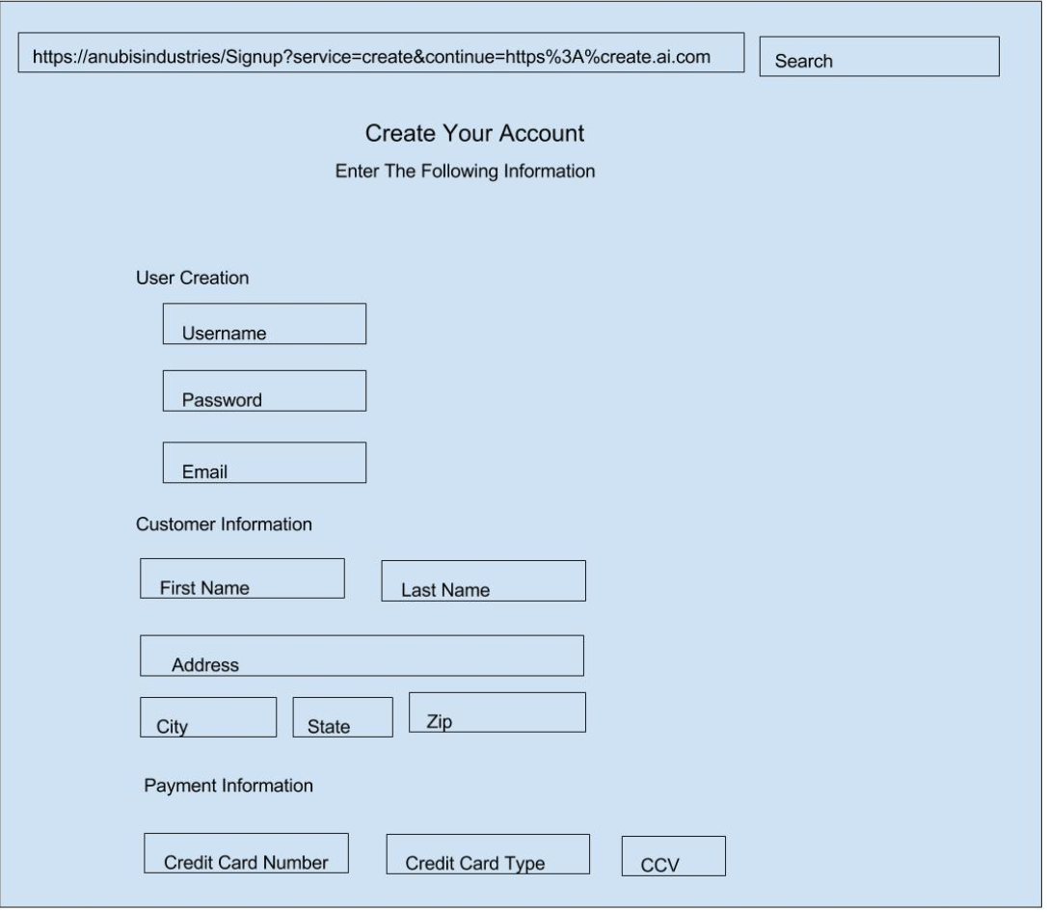

* + 1. Ordering A Taxi

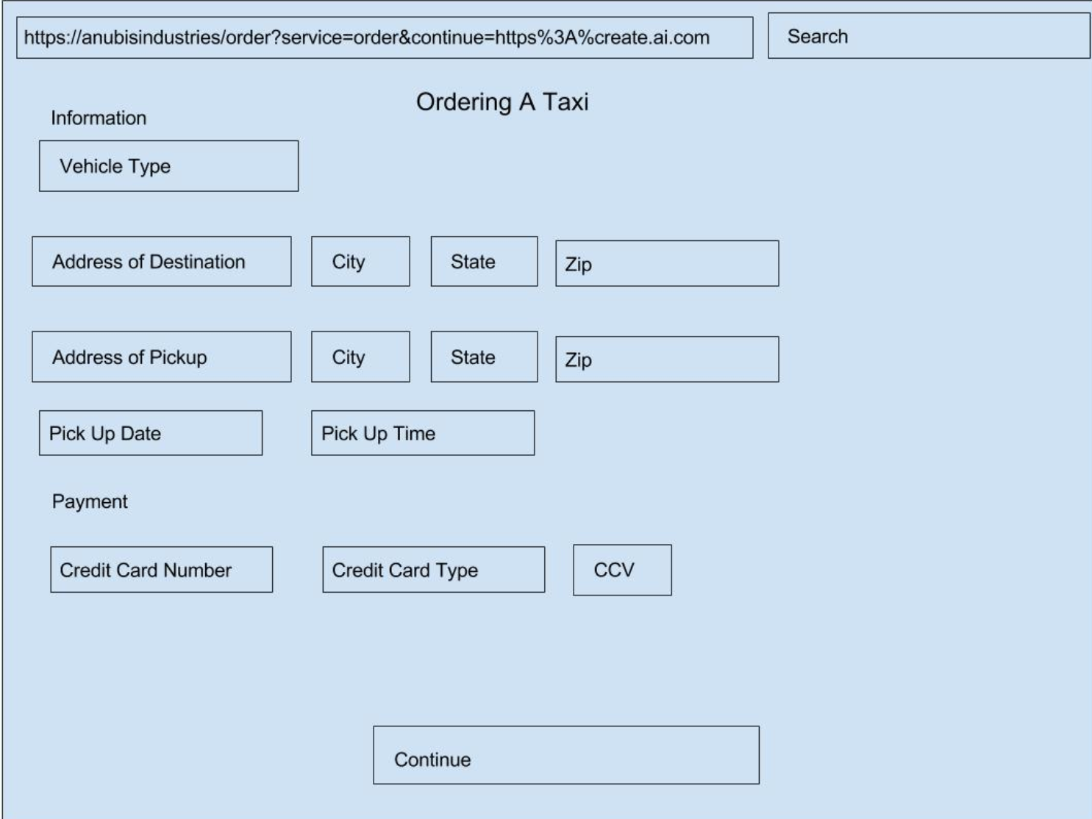

1. **Construction and Testing** 
   1. One way to test the new system is to see how long it takes for a customer orders a transaction. To this feature using the test driven development, could be by another feature like, the customer when orders he can see where his taxi is. So we will make the code for that, compile it. If it fails, alter it and make sure it passes, and then refractor the code.
   2. Another way is to test the new system is to see, whether or not if a customer can log back in and see his/her itinerary, and whether or not that information is correct. We might add a new feature, that will combine all the information into one page, rather than separate pages. So we will write a code for that, using HTML, PHP, CSS and more, than we will compile the code. The test code, is probably going to succeed, but if it does fail, the code will be altered, make the code passes, and then refractor the code.
2. **Installation and Delivery**
   1. To provide smooth transition to the new system, the new system will run parallel until the new system has been deemed acceptable to replace the old system, which should take around 4 – 6 months. When the new system has been in placed it will be able to do lessen the time when the customer orders a taxi, make sure that information is not lost, it will make backing up easier and faster. It will also be able to generate reports daily and monthly for the company operation. This new system will be used by the customers who orders our taxi. Suppliers who repairs our cars. Finally, it will be used by our employees who can edit supplier and customer information, and create backup.