MongoDB Checkpoint
DataBase: contact
Collection: contactlist
Data:
The initial data to be inserted into the database”
[{"last name":"Ben Lahmer","first name":"Fares","email":"fares@gmail.com","age":26},{"last name":"Kefi","first name":"Seif","email":"kefi@gmail.com","age":15},{"last name":"Fatnassi","first name":"Sarra","email":"sarra.f@gmail.com","age":40},{"last name":"Ben Yahya","first name":"Rym","age":4},{"last name":"Cherif","first name":"Sami","age":3}]
- Step one: create the database:
Command lines:
Use contact
Db.contactlist.insertMany([data])
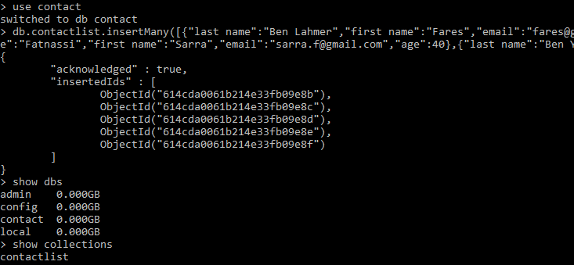
Database content:
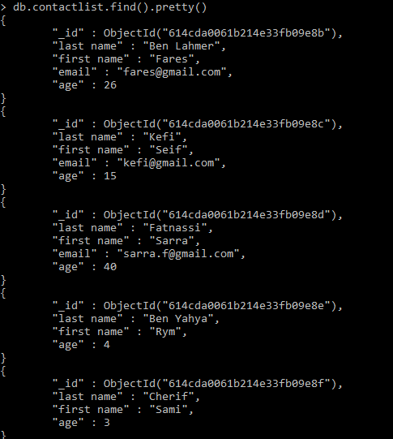
- Step two: Display all the information about only one person using his ID
Command line:
Db.contactlist.find({criteria})
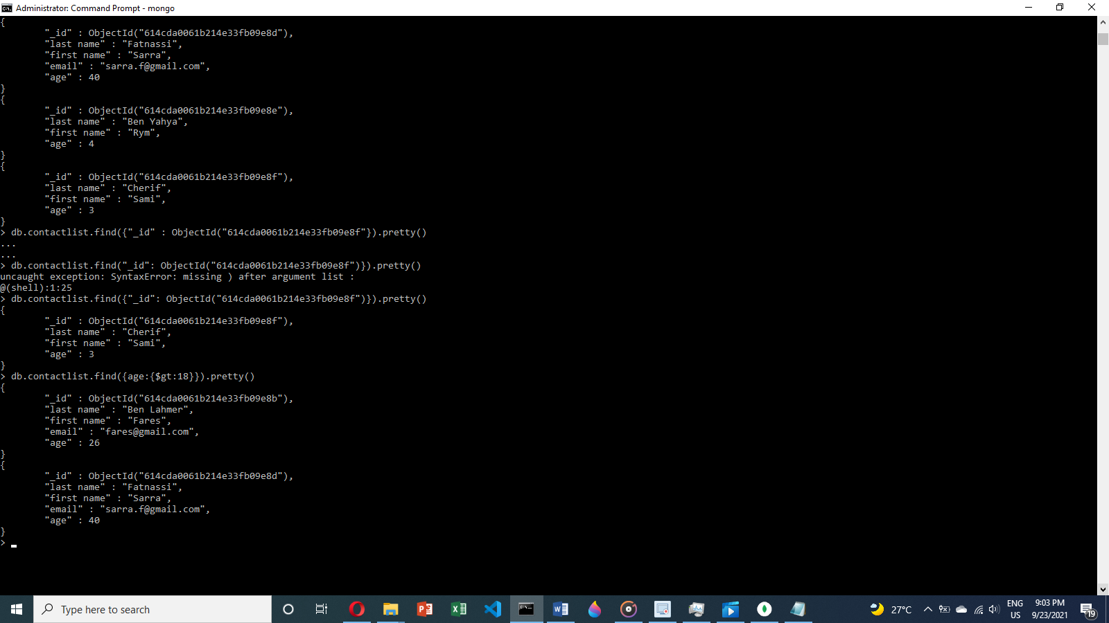
- Step three: Display all the contacts with an age >18
Command line:
Db.contactlist.find({criteria:{condition}})
- Step four: Display all the contacts with an age>18 and name containing "ah"
Command line:
Db.contactlist.find({$and:[{criteria1:{condition1}},{criteria2:{condition2}}]})
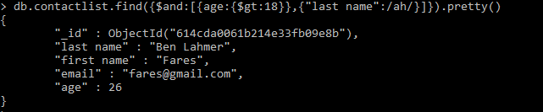
- Step five: Change the contact's first name from"Kefi Seif" to "Kefi Anis"
Command line:
Db.contactlist.update({element id},{$set:{field: the change}})
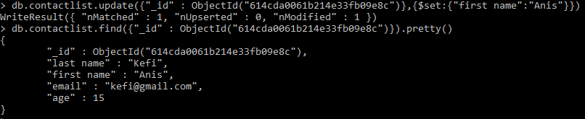
- Step six: Delete the contacts that are aged under <5
Command line:
Db.contactlist.deleteMany({criteria})
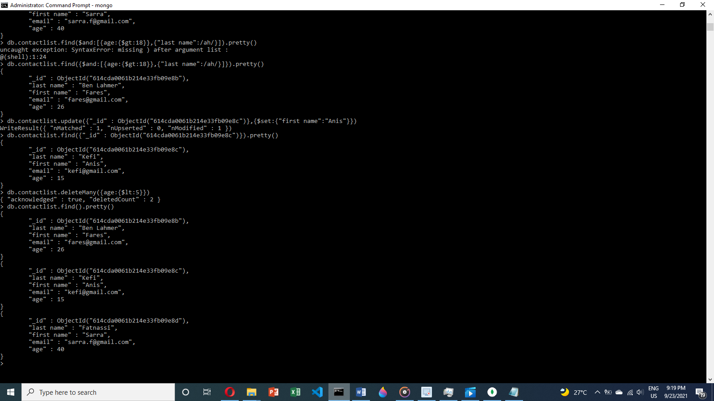
- Step seven: Display all of the contacts list
Command line:
Db.contactlist.find().pretty()

